CMGT 235 – Electrical and Mechanical Systems
Homework #29 – Residential Service Entrance Calculation
Due: 12/1/2022
Points: 20
Answers
Name: _______________________________________________________________________________

- What is the demand load for a 1 hp 120 VAC food waste disposal, ½ hp trash compactor, 1800-watt 120 VAC dishwasher, and a 15A 120 VAC Whirlpool Bathtub?
Food Waste Disposal 16 A x 120 V = 1920 VA
trash compactor 9.8 A x 120 V = 1176 VA
Dishwasher 1800 VA
Hydro Tub 15 A x 120 V = 1800 VA

Total 6696 VA

Apply 75% demand factor if Four or More “Fastened-in-Place” Appliances

Demand Load = 6696 VA x 0.75 = 5022 VA

- What size grounding electrode conductor is required for a 15,000 sq. ft. commercial building that has installed 400 copper ungrounded service-entrance conductors? Where in the NEC do you find the answer?
1/0 AWG CU
Table 250.66
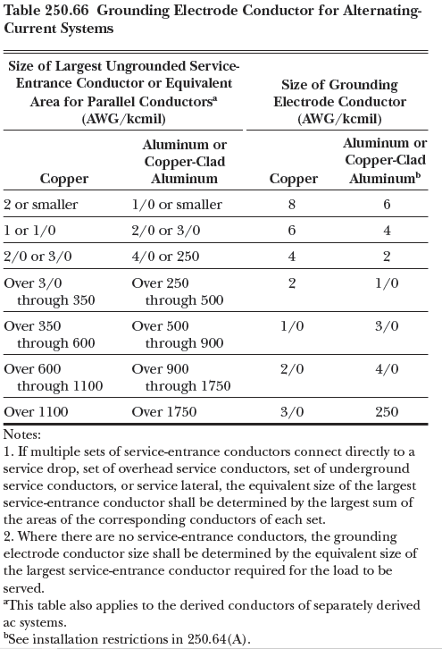
- What size Over Current Protection Device (OCPD) is recommended for a 6500 W, 208V 3 phase sauna?

I = 6500 W / 208 V x 1.73 = 18 A

FLA (Continuous)
I = 18 A x 1.25 = 22.6 A

OCPD = 25 A Circuit Breaker or Fuse

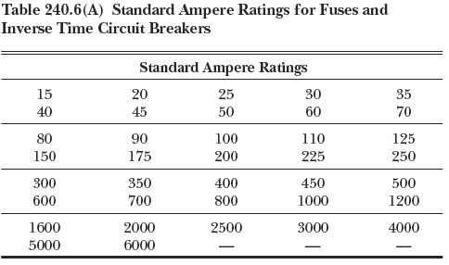

- Given a single-family residence with a general lighting load of 24,500 watts. What is the demand lighting load for the residence?

3000 VA @ 100% = 3000 VA
24,500 – 3000 = 21,500 @ 35% = 7525 VA

Total Demand 10,525 VA

