CMGT 235 – Electrical and Mechanical Systems
Discussion No. 32 – Construction Scheduling

Key Terms
Precedence Diagramming Method (PDM) A graphical scheduling methodology composed of activity nodes and relationship arrows that show the interrelations and constraints between activities.
Arrow Diagramming Method (ADM) A graphical scheduling methodology that is composed of activity arrows that are joined by nodes.
Critical Path The longest path through the schedule.
Critical Activity An activity that must be started and finished on a specific date in order not to extend the project duration.
Lag A period of no activity that must lapse between two events.
Early Dates The earliest that a scheduled event can begin or end.
Late Dates The latest that a scheduled event can begin or end.
Forward Pass A calculation starting with the first activity and culminating with the last activity performed to find the early dates and the duration of a specific project.
Backward Pass A scheduling calculation done to determine the activity late dates. This calculation begins with the last activity and project duration and culminates with the first activity.
Float The number of days that an event or lag can be delayed or extended without impacting the completion of the project.
Project Days The number of days that a project, activity, or lag has or will be under way.
Early Start (ES) The earliest that an activity can start.
Early Finish (EF) The earliest that an activity can possibly finish.
Late Start (LS) The latest that an activity can start and not impact project completion.
Late Finish (LF) The latest that an activity can be completed without impacting the project completion.

Scheduling
Activity ID
Activity Relationships
finish-to-start
Description
start-to-start
finish-to-finish
Duration
start-to-finish

Lags
Duration of a lag should be the minimum number of days that must elapse between activities.

Milestones
Start Milestone – Notice to Proceed
End Milestone – Substantial Completion

Hammock
An activity that spans a group of activities for summarizing purposes.

Bar Chart Schedule
Finish-to-Start. The Finish-to-Start relationship means that one activity — the predecessor — must be fully complete before any following — successor — activities may begin.

Example: Placing of One of Four Runs of Continuous Footings for a Building Foundation
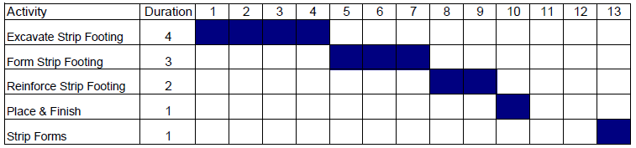

Example: Construction of all sides of the foundation system
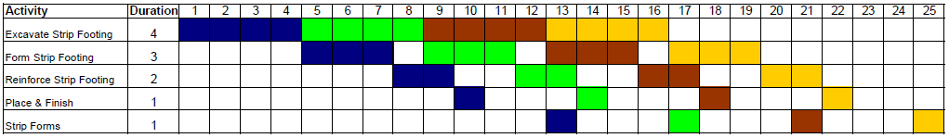

Example: Schedule for Continuous Footings with Reused Forms

Step-By-Step Example of Drawing a Network Diagram

Activities and their logical sequence:
Once you have received the 10-notice to proceed (milestone activity-0 days), begin 20-excavation (3) and 30-order/deliver the brick (20) so it comes in on time. The 40-footing and foundation (13) will follow the excavation and precede 50-slab-on-grade (4). When the slab is done both the 60-exterior wall framing (7) and 70-backfill (2) can begin. You will start running the 80-site utilities (10) with the backhoe when you are done backfilling. Your framing crew will begin to 90-frame and shingle the roof (6) and 100-frame the interior partitions (9) after they finish framing the exterior walls. Your electrical contractor doesn't want to do the 110-electrical work (5) until after the interior walls are up and the site utilities have been run to the building. This way they can save an extra trip. When they are done with the electrical work, they can install the 120-space heaters (6). The 130-masonry (10) can begin after the roof and backfill is complete and the brick has been delivered. The 140-exterior trim (4) can begin five days SS(5) after the masonry begins. 150-Landscaping (4) will follow both masonry and the site utility runs. The project can be 160-punched out (3) after the exterior trim, landscaping, and space heaters are done. 170-Project management (hammock activity) will start when notice to proceed starts and will finish when punch-out finishes.

