**CMGT 235 – Electrical and Mechanical Systems**

Department of Construction Management 🏵 California State University, Chico

Exam #3 – Electrical Systems

All problems refer to the NEC [Unless Noted Otherwise]

5 points Each Answer

Name: ____________________________________________________________________________________

1. The transformer on a power pole steps down the voltage from 10,800 volts to 120 volts. If the secondary coil contains 360 turns, how many turns are found on the primary coil?
2. An electric dryer consumes 1667 Wh of energy when operating at 220 volts for 30 minutes. During operation approximately how much current does the dryer draw?
3. A department store is illuminated with 215 fluorescent lighting fixtures and connected to a 120-volt supply. Each lighting fixture draws 2.2 amperes. How many 20 A branch circuits are necessary to feed these fixtures if each branch circuit must not exceed 80% of the branch circuit rating?
4. Determine the equivalent resistance Rab at terminals a-b for the circuit shown:

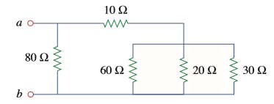

1. Diagram

   Description automatically generatedA homeowner is building a shop 95 feet from the main power source and needs a 200A service.
2. What size THHN 75°C CU wire is required for the feeders (conductors) to the subpanel and where in the NEC is the answer found?
3. If the minimum ampacity for the neutral service-entrance conductor is 97A what size neutral conductor is required at the shop’s subpanel and where in the NEC is the answer found?
4. What size grounding electrode conductor is required at the shop’s subpanel and where in the NEC is the answer found?
5. What is the smallest trade size PVC Sched 40 raceway required for installing the ungrounded feeders?

|  |  |  |  |  |  |
| --- | --- | --- | --- | --- | --- |
| QTY | GAUGE | TYPE | Cross-Section Area | |  |
|  |  |  |  | | PVC Sched. 40 |
|  |  |  | Total Cross-Section Area |  |  |

1. What is the percentage voltage loss for the ungrounded service conductors? Is it acceptable per the NEC recommendation? If not, what should be done to reduce the VD?
2. Fill in the box with the name of the item. [1 pt each answer]

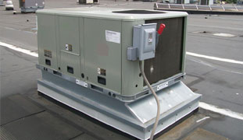

1. What is the power rating in watts for the motor shown below if the power factor is 70%?

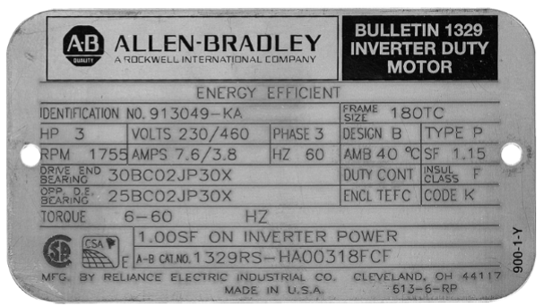

1. What organization publishes a set of regulations governing the construction and installation of electrical wiring and apparatus, established by the National Fire Protection Association and suitable for mandatory application by governing bodies exercising legal jurisdiction?
2. 1 Hp = _______________ ft-lb/min. = __________ W
3. What is the ratio of the active power (W) to the apparent power (VA) expressed as a percentage called?
4. What is UL an abbreviation for?
5. What license is required in the state of California to be a licensed electrical contractor?
6. The amount of power required to maintain a current of one ampere at a pressure of one volt is called a __________.
7. List two overcurrent protection devices:

1.

2.