CMGT 235 – Electrical and Mechanical Systems
Department of Construction Management California State University, Chico
Exam #3 – Electrical Systems
All problems refer to the NEC [Unless Noted Otherwise]
Show All Work for Full Credit

Name: ____________________________________________________________________________________
10 pts
- An electrician needs to install a feeder to a subpanel in a newly constructed remote workshop at a single-family dwelling. The source power is 120/240V single phase. The load in the workshop is designed to be 85 amperes continuous at 240V, and a non-continuous 240V load of 35 amperes. The wire length will be 245 ft from the main service termination point to the workshop termination point.

Use Article 310, Table 310.15(B)(16) and Chapter 9, Table 8 to size the THWN copper feeder to provide reasonable efficiency of operation by preventing excessive voltage drop (less than 3%) and keeping the wires as small as possible.

NEC requires the load to be calculated as follows: 35A @ 100% + 85A @ 125% = 35A + 106.25A = 141.25A

VD_{Line} = 3% x 240V = 7.2 V (Maximum)

Table 310.15(B)(16)
1/0 150 A
2/0 175 A

VD = 2 x L x R x I / 1000

Solve for R
R = VD x 1000 / 2 x L x I = 7.2V x 1000 ft / 2 x 245 ft x 141.25 A = 0.104027 Ω

Table 8
1/0 R = 0.122 Ω (Too large)
2/0 R = 0.0967 Ω

1/0
VD = 2 x L x R x I / 1000 = 2 x 245 ft x 0.122 Ω x 141.25 A / 1000 ft = 8.44 V > 7 V (Maximum)

2/0
VD = 2 x L x R x I / 1000 = 2 x 245 ft x 0.0967 Ω x 141.25 A / 1000 ft = 6.69 V < 7 V (Maximum)

Use, 2/0

- A local school received a donation of 12 cooktop stoves to upgrade their home economics classroom. Each unit is 8,600 watts @240V.
12 pts
- Calculate the total wattage of the units

- Using NEC Article 220, Table 220.55 determine the required demand factor that must be applied to the total combined wattage and multiple this factor to the total wattage of the units.

- Calculate the total current (round to whole number).

- If each individual cooktop will have a dedicated branch circuit, what is each circuit’s individual ampacity? Round to whole number.

4 pts
- A 150 KVA, single-phase transformer having a secondary voltage of 120/240 is installed at a multi-family dwelling. What is the full-load current rating, in amperes, of the secondary?

- A commercial building has a service-entrance conduit having a length of six (6) feet and contains four (4) size 2 AWG THWN insulated copper current-carrying conductors.
8 pts

Using Table 310.15(B)(16) determine the allowable ampacity of the conductors (before derating).

Using Table 310.15(B)(a) shown below, determine the required adjustment factor and calculate the allowable ampacity.

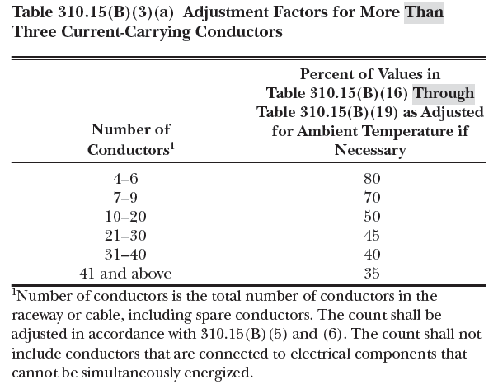
4 pts
- What is the minimum size EMT conduit required for 132 #14 THWN copper wires used for signaling in a Class 1 system, and 5 #12 THWN spare copper conductors?

4 pts
- How many 10 AWG THHN conductors are permitted in 3/4 in IMC conduit?

- A single-family dwelling has a demand load of 200 amperes supplied with a 120/240-volt, single-phase electrical system from a local utility company. What is the minimum size aluminum THW conductors required as a service-entrance conductors for the residence?
4 pts

What size grounding electrode conductor is required? Where in the NEC do you find the answer?

4 pts
- Calculate the power factor in a circuit having true power 800 watts and apparent power 1000 watts.

4 pts
- Determine the equivalent resistance of three resistances each 3Ω connected in parallel.

4 pts
- In a 60Hz a.c circuit, its voltage is 120V and current is 12A, the current lags the voltage by 60 deg. Find the power in watts.

4 pts
- A lamp operated at 120V has a resistance of 10 Ω. What is the wattage of the lamp?

[2 pts each answer]
- What type of load produces a leading power factor? ____________________________________

- What are the units used for the useful power used to drive a motor or light a bulb? ______________________
- Which of the following listed circuit breakers is not a standard ampere rating?
- 75 amperes
- 90 amperes
- 110 amperes
- 225 amperes

Where in the NEC do you find the answer? _________________________________________________

- Which of these conductor insulations are not approved for a wet location?
- THW
- THHW
- THHN
- THWN

- A Wattmeter measures which of the following power?
- Apparent Power
- Real Power
- Reactive Power

- Which of these cannot be caused by having a poor power factor in a circuit line?
- Insulation failure
- Voltage dips in the circuit
- Poor voltage regulation
- Increases in losses

- Inductive motors generally operate with __________ power factor.
- Leading
- Lagging
- Unity

- According to the NEC the total load on any overcurrent device located in a panelboard shall not exceed what percentage of its rating if in normal operation the load will be continuous?
- 100%
- 125%
- 80%
- 75%

- Which of the following panelboard type is used with concealed-wiring installation?
- Flush mounted type
- Surface mounted type

- Panelboards provide a compact and convenient method of grouping __________ at some common point.
- Circuit switching and Protective devices
- Protective devices only
- Circuit switching only

- Grounding is a specific form of bonding wherein one or more conductive objects are connected to the ground by means of a conductor such as a wire or rod.
- False
- True

- Electrically conductive materials that are likely to become energized shall be connected together and to the electrical supply source in a manner that establishes an effective ground-fault current path refers to _____ of electrically conductive material and other equipment:
- Grounding
- Bonding
- Either Grounding or Bonding

- Candela is the unit of which of the following:
- Light
- Luminance
- Luminous intensity
- Illumination

- Heat from the filament lamp is transmitted to the surroundings mainly through
- Circulation
- Radiation
- Conduction
- Convection

- The unit of illumination is:
- Lux
- Lumen
- cd/m2
- Candela

- Which of the following material is used as filament in the incandescent lamps:
- Silver
- Tungsten
- Osmium
- Tantalum

- Visible spectrum of light has a wavelength in the range:
- 12500 - 30000 Angstroms
- 4000 - 7000 Angstroms
- 1000 - 4000 Angstroms
- 7500 - 12500 Angstroms

- Maximum overcurrent protection for 12 AWG copper conductor is:
- 25 Amperes
- 30 Amperes
- 20 Amperes
- 15 Amperes

Where in the NEC is the answer found? ____________________________________________________

- The full load current (FLC) for 1 hp three phase alternating current motor supplied by 208 V supply voltage is _________. Hint: See NEC 430.
- 4.30 A
- 4.80 A
- 4.60 A
- 4.20 A

