CM 352 – Electrical Construction Estimating
Accubid Activity #10
Accubid Office Building – 12 POWER BRANCH

Procedure
- Obtain your 12 POWER BRANCH completed take off sheet.
- Start the program Accubid Pro 13 [Start, All Programs, Trimble, Classic 13, Accubid Pro 13]
- Press the CAPS LOCK Key ON
- From the Job Schedule Screen open the file, Accubid Office Building.
- If not already selected, select the Takeoff tab at the bottom of the screen.
- Set the Breakdown as shown in Figure 1.
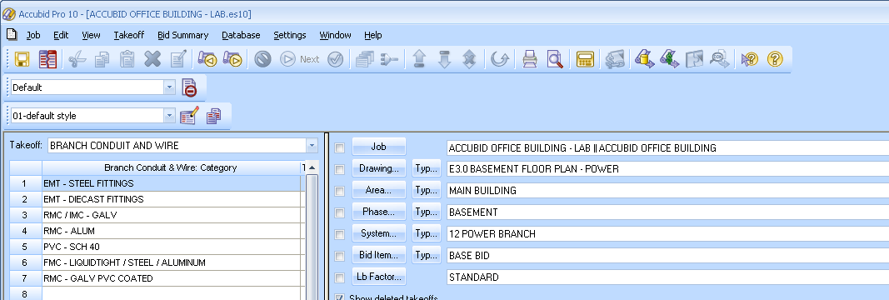
Figure 1

- Choose BRANCH CONDUIT AND WIRE from the drop down list in the Takeoff: area of the screen.

- Double click:
[Line 1] EMT – STEEL FITTINGS
[Line 1] 1/2" EMT - STEEL SET SCREW W/ BOX
[Line 8] 1/2" EMT STRUT MNT

- In the Measure Takeoff window make the changes as shown in Figure 2.
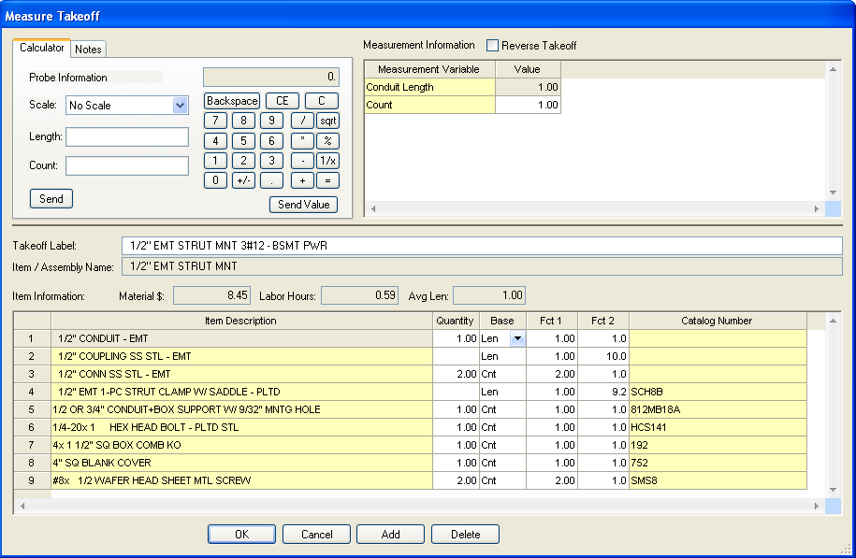
Change the Length and Count (Runs) values to the numbers on your takeoff sheet.
Edit the Takeoff Label as shown.
Figure 2

- Click the OK Button. Using a red pencil draw a RED LINE through the value you just entered into your Accubid estimate that is shown on your takeoff sheet, or else you will be severely shocked with an electrical probe.

- Repeat these steps for all of the Basement Power Branch on your takeoff sheet, i.e. 4#12, 5#12, 6#12, 7#12, 8#12, or 9#12.

- Change the Breakdown as shown in Figure 3 and repeat the steps for the First Floor Power Branch. Be sure to edit each Takeoff Label, i.e 1/2" EMT STRUT MNT 4#12 – FIRST FLR PWR
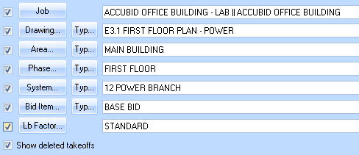
Figure 3

- Change the Breakdown as shown in Figure 4 and repeat the steps for the Typical Floors 2-4 Power Branch. Be sure to edit each Takeoff Label, i.e. 1/2" EMT STRUT MNT 4#12 – TYP FLRS 2-4 PWR
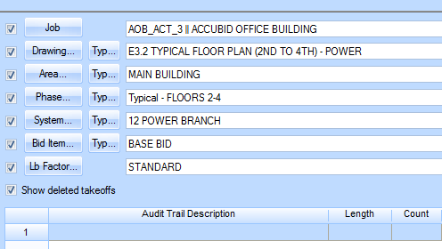
Figure 4

- Change the Breakdown as shown in Figure 5
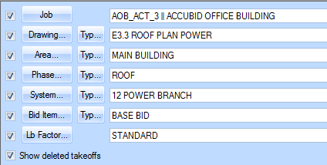
Figure 5

- Choose COMMON ASSEMBLIES from the drop down list in the Takeoff: area of the screen.

- Double click:
[Line 13] GRC (Branch) IMC (Empty)
[Line 1] GRC (Branch) ON CONCRETE
[Line 2] 1/2" GRC 3/12 ON-CONC

- In the Measure Takeoff window make the changes as shown in Figure 6.
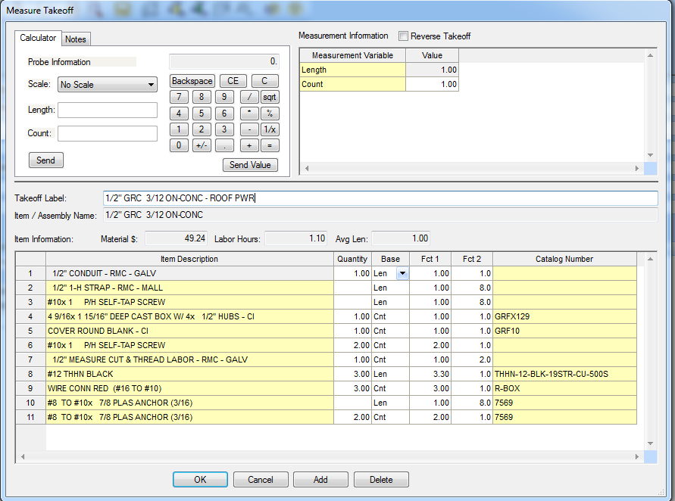
Change the Length and Count (Runs) values to the numbers on your takeoff sheet.
Edit the Takeoff Label as shown.
Figure 6

- Choose BRANCH CONDUIT AND WIRE from the drop down list in the Takeoff: area of the screen.

- Double click:
[Line 11] EMT – STEEL FITTINGS
[Line 1] 1/2" EMT - STEEL SET SCREW W/ BOX
[Line 8] 1/2" EMT STRUT MNT

Add the takeoff to your estimate for the:
½" EMT STRUT MNT 5#12 – ROOF PWR
½" EMT STRUT MNT 6#12 – ROOF PWR

- Save your estimate.

