CM 352 – Electrical Construction Estimating
Accubid Activity #11
Accubid Office Building – SYS 16 CABLE TRAY & SYS 19 TELE/DATA CONDUIT

SYS 16 Cable Tray
Procedure
- Start the program Accubid Pro 13.0. [Start, All Programs, Trimble, Classic 13, Accubid Pro 13]
- Press the CAPS LOCK Key ON
- From the Job Schedule Screen open the file, Accubid Office Building.
- If not already selected, select the Takeoff tab at the bottom of the screen.
- Make sure that the L100 v8 us neca imp is the currently selected database. If not, switch to it by clicking on the Database menu and choosing the Select command.
- Obtain the SYS 16 CABLE TRAY Takeoff Sheet
- Create the Typical for the Phase Breakdown Label, FLOORS 1 to 4 TRAY, as shown in Figure 1.
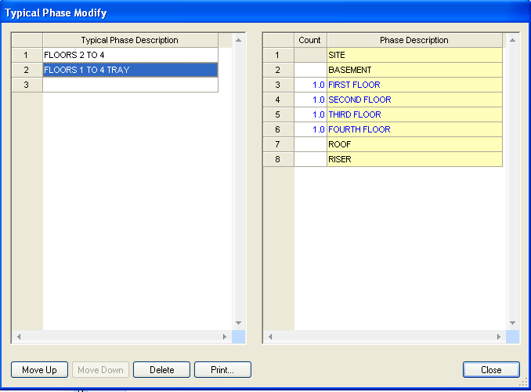
Figure 1

- Set the breakdown labels as shown in Figure 2.
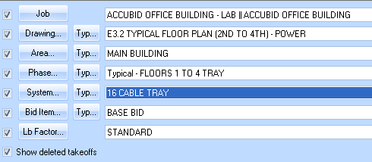
Figure 2

- Choose DUCTS AND TRAYS from the drop down list in the Takeoff: area of the screen.
- Double click:
[Line 1] CABLETRAY
[Line 3] 12" WIDE - STEEL GALV
[Line 2] 12" Wx 3" Dx 9" SPCG LADDER TRAY - STEEL GALV

- In the Create/Modify Description window click on OK.
- In the Measure Takeoff window change the Length of run to YOUR NUMBER and make sure that the Parallel Runs is set to 1. Then click on OK.
- Add the following Items and QTY to the Takeoff:
Item QTY
12" Wx 3" Dx 24" RAD LADDER 30 HORZ BEND - STL GALV 2.00
12" Wx 3" Dx 12" RAD LADDER HORZ T SECTION - STL GALV 2.00
12x 12x 18x 3" Dx 12" RAD LADDER HORZ XPND T SECTION - STL GALV 1.00
TRAY FIRE BARRIER 1.00
1 5/8x 1 5/8x 14G STRUT GALV 38.00
MALL BEAM CLAMP TO 1" FLNG W/ 3/8-16 THRD HOLE BTM+BACK 60.00
3/8" THREADED ROD - PLTD 120.00
3/8-16 HEX NUT - PLTD STL 120.00
3/8" LOCK WASHER - PLTD STL 120.00
3/8x 1 FENDER WASHER - PLTD STL 120.00

- Right click in the audit window and click finish and OK.
- Choose DUCTS AND TRAYS from the drop down list in the Takeoff: area of the screen.
- Double click:
[Line 1] CABLETRAY
[Line 4] 18" WIDE - STEEL GALV
[Line 2] 18" Wx 3" Dx 9" SPCG LADDER TRAY - STEEL GALV

- In the Create/Modify Description window click on OK.
- In the Edit Takeoff window change the Length of run to YOUR NUMBER and make sure that the Parallel Runs is set to 1. Then click on OK.
- Add the following Items and QTY to the Takeoff:
Item QTY
1 5/8x 1 5/8x 14G STRUT GALV 4.00
MALL BEAM CLAMP TO 1" FLNG W/ 3/8-16 THRD HOLE BTM+BACK 4.00
3/8" THREADED ROD - PLTD 8.00
3/8-16 HEX NUT - PLTD STL 8.00
3/8" LOCK WASHER - PLTD STL 8.00
3/8x 1 FENDER WASHER - PLTD STL 8.00

- Right click in the audit window and click finish and OK.
- Save your Estimate.

SYS 19 TELE/DATA CONDUIT
Procedure
- Obtain the SYS 19 TELE/DATA CONDUIT Takeoff Sheet.
- Set the breakdown labels as shown in Figure 2.
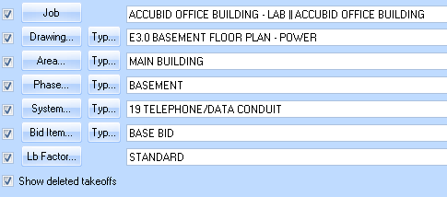
Figure 2

- Choose COMMON ASSEMBLIES from the drop down list in the Takeoff: area of the screen.
- Double click:
[Line 29] SYSTEMS - VOICE & DATA
[Line 1] TEL / DATA OUTLET - STUD WALL(10' - 3/4" EMT)

- Enter the count value in the Measure Takeoff window and click OK.
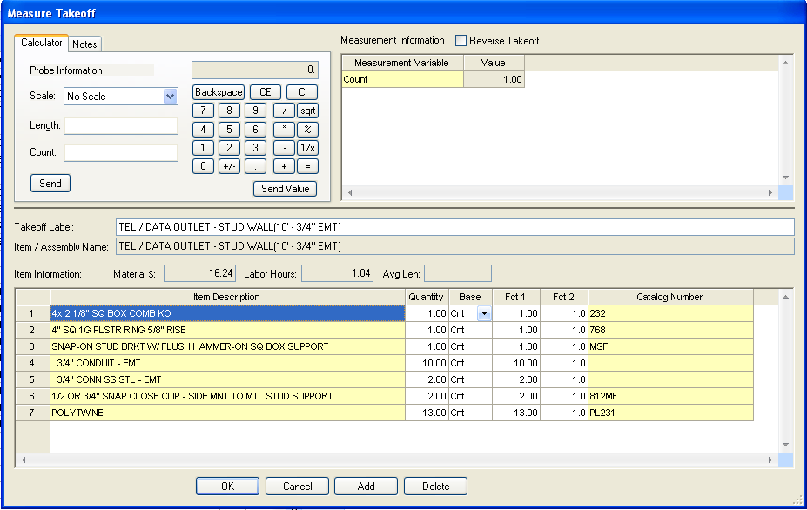
Figure 3

- Change the Breakdown and repeat for the remaining takeoff.
- Save the Estimate.

