CM 352 – Electrical Construction Estimating
Accubid Activity #14
Accubid Office Building - 43 SITE LIGHTING

Procedure
- Start the program Accubid Pro 15 [Start, Trimble, Accubid Pro 15]
- Press the CAPS LOCK Key ON
- From the Job Schedule Screen open the file, Accubid Office Building.
- If not already selected, select the Takeoff tab at the bottom of the screen.
- Make sure that the L100 v8 us neca imp is the currently selected database. If not, switch to it by clicking on the Database menu and choosing the Select command.
- Set the breakdown labels as shown in Figure 1.
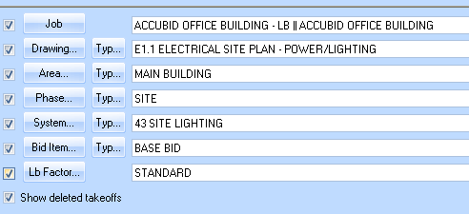
Figure 1

- Choose FIXTURES form the Takeoff: area of the screen.
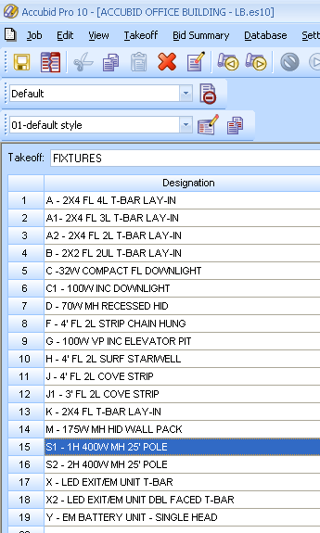
Figure 2

- Using your SYS 43 SITE LIGHTING Takeoff sheet, add the Site Fixtures S1 & S2 to your estimate. Be sure to put a red line through the quantity on your takeoff sheet.

- Change the Takeoff: to FEEDER CONDUIT AND WIRE
Double click on:
[Line 6] PVC
[Line 2] 3/4" PVC (TRENCH)

In the Create/Modify Takeoff Description box edit the Takeoff Label as shown in Figure 3 and click OK.
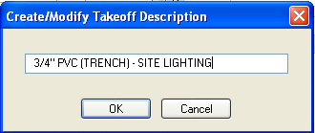
Figure 3

- In the Measure Takeoff window enter in the Conduit Length, Count, and Parallel Runs. Edit the Item Description area, Base, Fct 1, and Fct 2 values as shown in Figure 4 and click OK.
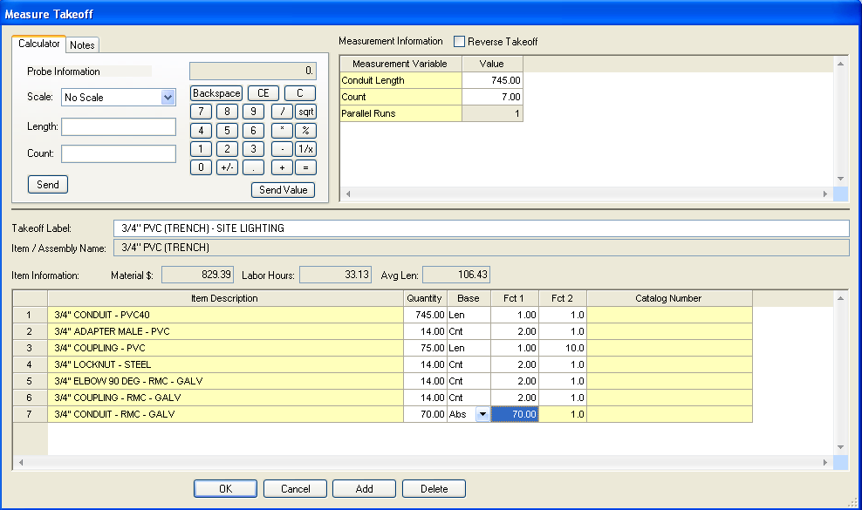
Enter in your conduit Length, Count, and Parallel Runs
Add the RMC elbows and conduit for the stub-ups at the light pole bases and into the electrical room (ER).
Figure 4

- Using the Takeoff: FEEDER WIRE double click on:
[Line 1] THHN WIRE
[Line 7] # 8 THHN BLACK

In the Measure Takeoff window change the # of conductors to 2 and click OK.

- Using the Takeoff: FEEDER WIRE double click on:
[Line 3] #10 THHN BLACK

In the Measure Takeoff window change the # of conductors to 1 and click OK.

- Right Click in the Item Description and click Finish and OK.
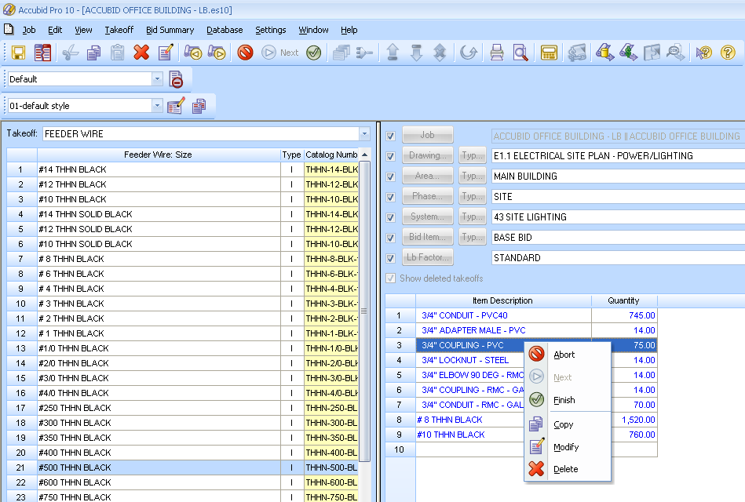
Figure 5

- Save your Estimate.

