CM 352 – Electrical Construction Estimating
Accubid Activity #15
Accubid Office Building – TEMPORARY ITEMS

Temporary Items
Temporary items are items saved as part of the job, rather than the database. You can take off temporary items just as you would items from the material database. You can also copy and paste temporary items just like database items.

Procedure
- Start the program Accubid Pro 13 [Start, All Programs, Trimble, Classic 13, Accubid Pro 13]
- Press the CAPS LOCK Key ON
- From the Job Schedule Screen open the file, Accubid Office Building.
- If not already selected, select the Takeoff tab at the bottom of the screen.
- Make sure that the L100 v8 us neca imp is the currently selected database. If not, switch to it by clicking on the Database menu and choosing the Select command.

- To Create a TEMPORARY ITEM:
Choose from the Takeoff: TEMPORARY ITEMS
Double click in the first blank line (Line 1)
In the Create/Modify Temporary Item window edit the fields as shown in Figure 1 and click OK.
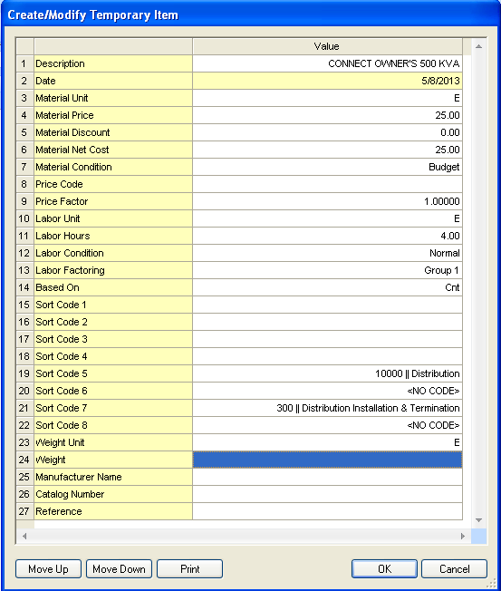
Figure 1
The Temporary Item, CONNECT OWNER’S 500 KVA, is displayed in the Temporary Item list.
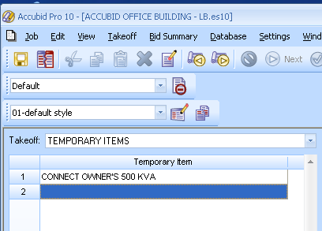
Figure 2

- Create additional Temporary Items as shown in Figures 3, 4, and 5.
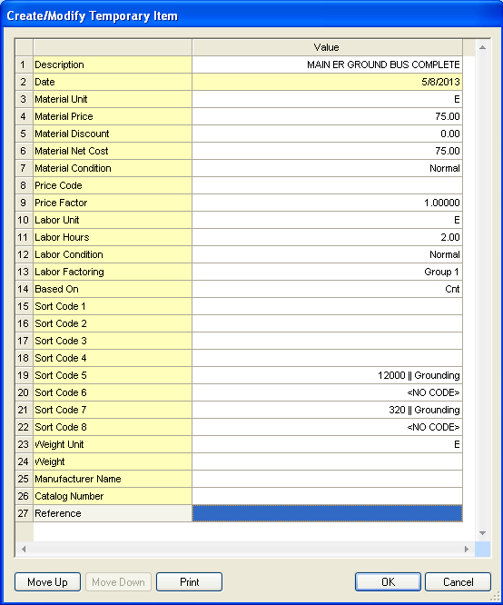
Figure 3

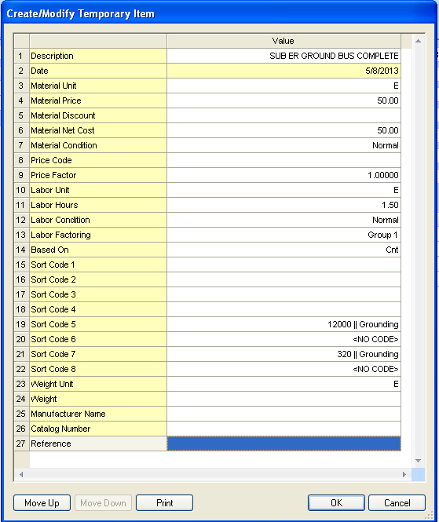
Figure 4

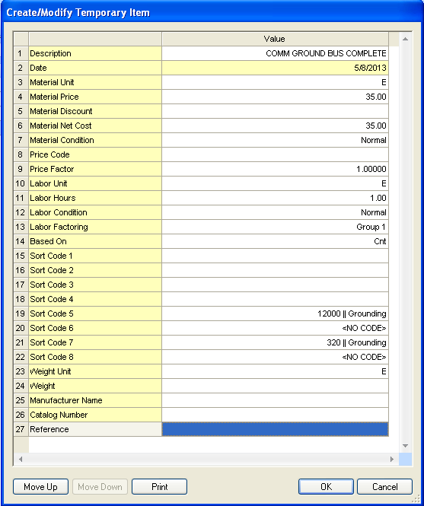
Figure 5
When finished the Temporary Items shown in Figure 6 should be displayed in the Temporary Item list:
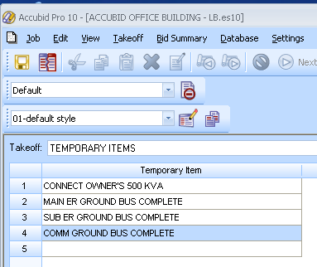
Figure 6

Note: These Temporary Items will be used in a later takeoff.

- Save your estimate.

