**CM 352 – Electrical Construction Estimating**

lightbul

**Accubid Activity #17**

**Accubid Office Building – TEMPORARY ASSEMBLIES**

Temporary Assemblies are groups of related items identified by a single description. For example, a copper pipe assembly consists of pipe, couplings, and hangers. A conduit assembly consists of conduit, connectors, couplings, straps, and possibly wire. When you take off an assembly, you are actually taking off several items at the same time. This can greatly increase the speed and accuracy of your takeoffs. Unlike common assemblies, temporary assemblies are not saved in the materials database, they are only saved with the current job.

You can create a temporary assembly or modify existing ones. You can only modify a single temporary assembly by adding to or deleting items from the temporary assembly. You can, however, delete the entire temporary assembly if it has not been taken off.

You can insert or reorder items within the temporary assembly list by right clicking over an existing entry and selecting the appropriate menu option. If a temporary assembly has not been taken off, you can delete it by right clicking over the assembly and selecting Delete.

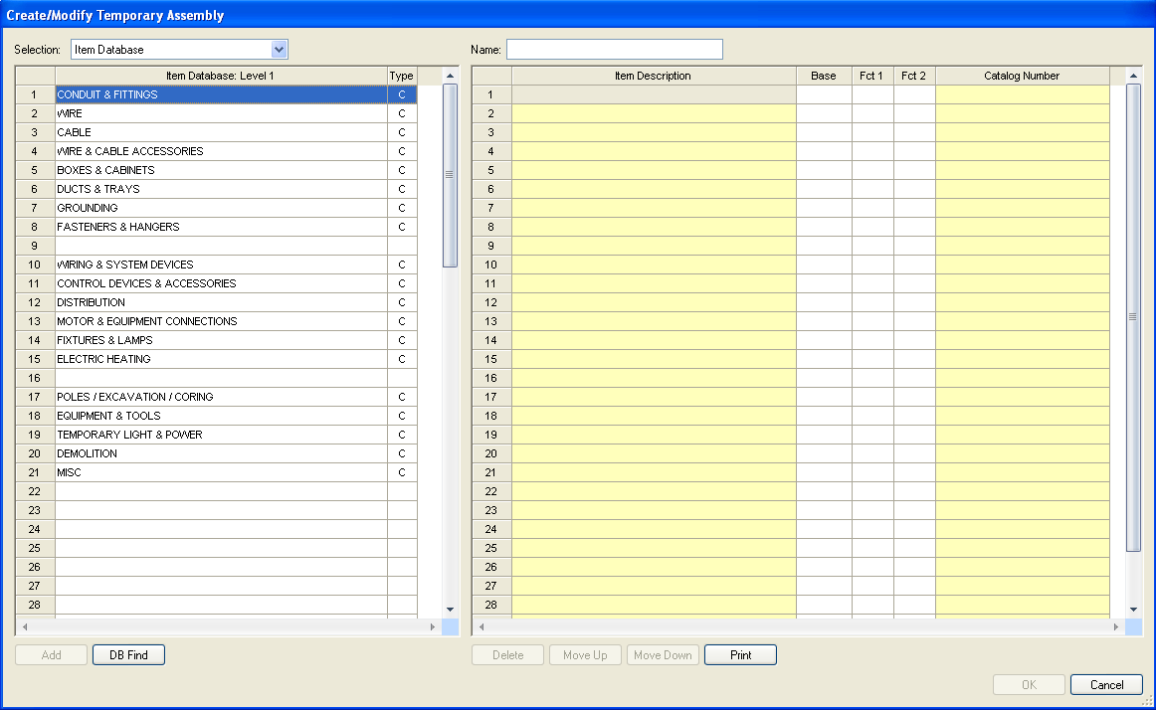

Figure 1

The left side of the Create/Modify Temporary Assembly window is where you can select the items to add to the Temporary Assembly. The right side is the Name and contents of the temporary assembly.

**Procedure**

1. Start the program Accubid Pro 13 [Start, All Programs, Trimble, Classic 13, Accubid Pro 13]
2. Press the CAPS LOCK Key ON
3. From the Job Schedule Screen open the file, Accubid Office Building.
4. If not already selected, select the Takeoff tab at the bottom of the screen.
5. Make sure that the **L100 v8 us neca imp** is the currently selected database. If not, switch to it by clicking on the Database menu and choosing the Select command.
6. Choose Takeoff: TEMPORARY ASSEMBLIES from the Takeoff list.
7. Double click on the first blank line below the Temporary Assembly heading. The Create/Modify Temporary Assembly dialog appears.
8. In the Create/Modify Temporary Assembly make the changes as shown in Figure 2.

1 Name: CONNECT OWNER’S 500 KVA

2 Using Selection:TEMPORARY ITEM add the Temp Item CONNECT OWNER’S 500 KVA

2 Using Selection: ITEM DATABASE add the items shown in Figure 2 (traverse codes are shown)

3 Change Fct 1 and Fct 2 as shown in Figure 2

4 Click OK

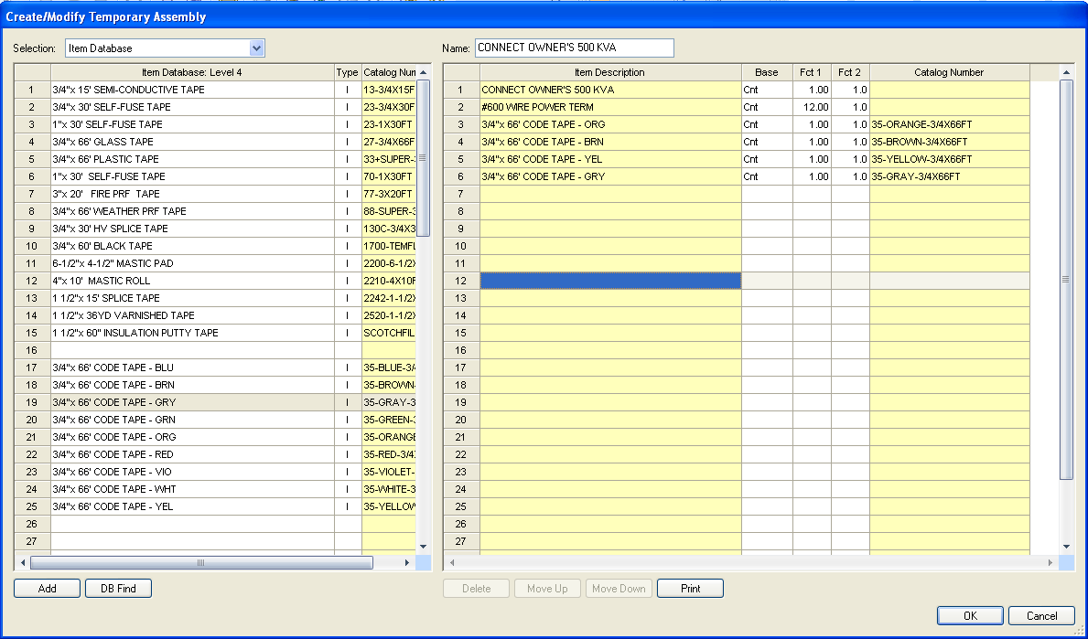

**4**

TEMPORARY ITEM

ITEM DATABASE

13, 6, 21

4, 11, 2, 21

4, 11, 2, 18

4, 11, 2, 25

4, 11, 2, 19

**1**

**3**

**2**

Figure 2

1. Using this procedure create the Temporary Assemblies shown on the next pages.

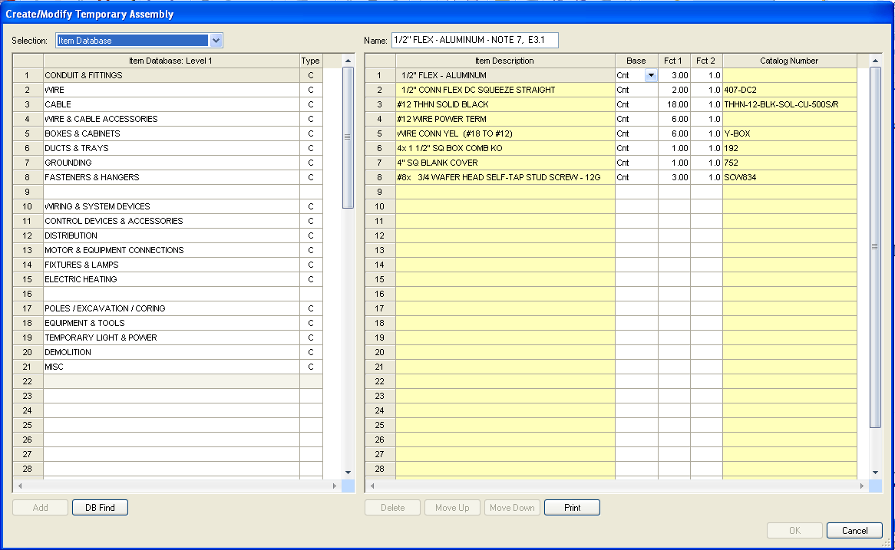

Figure 3

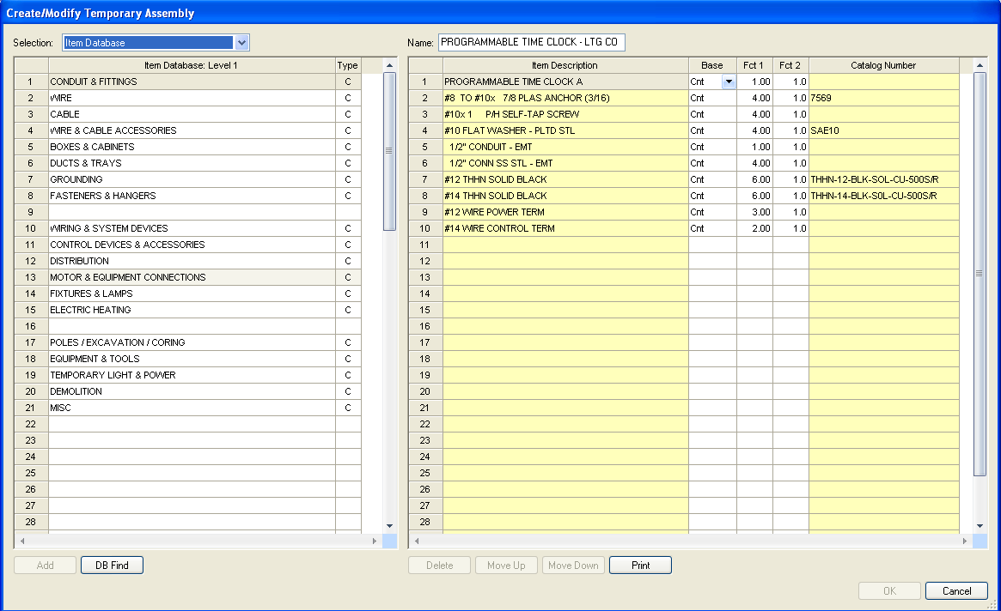

Figure 4

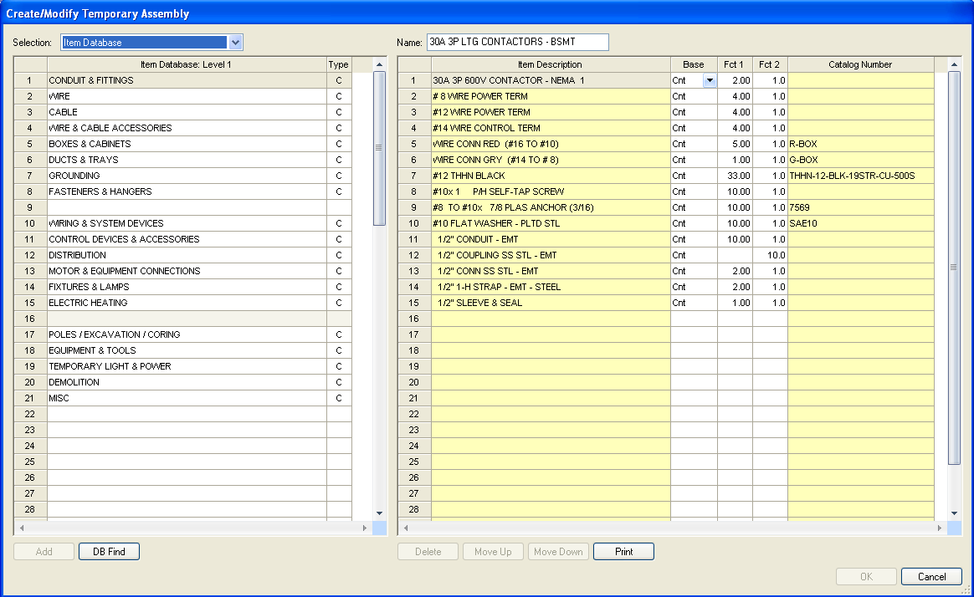

Figure 5

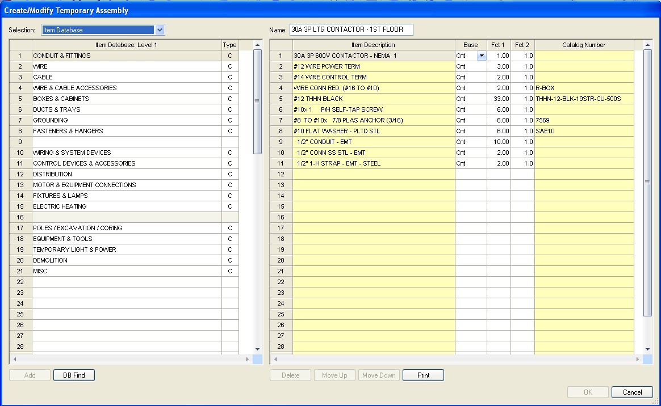

Figure 6

When completed the following should display in the Takeoff: TEMPORARY ASSSEMBLIES list.

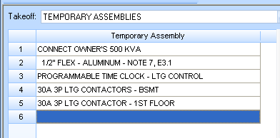

Figure 7

1. Save your estimate.