**CM 352 – Electrical Construction Estimating**

lightbul

**Accubid Activity #19**

**Accubid Office Building – FINAL CLEANUP OF TAKEOFF**

**Procedure**

1. Start the program Accubid Pro 13 [Start, All Programs, Trimble, Classic 13, Accubid Pro 13]
2. Press the CAPS LOCK Key ON
3. From the Job Schedule Screen open the file, Accubid Office Building.
4. If not already selected, select the Takeoff tab at the bottom of the screen.
5. Make sure that the **L100 v8 us neca imp** is the currently selected database. If not, switch to it by clicking on the Database menu and choosing the Select command.
6. Set the Breakdown and choose Takeoff: TEMPORARY ASSEMBLIES from the Takeoff list.

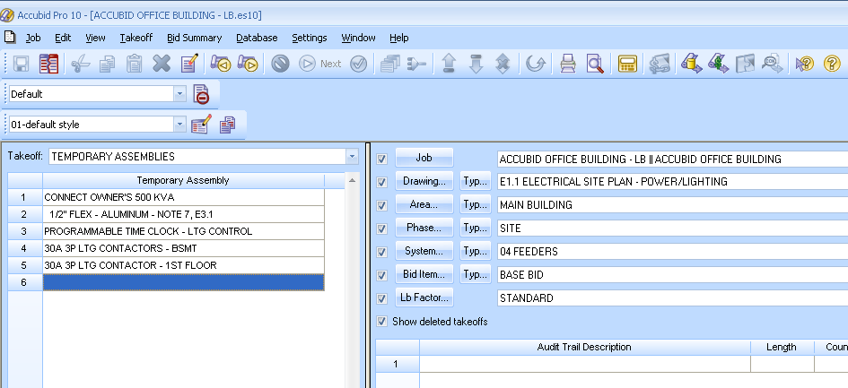

Figure 1

1. Double click on the TEMPORARY ASSEMBLY, CONNECT OWNER’S 500 KVA to add it to your takeoff.
2. In the Measure Takeoff window set the Count =1 and click OK.
3. Change the Breakdown as shown in Figure 2.

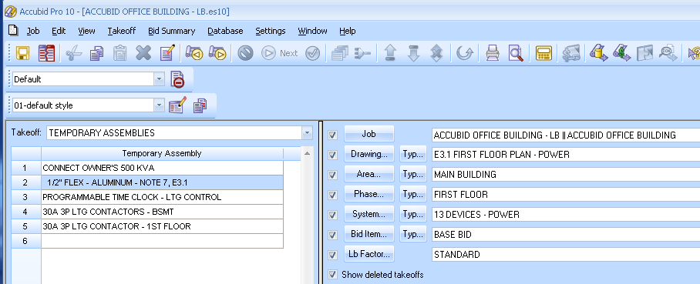

Figure 2

1. Double click on the TEMPORARY ASSEMBLY, 1/2" FLEX - ALUMINUM - NOTE 7, E3.1 to add it to your takeoff.
2. In the Measure Takeoff window set the Count to the number on your 13 DEVICES – POWER takeoff sheet and click OK.
3. Place a red line through the count on your 13 DEVICES – POWER takeoff sheet.
4. Choose Takeoff: ITEM DATABASE from the Takeoff list.
5. Double click on:  
   [Line 1] CONDUIT & FITTINGS  
   [Line 1] EMT  
   [Line 1] EMT CONDUIT  
   [Line 3] 1" CONDUIT – EMT
6. In the Measure takeoff window edit the Takeoff Label to: 1" EMT 2#4, 1#8 W/LT FLEX CONN L1-22/24 [NOTE 6]
7. Using the ITEM DATABASE, add the items shown in the Item Description and edit Fct 1 and Fct 2 as shown in Figure 3.



Figure 3

1. Click OK.
2. Place a red line through the count on your 13 DEVICES – POWER takeoff sheet.
3. Choose Takeoff: ITEM DATABASE from the Takeoff list.
4. Double click on:  
   [Line 1] CONDUIT & FITTINGS  
   [Line 1] EMT  
   [Line 1] EMT CONDUIT  
   [Line 3] 3/4" CONDUIT – EMT
5. In the Measure takeoff window edit the Takeoff Label to: 3/4" EMT 2#8, 1#10 W/LT FLEX CONN L1-26/28 [NOTE 6]
6. Using the ITEM DATABASE, add the items shown in the Item Description and edit Fct 1 and Fct 2 as shown in Figure 4.

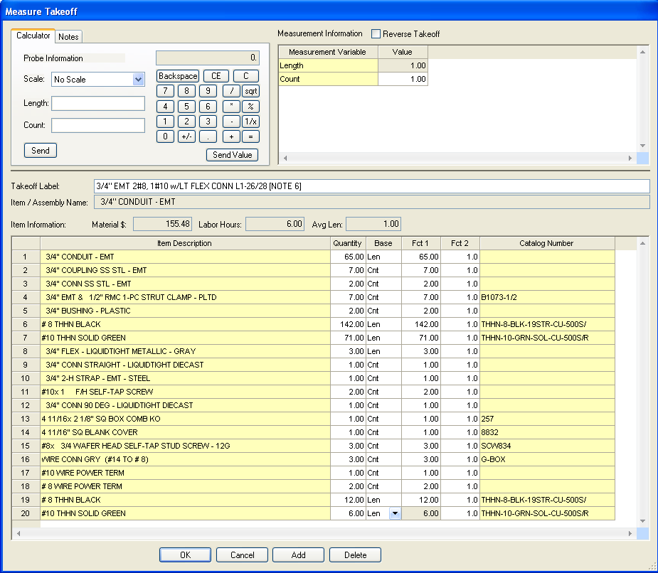

Figure 4

1. Click OK.
2. Place a red line through the count on your 13 DEVICES – POWER takeoff sheet.
3. Save your estimate.