**CM 352 – Electrical Construction Estimating**

lightbul

**Accubid Activity #1 – Getting Started with Accubid Pro**

**Setting Up Accubid and Creating a New Job**

1. Start the program Accubid Pro 13 [Start, All Programs, Trimble, Classic 13, Accubid Pro 13

The opening window is the called the [Schedule] screen.

The [Schedule] screen is used to help you to keep track of your estimates and bids.

Information about pending bids and closed jobs can be recorded in the [Schedule] screen.

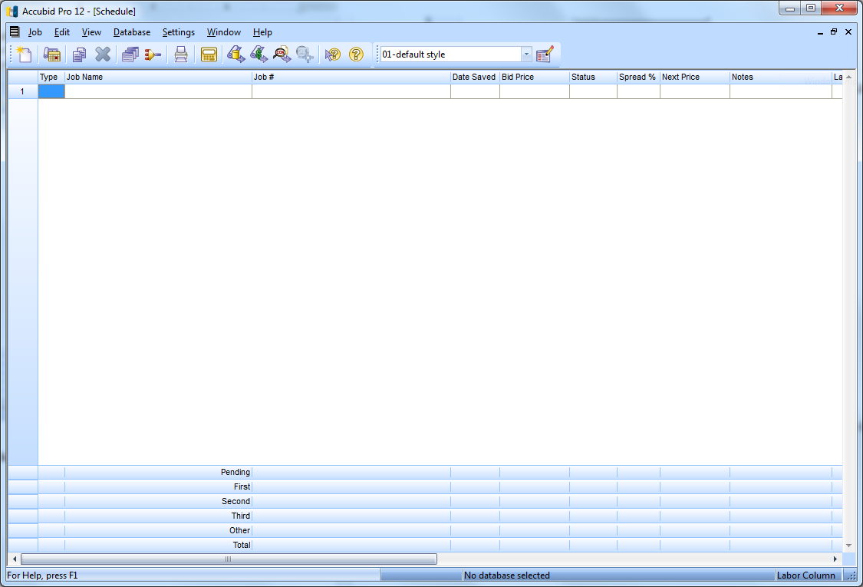

Figure 1

1. From the Menu Bar click on: **Settings, Job Folders…**

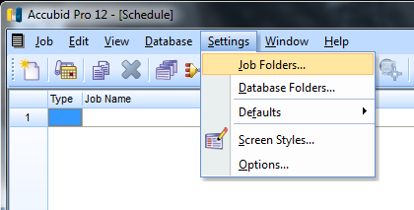

Figure 2

When Accubid Pro v13 is first installed the default location for saving all jobs (Job Folder) is automatically setup for saving them to the location, C:\ProgramData\Accubid\JOBDATA.

|  |  |
| --- | --- |
| Figure 3 | From the Job Folders window you can Add, Remove, Edit, Select All, and Clear All the folders to use in the program to save your Jobs to.   1. Choose the location C:\Program Files\Accubid\JOBDATA by clicking the box next to it to place a check in it. Uncheck any other locations. 2. To close the Job Folders window and save any changes, Click OK   Note: The ProgramData folder is a protected folder in Windows and requires changing the security settings for users to have full control. In the CMGT computer lab the folder C:\Program Files\Accubid\JOBDATA was added and will be used as the default location for saving all jobs. |

1. From the Menu Bar click on: **Settings, Database Folders…**

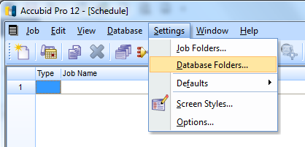

Figure 4

The default folder that all Databases are saved in is: C:\ProgramData\Accubid\Databases

|  |  |
| --- | --- |
| Figure 5 | From the Database Folders window you can Add, Remove, Edit, Select All, or Clear All the folders used in the program to select Databases from.   1. Choose the location C:\Program Files\Accubid\Database by clicking the box next to it to place a check in it. Uncheck any other locations. 2. To close the Database Folders window and save any changes, Click OK |

1. Right Click on the Start button and select Open Windows Explorer.
2. From the Explorer window click Computer OS (C:) Program Files, Accubid, JOBDATA

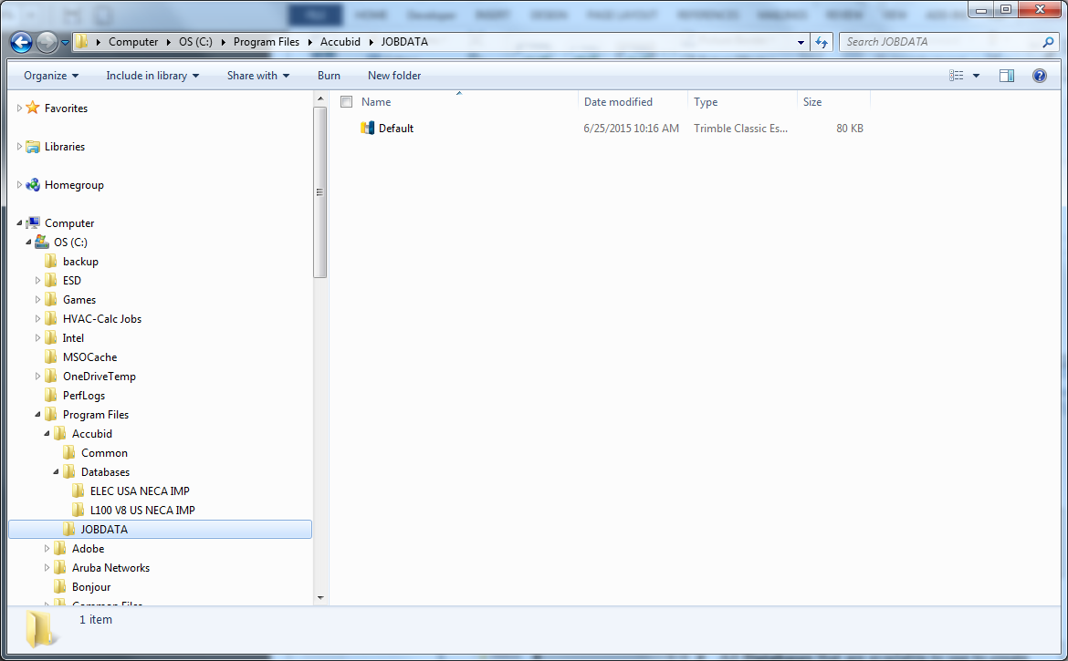

* All **New Jobs** (Estimates) are created from the estimate named **Default** saved in the JOBDATA folder.
* All **Databases** that are available to use to create estimates are saved in separate folders under the folder named, Databases.

Figure 6

From the screen shot in Figure 6 we can see that the only file saved in the JOBDATA folder is the file named Default. Once you start creating new estimates they will be saved in this folder automatically. To save your estimates to your own USB drive you can use Windows Explorer to perform the copying task.

1. Close Windows Explorer.
2. To begin a new Job (estimate), click on the Job menu and click New…

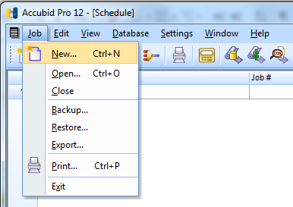

Figure 7

The New Database dialog box appears:

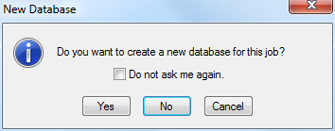

Figure 8

1. Click the check box, Do not ask me again and then click on the No button.

The New Job dialog box appears. To create a new job you must enter a job name and job number. You can also select the database to use and the folder to save the job to.

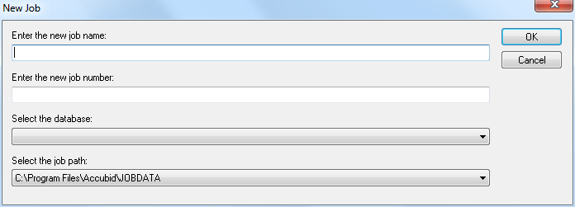

Figure 9

1. Enter “Accubid Office Building” for the job name and “Accubid Office Building – *First Name Last Name*” for the job number. Use your own name!

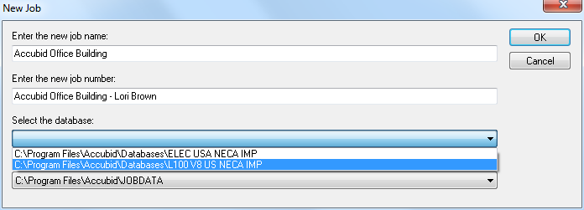

You must also select a material database and job path for the new job:

1. Click the drop down list arrow for Select the database: and click on  
   C:\Program Files\Accubid\Databases\ L100V8 US NECA IMP
2. Select the default location for saving your estimate from the job path drop down list arrow.
3. Click on the OK button

The first screen to open in a newly created job is the Job Info Screen:

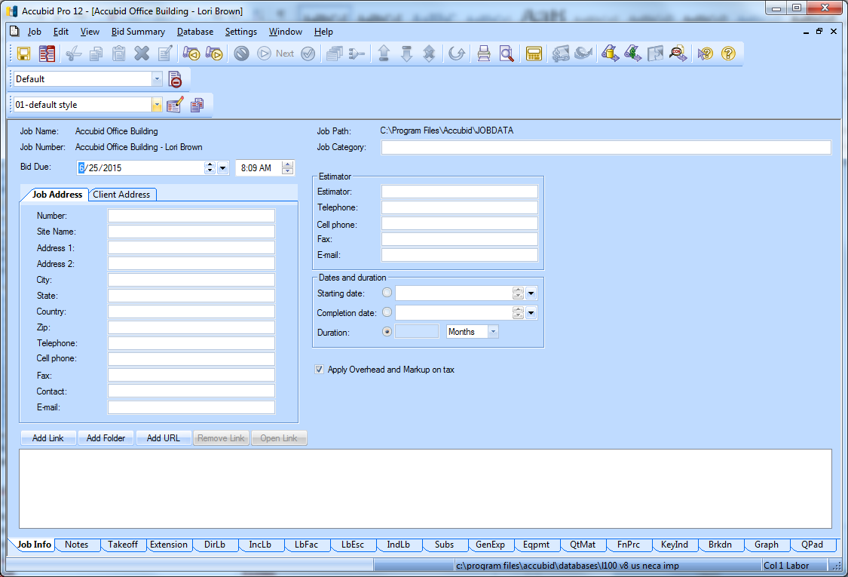

Figure 10

Accubid has 18 different screen tabs to work in:

|  |  |
| --- | --- |
| Job Info  Notes  Takeoff  Extension  DirLb  IncLB  LbFac  LbEsc  IndLb | Subs  GenExp  Eqpmt  QtMat  FnPrc  KeyInd  Brkdn  Graph  QPad |

**Setting Up the Estimate**

1. In the Job Info screen add the following information:

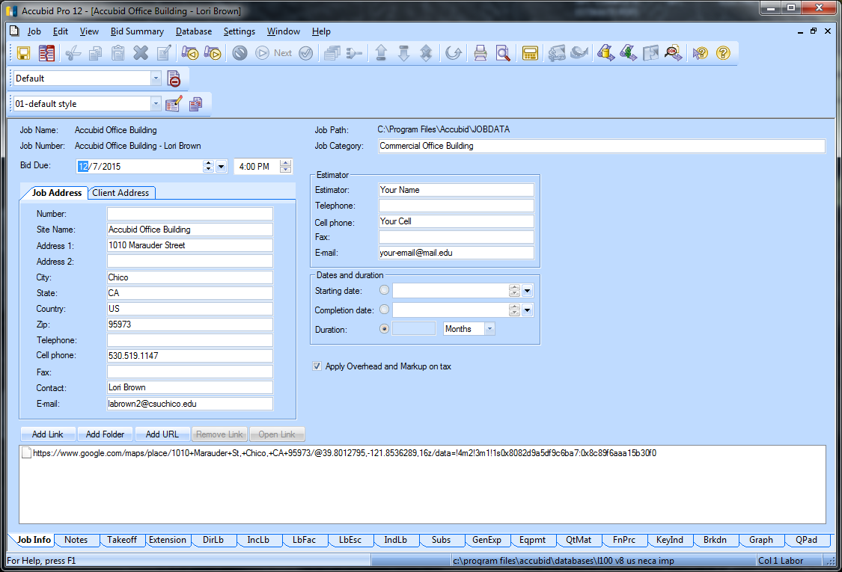

Figure 11

1. Click on the **Takeoff** tab to select the Takeoff screen.

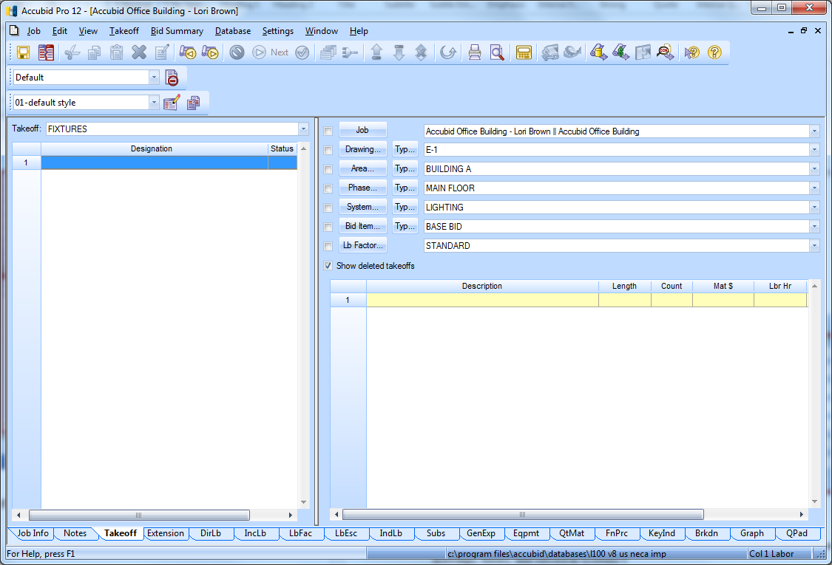

3 Audit Trail

2 Breakdown

1 Takeoff

Figure 12

The Takeoff screen is divided into three different areas:

**1** Takeoff

What do you want to Takeoff ?

**2** Breakdown

Where do you want it Taken Off ?

**3** Audit Trail

What did you Takeoff ?

The first step in preparing a new estimate in the Takeoff screen is to setup the **Breakdown**.

There are seven different Breakdown Labels:

Job

Drawing…

Area…

Phase…

System…

Bid Item…

Lb Factor…

When you first start a new estimate the **Breakdown** fields are completed automatically using the **Default** estimate file.

Job ACCUBID OFFICE BUILDING – Lori Brown (Current open job)

Drawing… E-1

Area… BUILDING A

Phase… MAIN FLOOR

System… LIGHTING

Bid Item… BASE BID

Lb Factor… STANDARD

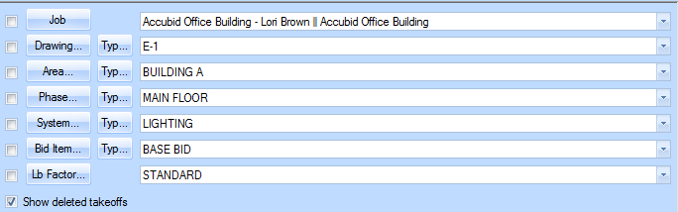

Figure 13

* The fields contained in each of the Takeoff Breakdown Labels are user definable.
* Takeoff **Breakdowns** are logical and/or physical areas that are created for the estimate, such as drawings, floors, and electrical systems.
* Each item or assembly that is taken off is assigned to the selected takeoff **Breakdown**.
* **Breakdown** allows the estimate to be sorted and analyzed by any combination of the Takeoff Breakdown Fields selected.

**BREAKDOWN IS THE MOST CRUCIAL STEP IN TAKING OFF MATERIAL FOR AN ESTIMATE!**

**Creating or Modifying Takeoff Breakdown Fields**

1. Click on the Breakdown 
2. In the Drawing Modify dialog box select Line 1 E-1

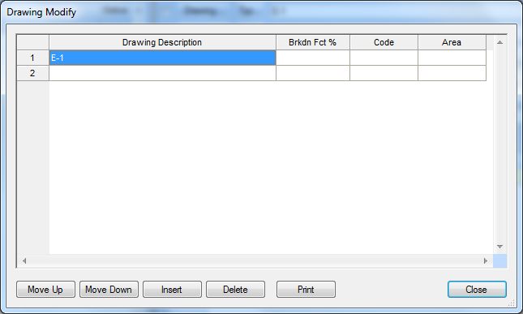

Figure 14

1. Press the Caps Lock key. Change the label E-1 to E0.1 ELECTRICAL SYMBOLS LEGEND
2. Press Enter to move to the next line. Continue adding the names of the Accubid Office Building plans to the list as shown in Figure 15. When finished click the Close button.

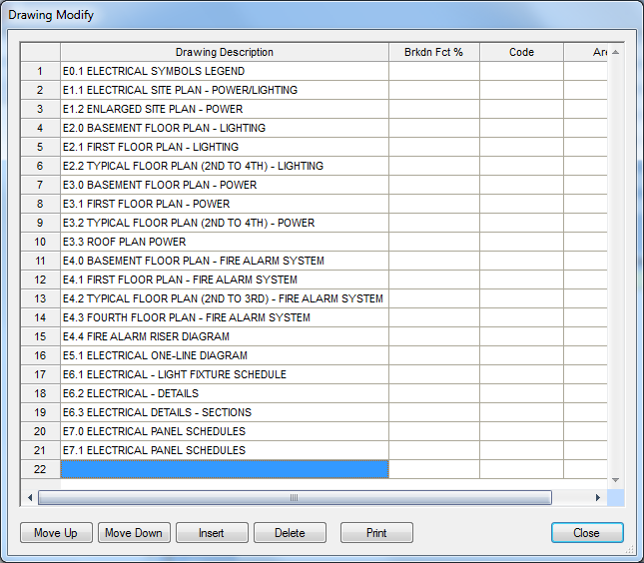

Figure 15

1. Click on the Breakdown 
2. In the Area Modify dialog box change the label from BUILDING A to MAIN BUILDING

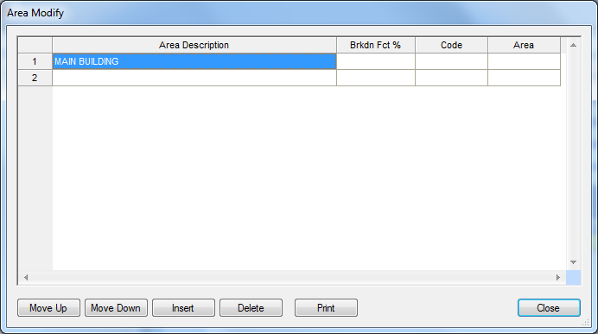

Figure 16

1. Click the Close button.
2. Click on the Breakdown 
3. In the Phase Modify dialog box make the following changes:

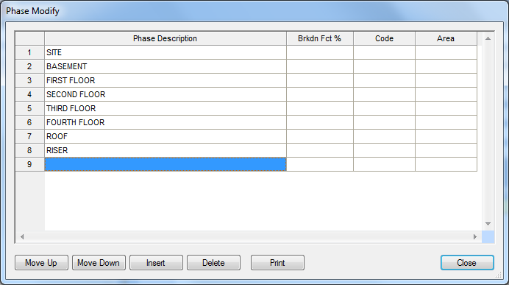

Figure 17

1. Click the Close button.
2. Click on the Breakdown 

The System Descriptions shown in Figure 17 are from the **Default** job.

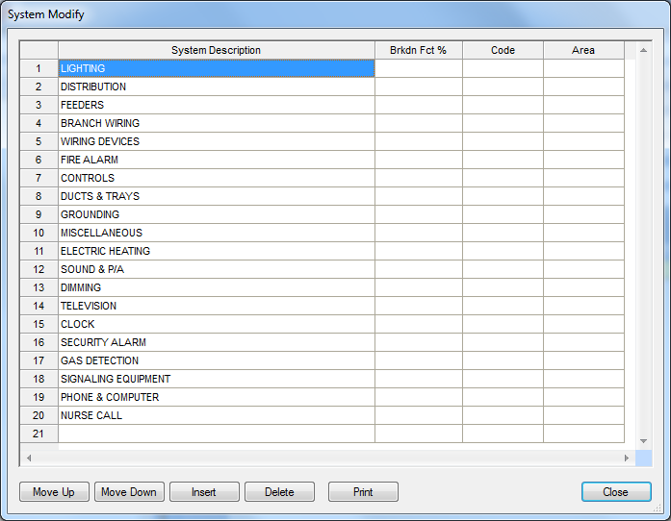

Figure 18

1. Select Line 1 LIGHTING and change it to: 01 SWITCHGEAR
2. Select Line 2 and press and hold down the SHIFT Key. Press the arrow down key until you have selected Line 2 through Line 20.

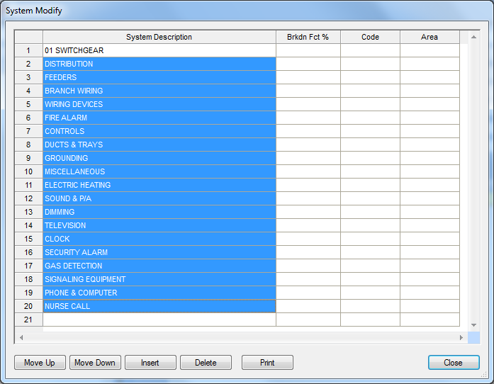

Figure 19

1. Click on the Delete button in the System Modify window.
2. Click Yes in the “Are you sure you want to delete these systems?” dialog box.
3. Add the following fields to the System Breakdown Label:

01 SWITCHGEAR

02 BUS DUCT/BUS PLUGS

03 EM. GEN/TR. SW./MG

04 FEEDERS

05 MOTOR BR. BRANCH/EQUIP CONNECT

06 FIXTURES

07 LIGHTING BRANCH

08 DEVICES - LIGHTING

09 MC CABLE LIGHTING BRANCH

10 MC DEVICES - LIGHTING

11 LIGHTING SOFT WIRE

12 POWER BRANCH

13 DEVICES - POWER

14 MC CABLE POWER BRANCH

15 MC DEVICES - POWER

16 CABLE TRAY

17 WIREMOLD (SURFACE RACEWAY)

18 RAISED FLOOR POWER DISTRIBUTION

19 TELEPHONE/DATA CONDUIT

20 TELEPHONE/DATA CABLE

21 FIRE ALARM SYSTEM

22 PUBLIC ADDRESS SYSTEM

23 DR. SECURITY/CARD READER

24 DR. MONITORING.INTRUSION

25 INTERCOM SYSTEM

26 CCTV

27 MATV

28 CLOCK SYSTEM

29 NURSE CALL SYSTEM

30 GAS DETECTION SYSTEM

31 TEMPERATURE CONTROL SYSTEM

32 ENERGY MANAGEMENT SYSTEM

33 PROCESS CONTROL SYSTEM

34 KITCHEN EQUIPMENT

35 MEDICAL EQUIPMENT

36 HALON SYSTEM

37 LEAK DETECTION

38 GROUNDING

39 LIGHTING CONTROL/DIMMING

40 LIGHTNING PROTECTION

41 CATHODIC PROTECTION

42 SITE WORK

43 SITE LIGHTING

44 INCOMING SERVICE - POWER

45 INCOMING SERVICE - TELEPHONE

46 DUCT BANKS AND MANHOLES

47 TRAFFIC SIGNAL AND STREET LIGHTING

48 REWORK EXISTING

49 DEMOLITION

50 TEMPORARY POWER

51 WALKER DUCT

70 PV MODULES

71 DC WIRING

72 COMBINER BOXES

73 DC DISCONNECTS

74 INVERTERS

75 AC SWITCHGEAR

76 AC WIRING

77 MODULE RACKING

98 OTHER

99 DIRECT JOB COSTS

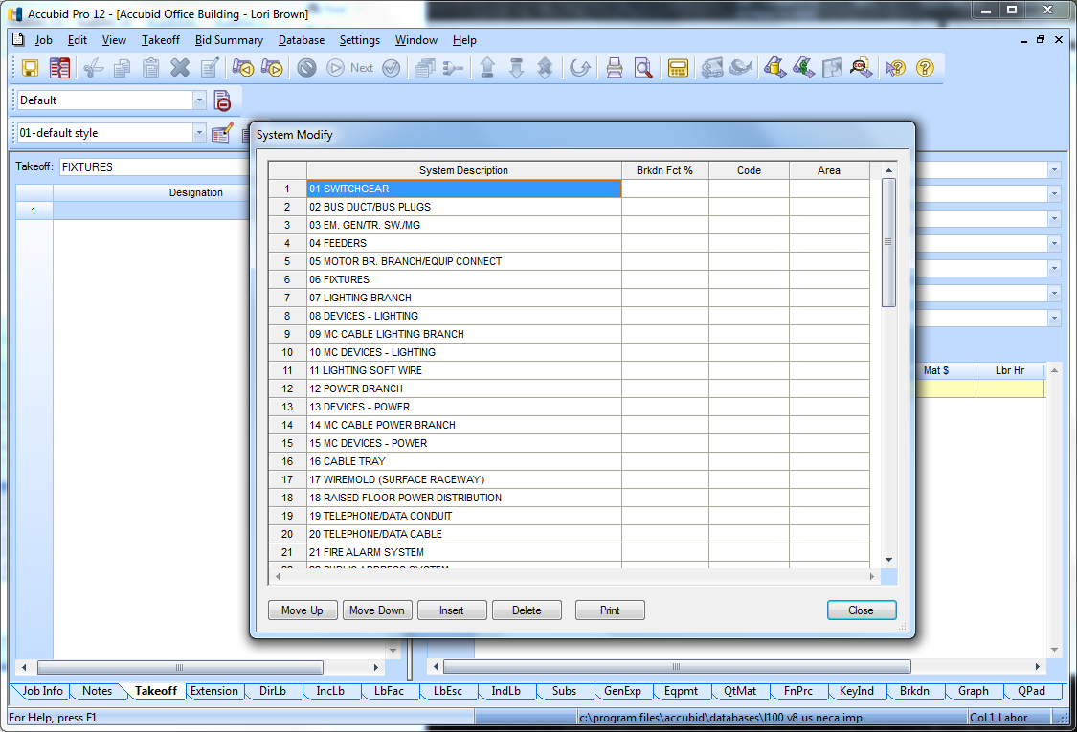

Figure 20

1. Click the Close button.
2. Save your estimate:

From the Toolbar click the Save icon 

From the Job Menu select Save

Using the keyboard press Ctrl + s

Notice that the icon changes color when the file has been saved 

1. Click the Job menu and click on Exit to Close Accubid.
2. Right Click on the Start button and select Open Windows Explorer.
3. From the Explorer window click Computer OS (C:) Program Files, Accubid, JOBDATA

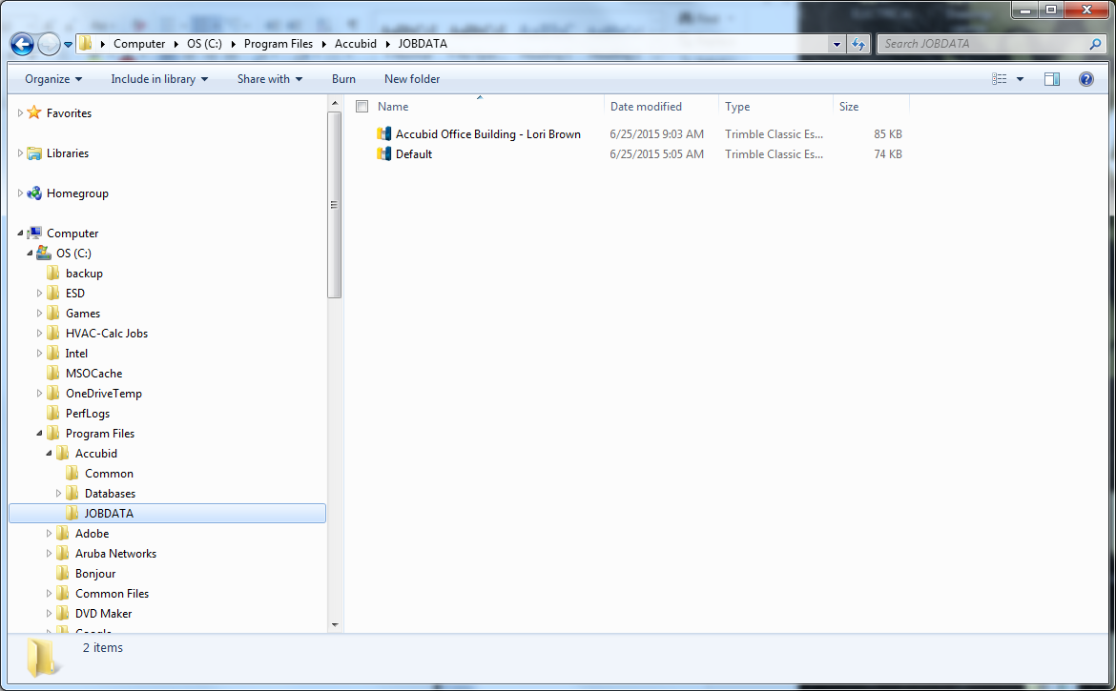

Figure 21

The job you created has been saved to the local computer’s hard drive in the default folder.

1. Copy the Job to your own USB drive:

Right click on the file and select Copy

Scroll down to find your USB drive and right click on your USB drive and select Paste.

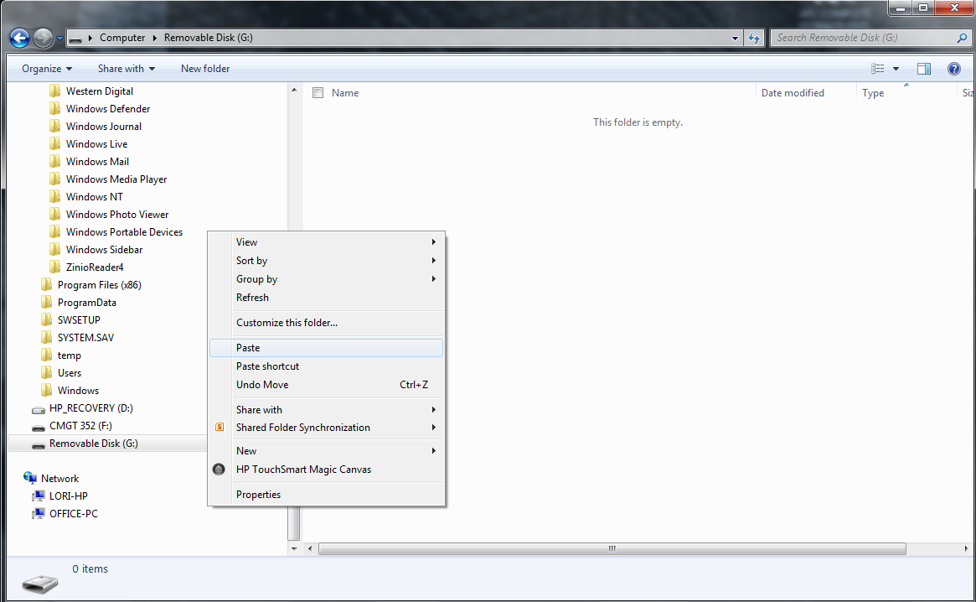

Figure 22

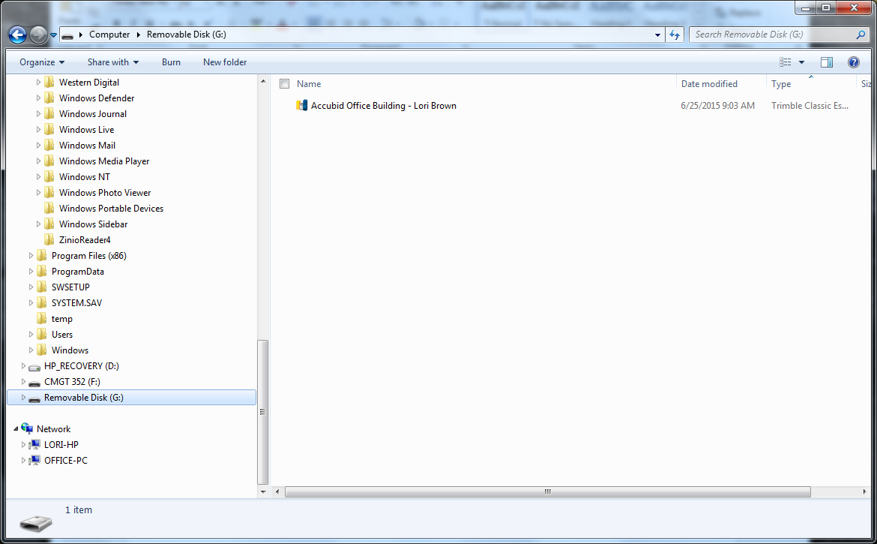

Figure 23

**Editing the Default File**

1. In Windows Explorer scroll back to: Computer OS (C:) Program Files, Accubid, JOBDATA
2. Double Click on the file Default to Open it in Accubid

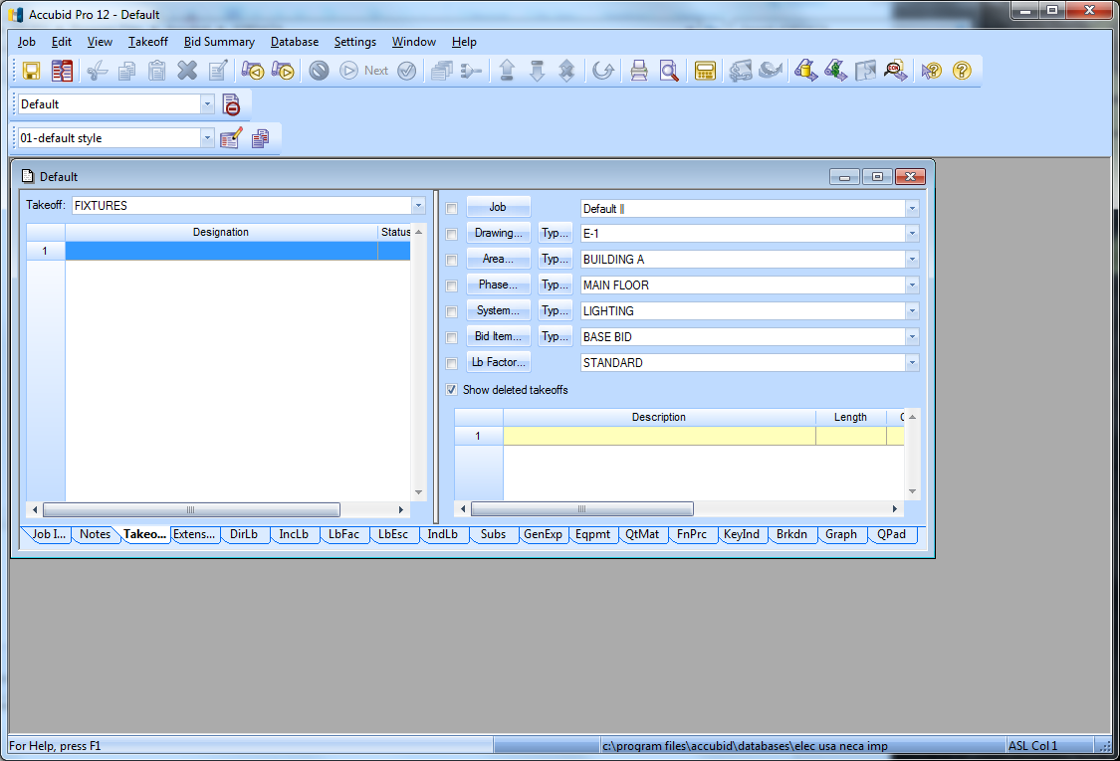

Figure 24

1. If the Default window is not maximized as shown in Figure 24, click the Maximize button in the Default window to maximize the window.

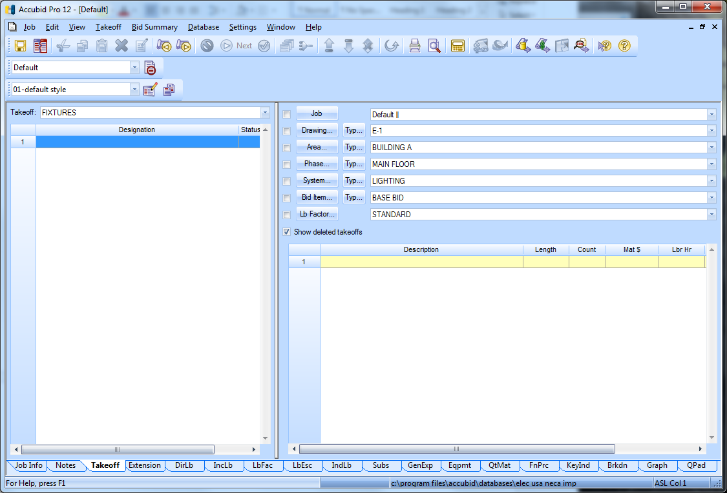

Figure 25

1. From the Job menu select Open

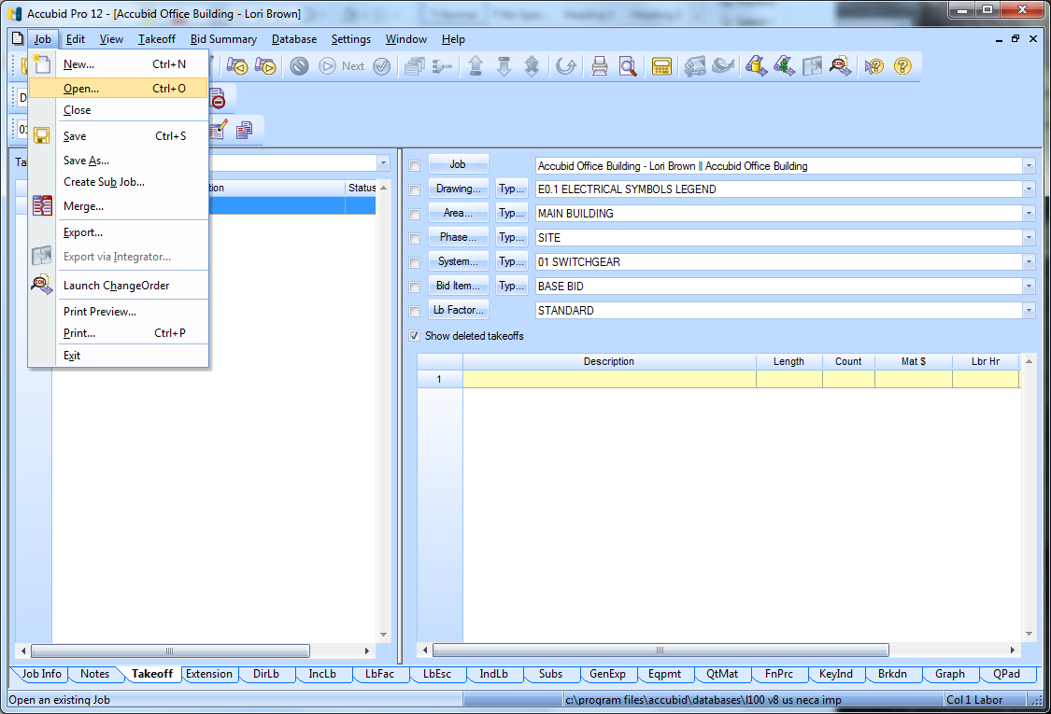

Figure 26

1. Click on the Job Accubid Office Building – Your Name and click Open.

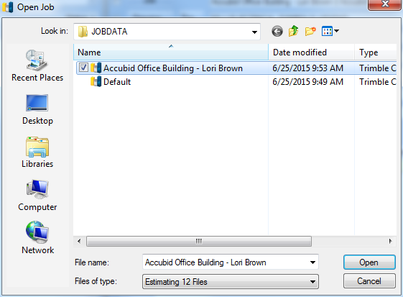

Figure 27

1. Click on the System Breakdown Label
2. In the System Modify window select Line 1 through Line 61

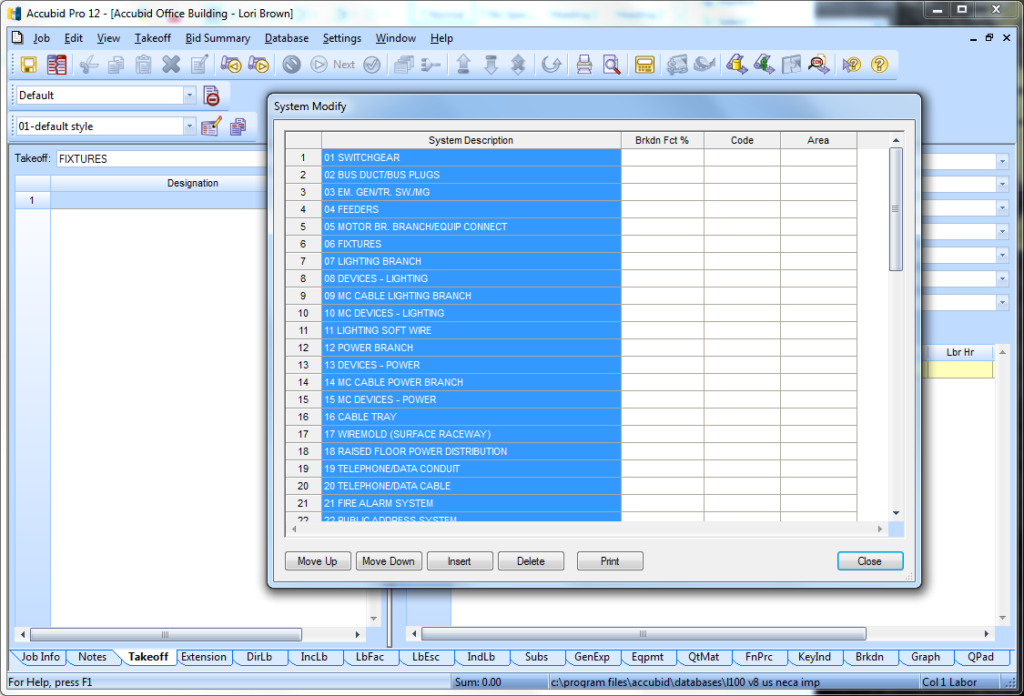

Figure 28

1. Press and hold down the Ctrl key and then press C to copy the System Descriptions to the Clipboard.
2. Click the Close button.
3. From the Window menu select Default to switch back to the Default file.

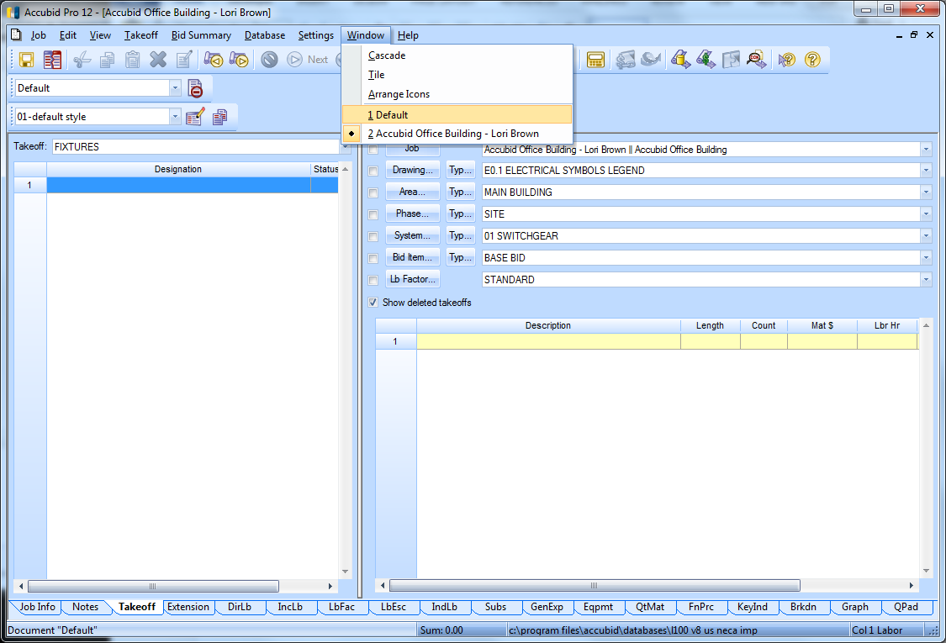

Figure 29

1. Click the System Breakdown Label

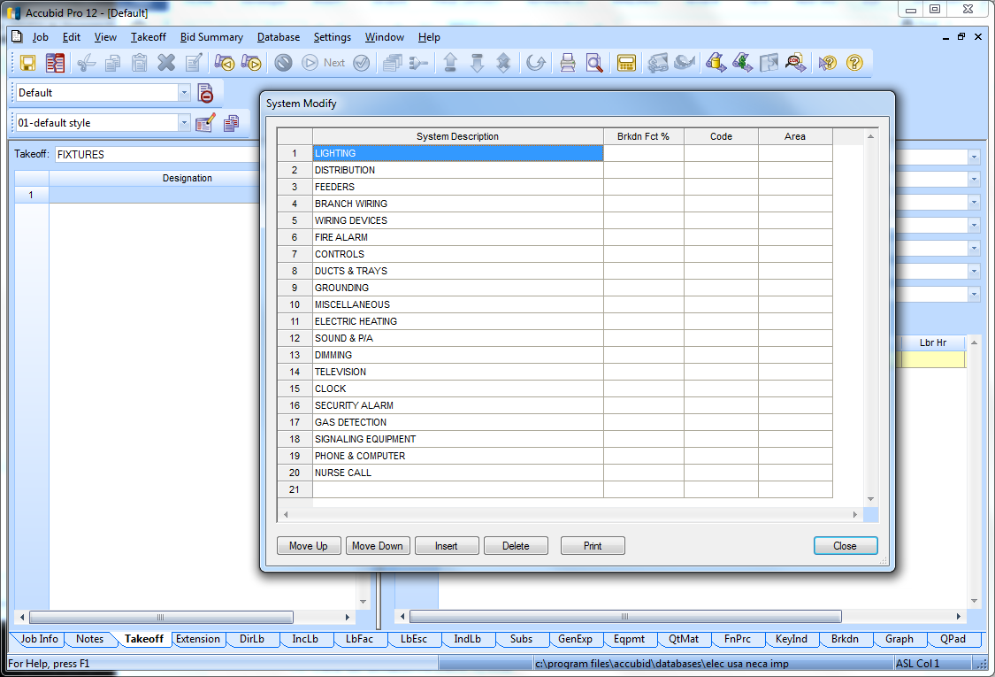

Figure 30

1. Select Line 1
2. Press and hold down the Ctrl key and press v to paste over the System Descriptions.

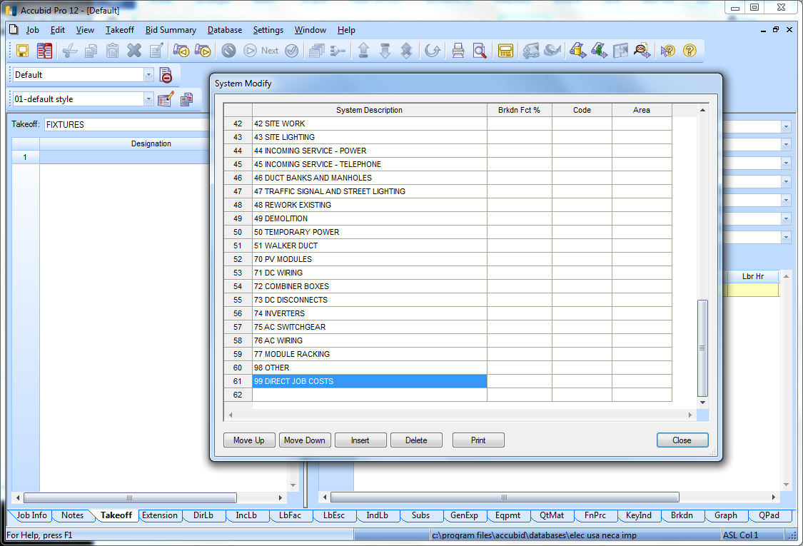

Figure 31

1. Click Close
2. Save the changes by clicking on the Save Job icon in the Toolbar  .
3. From the Job menu select the Close command to close the Default File.

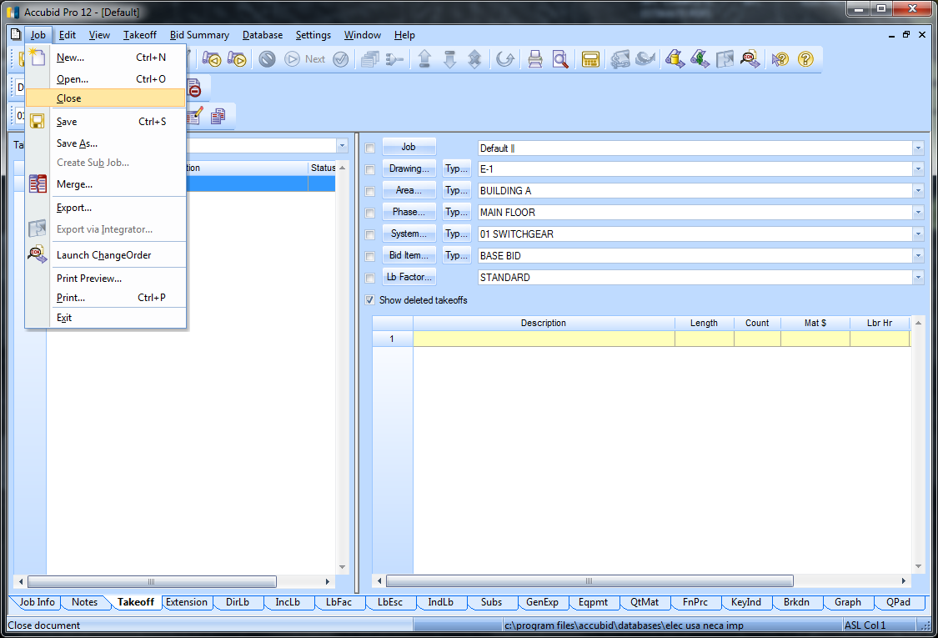

Figure 32

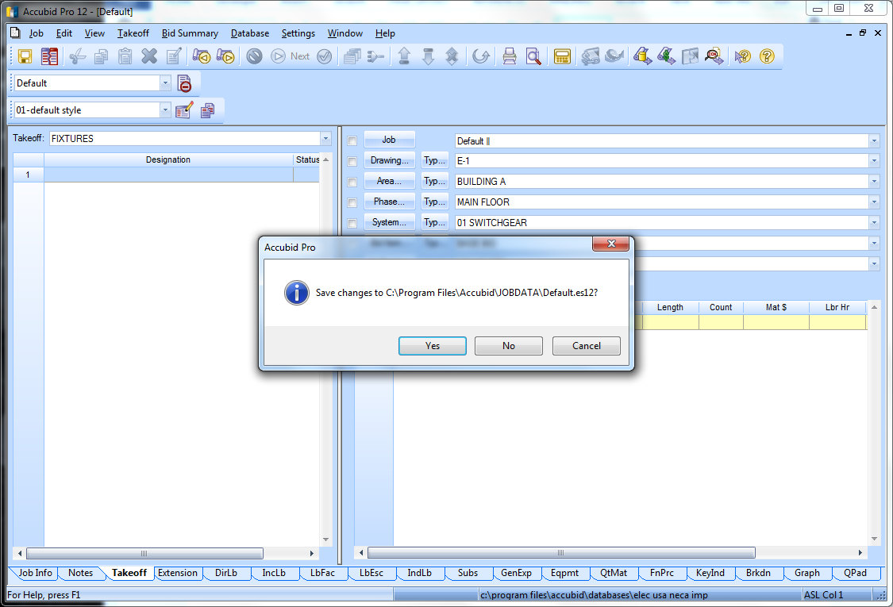

Figure 33

1. In the Accubid Pro window click Yes to Save Changes to the Default.es13 file.
2. Close the Accubid Office Building – Your Name file and click No to Save Changes to the file.
3. Exit Accubid (Close the Program)

All new jobs from this point on will automatically have the fields entered in the System Breakdown Label that are used by North State Electric i.e. 01 SWITCHGEAR

1. Start the program Accubid Pro 13 [Start, All Programs, Trimble, Classic 13, Accubid Pro 13
2. From the [Schedule] screen create a new job use the job name “Atlantic Food Company” and job number “Atlantic Food Company – Your Name”
3. Click the Takeoff tab to select the Takeoff screen
4. Verify that the System Breakdown Label has the correct fields.
5. Exit Accubid
6. Select Yes to Save Changes.