CM 352 – Electrical Construction Estimating
Accubid Office Building
Accubid Activity #20 - Bid Summary

Procedure
Edit each Accubid Sheet as follows.

DirLb
Change the Rate $ and Brdn % and delete the Frng $ entries as shown in Fig. 1
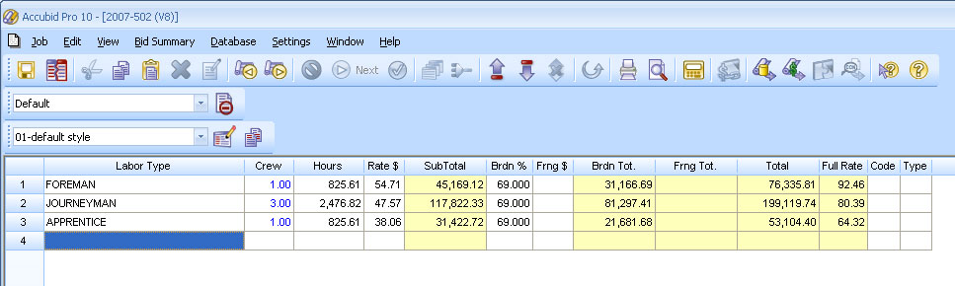
Fig. 1

IncLb
Edit the IncLb Screen as shown in Fig. 2

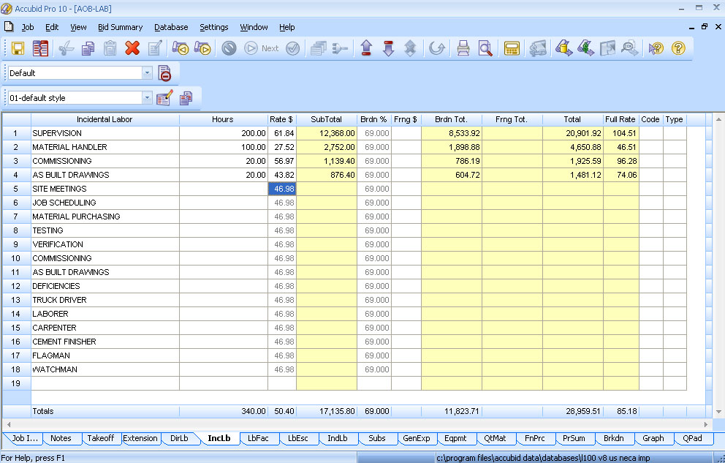
Fig. 2
IndLb
Edit the IndLb screen as shown in Fig. 3

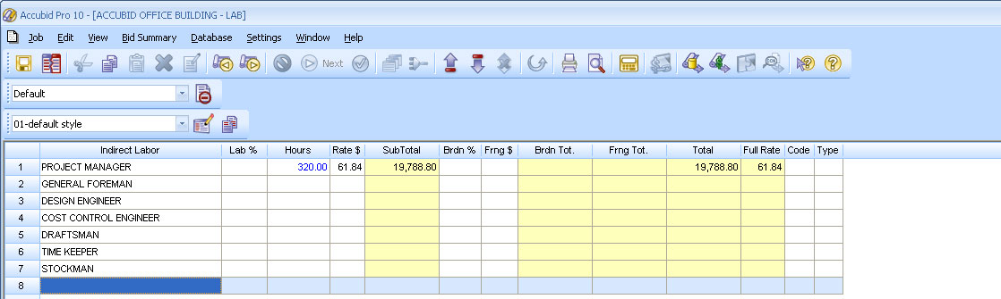
Fig. 3

Subs
TAX = BLANK
OVERHEAD = 5%
MARKUP = 4%

EXCAVATION
VENDOR QUOTE NOTE
BEST EXCAVATION 6,500.00
FAST EXCAVATION 1,800.00 NO POLE BASES
RELIABLE EXCAVATORS 4,400.00

CIVIL WORK
VENDOR QUOTE NOTE
A1 CONTRACTING 3,700.00
CHEAP CONTRACTING 3,600.00
A2 CONTRACTING 3,850.00

FIRESTOPPING
VENDOR QUOTE NOTE
ALPHACORE & FIRE STOP 3,200.00
BUDGET 2,000.00

GenExp
TAX = 9.250
OVERHEAD = 5%
MARKUP = 3%

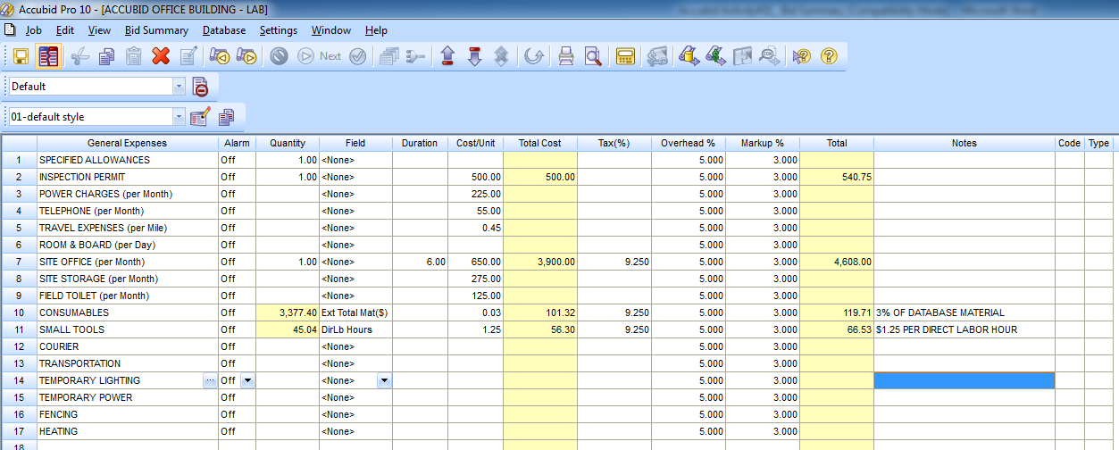
Fig. 4

QtMat

LIGHTING FIXTURES
VENDOR QUOTE
GE SUPPLY 34,100.00
GRAYBAR 35,100.00
WESCO 35,700.00
IES 31,889.00
WALTERS

DISTRIBUTION
VENDOR QUOTE
GE SUPPLY 14,300.00
GRAYBAR 17,300.00
WESCO 15,000.00

FIRE ALARM
VENDOR QUOTE
EDWARDS 11,000.00
NOTIFIER 10,750.00
SIMPLEX 14,500.00

CABLE TRAY
VENDOR QUOTE
GE SUPPLY 9,000.00
GRAYBAR 9,200.00
WESCO 10,800.00

EQUIPMENT / CONTROLS
VENDOR QUOTE
GE SUPPLY 4,100.00
GRAYBAR 3,600.00
WESCO 3,290.00
IES 3,475.00

