CM 352 – Electrical Construction Estimating
Accubid Office Building
Accubid Activity #21 – Final Pricing

Procedure:

Edit the Final Pricing Screen
Material Tax 9.250
Database Material Overhead 8.000
Quoted Material Overhead 3.000
Labor Overhead 18.000

Database Material Markup 4.000
Quoted Material Markup 2.000
Labor Markup 13.500

Print your final pricing screen in Portrait by using the settings shown in Fig. 1.
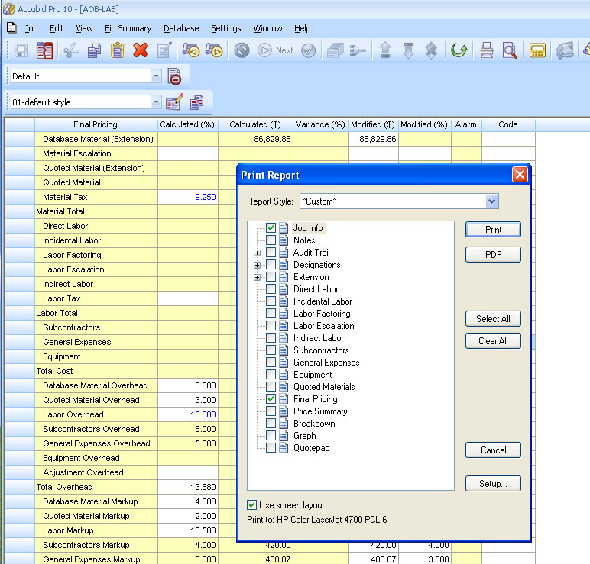
Fig. 1

