**CM 352 – Electrical Construction Estimating**

lightbul

Accubid Activity #2

Building Fixture Designations and Fixture Takeoff SYS 06 FIXTURES

**Building Fixture Designations**

1. Start the program Accubid Pro 13 [Start, All Programs, Trimble, Classic 13, Accubid Pro 13]
2. Press the CAPS LOCK Key ON
3. From the Job Schedule Screen open the file, Accubid Office Building.

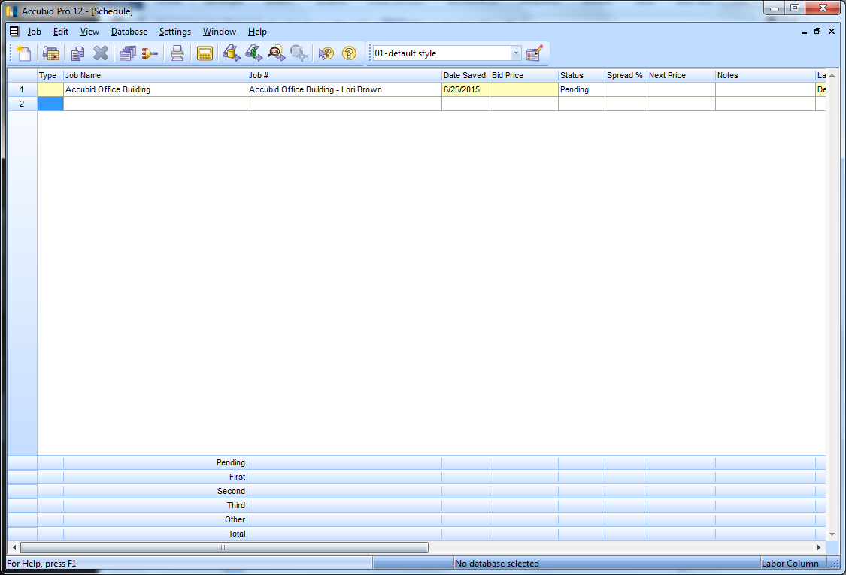

Figure 1

1. Make sure you are using the Database: L100 V8 US NECA IMP



1. If not already selected, select the Takeoff tab at the bottom of the screen.

**FIXTURES - DESIGNATIONS**

In Accubid (Electrical) there are three systems that use **Designations**:

FIXTURES

HEATING

DISTRIBUTION

Creating a designation involves selecting any number of different items and assemblies, and then assigning them a designation name. Once you have created the designation, you can take off all the items in the designation in a single step. Any changes you make to the designation will be automatically reflected in all takeoffs performed using that designation.

1. Choose FIXTURES from the DROP DOWN list in the Takeoff: area of the screen.

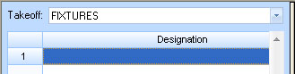

1. Double click the first blank line below the Designation heading.

The Create/Modify Designation Description dialog will appear. Descriptions can be a maximum of 80 characters.

1. Enter: A - 2X4 FL 4L T-BAR LAY-IN in the dialog box and press OK.

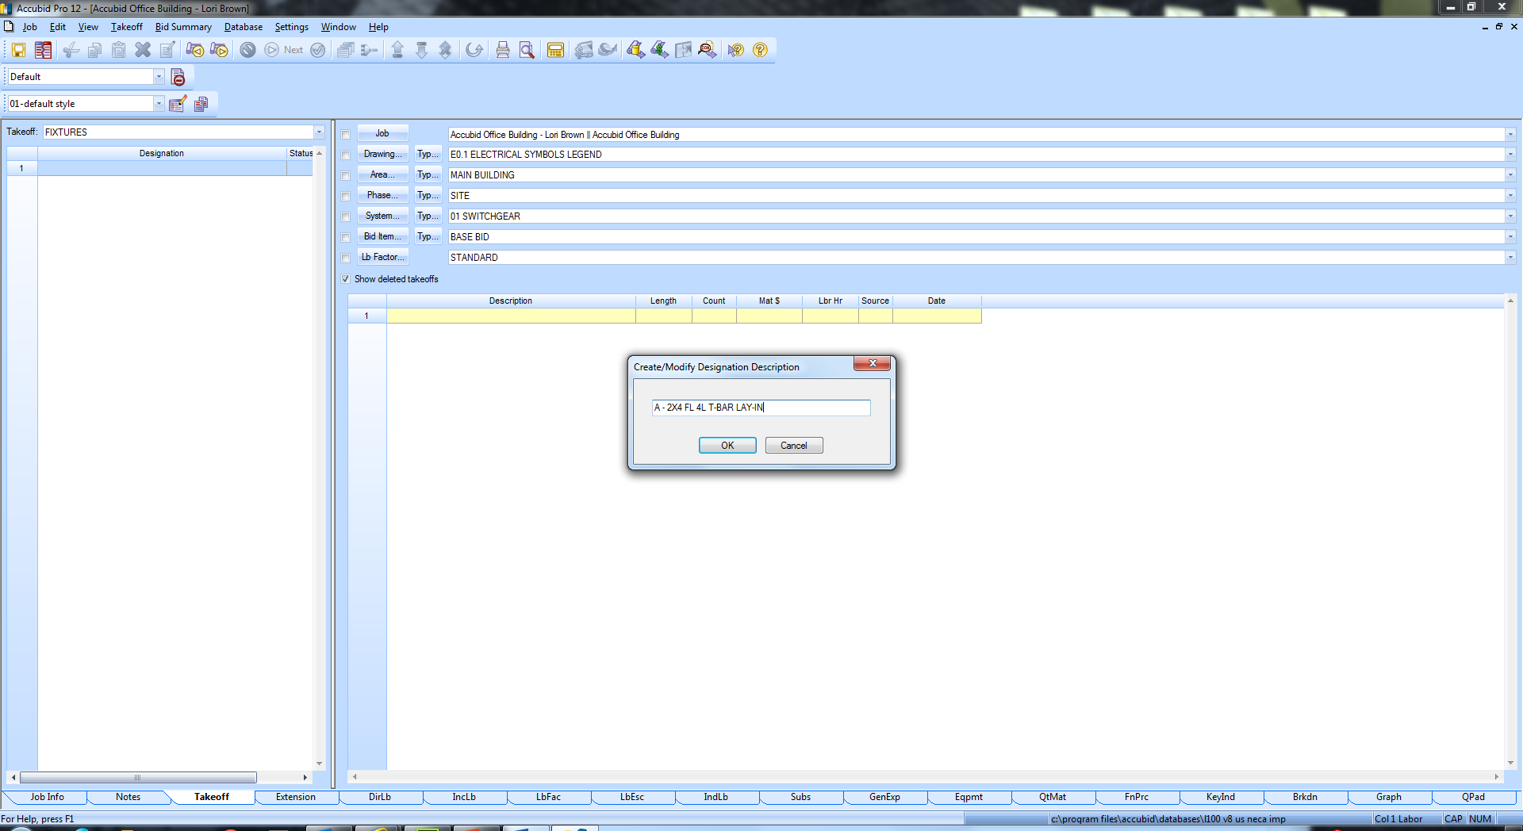

Figure 2

Using a series of dialog boxes Accubid will step through building the FIXTURE DESIGNATION in the following order:

Fixtures: Category

Fixtures: Type

Fixtures: Size

1. To build the Fixture Designation: A - 2X4 FL 4L T-BAR LAY-IN  
   Double click to select the following:

Fixtures: Category

Line 1 FLUORESCENT LUMINAIRES

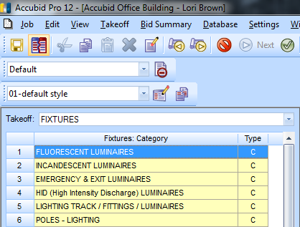

Figure 3

Fixtures: Type

Line 1 FLUORESCENT LUMINAIRES - RECESSED

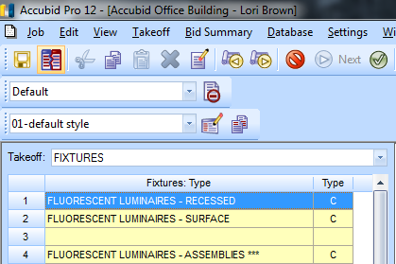

Figure 4

Fixtures: Size

Line 8 2′ x 4′ DROP-IN T-BAR

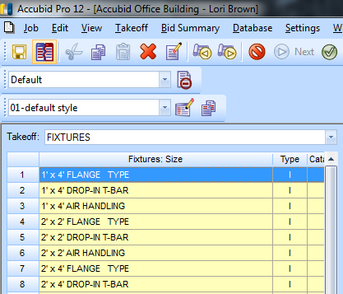

Figure 5

The Measure Takeoff dialog box appears which is used to build the designation one **item** at a time.

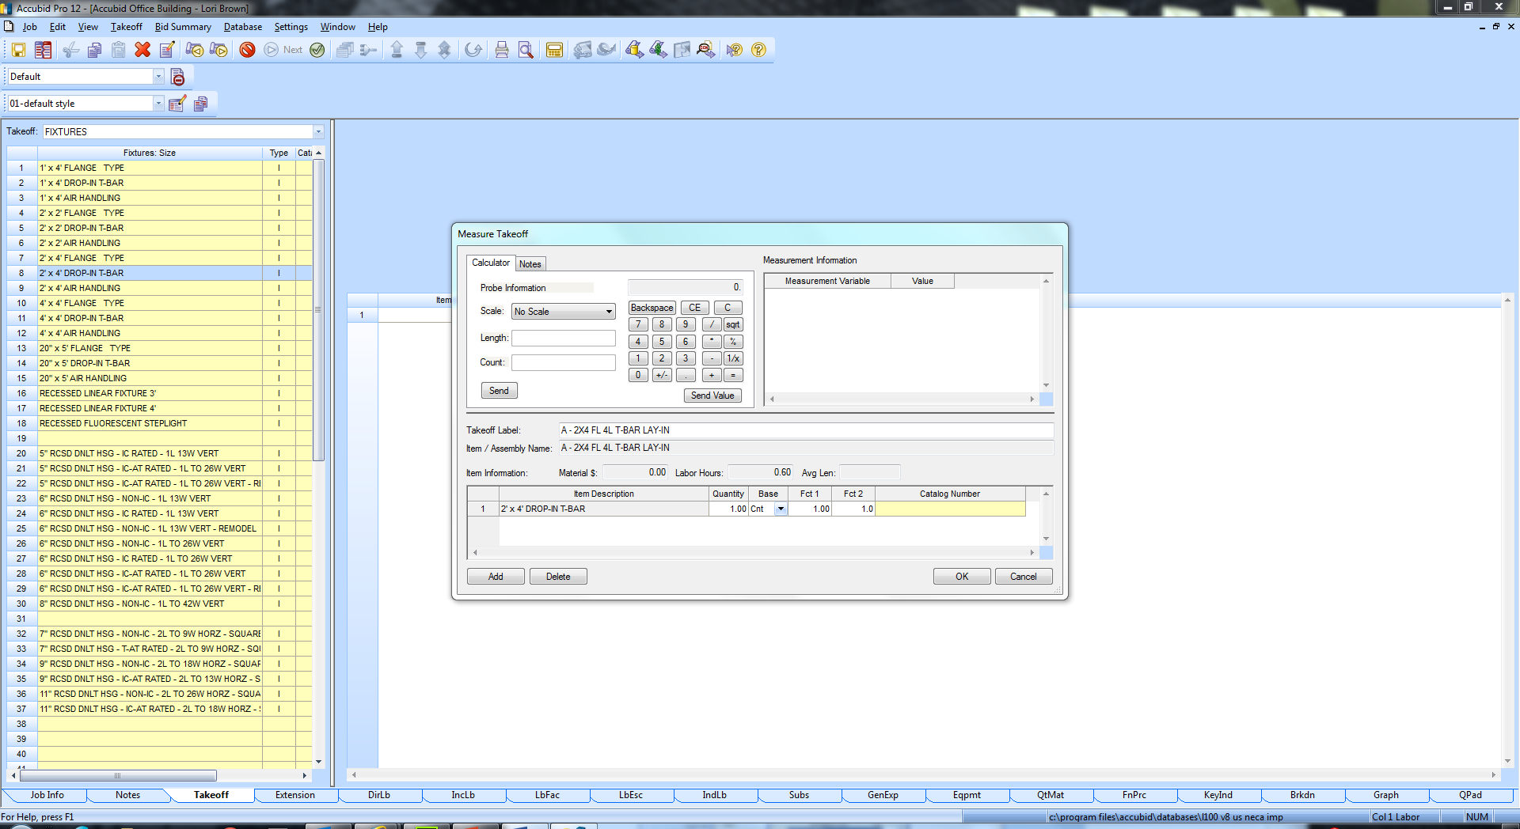

Figure 6

Example: FIXTURE A

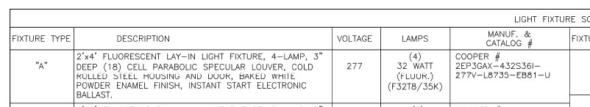

Below is the list of items that will be added to the FIXTURE DESIGNATION:

(Instructions are on the next page)

ITEM QTY

2' x 4' DROP-IN T-BAR 1.00

#14/2C CABLE MC - STL ARMOR 7.00

3/8" CONN AC-90 / MC DC SS 2.00

3/8" CABLE SUPPORT FOR ROD OR FLNG 1.00

WIRE CONN YEL (#18 TO #12) 3.00

CEILING CLIP W/ 27mm STD NAIL - STL/CONC 2.00

#12 CEILING WIRE 14.00

T-BAR CLIP FOR STRAIGHT LIP LAY-IN FIXTURE 4.00

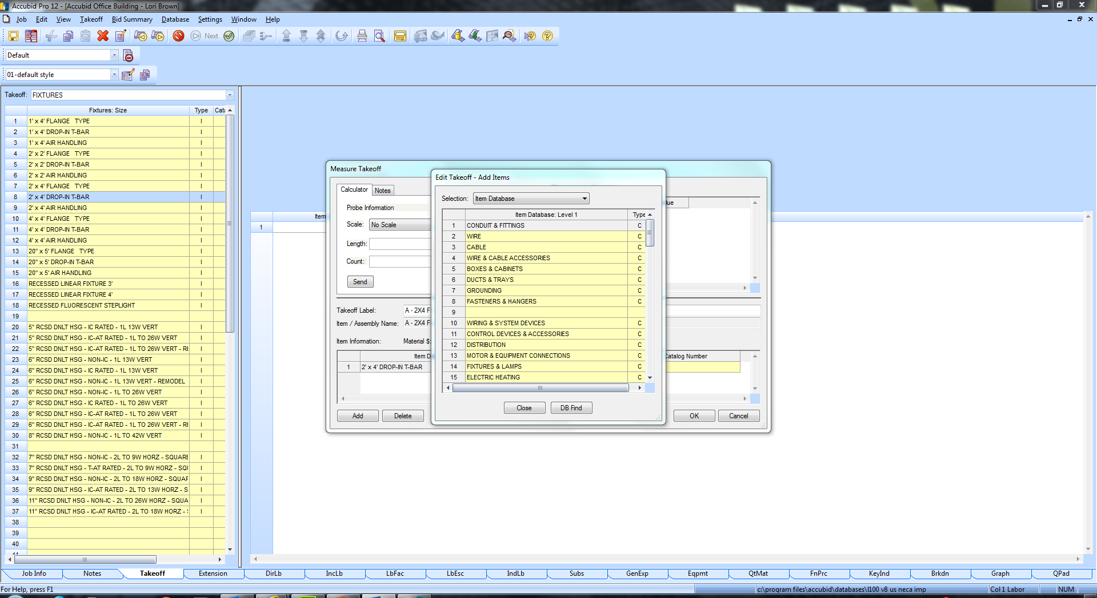

Figure 7

1. Click on ADD in the Measure Takeoff window. To ADD the Item, **#14/2C CABLE MC - STL ARMOR** to the FIXTURE DESIGNATION:

Double Click on:

Line 3 – CABLE C

Line 2 – MC CABLE C

Line 1 – MC CABLE 600V STEEL ARMOR C

Line 1– #14/2C CABLE MC - STL ARMOR I

Notice that the Item was ADDED to the Item Description list in the Measure Takeoff dialog box.

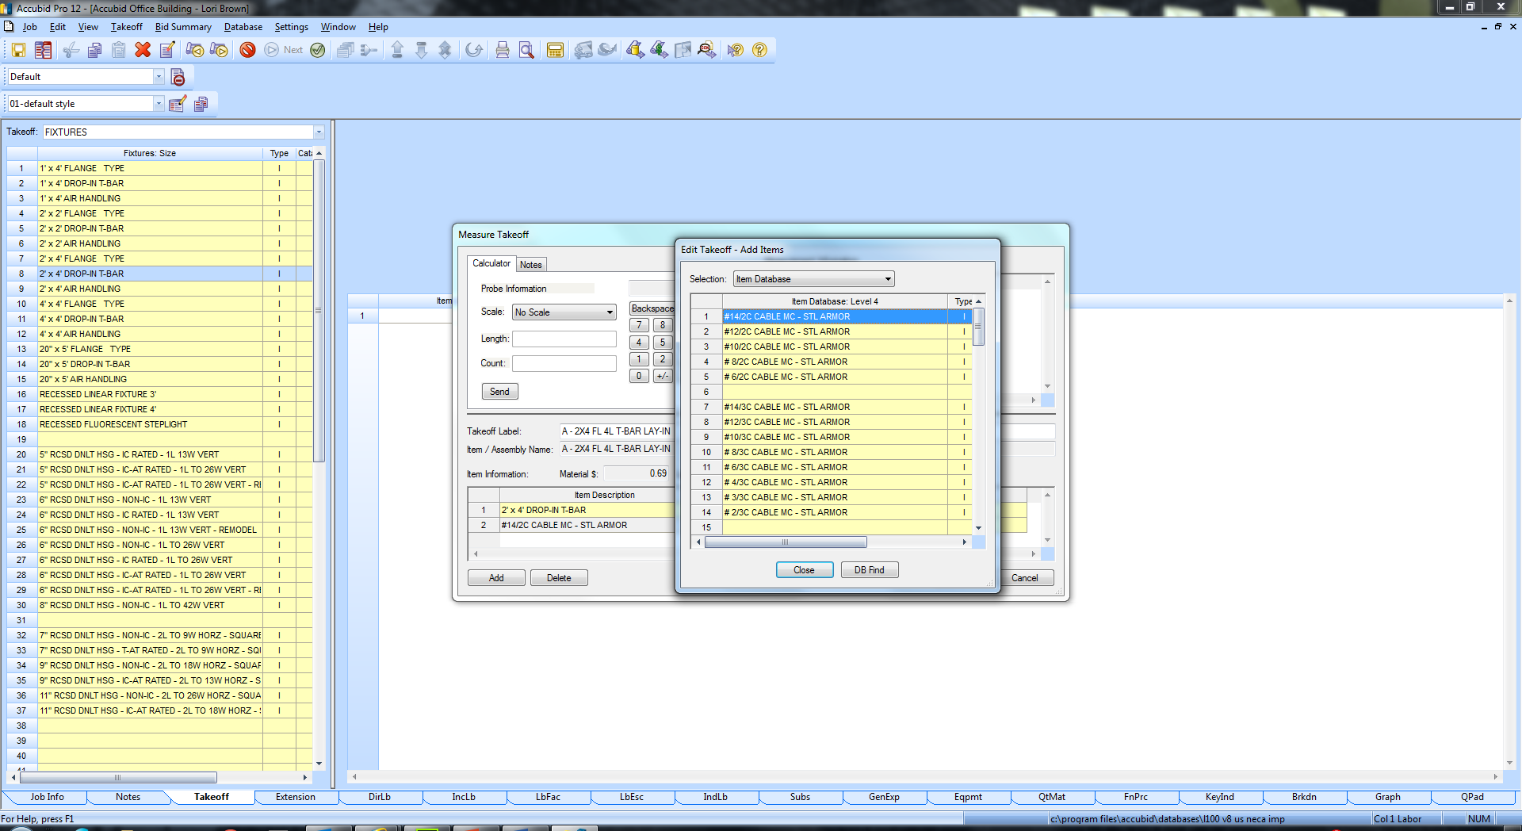

Figure 8

Note: To “Backup” in the Edit Takeoff – Add Items dialog box you can press the ESC Key or click the Right Mouse button in the Window.

1. Press the Right Mouse Button Three Times to get back to **Item Database: Level 1**.
2. To Add the Item, **3/8" CONN AC-90 / MC DC SS** by double click on the following:

Line 4 – WIRE AND CABLE ACCESSORIES C

Line 2 – AC-90 /MC / NM-B CONN & FITTINGS C

Line 1 – BX CONNECTORS C

Line 1 – 3/8" CONN AC-90 / MC DC SS I

**USING DB FIND**

1. To Add the Item, **3/8" CABLE SUPPORT FOR ROD OR FLNG** click on the DB Find button.
2. In the Find Database Item/Assembly window enter the Item in the Search Text: textbox and under the Search for command select the radio button **Items only**. Click on the **Find Now** button.

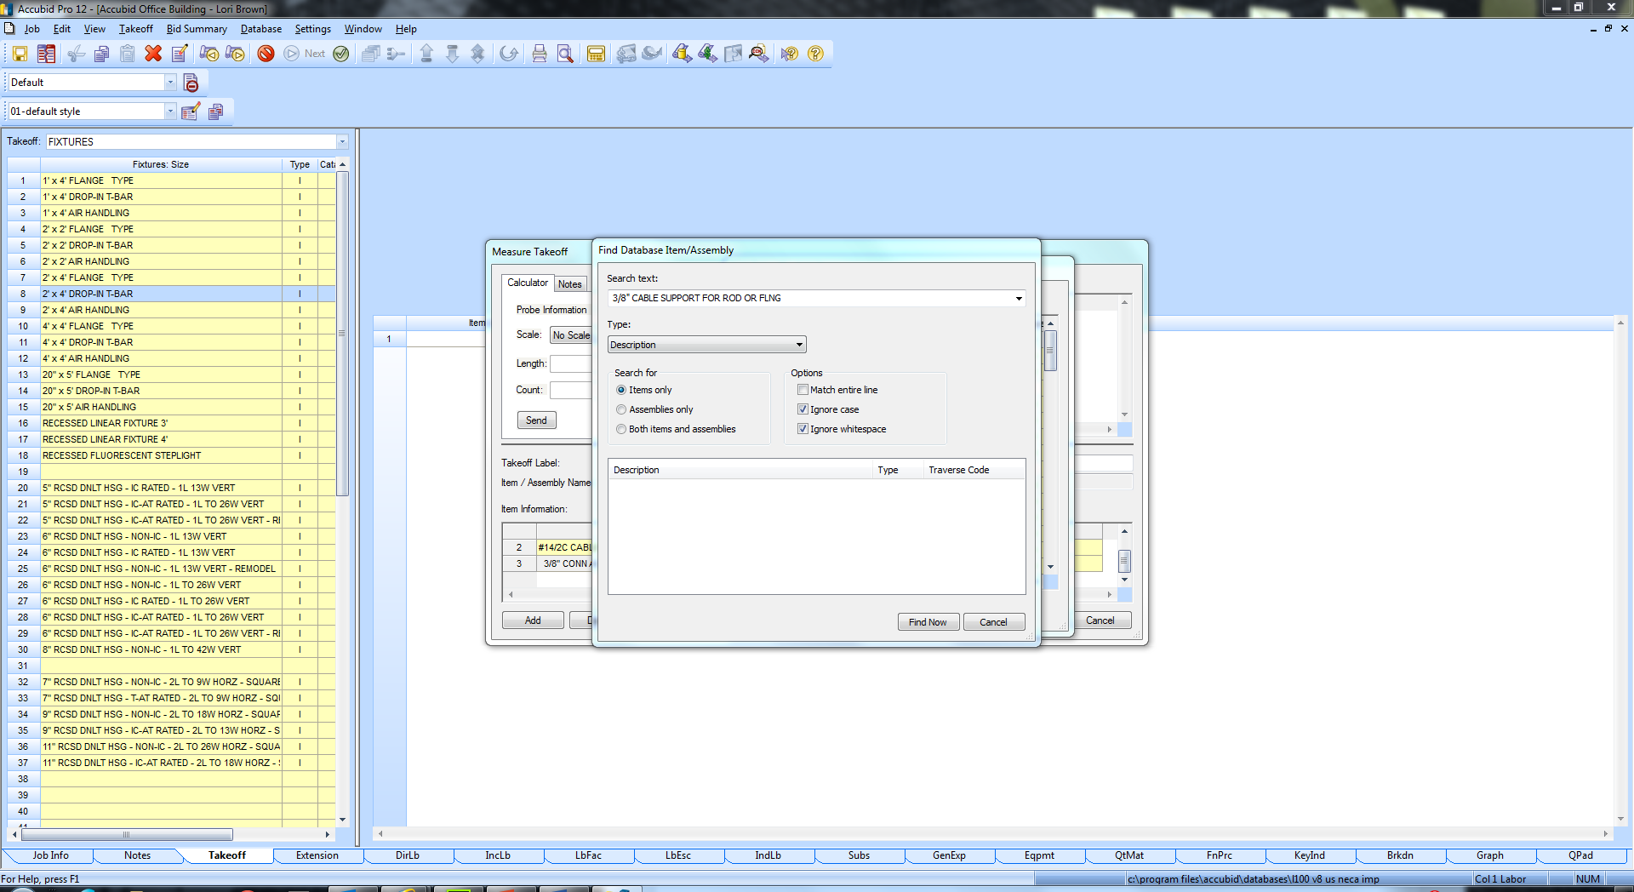

Figure 9

The Item is located and displays in the dialog box.

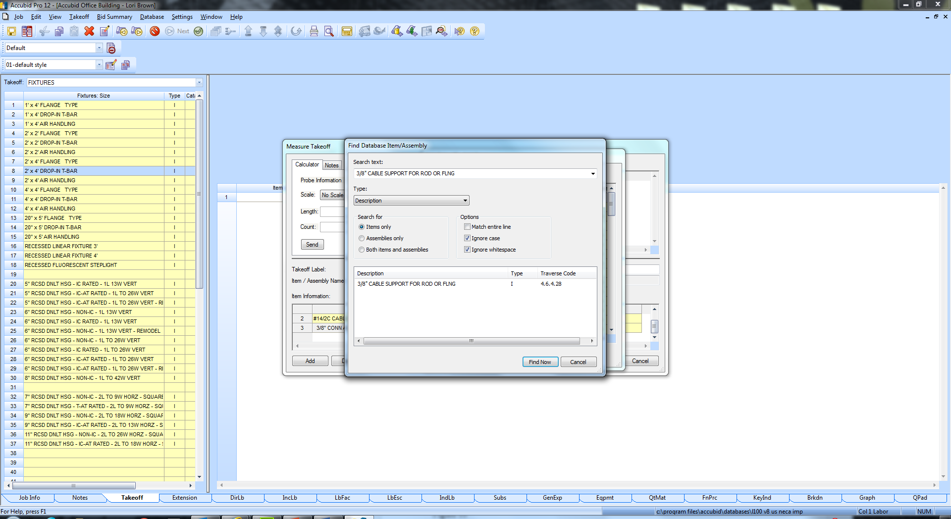

Figure 10

Notice the TRAVERSE CODE 4.6.4.28

The Traverse Code is the list of Line numbers starting from Item Database: Level 1 to the Item.

1. Double Click on the item listed under Description to open the Item Database for that Item.

The Edit Takeoff – Add Items Window is opened leaving the Find Database Item/Assembly Window open. Click Cancel to close the Find Database Item/Assembly Window.

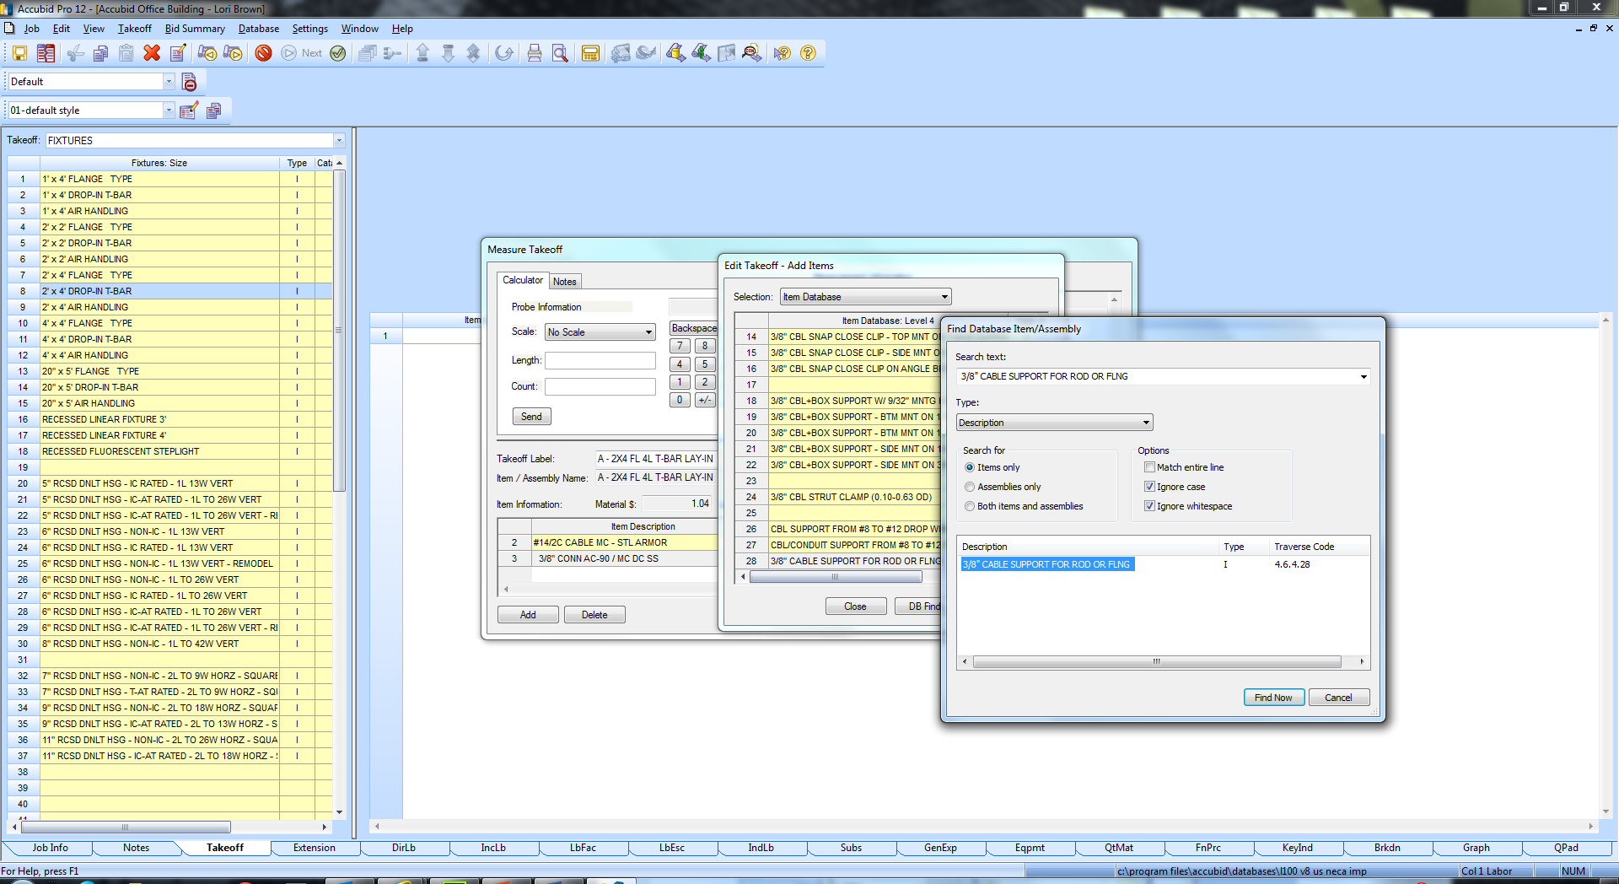

Figure 11

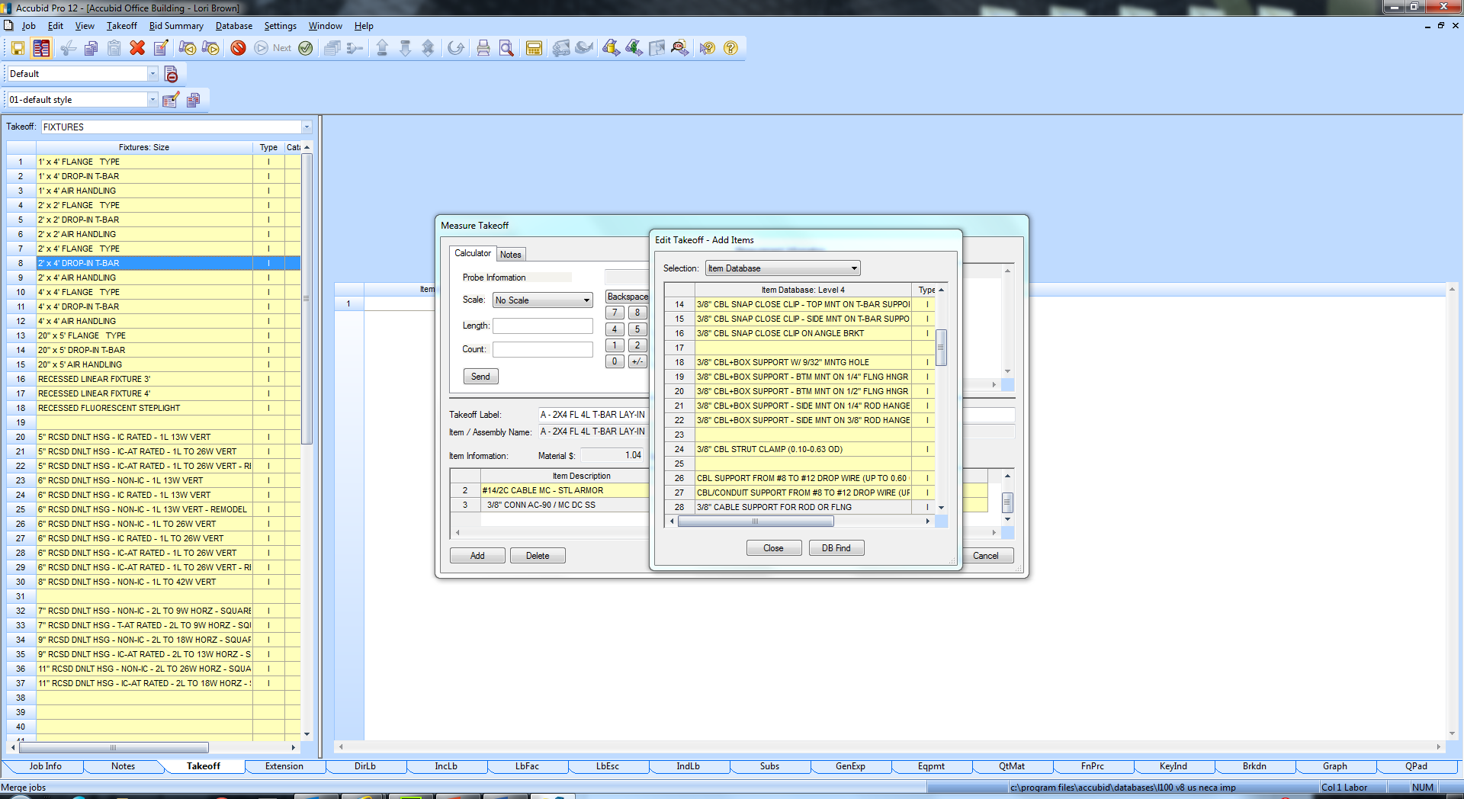

Figure 12

1. Double click on Line 28 3/8" CABLE SUPPORT FOR ROD OR FLNG to Add it to your FIXTURE DESIGNATION.

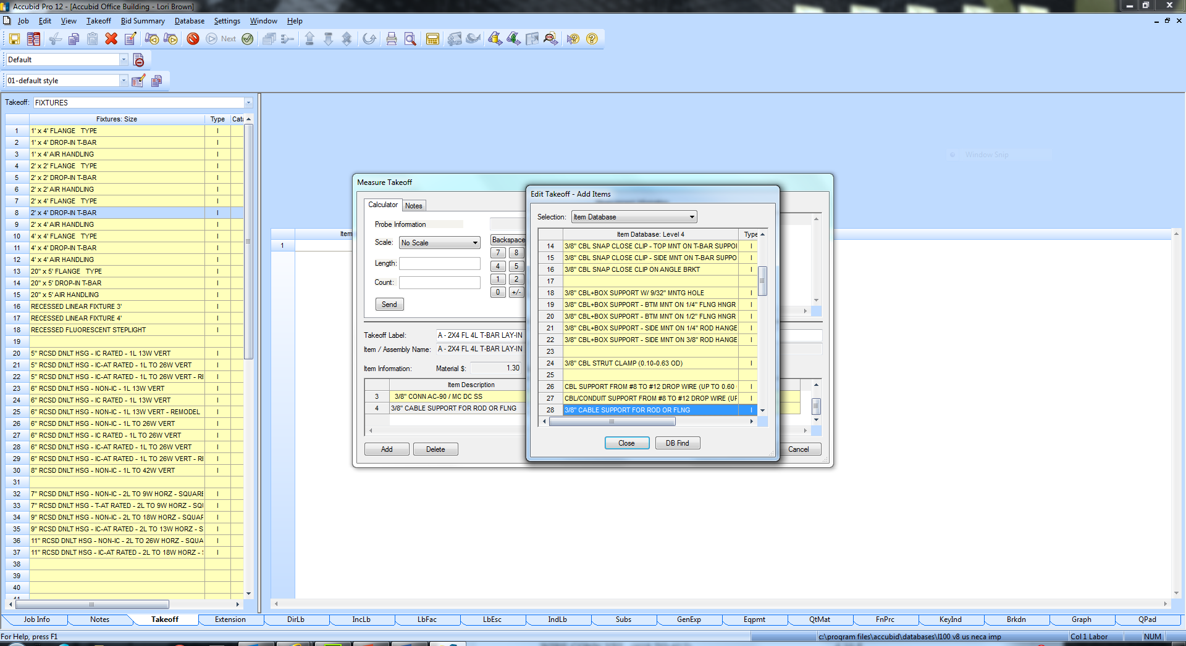

Figure 13

1. Press the Right Mouse Button Three Times to get back to **Item Database: Level 1**.
2. ADD the Remaining Items Using Either the DB Find or by Browsing the Item Database (see Traverse Codes below).

Remaining Items Traverse Codes (Item Database)

WIRE CONN YEL (#18 TO #12) 4.10.5

CEILING CLIP W/ 27mm STD NAIL - STL/CONC 8.11.8.1

#12 CEILING WIRE 8.13.3.4

T-BAR CLIP FOR STRAIGHT LIP LAY-IN FIXTURE 8.9.14.1

1. Click the Close button to close the Edit Takeoff – Add Items Window

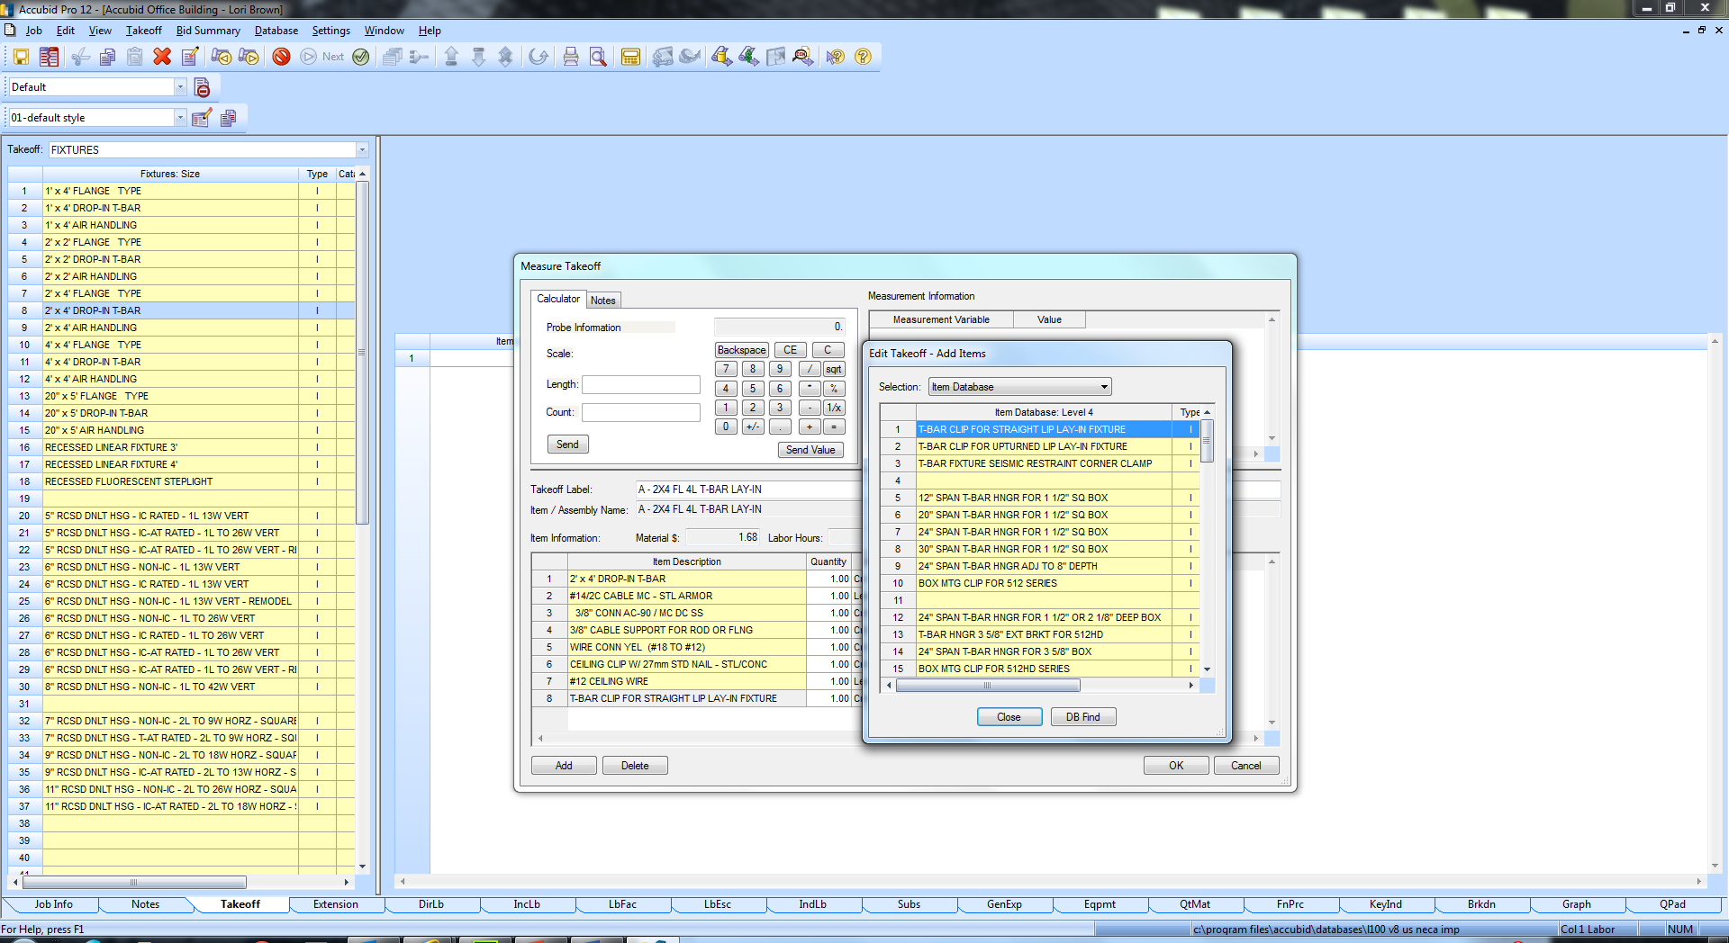

Figure 14

All Items have now been Added to the Fixture Designation.

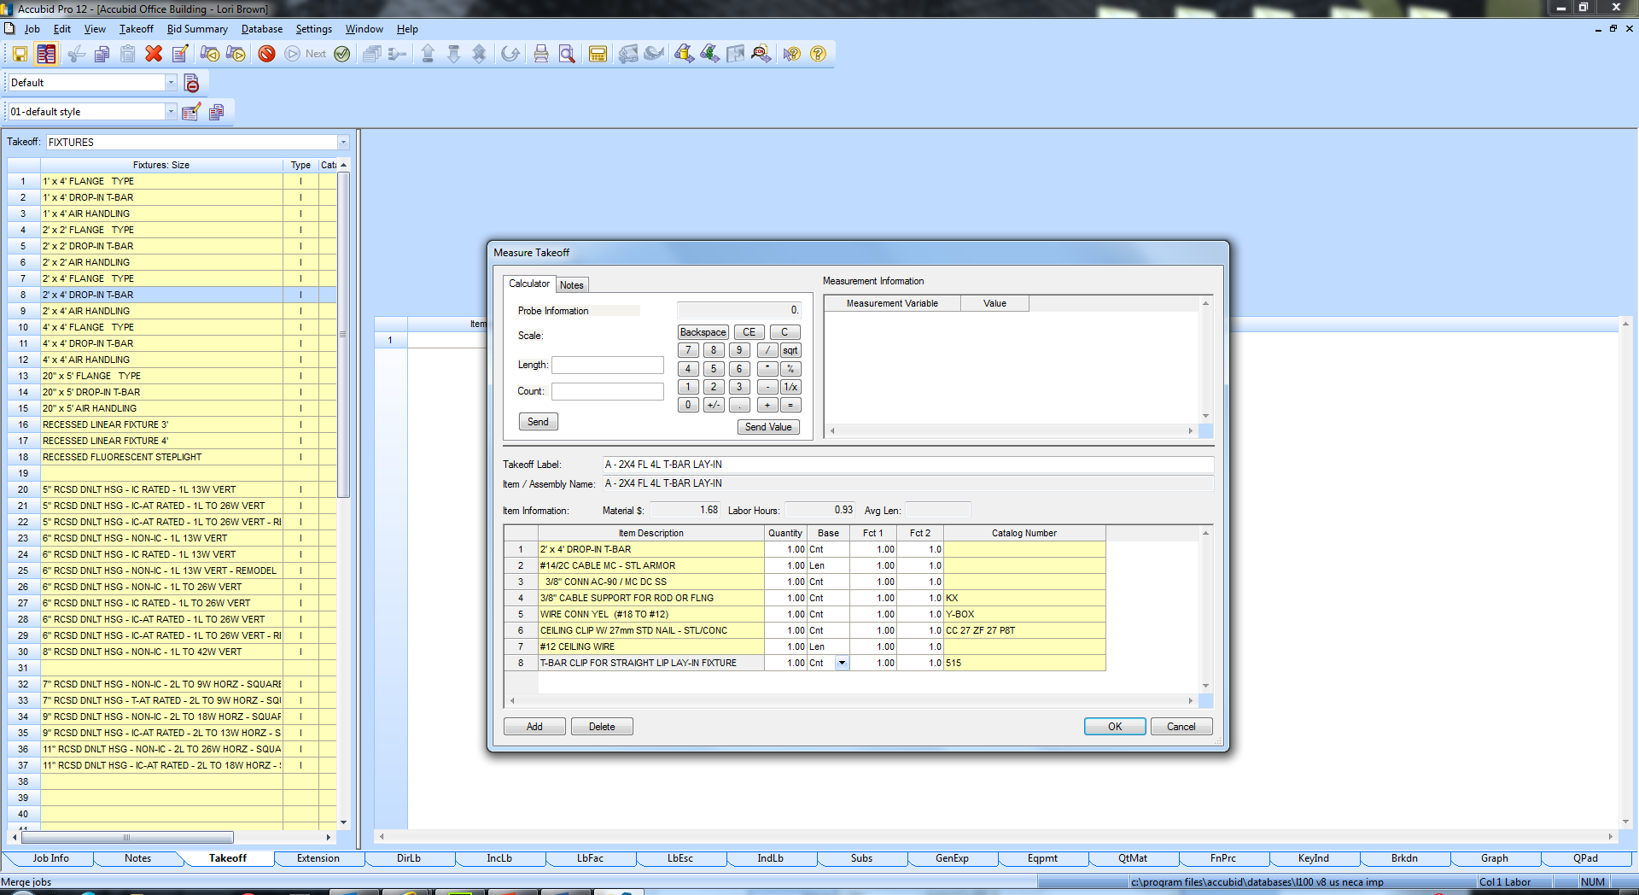

Figure 15

In the Measure Takeoff dialog box the Quantity of Each Item is determined by the Base and the variables Fct 1 and Fct 2.

Base can be set to Cnt, Len, or Abs [i.e. Based on Count, Length, or Absolute (fixed)]

Fct 1 is a Multiplier

Fct 2 is a Divider

**NEVER TYPE IN THE QUANTITY FIELD UNLESS INSTRUCTED TO!**

1. For each FIXTURE A Designation taken off we want to include the QTY of material shown below. Change the following for each item, if necessary, the Base, Fct 1 and Fct 2 as shown below:

ITEM Base Fct 1 Fct 2

2' x 4' DROP-IN T-BAR Cnt 1.00 1.0

#14/2C CABLE MC - STL ARMOR Cnt 7.00 1.0

3/8" CONN AC-90 / MC DC SS Cnt 2.00 1.0

3/8" CABLE SUPPORT FOR ROD OR FLNG Cnt 1.00 1.0

WIRE CONN YEL (#18 TO #12) Cnt 3.00 1.0

CEILING CLIP W/ 27mm STD NAIL - STL/CONC Cnt 2.00 1.0

#12 CEILING WIRE Cnt 14.00 1.0

T-BAR CLIP FOR STRAIGHT LIP LAY-IN FIXTURE Cnt 4.00 1.0

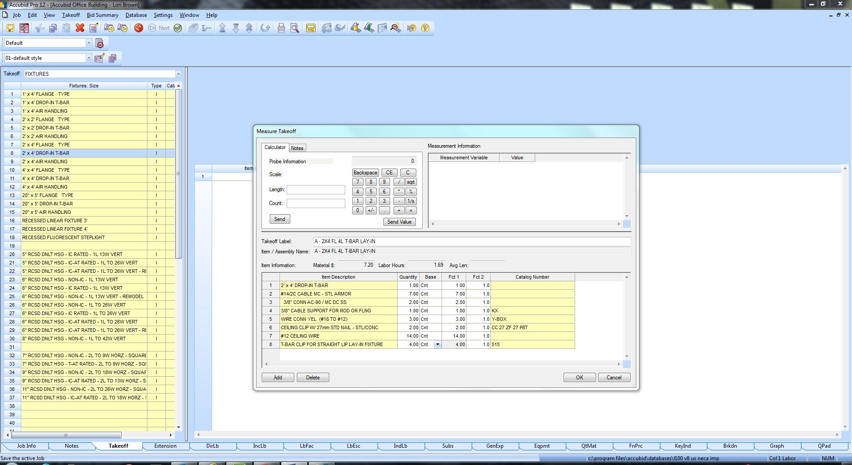

Figure 16

1. Click the OK button.

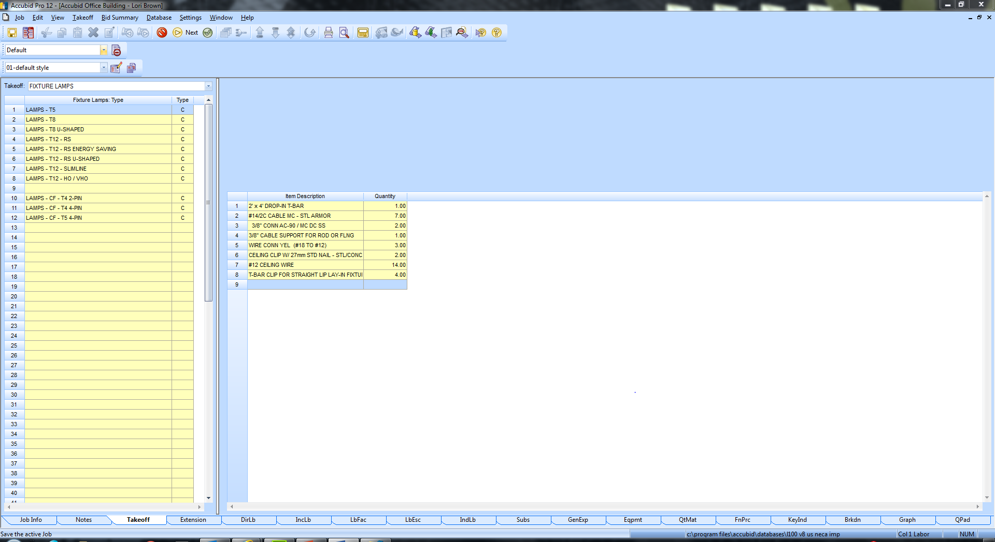

Figure 17

**The Fixture Lamps: Type screen appears next [Takeoff:]**

1. To Add Lamps to your Fixture Designation double click on:

LAMPS – T8 Line 2

48" 3500K 78 CRI 32W LAMP - T8 Line 8

1. Change the Count per Unit Value to 4.00 and press the enter key.
2. Click OK to Add the Lamps to the Fixture Designation

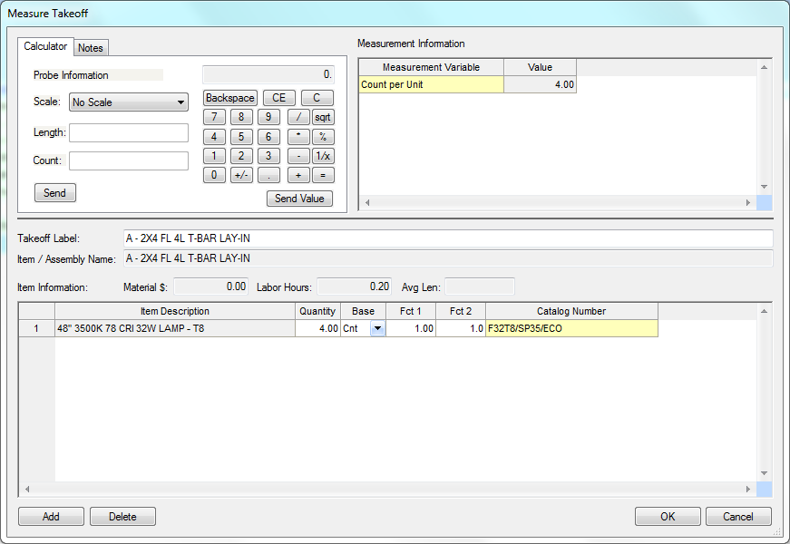

Figure 18

1. Right Click in the Fixture Item List and click accubid34.jpg Finish

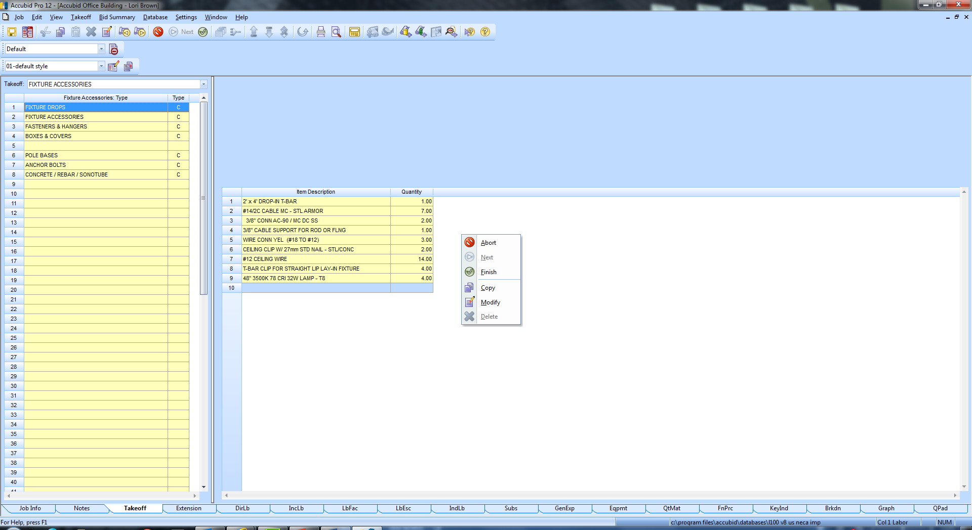

Figure 19

The completed Fixture Designation displays in the Takeoff: Fixtures designation list on Line 1.

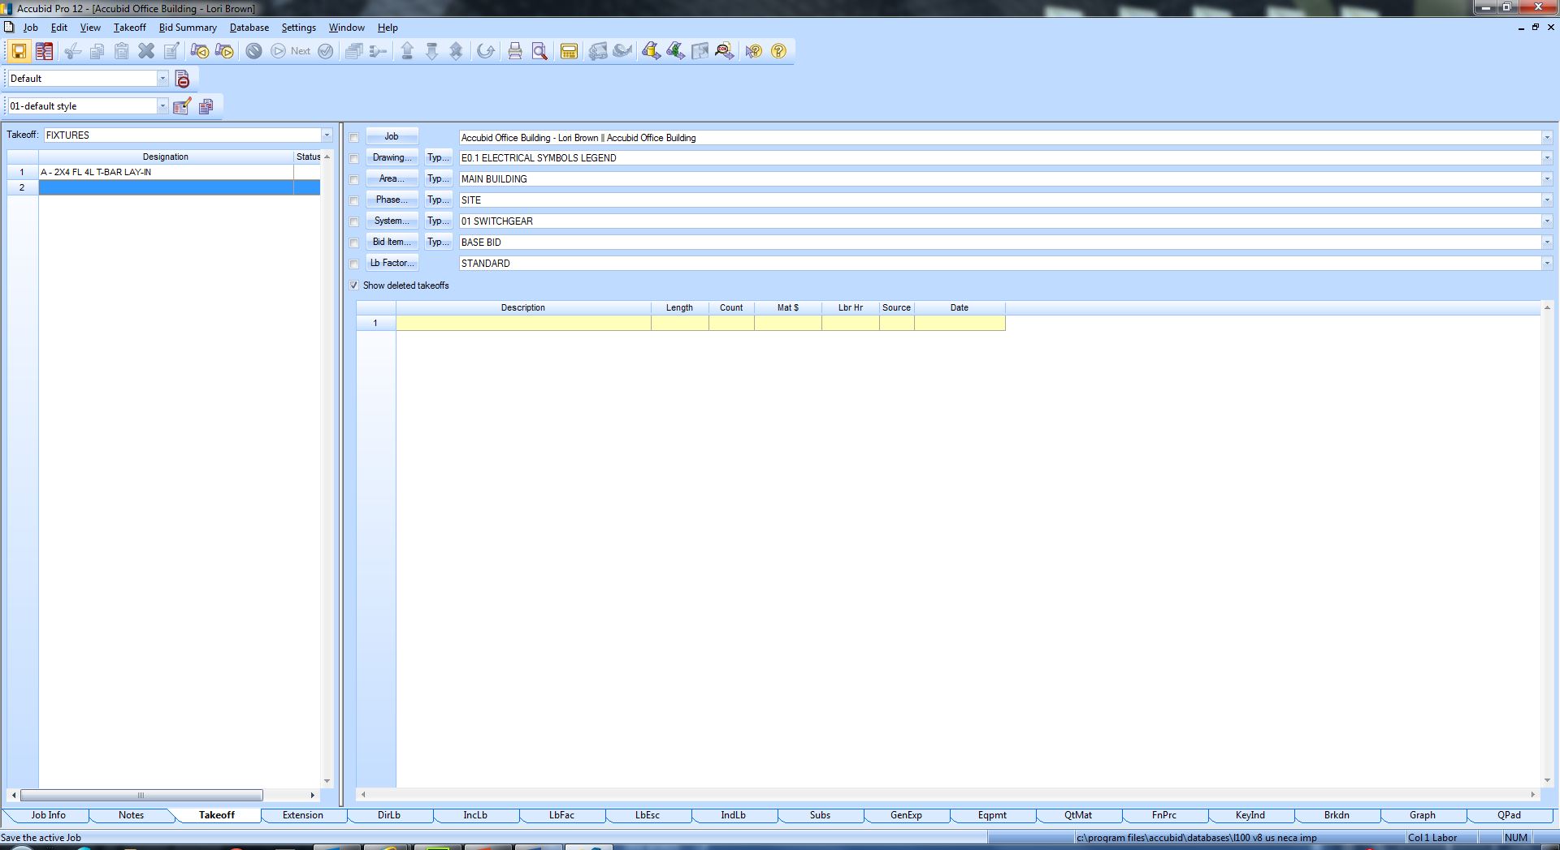

Figure 20

JUST READ. No steps involved.

Note: **If** you double click on the Fixture Designation that is the command to “Takeoff” the Fixture and it brings up the Designation Count Dialog box, Figure 21.

To abort a takeoff click Cancel.

**Never perform a Takeoff without first checking the BREAKDOWN!**

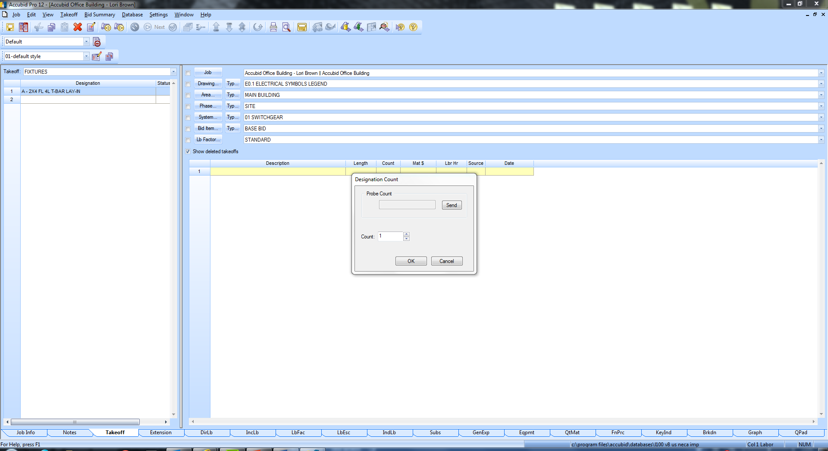

Figure 21

**If** you need to Edit or Change the Fixture Designation you RIGHT CLICK on the Fixture Designation name and Select Modify.

**To Build Fixtures A1 and A2 follow these steps:**

1. Right Click on the Fixture Designation: A - 2X4 FL 4L T-BAR LAY-IN and click Copy.
2. Right click on Line 2 and select Paste.
3. Right click on Line 3 and select Paste.
4. Right click on Line 2 and select Modify.
5. Double click on Line 9 in the Item Description box and change the number of Lamps to 3, then click on OK.
6. To finish the changes, you can either click on the accubid34.jpg Finish Takeoff button on the Toolbar, or right click on the list of items and select Finish.
7. In the Create/Modify Designation Description box edit the Fixture Designation name to:  
   A1 - 2X4 FL 3L T-BAR LAY-IN

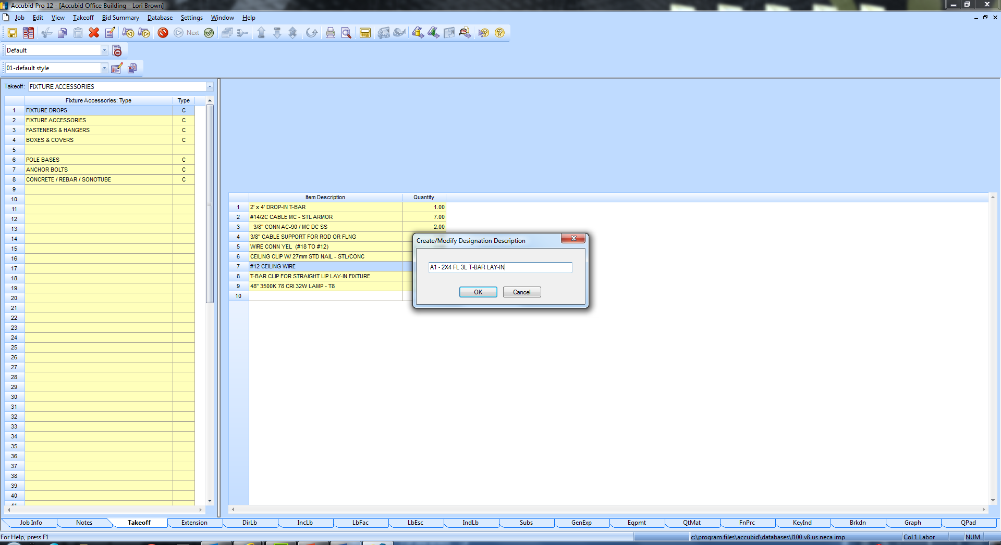

Figure 22

1. Repeat this Procedure to change the number of lamps to 2 for Fixture A2, and rename the Fixture Designation to: A2 - 2X4 FL 2L T-BAR LAY-IN

The Fixture Designation List now displays the three designations.

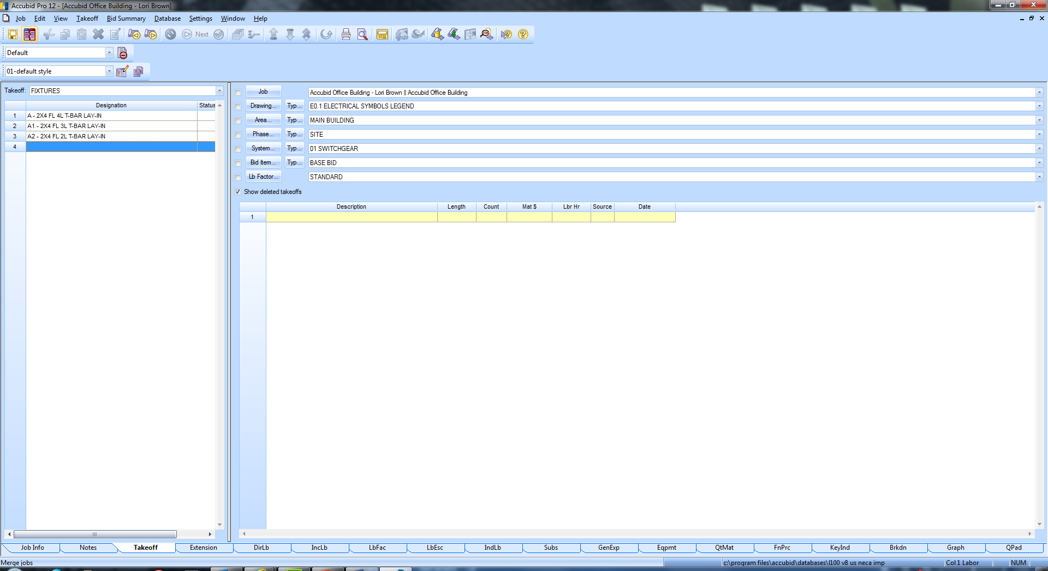

Figure 23

**To create Fixture Designations from already existing “Assemblies” follow these steps:**

1. Double Click on Line 4 to create a new Fixture Designation.
2. In the Create/Modify Designation Description box enter: B – 2X2 FL 2UL T-BAR LAY-IN and click on OK.
3. Click on:

Fixtures: Category FLUORESCENT LUMINAIRES (Line 1)

Fixtures: Type **FLUORESCENT LUMINAIRES ASSEMBLIES*** (Line 4)**

1. Double Click on 2′ x 2′ DROP-IN T-BAR (14/2 WHIP) (Line 2)
2. Click on OK
3. Double Click on LAMPS – T8 U-SHAPED (Line 3)
4. Double Click on 24" 3500K 78 CRI 32W LAMP - T8 6" SPACING (Line 2)
5. Change the Count per Unit value to 2 and click OK.
6. Right click and select Finish. Click OK.

Using the Fixture Designation names shown in Figure 24:

1. Complete building all of the remaining Fixture Designations using:  
   For FL (Fluorescent) Fixtures:  
   FLUORESCENT LUMINAIRES (Line 1)  
   FLUORESCENT LUMINAIRES ASSEMBLIES*** (Line 4)  
     
   For INC (Incandescent) Fixtures:  
   INCANDESCENT LUMINAIRES (Line 2)  
   INCANDESCENT LUMINAIRE ASSEMBLIES *** (Line 11)  
     
   For HID (High Intensity Discharge) Fixtures:  
   HID (High Intensity Discharge) LUMINAIRES (Line 4)  
   HID LUMINAIRES - ASSEMBLIES *** (Line 9)  
   For Exit Light Fixtures:EMERGENCY & EXIT LUMINAIRES [Line 3]  
   EXIT & EMERGENCY LIGHTING ASSEMBLIES *** [Line 5]  
     
   Use the Fixture Schedule (E6.1) to locate the correct type and quantity of lamp to add to the designation.

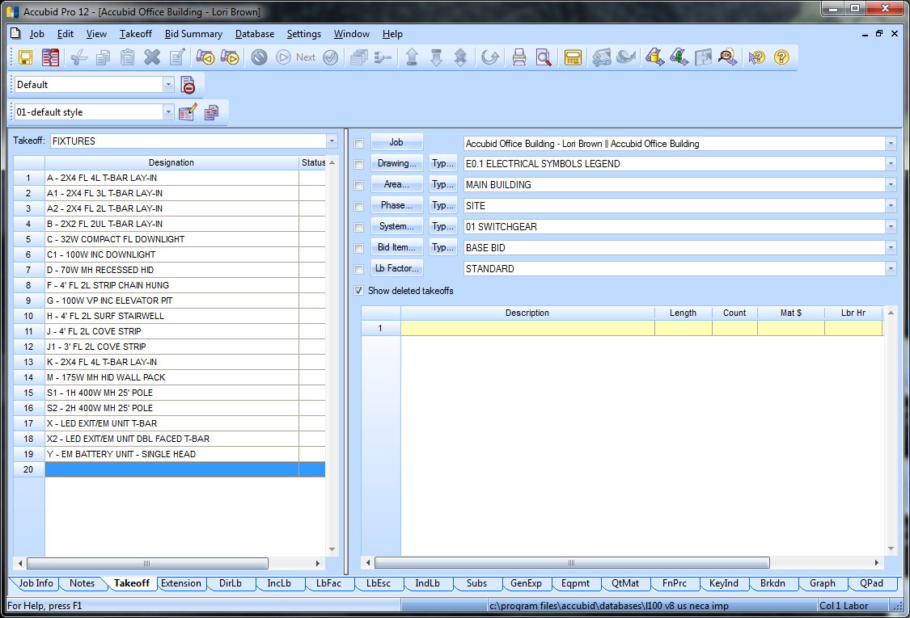

Figure 24

E6.1 – ELECTRIAL LIGHT FIXTURE SCHEDULE

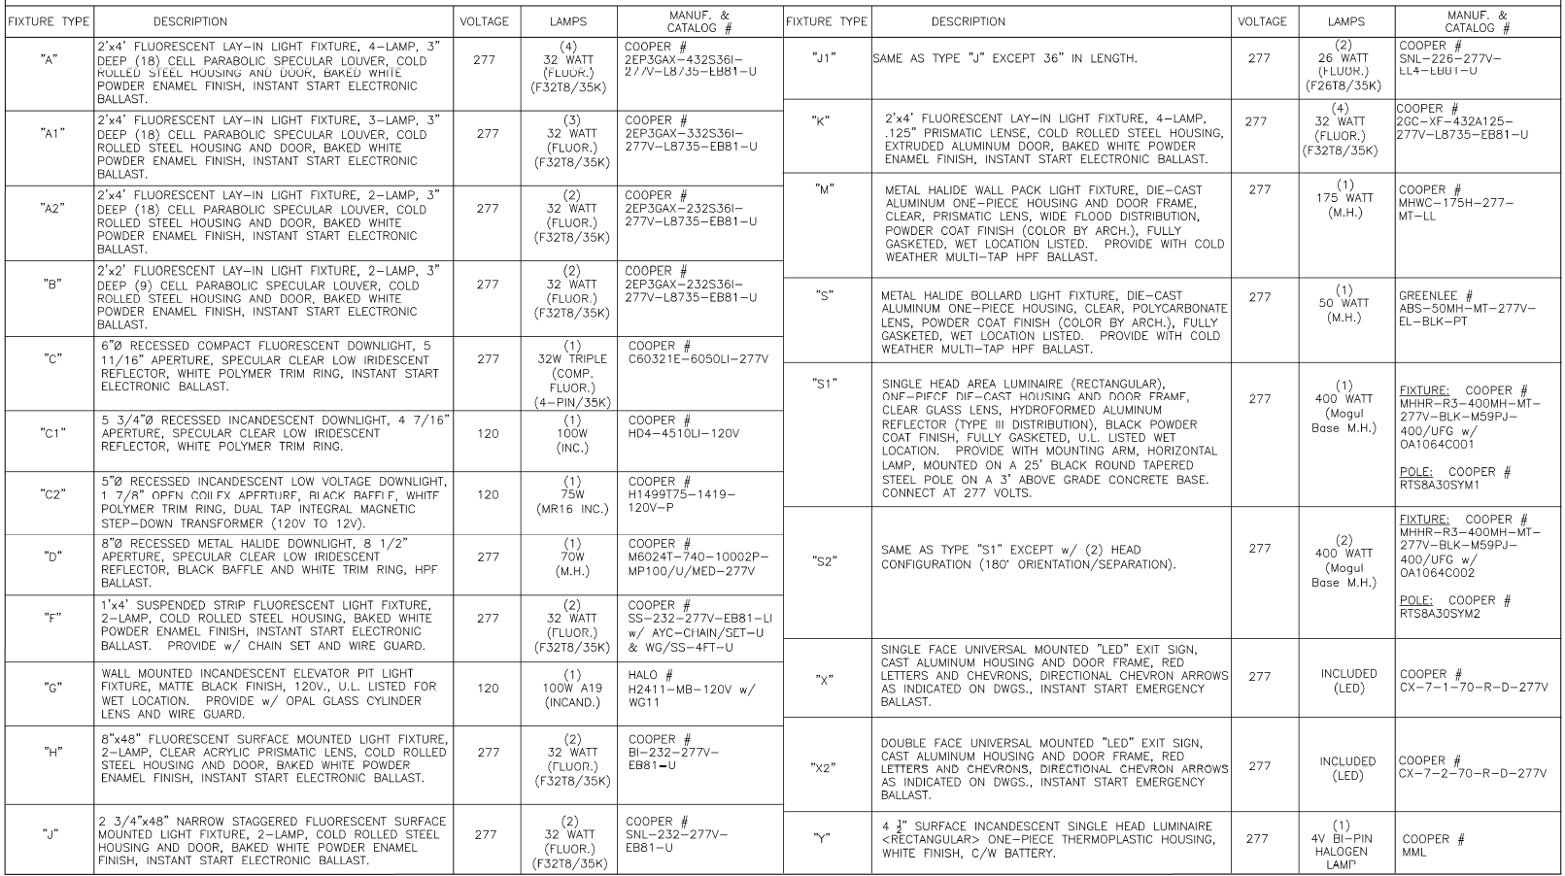

**Printing Fixture Designations**

1. Select Takeoff: FIXTURES.
2. Click on the Job menu and click on the Print command.
3. Uncheck Use screen layout
4. Click Clear All.
5. Place a check in the Job Info box.
6. Click on the plus sign next to Designations and select the Current Designation List radio button.
7. Click Print.
8. Click the Save icon on the toolbar or File, Save from the menu bar.

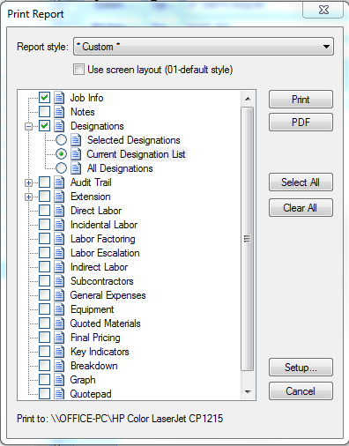

Figure 25

Once all of the Fixture Designations have been built, the estimator is now ready to begin entering the quantities of each fixture type (designation). Typically, light fixtures counts are entered by Drawing, Phase (floor) and by System.

**Fixture Takeoff**

1. Complete the 06 FIXTURES takeoff (count) using the takeoff sheet provided in class.

**Note: Set the correct Breakdown Labels BEFORE taking off the fixtures.**

1. For Example, to takeoff the Fixture A1 on the First Floor set the breakdown as shown in Figure 26.

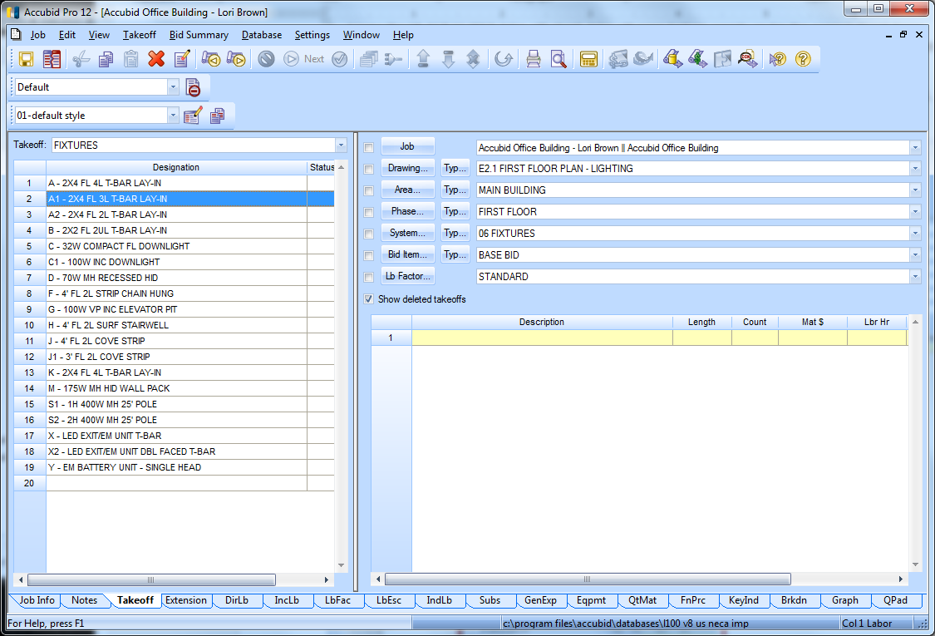

Figure 26

1. Double click on the fixture designation: Line 2 A1 – 2x4 FL 3L T-BAR LAY-IN
2. Enter in the quantity in the Designation Count window and click on OK.

The take-off appears in the Audit Trail Description area.

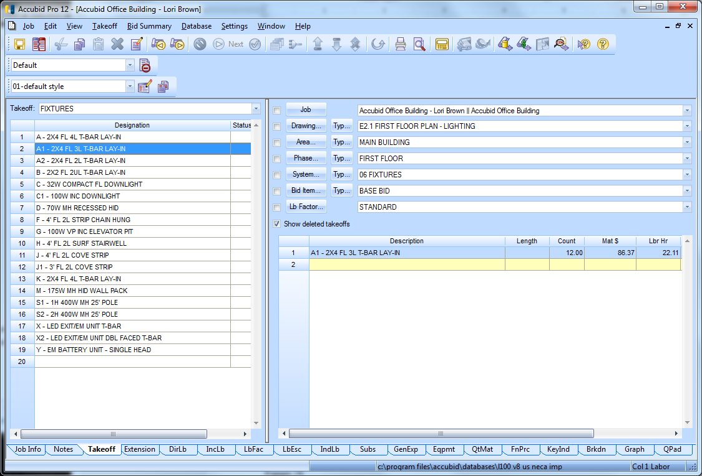

Figure 27

1. Using the 06 FIXTURES take-off sheet, take off your fixture counts for E2.0 BASEMENT FLOOR PLAN - LIGHTING and E2.1 FIRST FLOOR PLAN – LIGHTING under the correct Breakdown labels. After entering the fixture count in Accubid, using a red pencil, line through the fixture count on your take-off sheet. To complete the takeoff for E2.2 TYPICAL FLOOR PLAN (2ND TO 4TH) – LIGHITNG see below.

**Performing Fixture Takeoff Using Typical (Typ…)**

The Typical takeoff can be used when an estimate has repetitive takeoff, for example, fixtures are the same for each floor.

1. To create the **Typical** label click the accubid50.jpg button next to the accubid51.jpg button.

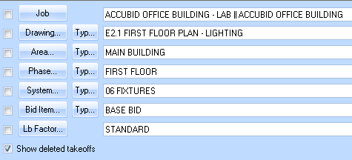

Figure 28

The Typical Phase Modify Window opens.

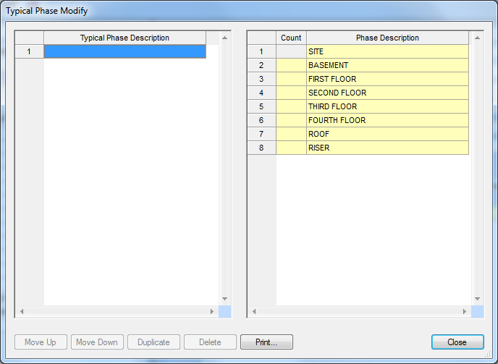

Figure 29

1. Modify the dialog box as shown in Figure 30 and click Close.

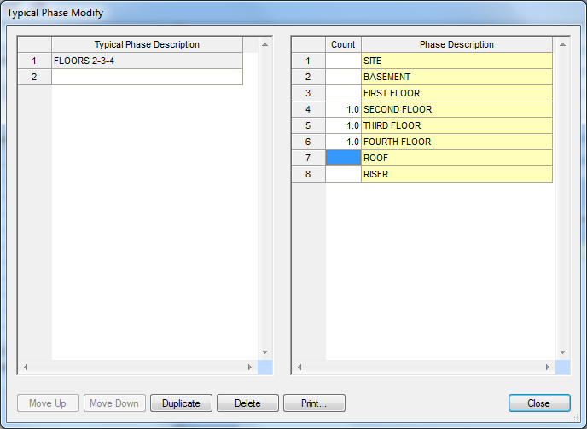

Since the fixture takeoff repeats itself on different floors, called phases, a count value must be entered for each of the Phase Descriptions (floors) that include fixtures.

Enter in 1.0 in the count field for floors 2, 3, 4.

Figure 30

Example:

1. To Take-Off Fixture A for E2.2 TYPICAL FLOOR PLAN (2ND TO 4TH) - LIGHTING in the Phase Breakdown Label select: Typical–FLOORS 2-3-4 as shown in Figure 31.

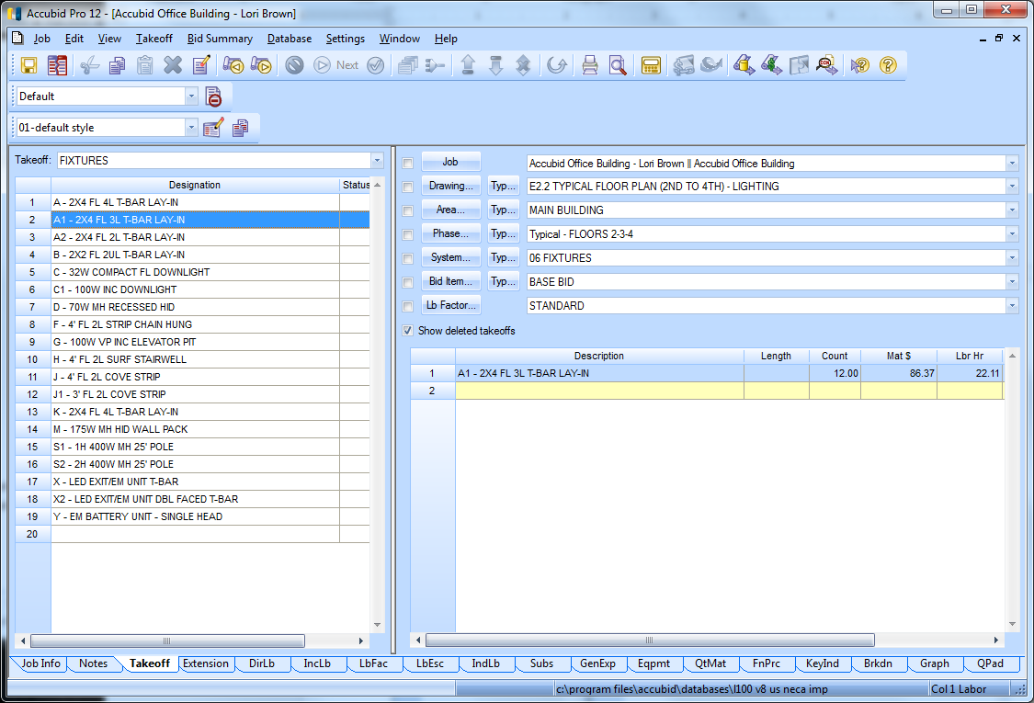

Figure 31

Once the typical phase is selected, everything taken off under this Phase will be multiplied by 3, once for floor 2, 3, and 4.

**Accubid Extension Screen**

The complete take off can be seen by viewing the Extension screen. The Extension screen will contain no items until you start taking things off.

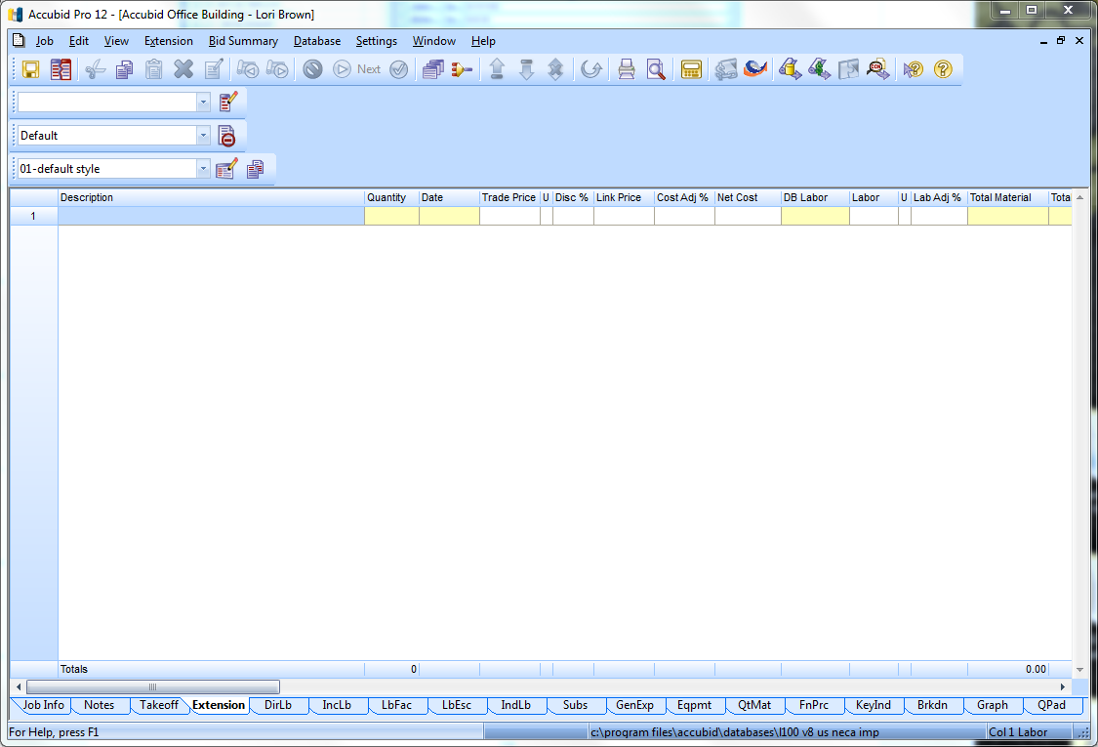

Figure 32

1. Click on the Extension tab to access the screen
2. Verify the Fixture takeoff by checking the total number of each Fixture added to the estimate in the Extension screen.

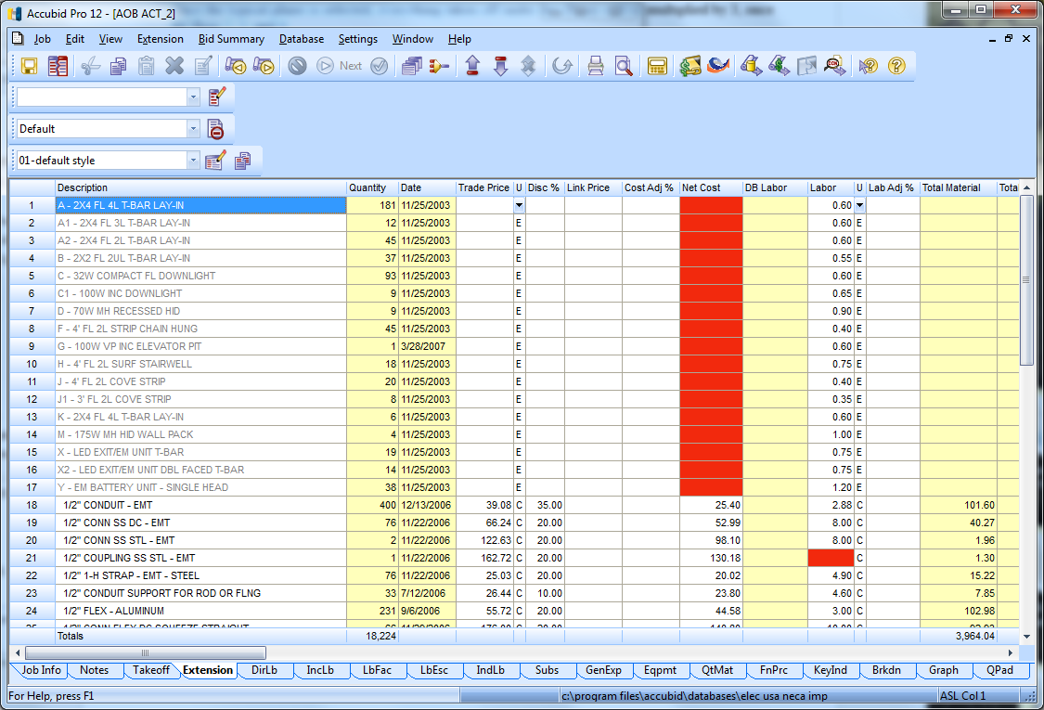

Figure 33

1. Save your estimate.
2. Close Accubid when you have finished the Fixture Takeoff.
3. Be sure to copy your estimate file to your own USB drive before leaving the lab.