**CM 352 – Electrical Construction Estimating**

lightbul

**Accubid Activity #3**

**Accubid Office Building - SYS 08 DEVICES - LIGHTING & SYS 13 DEVICES – POWER**

**SYS O8 DEVICES - LIGHTING**

**Procedure**

1. Obtain your 08 DEVICES – LIGHTING completed take off sheet.
2. Start the program Accubid Pro 13 [Start, All Programs, Trimble, Classic 13\Accubid Pro 13]
3. Press the CAPS LOCK Key ON
4. From the Job Schedule Screen open the file, Accubid Office Building.
5. If not already selected, select the Takeoff tab at the bottom of the screen.
6. Make sure you are using the Database: L100 V8 US NECA IMP
7. Set the Breakdown as shown in Figure 1.

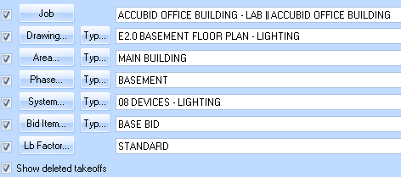

Figure 1

1. Choose COMMON ASSEMBLIES from the drop down list in the Takeoff: area of the screen.
2. Double click:  
   [Line 3] SWITCHES

[Line 1] SWITCHES - (EMT) ****

[Line 1] 20A 120V S/P SW (1/2" EMT-METAL STUD)

In the Measure Takeoff window change the Count Value to the number of 20A 120V S/P SW (1/2" EMT-METAL STUD) assemblies to add. Note that the 20A 120V S/P SW (1/2" EMT-METAL STUD) assembly includes 15 ft of 1/2" CONDUIT – EMT along with 1/2" set screw connectors and 1/2" set screw couplings. For every switch added to the takeoff this material will be included.

Click the OK button to complete the takeoff.

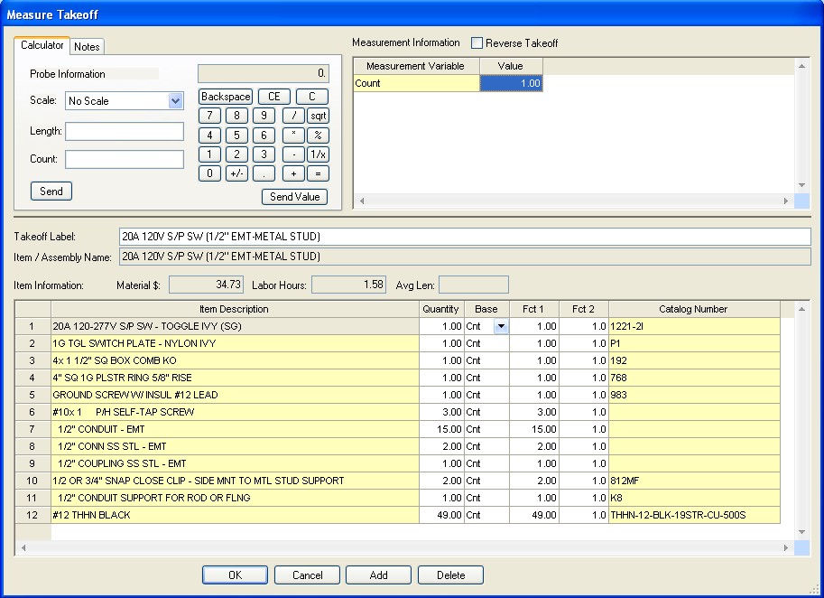

Figure 2

1. Repeat these steps for the remaining 08 DEVICES - LIGHTING. Be sure to set the Breakdown!  
   All devices can be located in the Takeoff: COMMON ASSEMBLIES by click on the following:

Level 1 [Line 3] SWITCHES

Level 2 [Line 1] SWITCHES - (EMT) ****

Level 3 Line number depends on the assembly being taken off.

1. When finished taking off the lighting devices, save the estimate.

**Occupancy Sensor – Wall Mounted**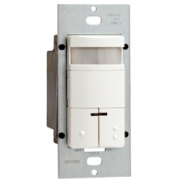 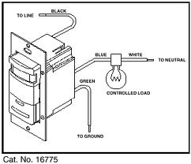

<http://www.leviton.com/OA_HTML/ProductDetail.jsp?partnumber=ODS0D-IDT&section=38557&minisite=10251>

**SYS 13 DEVICES – POWER**

1. Obtain the 13 DEVICES – POWER completed take off sheet.
2. Set the Breakdown as shown in Figure 3.

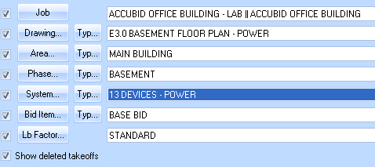

Figure 3

1. Choose COMMON ASSEMBLIES from the drop down list in the Takeoff: area of the screen.
2. Double click:  
   [Line 4] RECEPTACLES

[Line 1] RECEPTACLES - (EMT) ****

[Line 1] 20A 120V DUP REC (1/2" EMT-METAL STUD)

In the Measure Takeoff window change the Count Value to the number of 20A 120V DUP REC (1/2" EMT-METAL STUD) assemblies to add. Note that the 20A 120V DUP REC (1/2" EMT-METAL STUD) assembly includes 15 ft of 1/2" CONDUIT – EMT along with 1/2" set screw connectors and 1/2" set screw couplings. For every receptacle added to the takeoff this material will be included. Click the OK button to complete the takeoff.

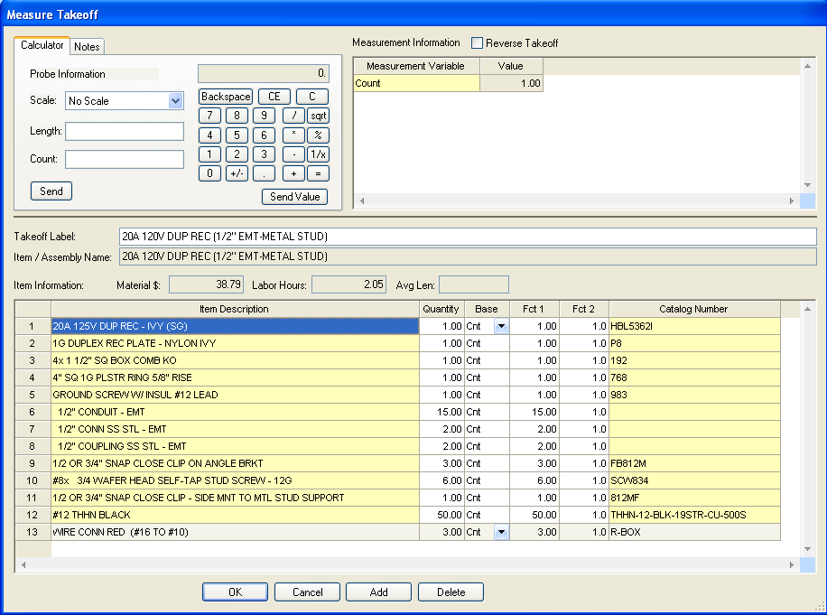

Figure 4

1. Repeat these steps for the remaining 13 DEVICES - POWER. Be sure to set the Breakdown!  
     
   All devices with the exception of the special receptacles (70A and 50A) Note ⑥ shown on E3.1 First Floor Plan – Power can be located in the Takeoff: COMMON ASSEMBLIES by click on the following:

Level 1 [Line 4] RECEPTACLES

Level 2 [Line 1] RECEPTACLES - (EMT) ****

Level 3 Line number depends on the assembly being taken off.  
  
Note: The two special receptacles shown on E3.1 First Floor Plan – Power Note ⑥ will be added to the estimate later.

1. When finished taking off the power devices, save the estimate.
2. Copy the estimate to your own USB drive before leaving the lab.