CMGT 352 – Electrical and Mechanical Construction Estimating
Accubid Activity #1 – Getting Started with Accubid Pro

Setting Up Accubid and Creating a New Job
- Start the program Accubid Pro 15 [Start, Trimble, Accubid Pro 15

The opening window is the called the [Schedule] screen. The [Schedule] screen is used to help you to keep track of your estimates and bids. Information about pending bids and closed jobs can be recorded in the [Schedule] screen.
Figure 1

- From the Menu Bar click on: Settings, Job Folders…
Figure 2
When Accubid Pro v15 is first installed the default location for saving all jobs (Job Folders) is automatically setup for saving them to the location, C:\ProgramData\Accubid\JOBDATA

The C:\ProgramData folder is a protected folder in Windows and requires changing the security settings for users to have full control. You should make sure you have full access to this folder. It is recommended that you change the folder to a different location as shown below in Figure 4. Note: Before adding a new Job Folder location the folder must first be created in File Explorer.
Steps to Add a New Location for Saving Job Files
- Choose a location for saving all your job files. Such as, the C: drive. It is recommended that you use an internal hard drive and not a portable drive.
- Using File Explorer, create the folders:
C:\Accubid\Jobdata
- In the Job Folders window (Figure 3) use the Add button to select the folder location you choose.
- Place a check in the box next to the folder location you added to use to save job files to.
- Click OK
Figure 3.

In Figure 4. the default Job Folder was changed to an internal hard drive (D:) in the location D:\Accubid\JOBDATA.
Figure 4

- From the Menu Bar click on: Settings, Database Folders…
Figure 5
When Accubid Pro v15 is first installed the default location for saving all Databases (Databases Folders) is automatically setup for saving them to the location, C:\ProgramData\Accubid\DATABASES

It is recommended that you change the folder to the same location as the [Your Location:]\Accubid\Jobdata folder you setup in Step 2. i.e. [Your Location:]\Accubid\Databases). Note: Before adding a new Database Folder location the folder must first be created in File Explorer.
Steps to Add a New Location for Database Folders
- Choose a location for saving all your Database Folders. Such as, the C: drive. It is recommended that you use an internal hard drive and not a portable drive.
- Using File Explorer, create the folders:
C:\Accubid\Databases
- In the Database Folders window (Figure 6) use the Add button to select the folder location you choose.
- Place a check in the box next to the folder location you added to use to save Database folders to.
- Click OK
Figure 6

In Figure 7., the default location for the Databases was changed to an internal hard drive (D:) in the location D:\Accubid\Databases
Figure 7

Important: Be sure to obtain the Database folder L100 V8 US NECA IMP and copy it to the location you setup in
step 3. The electrical estimate will use the L100 V8 US NECA IMP database for creating the estimate. Do this before going to the next step.

The USB Drive provide has the L100 V8 US NECA IMP Database Folder that you need to copy to the location
C:\Accubid\Databases (see Figure 8).

The L100 V8 US NECA IMP database
Figure 8

- To begin a new Job (estimate), click on the Job menu and click New…
Figure 9

- If the New Database for this job dialog box appears, Click the check box, Do not ask me again and then click on the No button.
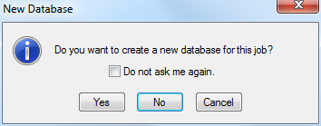
Figure 10

The New Job dialog box appears.
Figure 11

- Enter “Accubid Office Building” for the new job name and “Accubid Office Building – First Name Last Name” for the new job number. Use your own name!
Figure 12

You must also select the material database and job path for the new job:
Click the drop-down list arrow for Select the database: and click on [Your Location:]\Accubid\Databases\ L100V8 US NECA IMP.

- Select the default location for saving your estimate from the job path drop down list arrow.

- Click on the OK button.

The first screen to open in a newly created job is the Job Info Screen:

Figure 13

Accubid has 18 different screen tabs to work in:
Job Info  Notes  Takeoff  Extension  DirLb  IncLB  LbFac  LbEsc  IndLb | Subs  GenExp  Eqpmt  QtMat  FnPrc  KeyInd  Brkdn  Graph  QPad

Setting Up the Estimate

- In the Job Info screen add the following information:

Figure 14

- Click on the Takeoff tab to select the Takeoff screen.

1 Takeoff
2 Breakdown
3 Audit Trail
Figure 15

The Takeoff screen is divided into three different areas:

1 Takeoff
What do you want to Takeoff?

2 Breakdown
Where do you want it Taken Off?

3 Audit Trail
What did you Takeoff?

The first step in preparing a new estimate in the Takeoff screen is to setup the Breakdown.

There are seven different Breakdown Labels:
Job
Drawing…
Area…
Phase…
System…
Bid Item…
Lb Factor…

When you first start a new estimate the Breakdown fields are completed automatically using the Default estimate file.

Job ACCUBID OFFICE BUILDING – Lori Brown (Current open job)
Drawing… NO DRAWING
Area… BUILDING A
Phase… MAIN FLOOR
System… LIGHTING
Bid Item… BASE BID
Lb Factor… STANDARD

Figure 13

- The fields contained in each of the Takeoff Breakdown Labels are user definable.
- Takeoff Breakdowns are logical and/or physical areas that are created for the estimate, such as drawings, floors, and electrical systems.
- Each item or assembly that is taken off is assigned to the selected takeoff Breakdown.
- Breakdown allows the estimate to be sorted and analyzed by any combination of the Takeoff Breakdown Fields selected.

BREAKDOWN IS THE MOST CRUCIAL STEP IN TAKING OFF MATERIAL FOR AN ESTIMATE!

Creating or Modifying Takeoff Breakdown Fields
- Click on the Breakdown
- In the Drawing Modify dialog box select Line 1 – No Drawing
Figure 14

- Press the Caps Lock Key. Change NO DRAWING to E0.1 ELECTRICAL SYMBOLS LEGEND
- Press Enter to move to the next line. Continue adding the names of the Accubid Office Building plans to the list as shown in Figure 15. When finished click the Close button.
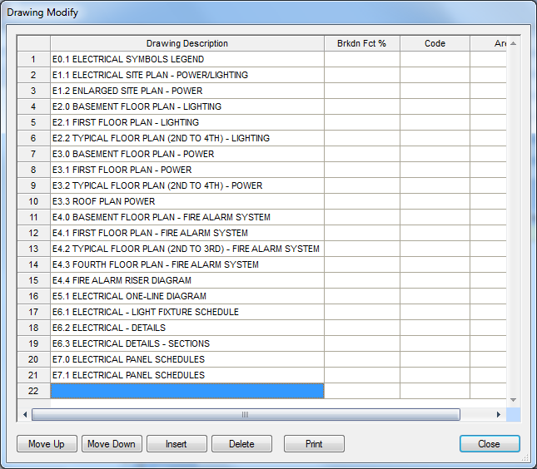
Figure 15

- Click on the Breakdown
- In the Area Modify dialog box change the label from BUILDING A TO MAIN BUILDING.
Figure 16

- Click the Close button

- Click on the Breakdown
- In the Phase Modify dialog box make the following changes:
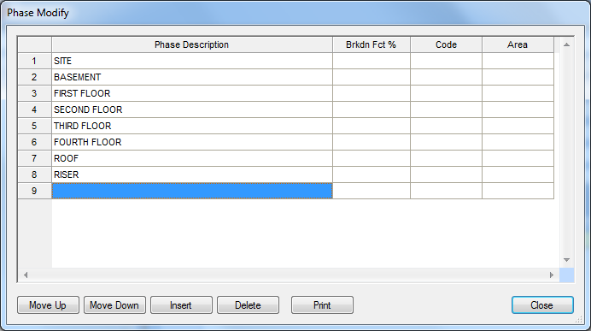
Figure 17

- Click the Close Button.

- Click on the Breakdown
- The System Descriptions shown in Figure 18 are from the Default job.
Figure 18

- Select Line 1 LIGHTING and change it to: 01 SWITCHGEAR
- Select Line 2 and press and hold down the SHIFT Key. Press the arrow down key until you have selected Line 2 through Line 20.
Figure 19

- Click on the Delete button in the System Modify window.
- Click Yes in the “Are you sure you want to delete these systems?” dialog box.

- Starting with Line 2 add the following fields in the order given to the System Breakdown Label:
02 BUS DUCT/BUS PLUGS  03 EM. GEN/TR. SW./MG  04 FEEDERS  05 MOTOR BR. BRANCH/EQUIP CONNECT  06 FIXTURES  07 LIGHTING BRANCH  08 DEVICES - LIGHTING  09 MC CABLE LIGHTING BRANCH  10 MC DEVICES - LIGHTING  11 LIGHTING SOFT WIRE  12 POWER BRANCH  13 DEVICES - POWER  14 MC CABLE POWER BRANCH  15 MC DEVICES - POWER  16 CABLE TRAY  17 WIREMOLD (SURFACE RACEWAY)  18 RAISED FLOOR POWER DISTRIBUTION  19 TELEPHONE/DATA CONDUIT  20 TELEPHONE/DATA CABLE  21 FIRE ALARM SYSTEM  22 PUBLIC ADDRESS SYSTEM  23 DR. SECURITY/CARD READER  24 DR. MONITORING.INTRUSION  25 INTERCOM SYSTEM  26 CCTV  27 MATV  28 CLOCK SYSTEM  29 NURSE CALL SYSTEM  30 GAS DETECTION SYSTEM  31 TEMPERATURE CONTROL SYSTEM | 32 ENERGY MANAGEMENT SYSTEM  33 PROCESS CONTROL SYSTEM  34 KITCHEN EQUIPMENT  35 MEDICAL EQUIPMENT 36 HALON SYSTEM  37 LEAK DETECTION  38 GROUNDING  39 LIGHTING CONTROL/DIMMING  40 LIGHTNING PROTECTION  41 CATHODIC PROTECTION  42 SITE WORK  43 SITE LIGHTING  44 INCOMING SERVICE - POWER  45 INCOMING SERVICE - TELEPHONE  46 DUCT BANKS AND MANHOLES  47 TRAFFIC SIGNAL AND STREET LIGHTING  48 REWORK EXISTING  49 DEMOLITION  50 TEMPORARY POWER  51 WALKER DUCT  70 PV MODULES  71 DC WIRING  72 COMBINER BOXES  73 DC DISCONNECTS  74 INVERTERS  75 AC SWITCHGEAR  76 AC WIRING  77 MODULE RACKING  98 OTHER  99 DIRECT JOB COSTS

Figure 20

- Click the Close button.
- Save your estimate.
From the Toolbar click the Save icon

From the Job Menu select Save

Using the keyboard press Ctrl + s

Notice that the icon changes color when the file has been saved
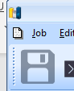

- Click the Job menu and click on Exit to Close Accubid.

Editing the Default File
Every new job is created from the default file. To make changes that all new jobs will have, such as SYSTEM BREAKDOWN labels, the default file must be edited. The only way to edit the default file is to open it from the File Explorer.
- Right Click on the Start button and select the File Explorer.
- Using File Explorer locate the [Your Location:]\Accubid\Jobdata folder.
Figure 21

- In File Explorer Double Click on the Default.es15 or Default file to Open it in Accubid. (If the .es15 is not displaying that is just a view option and not necessary to view. If the Default window is not maximized as shown in Figure 22, click the Maximize button in the Default window to maximize the window.
Figure 22
- From the Job menu select Open.
Figure 23

- Click on the Job Accubid Office Building – Your Name and click Open.
Figure 24
- Click on the System Breakdown Label
- In the System Modify window select Line 1 through Line 61.
Figure 25

- Press and hold down the Ctrl key and then press C to copy the System Descriptions to the Clipboard.
- Click the Close button.
- From the Window menu select Default to switch back to the Default file.
Figure 26

- Click the System Breakdown Label
Figure 27

- Select Line 1
- Press and hold down the Ctrl key and press v to paste over the System Descriptions.
Figure 28

- Click Close

- Save the changes by clicking on the Save Job icon in the Toolbar.
- From the Job menu select the Close command to close the Default File.
Figure 29

- Close the Accubid Office Building – Your Name file and click No to Save Changes to the file.
- Exit Accubid (Close the Program)

All new jobs from this point on will automatically have the fields entered in the System Breakdown Label that are used by North State Electric i.e. 01 SWITCHGEAR

- Start the program Accubid Pro 15
- From the [Schedule] screen create a new job use the job name “Atlantic Food Company” and job number “Atlantic Food Company – Your Name”
Figure 30

- Click the Takeoff Tab to select the Takeoff Screen
- Verify that the System Breakdown Label has the correct fields
Figure 31

- Exit Accubid
- Select Yes to Save Changes.
Figure 32

