**CM 352 – Electrical Construction Estimating**

lightbul

**Accubid Activity #3**

**Accubid Office Building - SYS 08 DEVICES - LIGHTING & SYS 13 DEVICES – POWER**

**SYS O8 DEVICES - LIGHTING**

**Procedure**

1. Obtain your 08 DEVICES – LIGHTING completed take off sheet.
2. Start the program Accubid Pro 15 [Start, Trimble\Accubid Pro 15]
3. Press the CAPS LOCK Key ON
4. From the Job Schedule Screen open the file, Accubid Office Building.
5. If not already selected, select the Takeoff tab at the bottom of the screen.
6. Make sure you are using the Database: L100 V8 US NECA IMP.

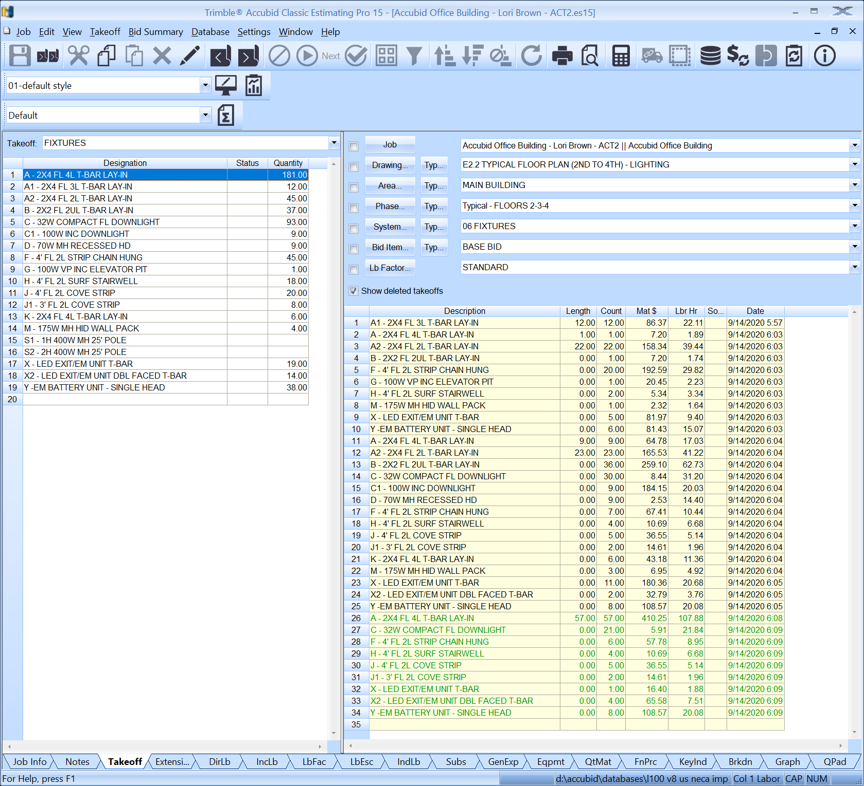

Figure 1.

1. Set the Breakdown Labels as shown in Figure 2.
2. Place check marks in all the boxes next to each Breakdown Label.
3. Choose COMMON ASSEMBLIES from the drop-down list in the Takeoff: area of the screen.

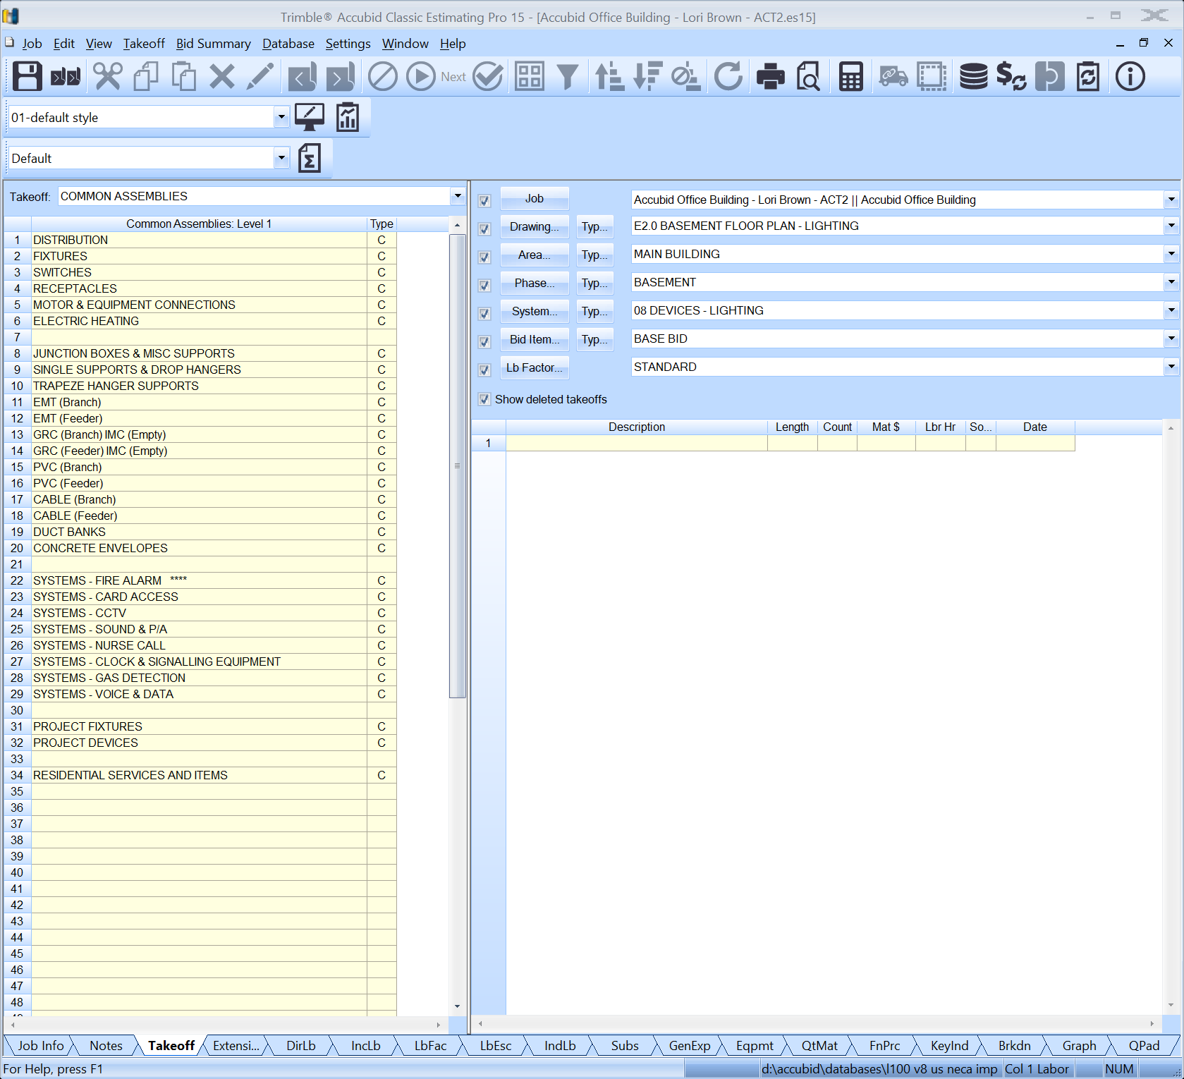

**9.**

**8.**

**7.**

Figure 2

1. The Check Boxes in Breakdown can be used to “Filter” the Audit Trail. When a box is checked, only material that was taken off using the Breakdown Label(s) selected will display in the Audit Trail.

To see how the check boxes work, change the SYSTEM Breakdown Label to 06 FIXTURES.

The Fixtures that were taken off using the Breakdown Labels shown below display in the Audit Trail.

Drawing E2.0 BASEMENT FLOOR PLAN – LIGHTING

Area MAIN BUILDING

Phase BASEMENT

System 06 FIXTURES

Bid Item BASE BID

Lb Factor STANDARD

Practice checking and unchecking the Breakdown Label filter boxes and changing the labels to make sure you understand their function. When done place checks in all the boxes.

1. Change the Breakdown Labels back to the Breakdown shown in step 7. and the Audit Trail displays no items taken off using the Breakdown Labels selected.

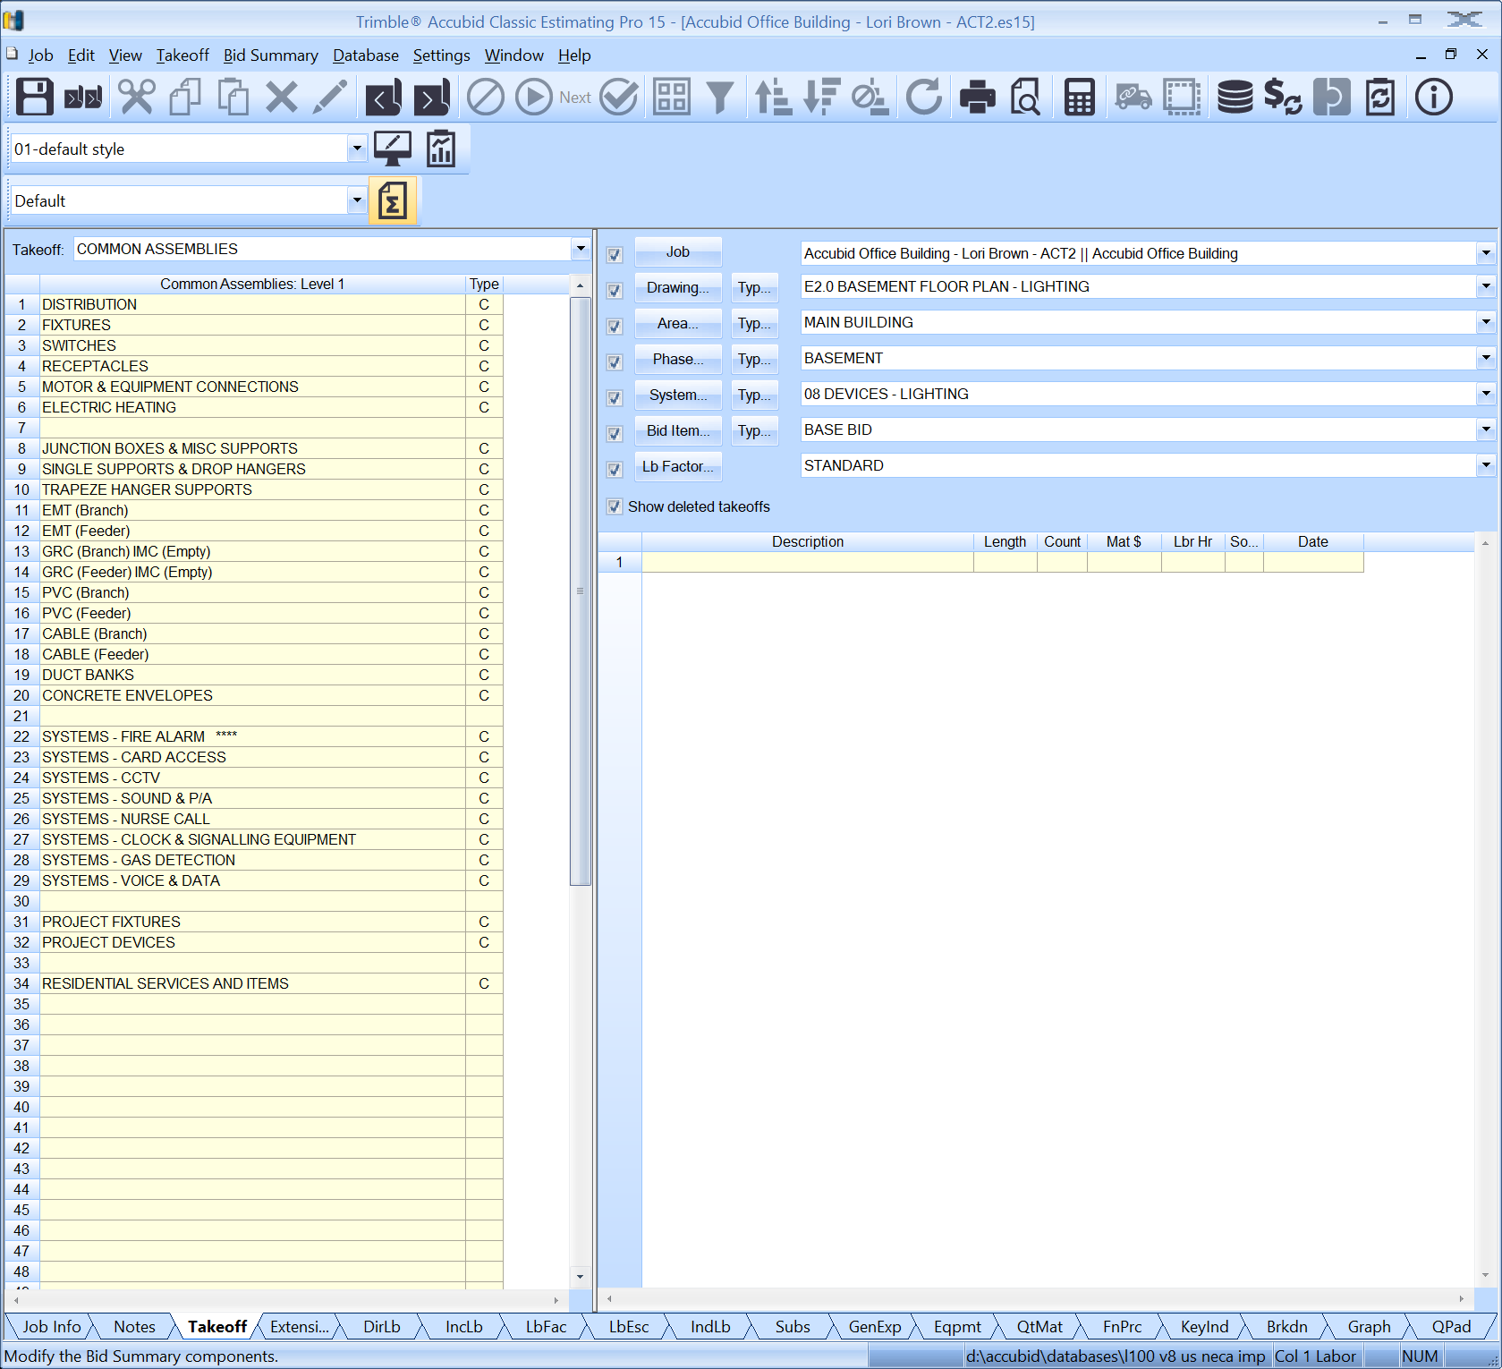

Figure 3

1. Obtain your 08 DEVICES – LIGHTING completed take off sheet and the Red Pencil form your toolkit.
2. To begin the 08 DEVICES – LIGHTING Take Off, in the Takeoff area Double click:  
   Common Assemblies: Level 1 [Line 3] SWITCHES [C]

Common Assemblies: Level 2 [Line 1] SWITCHES - (EMT) **** [C]

Common Assemblies: Level 3 [Line 1] 20A 120V S/P SW (1/2" EMT-METAL STUD) [A]

The Common Assemblies: Level 3 type changes to A (Assembly). Double clicking opens the Measure Takeoff window and displays the list of material (Item Description) for the 20A 120V S/P SW (1/2" EMT-METAL STUD) assembly as shown in Figure 4.

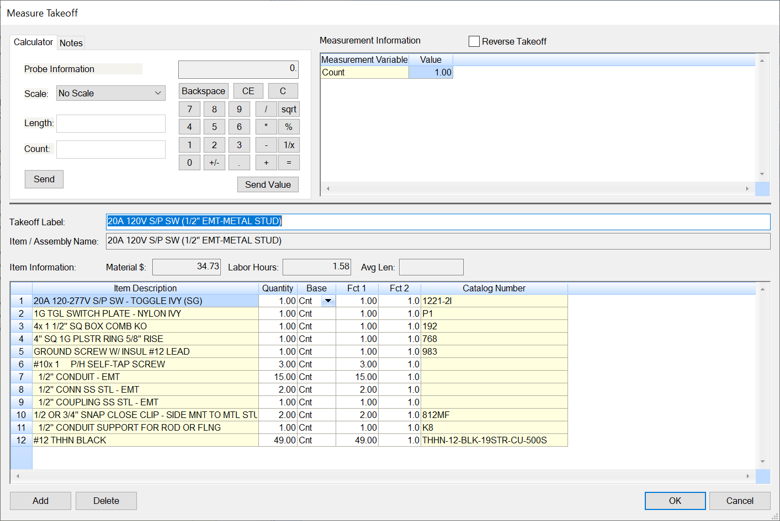

Figure 4

1. In the Measure Takeoff window change the Count Value to the number of 20A 120V S/P SW (1/2" EMT-METAL STUD) assemblies shown on your Take Off Sheet (E2.0 BASEMENT – LIGHTING)

Note that the 20A 120V S/P SW (1/2" EMT-METAL STUD) assembly includes 15 ft of 1/2" CONDUIT – EMT along with 1/2" set screw connectors and 1/2" set screw couplings. For every switch added to the takeoff this material will be included.

1. Click the OK button to complete the takeoff.
2. Place a RED LINE through the count number on your Take Off Sheet to indicate that it has been added to your Accubid Estimate.
3. Double click on Line 6 FLUSH WP 20A 120V S/P SW (1/2" EMT) to add the count to your estimate.
4. Place a RED LINE through the count number on your Take Off Sheet to indicate that it has been added to your Accubid Estimate.
5. Change the Breakdown labels:

Drawing E2.1 FIRST FLOOR-LIGHTING

Phase FIRST FLOOR

1. Using the Common Assemblies: Level 3 assemblies add the 20A Switches, 20A 3W Switches, and the Switches with Occupancy Sensors to the estimate. Place a RED LINE through the number on your take off sheet as you add them to your estimate.

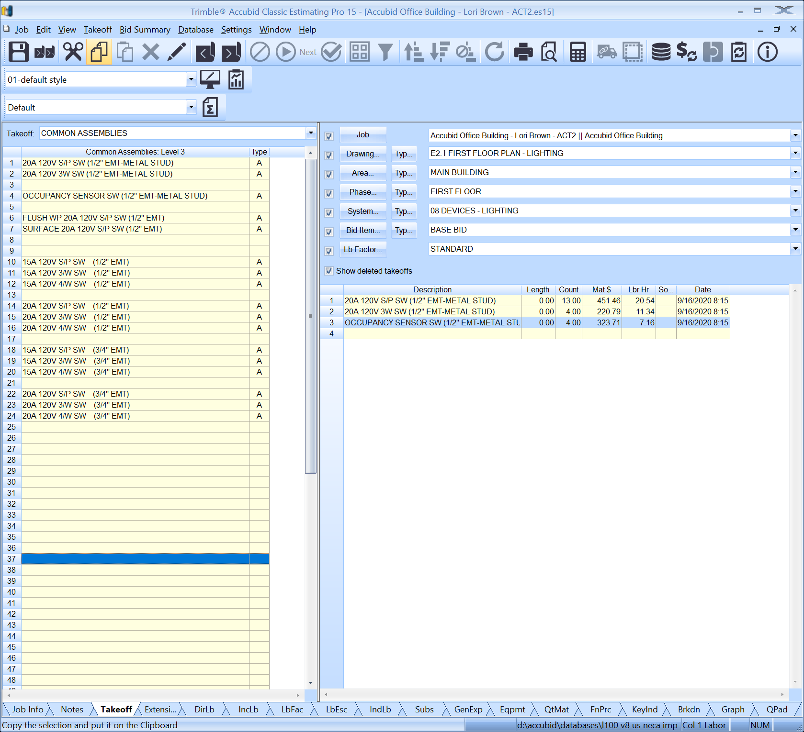

Figure 5

1. Change the Breakdown labels:

Drawing E2.2 TYPICAL FLOOR PLAN (2ND TO 4TH) - LIGHTING

Phase Typical – FLOORS 2-3-4

1. Using the Common Assemblies: Level 3 assemblies add the 20A Switches. Place a RED LINE through the number on your take off sheet as you add them to your estimate. See Figure 6

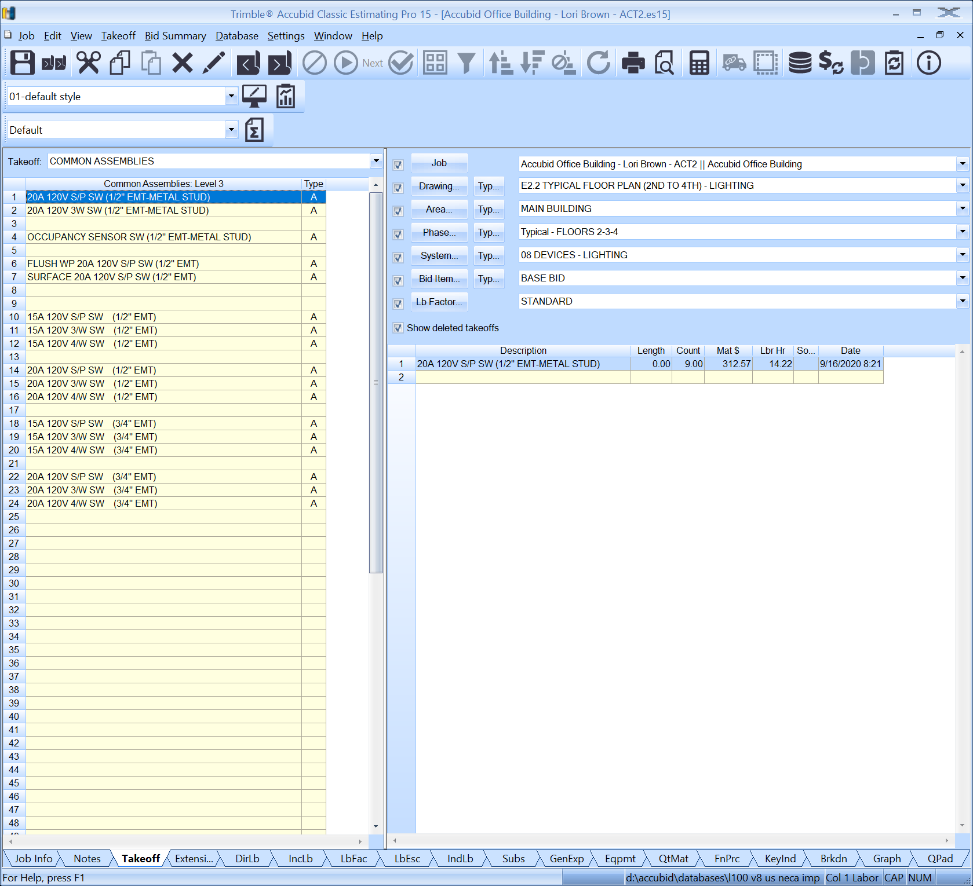

Figure 6

**This completes the take off for the 08 DEVICES – LIGHTING.**

1. Click on the Extension Tab to see all the items currently in your estimate. Scroll down the Description column and find the item 20A 120-277V S/P SW - TOGGLE IVY (SG) and check the quantity. It should be the same total of 20A Single Pole Switches as the number on your take off sheet.

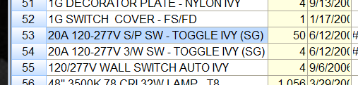

Figure 7

**SYS 13 DEVICES – POWER**

1. Obtain the 13 DEVICES – POWER completed take off sheet.
2. Set the Breakdown as shown in Figure 8.
3. Right click twice in the Takeoff area to go back to Common Assemblies: Level 1

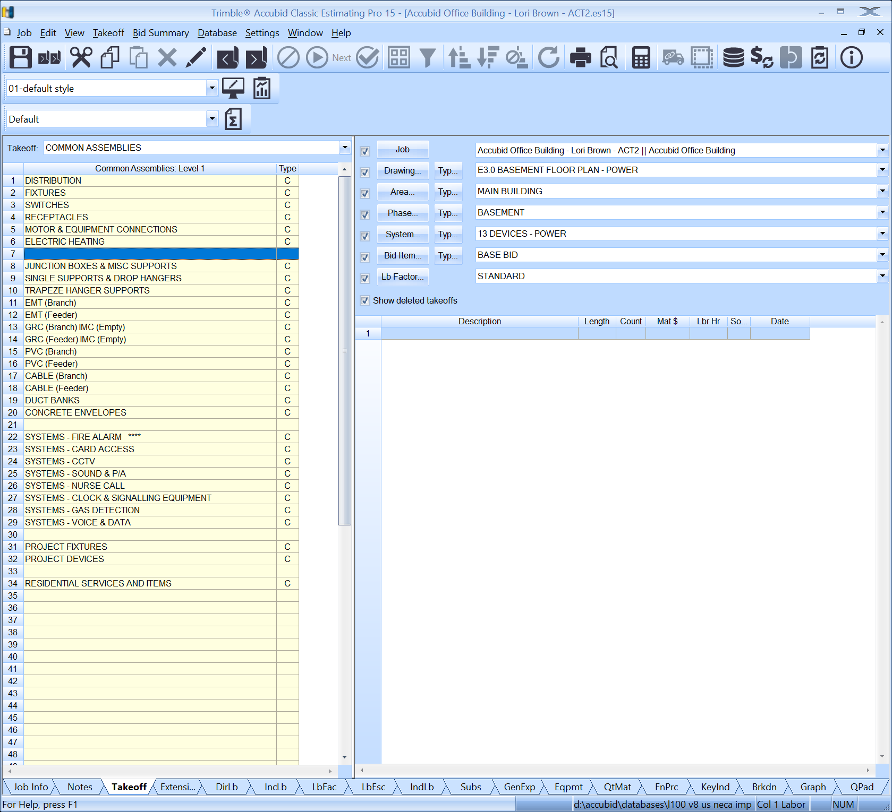

Figure 8

1. Double click:  
   Common Assemblies: Level 1 Line 4] RECEPTACLES [C]

Common Assemblies: Level 2 [Line 1] RECEPTACLES - (EMT) **** [C]

Common Assemblies: Level 3 [Line 1] 20A 120V DUP REC (1/2" EMT-METAL STUD) [A]

1. In the Measure Takeoff window change the Count Value to the number of 20A 120V DUP REC (1/2" EMT-METAL STUD) assemblies to add.

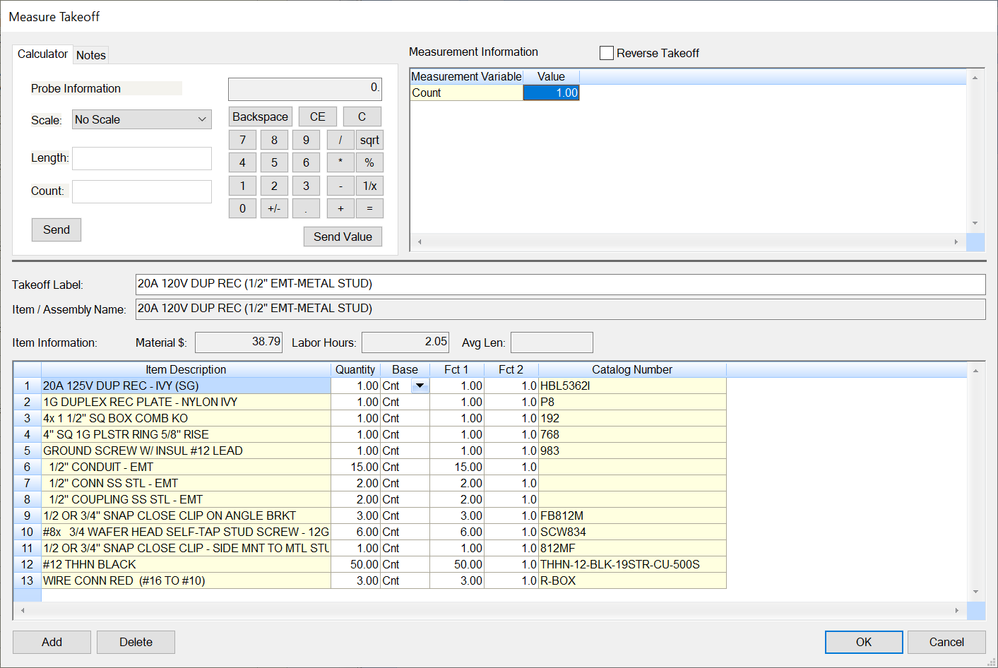

Figure 9

Note that the 20A 120V DUP REC (1/2" EMT-METAL STUD) assembly includes 15 ft of 1/2" CONDUIT – EMT along with 1/2" set screw connectors and 1/2" set screw couplings. For every receptacle added to the takeoff this material will be included. Click the OK button to complete the takeoff.

1. Click the OK button to complete the takeoff.
2. Place a RED LINE through the count number on your Take Off Sheet to indicate that it has been added to your Accubid Estimate.
3. **Double click on Line 4 - 20A 120V GFCI DUP REC (1/2" EMT-METAL STUD)** to add the count to your estimate. Place a RED LINE through the count number on your Take Off Sheet to indicate that it has been added to your Accubid Estimate.
4. **Double click on Line 5 - 20A 120V WP GFCI DUP REC (1/2" EMT-METAL STUD)** to add the count to your estimate. Place a RED LINE through the count number on your Take Off Sheet to indicate that it has been added to your Accubid Estimate.
5. **Double click on Line 2 - 2-GANG 20A 125V DUP REC (1/2" EMT-METAL STUD)** to add the count to your estimate. Place a RED LINE through the count number on your Take Off Sheet to indicate that it has been added to your Accubid Estimate.

Figure 10 shows the complete take off for the power devices in the basement.

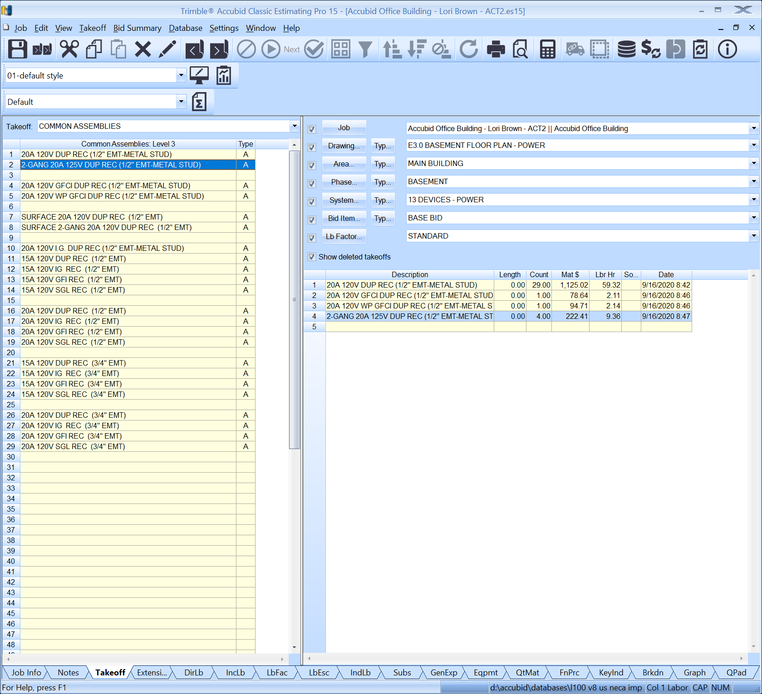

Figure 10

1. Change the Breakdown labels:

Drawing E3.1 FIRST FLOOR PLAN - POWER

Phase FIRST FLOOR

1. Using the Common Assemblies: Level 3 add the assemblies for the 20A DPLX RECEP, 20A GFCI DPLX RECEP, 20A WP GFCI DPLX RECEP, and the 20A DBL DPLX RECEP to your take off for the First Floor.

**Receptacles 6ʺ Above Countertop**

The take off for the power devices above the countertops is a good place for the estimator to adjust the common assembly to reflect the need for less material for the EMT drops. The common assemblies for the receptacles include 15 ft of 1/2" EMT for each receptacle assuming it is installed at 18ʺ AFF. Receptacles installed above countertops would require less conduit.

1. Using the Common Assemblies: Level 3 add the assemblies for the 20A DPLX RECEP, 20A GFCI DPLX RECEP, and the 20A DBL DPLX RECEP to your take off for the First Floor receptacles above the countertops. **In the Fct 1 column** in the Measure takeoff window, adjust the 1/2" EMT from 15 ft to 10 ft for each type of receptacle assembly take off.
2. Place a RED LINE through the number on your take off sheet as you add them to your estimate.

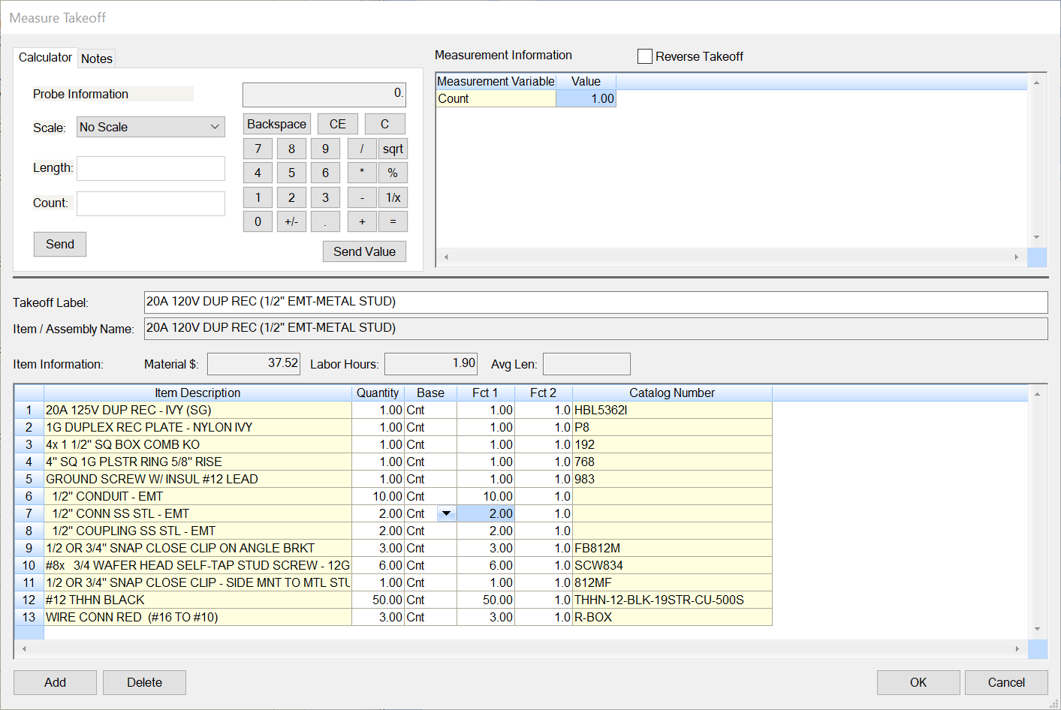

Figure 11

1. Change the Breakdown labels:

Drawing E3.2 TYPICAL FLOOR PLAN (2ND TO 4TH) - POWER

Phase Typical – FLOORS 2-3-4

1. Using the Common Assemblies: Level 3 assemblies add the 20A DPLX RECEP, 20A GFCI DPLX RECEP, and the 20A DBL DPLX RECEP. Place a RED LINE through the number on your take off sheet as you add them to your estimate. Adjust the Fct 1 for the 1/2" EMT from 15 ft to 10 ft for the 20A GFCI DPLX RECEP installed above the countertops. Figure 12 shows the audit trail for the typical floors take off.

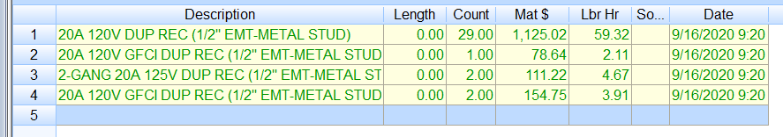

Figure 12

1. Change the Breakdown labels:

Drawing E3.3 ROOF PLAN POWER

Phase ROOF

1. Right click twice in the Takeoff area to go back to Common Assemblies: Level 1
2. Double click:

Com Assemblies: Level 1 [Line 4] RECEPTACLES [C]

Com Assemblies: Level 2 [Line 13] RECEPTACLES - SURFACE WEATHERPROOF **** [C]

Com Assemblies: Level 3 [Line 7] 20A 125V GFCI DUP REC SURF WP 1/2" *** [A]

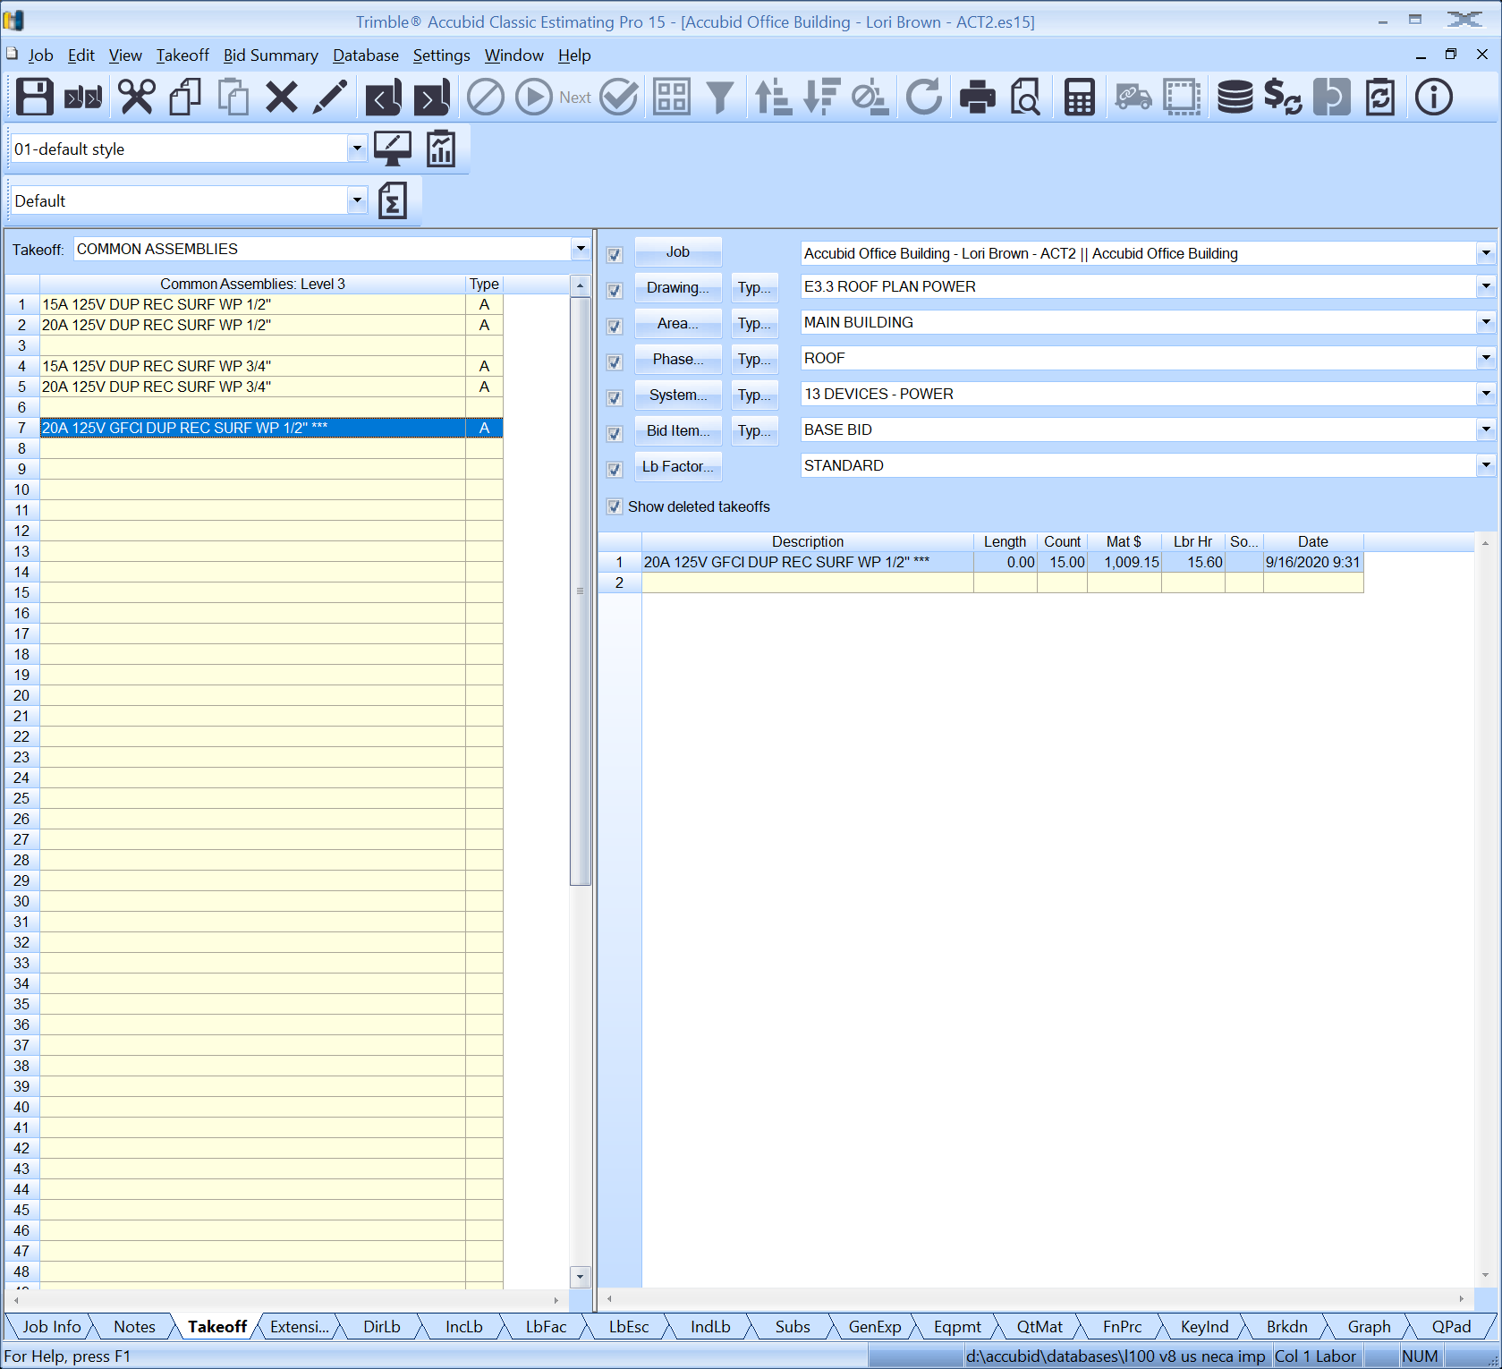

Figure 13

**NOTE: The two special receptacles shown on E3.1 First Floor Plan – Power Note ⑥ and the J-Boxes for the wall furniture power Note 7 will be added to the estimate later.**

1. When finished taking off the power devices, save the estimate.
2. ~~Copy the estimate to your own USB drive before leaving the lab.~~