CM 352 – Electrical Construction Estimating
Accubid Office Building
Activity #5 – Job Report Styles

Report Styles
In order to print a Job Report in Accubid a report style must be selected. A report style determines which job components are included in the report, and controls the layout of the report, including headers, footers, margins, and page orientation. You can create as many report styles as you wish, each with its own combination of job components and report parameters.

Report styles are used to control which columns are included in a particular job report. You can include or exclude entire job screens. You can also control the order in which columns are printed. As part of a report style, you can also control the font used for your report, as well as headers and footers, page margins, and page orientation. Until you create your own report style, the default style is used. The default report style includes all columns from all job screens. Report styles can only be used when printing job reports.

Procedure
To create a report style, follow these steps:
- With an open job, click on the Settings menu, and select the Report Styles option.
- Press the Caps Lock Key to turn on CAPS.
- From the Style name: drop down list select 01-default style.
- Verify that all job screens are in the Report Elements tab and in the same order as shown in Fig. 1. If they are in a different order use the Move Up (or Move Down) buttons to rearrange the screens. Note: they are in the same order as they appear along the bottom of the screen in the screen tabs. Click the select all button if all screens are not selected.
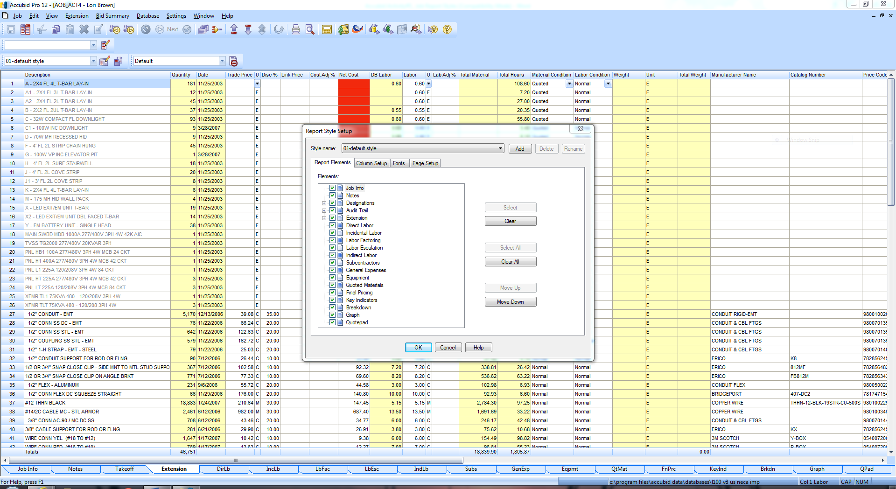
Fig. 1

- To create the CMGT352 Final Report style, click on the Add button.
- In the Add Style box enter the new style name and select the style to copy from (see Fig. 2).
Enter a new style name: CMGT352 FINAL REPORT
Select a style to copy from: select 01-default style
- Click OK.
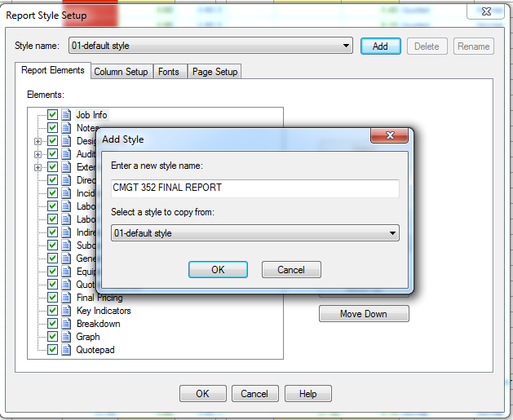
Fig. 2

- Click the Column Setup tab in the Report Style Setup window.
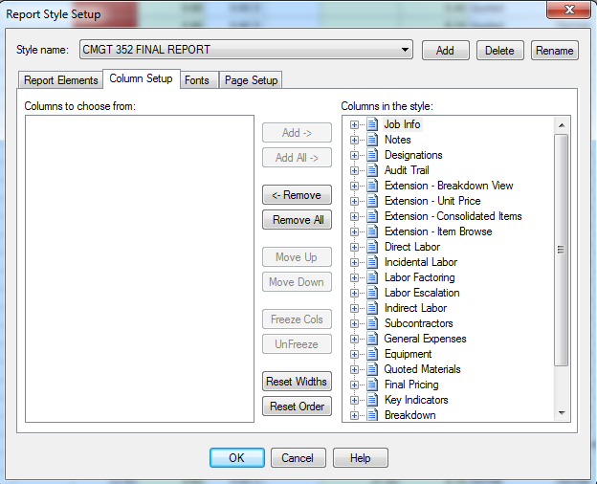
Fig. 3
- Click the Remove All button to move all of job screens to the Columns to choose from: list.
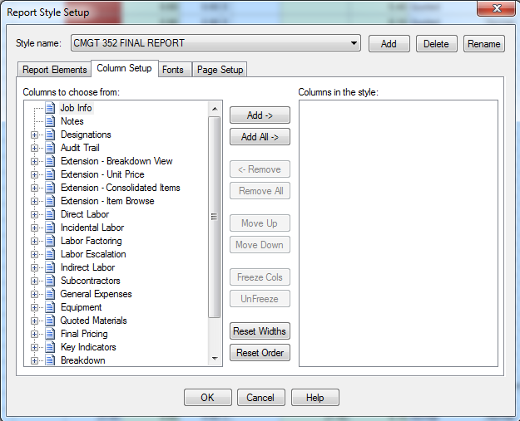
Fig. 4

- Click on Job Info from the Columns to choose from: list and click the Add -> button. The Job Info screen is now listed in the Columns in the style: list. Be sure that the Page break option under Job info is not selected as shown in Fig. 5.
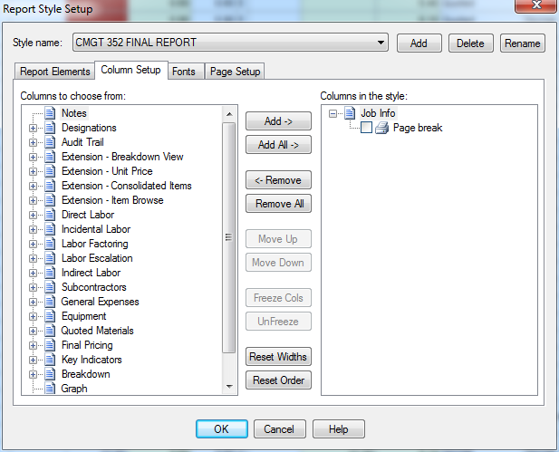
Fig. 5
- Add the Columns shown in Fig 6 (in the same order) to the Columns in the style: list.
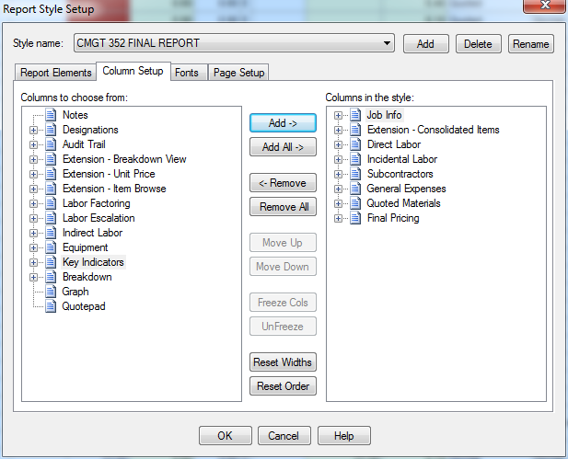
Fig. 6

- Click the + next to Extension – Consolidated Items in the Columns in the style: list and make the following changes using the Remove, Move Up, and Move Down buttons.
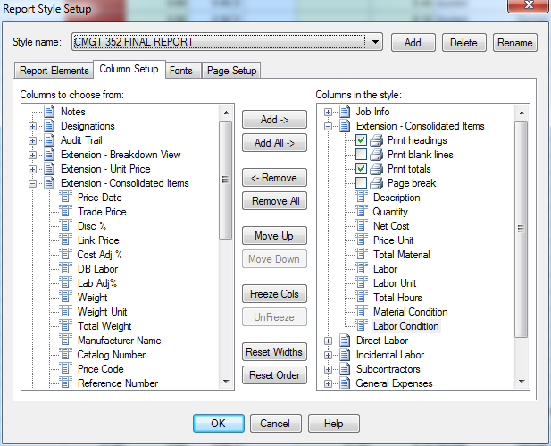
Fig. 7
- Continue editing the Columns in the style: list as shown in Fig. 8 through Fig 13.
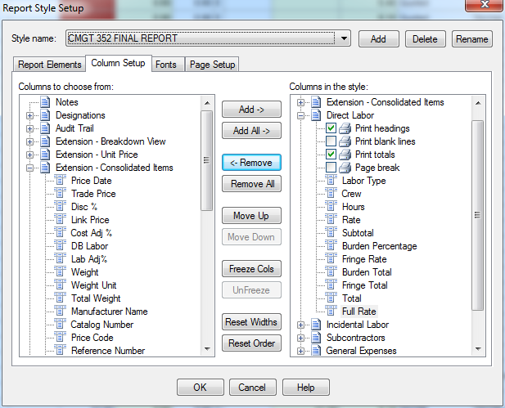
Fig. 8

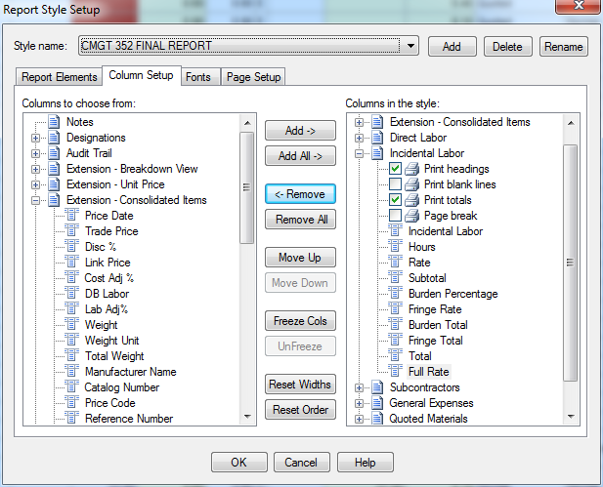
Fig. 9
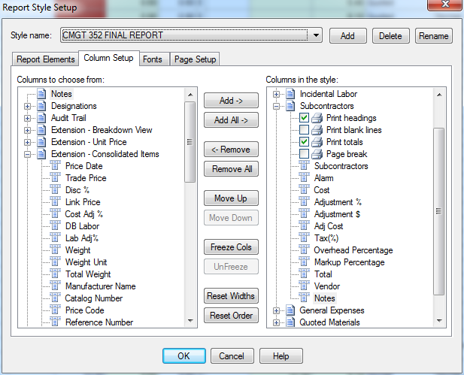
Fig. 10

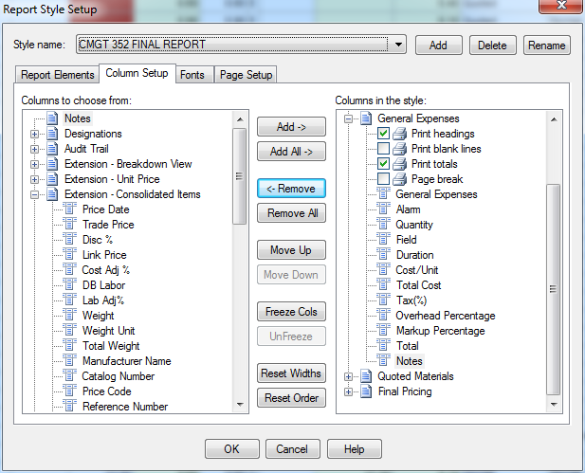
Fig. 11
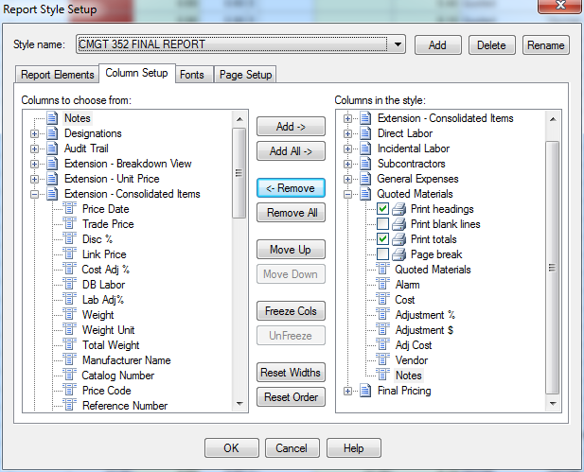
Fig. 12

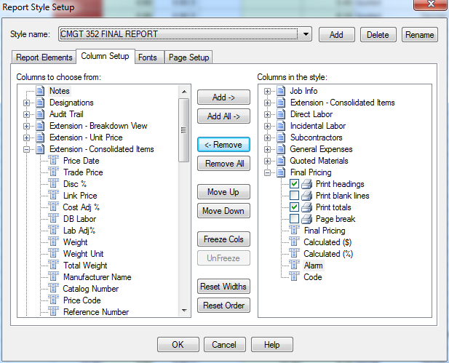
Fig. 13

- In the Reports Style Setup window click the Fonts tab and make sure the settings are:
Font: Arial Style: Normal Size: 8
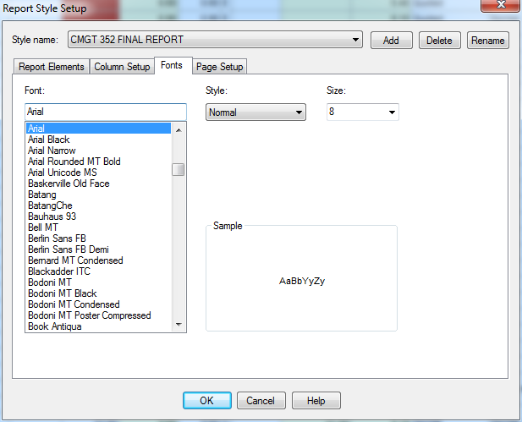
Fig. 14

- In the Report Style Setup window click the Page Setup tab and make sure the settings are:
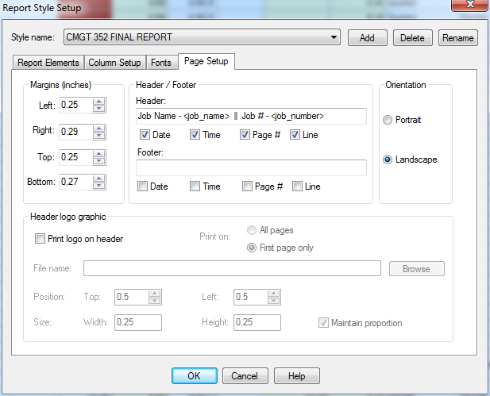
Fig. 15

- In the Report Style Setup window click on the Report Elements tab. Make sure the boxes shown are selected (Green Check)
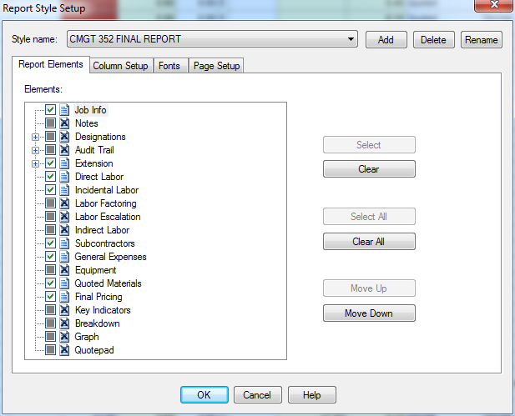
Fig. 16

- Click OK to close the Report Style Setup window.

- Click the Extension screen tab and select the View Using Report Styles option and select CMGT352 Final Report from the drop down list next to the Report Style Setup button.
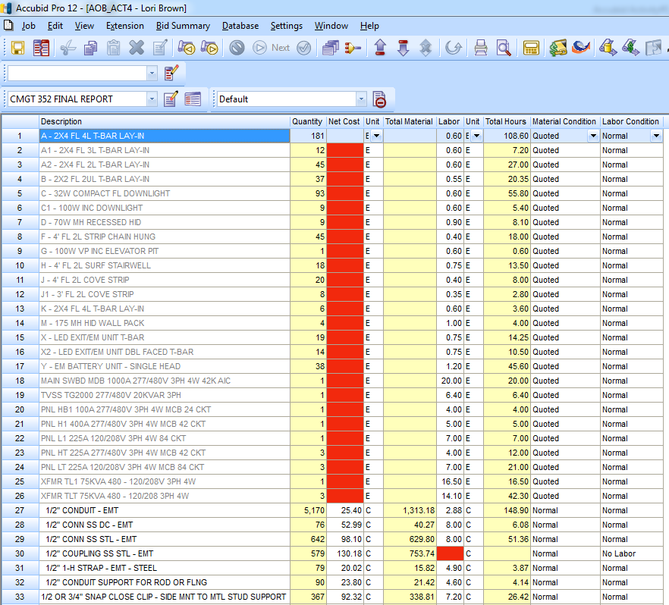
Toggle Button for View by Report Style or View by Screen Style.
Fig. 17

- Adjust each of the column widths to “best fit” by moving the mouse near the column heading between each of the columns until a double-headed arrow mouse pointer appears and then double-clicking to fit the data to the column as shown in Fig. 17. This is important to do otherwise the printed report will not fit on one page width.
- Toggle back using the same button to View Using Screen Styles and select the 01-default style.
- Right click in the Extension window and select the command Group.

- In the Quick View window under Group Options: select System and click Add to move it to the Group Order: list. Double Click Phase to move it to the Group Order: list.
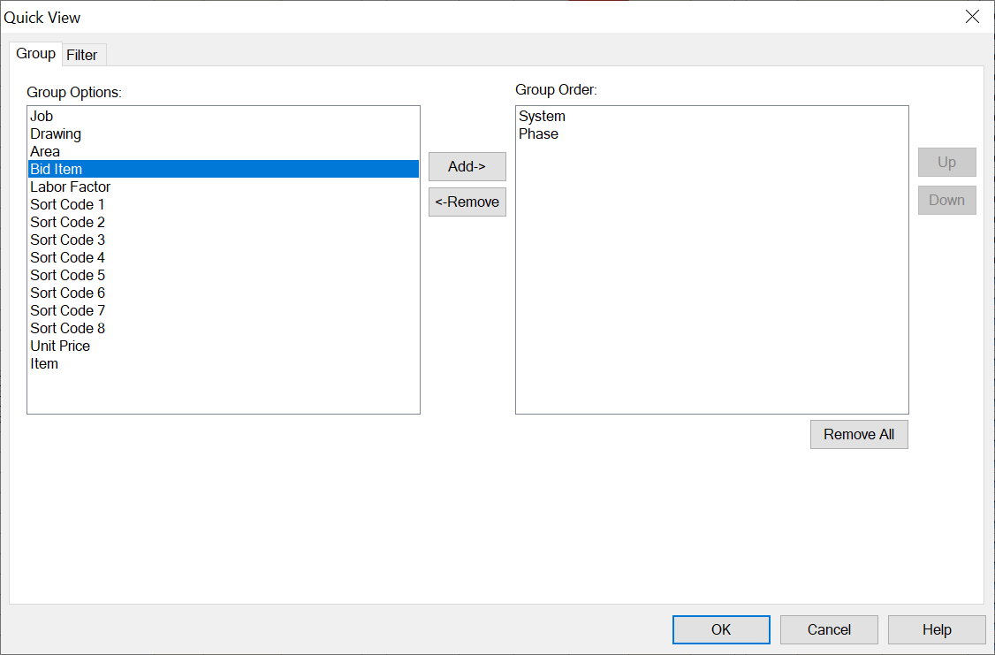
Fig. 18

- Click OK.
- The Extension screen is now grouped by System.
- From the Job menu select Print Preview.
- In the Print Preview window select the Report Style: CMGT352 Final Report and click OK.
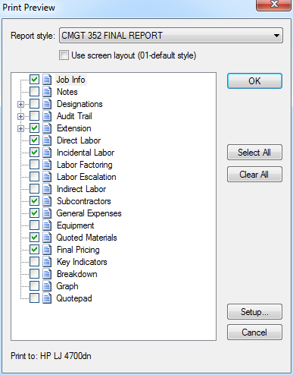
Fig. 19
- The Report must be in Landscape orientation, all columns fit across one page and it is grouped by System and Phase. See Fig 20. If correct, click Print.

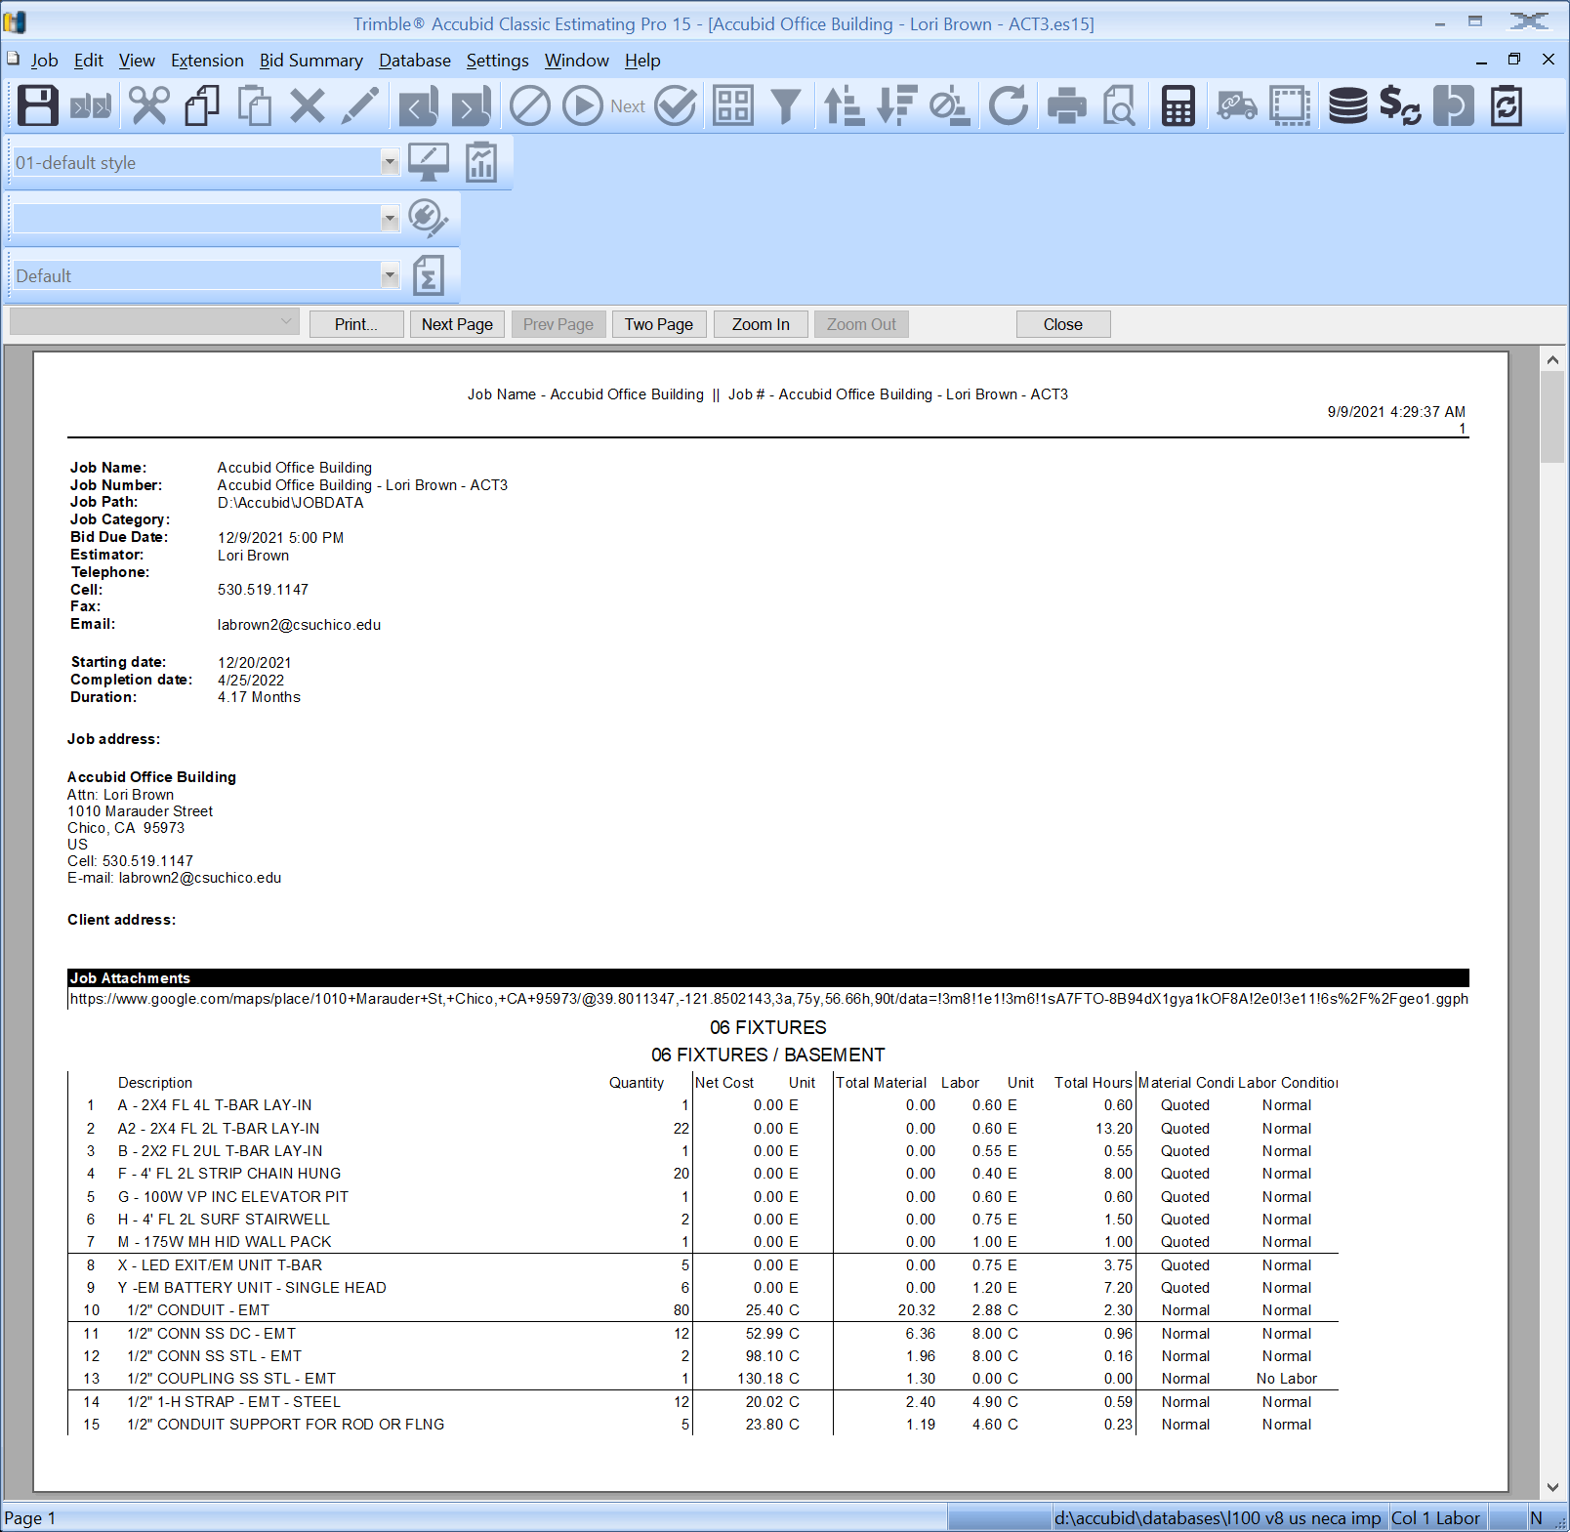
Fig. 20

- Click on the Extension tab. Right click in the Extension screen and select Clear View.
- Click the Save Job icon on the toolbar.
- Staple your printed Job Report in the upper left corner and hand in your print-out.

