**CM 352 – Electrical Construction Estimating**

lightbul

**Accubid Activity #4**

**Accubid Office Building – 01 SWITCHGEAR, Distribution Designations and Switchgear Takeoff**

**Building Distribution Designations**

1. Start the program Accubid Pro 15 [Start, All Programs, Trimble, Accubid Pro 15]
2. Press the CAPS LOCK Key ON
3. From the Job Schedule Screen open the file, Accubid Office Building.
4. If not already selected, select the Takeoff tab at the bottom of the screen.
5. Make sure you are using the Database: L100 V8 US NECA IMP.
6. Choose DISTRIBUTION from the drop down list in the Takeoff: area of the screen.

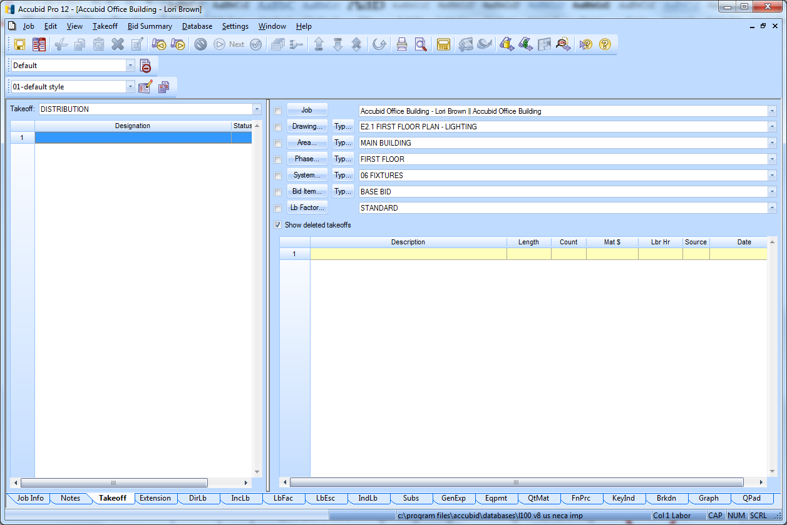

Figure 1

In Accubid (Electrical) there are three systems that use **Designations**:

FIXTURES

HEATING

DISTRIBUTION

Creating a designation involves selecting any number of different items and assemblies, and then assigning them a designation name. Once you have created the designation, you can take off all the items in the designation in a single step. Any changes you make to the designation will be automatically reflected in all takeoffs performed using that designation.

**DISTRIBUTION DESIGNATIONS**

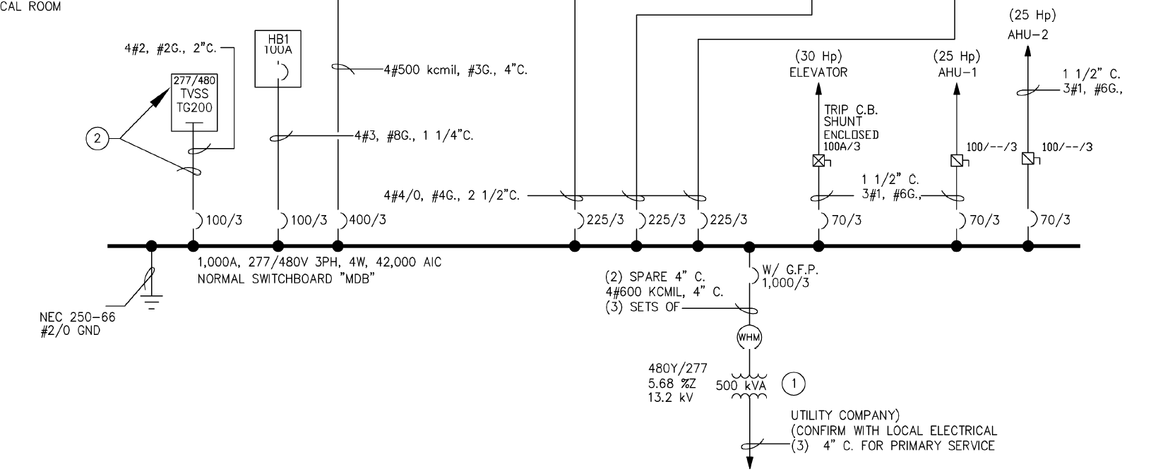

Figure 2

01 SWITCHGEAR

The first designation you will build is the Main Switchboard “MDB”.

From the One-Line Diagram the amperage, voltage, phase, wire numbers and AIC rating can be obtained for MDB. This information can also be found on the Panel Schedule.

The One-Line Diagram also indicates the size and number of circuit breakers (CB) in the MDB and the size and number of wires terminating at each breaker. From the One-Line Diagram complete the count for the CB’s and Wire Power Term’s and fill in the corresponding blank lines shown below.

MAIN SWBD MDB 1000A 277/480V 3Ø 4W 42K AIC

CB QTY

1000/3 ____

400/3 ____

CIRCUIT BREAKERS (CB)

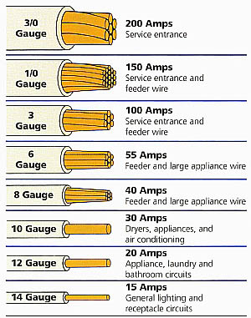225/3 ____

100/3 ____

70/3 ____

WIRE POWER TERM QTY

#8 ____

#6 ____

#4 ____

#3 ____

#2 ____

#1 ____

#2/0 ____

#4/0 ____

#500 ____

#600 ____

1. Double click on Line 1 in the Takeoff area under the word Designation.
2. In the Create/Modify Designation Description dialog box type the designation name:  
   MAIN SWBD MDB 1000A 277/480V 3PH 4W 42K AIC and click the OK button.
3. The first selection is the Distribution: Category

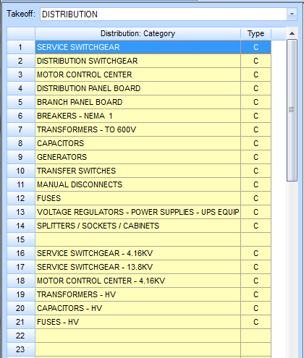

Figure 3

The MAIN SWBD MDB is SERVICE SWITCHGEAR

1. Double click on:  
   [Line 1] SERVICE SWITCHGEAR   
   [Line 5] 1200A  
   [Line 2] 1200A 2-SECTION SERVICE SWGR (See Details E6.2)
2. The Measure Takeoff window opens when you select the item. Click OK.
3. The next window in the takeoff: area is Distribution Fittings: Type

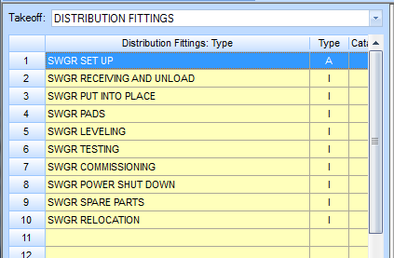

Figure 4

1. Double click on [Line 1] SWGR SET UP

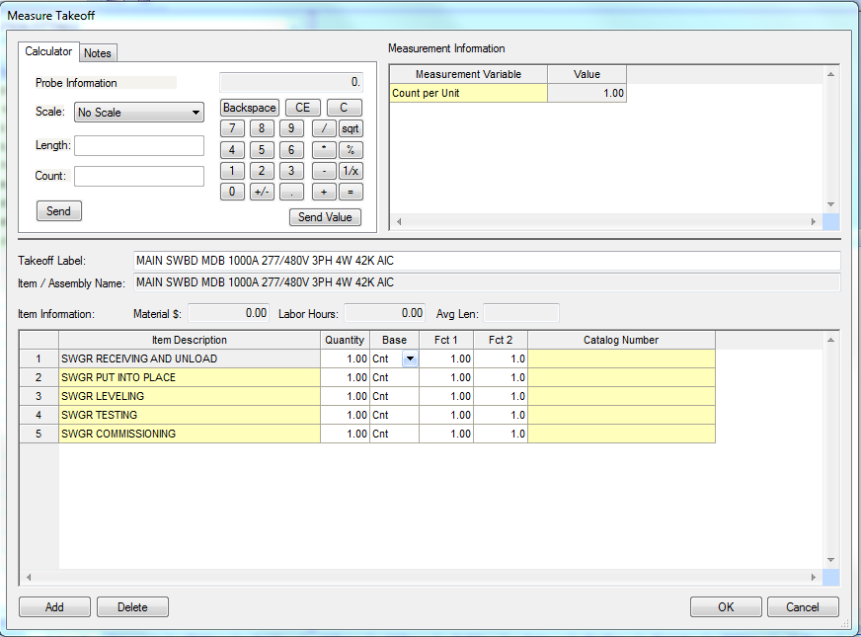

Figure 5

This adds the 5 items shown in Figure 5 with NO Labor Hours. The purpose for adding these is so that they become activities when the estimate is imported into Microsoft Project.

1. Click OK in the Measure Takeoff window. Notice that the takeoff: selection stays at DISTRIBUTION FITTINGS. If you need to add additional items you can continue using this window.
2. On the Toolbar locate the Next Step button 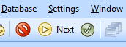and click it to move to the next takeoff: window, DISTRIBUTION ACCESSORIES.  
     
     
   Your Accubid window should look like the one shown in Figure 6 on the next page.

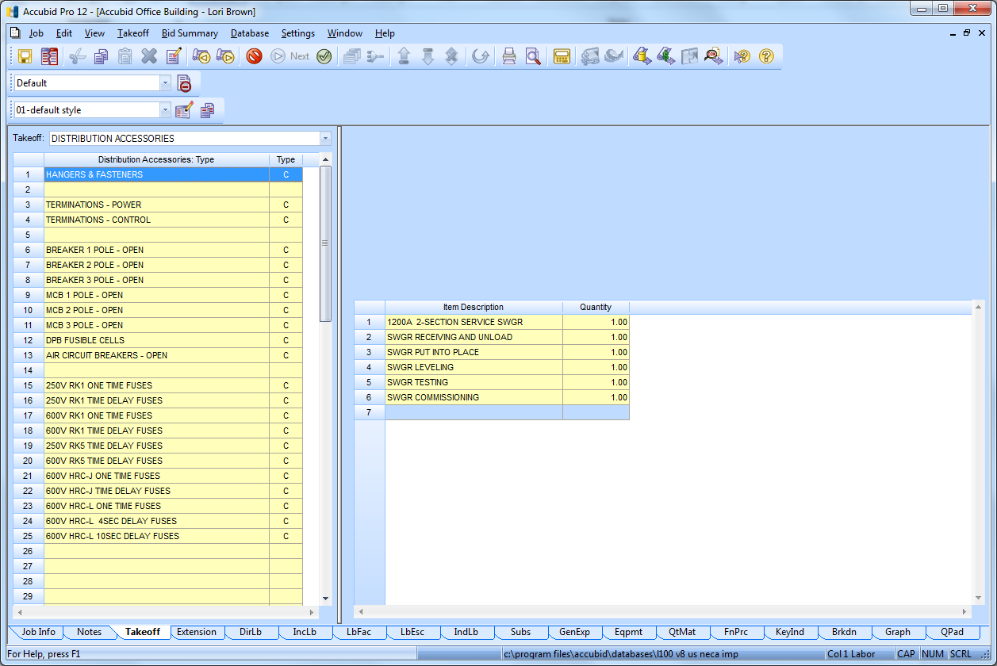

Figure 6

All of the AOB switchgear and panels will be fastened to concrete using strut supports.

1. To add the strut and misc material to the designation double click on:  
   [Line 1] HANGERS AND FASTENERS   
   [Line 1] 2X2' STRUT CONC SUPPORT  
     
   Leave the Count per Unit Value as 1.00 and click the OK button in the Measure Takeoff window to add the strut material to the designation.
2. Right click in the takeoff: area to go back one level (Distribution Accessories: Type)
3. Double click:

[Line 3] TERMINATIONS – POWER  
Add the WIRE POWER TERMS by wire size and quantity (see page 2 of this activity)  
i.e.

Double click:

[Line 6] #8 WIRE POWER TERM and leave the Count per Unit as 1.00 and click OK to add (1.00) #8 WIRE POWER TERM to the designation.  
  
Double click:

[Line 7] #6 WIRE POWER TERM and change the count per unit to 3.00 and click OK to add (3.00) #6 WIRE POWER TERM to the designation.  
  
When completed your designation should look like the one shown in Figure 7 on the next page.

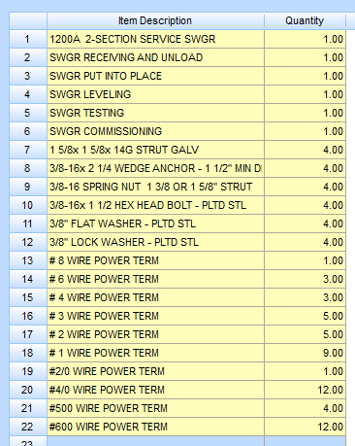

Figure 7

1. Right click in the Designation window and click on Finish to complete the designation.

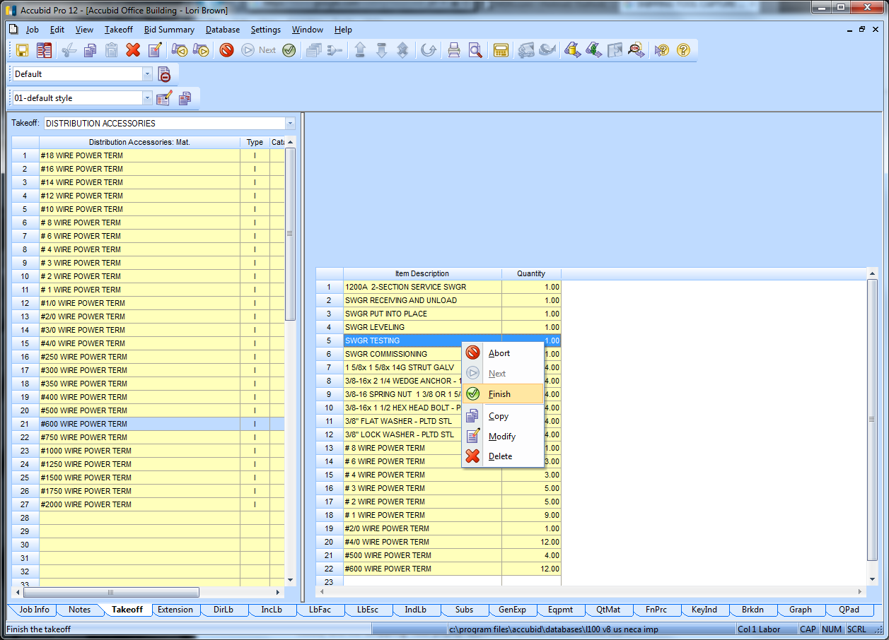

Figure 8

Note: To modify a Designation, right click on the designation name and click on Modify.

Right click and select Abort to cancel.

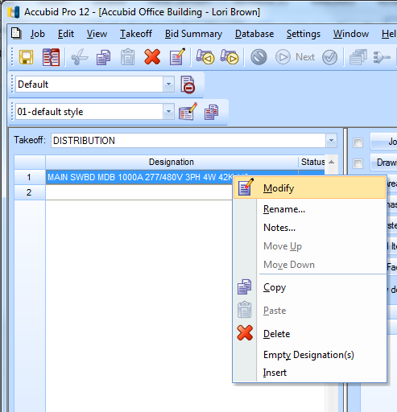

Figure 9

To add a Designation to your estimate as “takeoff”, FIRST SET THE BREAKDOWN, then, double click on the Designation name. In the Designation Count Window change the quantity to the number you want to add to the estimate and click on the OK button. For now, click Cancel if you opened the Designation Count window. (Takeoff will be done later.)

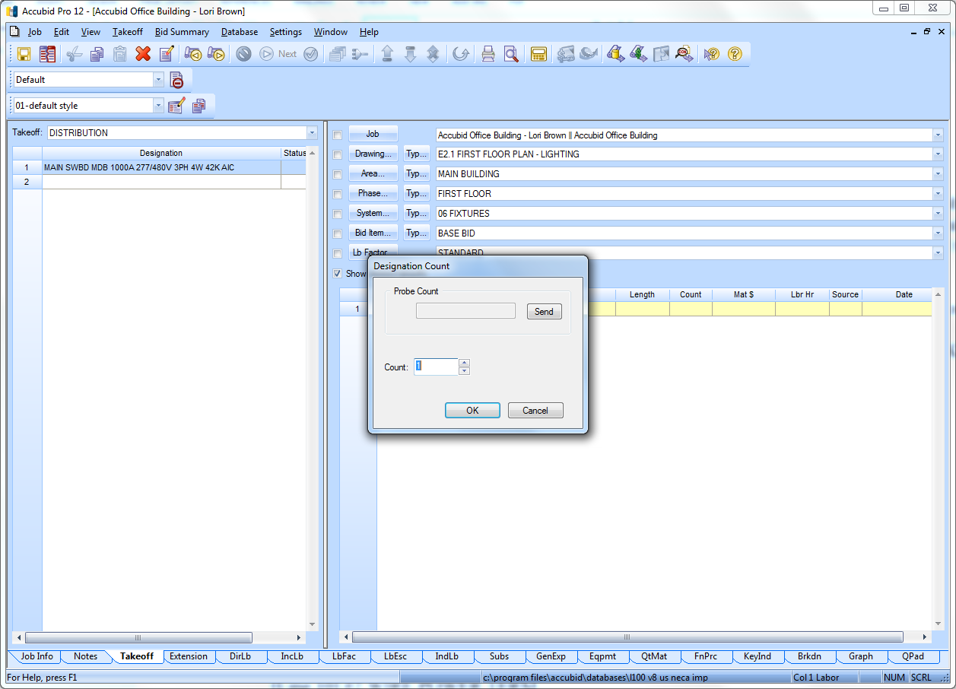

Figure 10

1. The next DISTRIBUTION DESIGNATION we will build is TVSS. To start a new designation Double click on the next blank line (Line 2) in the Designation window.
2. In the Create/Modify Designation Description dialog box type: TVSS TG2000 277/480V 20KVAR 3PH and click the OK button.
3. Double click:  
   [Line 8] CAPACITORS  
   [Line 2] 480 VOLT 3PH  
   [Line 22] 20KVAR CAPACITOR 480V 3PH - NEMA 3R  
   Click OK in the Measure Takeoff window.
4. Double Click  
   [Line 1] CAPACITOR SET UP click OK
5. Click the Next button on the Toolbar.   
   Add the strut:  
   [Line 1] HANGERS & FASTENERS  
   [Line 1] 2X2' STRUT CONC SUPPORT  
   Click OK in the Measure Takeoff window.
6. Right click in the takeoff: window to go back one level. Add the WIRE POWER TERMs  
   [Line 3] TERMINATIONS – POWER  
   [Line 10] #2 WIRE POWER TERM  
   Change the count per unit to 5 and click OK
7. Right click in the designation area and click finish.

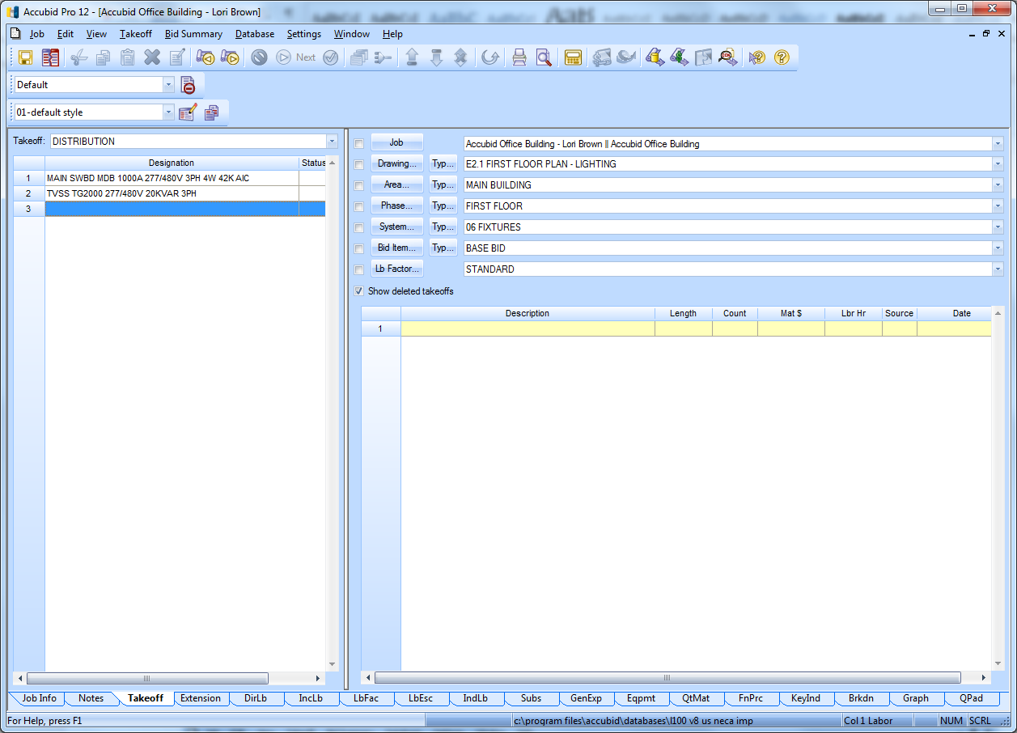

Figure 11

**Distribution Designations**

**Panel Board (PNL) & Transformer (XFMR)**

**Steps for creating Panel Board Designations:**

|  |  |
| --- | --- |
| Step 1 | Double click on the next blank line in the Takeoff: DISTRIBUTION Designation area |
| Step 2 | Type the Designation name in the Create/Modify dialog box:  PNL HB1 100A 277/480V 3PH 4W MCB 24 CKT  Click OK |
| Step 3 | Distribution: Category  [Line 5] BRANCH PANEL BOARD  [Line 1] 100 AMP  [Line 25] 100A 4W-24CCT RCSD BREAKER BPB - MAIN BRKR  Click OK |
| Step 4 | Distribution Fittings: Type  [Line 1] BPB SET UP  Click OK |
| Step 5 | Click the Next button on the Toolbar  Distribution Accessories: Type  [Line 1] FASTENERS & HANGERS  [Line 1] 2X2′ STRUT CONC SUPPORT 1.00  Click OK |
| Step 6 | Right click in the takeoff area to go back one level  [Line 3] TERMINATIONS – POWER  FEEDERS  [Line 6] # 8 WIRE POWER TERM 1.00 Click OK  [Line 9] # 3 WIRE POWER TERM 4.00 Click OK  BRANCH CKTS & MOTOR/EQUIP  [Line 4] #12 WIRE POWER TERM 10.00 Click OK  [Line 5] #10 WIRE POWER TERM 3.00 Click OK |
| Step 7 | Right click in the Designation area  Click Finish |
| Step 8 | Repeat for the remaining Panel Boards (see below) |

**PNL H1 400A 277/480V 3PH 4W MCB 42 CKT**

**ITEM QTY**

400A 4W-42CCT RCSD BREAKER BPB - MAIN BRKR 1.00

BPB RECEIVING AND UNLOAD 1.00

BPB PUT INTO PLACE 1.00

BPB LEVELING 1.00

BPB TESTING 1.00

1 5/8x 1 5/8x 14G STRUT GALV 4.00

3/8-16x 2 1/4 WEDGE ANCHOR - 1 1/2" MIN DEPTH 4.00

3/8-16 SPRING NUT 1 3/8 OR 1 5/8" STRUT 4.00

3/8-16x 1 1/2 HEX HEAD BOLT - PLTD STL 4.00

3/8" FLAT WASHER - PLTD STL 4.00

3/8" LOCK WASHER - PLTD STL 4.00

# 8 WIRE POWER TERM 1.00

# 3 WIRE POWER TERM 1.00

# 2 WIRE POWER TERM 3.00

#500 WIRE POWER TERM 4.00

#12 WIRE POWER TERM 22.00

#10 WIRE POWER TERM 27.00

**PNL L1 225A 120/208V 3PH 4W 84 CKT**

**ITEM QTY**

225A 4W-84CCT RCSD BREAKER BPB - DBL TUB 1.00

BPB RECEIVING AND UNLOAD 1.00

BPB PUT INTO PLACE 1.00

BPB LEVELING 1.00

BPB TESTING 1.00

1 5/8x 1 5/8x 14G STRUT GALV 4.00

3/8-16x 2 1/4 WEDGE ANCHOR - 1 1/2" MIN DEPTH 4.00

3/8-16 SPRING NUT 1 3/8 OR 1 5/8" STRUT 4.00

3/8-16x 1 1/2 HEX HEAD BOLT - PLTD STL 4.00

3/8" FLAT WASHER - PLTD STL 4.00

3/8" LOCK WASHER - PLTD STL 4.00

# 4 WIRE POWER TERM 1.00

#4/0 WIRE POWER TERM 4.00

#12 WIRE POWER TERM 56.00

#10 WIRE POWER TERM 17.00

# 8 WIRE POWER TERM 3.00

# 4 WIRE POWER TERM 2.00

**PNL HT 225A 277/480V 3PH 4W MCB 42 CKT**

**ITEM QTY**

225A 4W-42CCT RCSD BREAKER BPB - MAIN BRKR 1.00

BPB RECEIVING AND UNLOAD 1.00

BPB PUT INTO PLACE 1.00

BPB LEVELING 1.00

BPB TESTING 1.00

1 5/8x 1 5/8x 14G STRUT GALV 4.00

3/8-16x 2 1/4 WEDGE ANCHOR - 1 1/2" MIN DEPTH 4.00

3/8-16 SPRING NUT 1 3/8 OR 1 5/8" STRUT 4.00

3/8-16x 1 1/2 HEX HEAD BOLT - PLTD STL 4.00

3/8" FLAT WASHER - PLTD STL 4.00

3/8" LOCK WASHER - PLTD STL 4.00

# 8 WIRE POWER TERM 1.00

# 4 WIRE POWER TERM 4.00

#4/0 WIRE POWER TERM 4.00

#12 WIRE POWER TERM 17.00

#10 WIRE POWER TERM 23.00

**PNL LT 225A 120/208V 3PH 4W MCB 84 CKT**

**ITEM QTY**

225A 4W-84CCT RCSD BREAKER BPB - DBL TUB 1.00

BPB RECEIVING AND UNLOAD 1.00

BPB PUT INTO PLACE 1.00

BPB LEVELING 1.00

BPB TESTING 1.00

1 5/8x 1 5/8x 14G STRUT GALV 4.00

3/8-16x 2 1/4 WEDGE ANCHOR - 1 1/2" MIN DEPTH 4.00

3/8-16 SPRING NUT 1 3/8 OR 1 5/8" STRUT 4.00

3/8-16x 1 1/2 HEX HEAD BOLT - PLTD STL 4.00

3/8" FLAT WASHER - PLTD STL 4.00

3/8" LOCK WASHER - PLTD STL 4.00

# 6 WIRE POWER TERM 1.00

#1/0 WIRE POWER TERM 4.00

#12 WIRE POWER TERM 16.00

#10 WIRE POWER TERM 4.00

**Steps for creating Transformer Designations:**

|  |  |
| --- | --- |
| Step 1 | Double click on the next blank line in the Takeoff: DISTRIBUTION Designation area |
| Step 2 | Type the Designation name in the Create/Modify dialog box:  XFMR TL1 75KVA 480 - 120/208V 3PH 4W  Click OK |
| Step 3 | Distribution: Category  [Line 7] TRANSFORMERS – TO 600V  [Line 1] 3 PHASE TRANSFORMER - GENERAL PURPOSE  [Line 12] 75KVA 3PH TRANSFORMER - GP - FLOOR MNT  Click OK |
| Step 4 | Distribution Fittings: Type  [Line 1] TFMR LUG TO #2 3.00 Click OK  [Line 4] TFRM LUG TO #250 4.00 Click OK  [Line 21] TRANSFORMER SET UP 1.00 Click OK  [Line 22] TRANSFORMER NEOPRENE PADS 4.00 Click OK |
| Step 5 | Click the Next button on the Toolbar  Distribution Accessories: Type  [Line 1] FASTENERS & HANGERS  [Line 1] 2X2′ STRUT CONC SUPPORT 1.00  Click OK |
| Step 6 | Right click in the takeoff area to go back one level  [Line 3] TERMINATIONS – POWER  FEEDERS  [Line 6] # 8 WIRE POWER TERM 1.00 Click OK  [Line 7] # 6 WIRE POWER TERM 1.00 Click OK  [Line 8] # 4 WIRE POWER TERM 1.00 Click OK  [Line 10] # 2 WIRE POWER TERM 3.00 Click OK  [Line 15] # 4/0 WIRE POWER TERM 4.00 Click OK |
| Step 7 | Right click in the Designation area  Click Finish |
| Step 8 | Repeat for the remaining Transformer |

**XFMR TLT 45KVA 480 - 120/208V 3PH 4W**

**ITEM QTY**

45KVA 3PH TRANSFORMER - GP - FLOOR MNT 1.00

TFMR LUG TO # 2 3.00

TFMR LUG TO #1/0 4.00

TRANSFORMER NEOPRENE PADS 4.00

TRANSFORMER RECEIVE AND UNLOAD 1.00

TRANSFORMER PUT INTO PLACE 1.00

1 5/8x 1 5/8x 14G STRUT GALV 4.00

3/8-16x 2 1/4 WEDGE ANCHOR - 1 1/2" MIN DEPTH 4.00

3/8-16 SPRING NUT 1 3/8 OR 1 5/8" STRUT 4.00

3/8-16x 1 1/2 HEX HEAD BOLT - PLTD STL 4.00

3/8" FLAT WASHER - PLTD STL 4.00

3/8" LOCK WASHER - PLTD STL 4.00

# 8 WIRE POWER TERM 1.00

# 6 WIRE POWER TERM 2.00

# 4 WIRE POWER TERM 3.00

#1/0 WIRE POWER TERM 4.00

**SYS 01 SWITCHGEAR Takeoff**

Once all of the Distribution Designations have been built, the estimator is now ready to begin entering the quantities of each designation. Typically, SWITCHGEAR counts are entered by Drawing, Phase (floor) and by System.

1. Complete the 01 SWITCHGEAR takeoff (count) using the pricing sheets provided in class.

**Note: Set the correct Breakdown Labels BEFORE taking off the switchgear.**

1. Using the 01 SWITCHGEAR pricing sheet take off your 01 SWITCHGEAR counts under the correct Breakdown labels. After entering the 01 SWITCHGEAR count in Accubid, using a red pencil, line through the 01 SWITCHGEAR count on your pricing sheet.

For Example:

1. To takeoff the designation MAIN SWBD MDB 1000A 277/480V 3PH 4W 42K AIC set the breakdown as shown in Figure 12.
2. Double click on the distribution designation:

[Line 1] MAIN SWBD MDB 1000A 277/480V 3PH 4W 42K AIC

1. Enter in the quantity and click on OK
2. Continue taking off all of the distribution designations **changing the breakdown** as needed.
3. Print the Distribution Designations (Job Info and Current Designations)
4. Save your estimate
5. Close Accubid

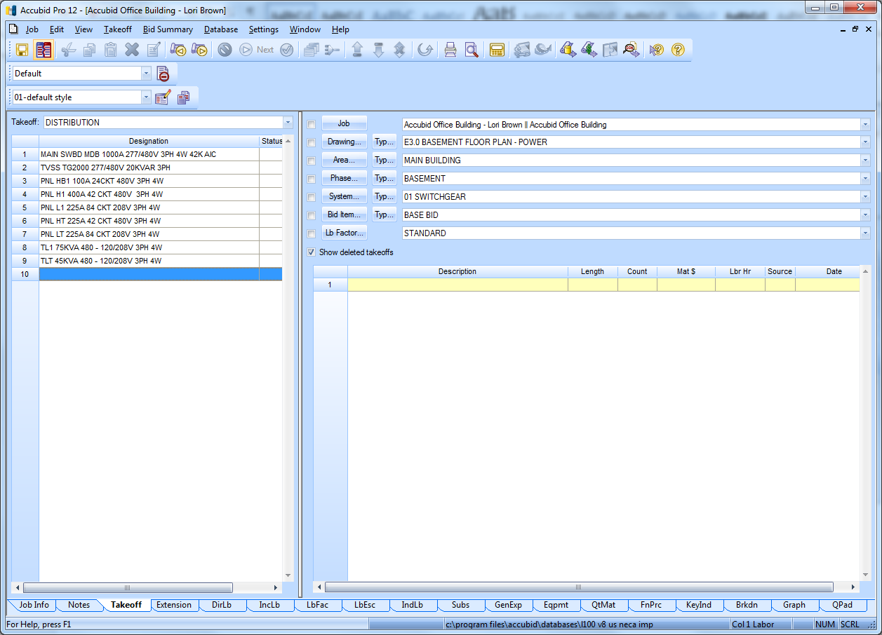

Figure 12