CM 352 – Electrical Construction Estimating
Accubid Activity #6
Accubid Office Building - SYS 04 Feeder Takeoff

Procedure:
- Prepare the SYS 04 FEEDER TAKEOFF SHEET and measure and record the length of each Feeder shown on drawing E5.1 ELECTRICAL ONE-LINE DIAGRAM.
- Start Accubid and open the Job: Accubid Office Building – your initials
- Turn on the CAPS Lock

Accubid Takeoff Screen
The first Feeder to Take Off will be the 3x4" PVC PRIMARY SERVICE TO XFMR (Utility Company’s Primary Service Entrance Feeders).

- Make the following changes to the Takeoff Screen:
Takeoff
Takeoff: FEEDER CONDUIT AND WIRE

Breakdown
DRAWING: E5.1 ELECTRICAL ONE LINE DIAGRAM
PHASE: SITE
SYSTEM: 04 FEEDERS
Place a check in all of the Breakdown filter boxes as shown.
Lb FACTOR: TRENCH 4 RUNS

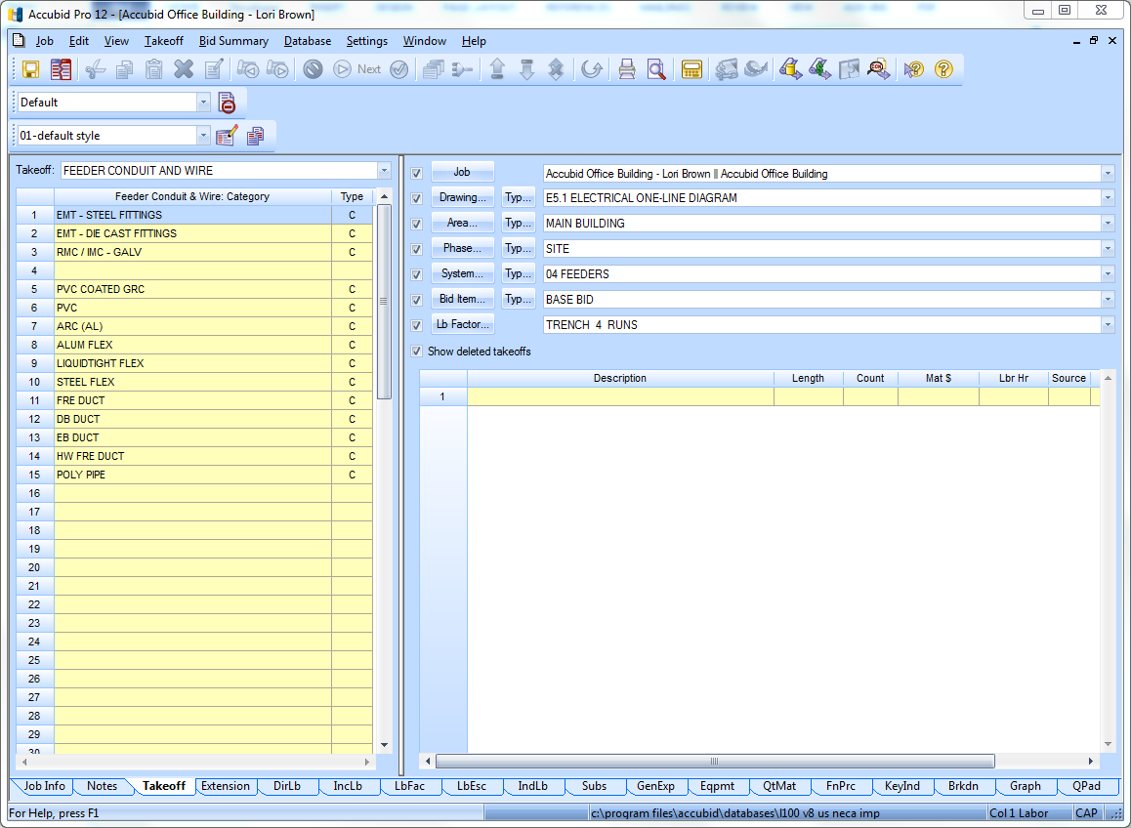
Fig. 1

- In the Takeoff: FEEDER CONDUIT AND WIRE Window Double click on:
[Line 6] PVC
[Line 10] 4" PVC (TRENCH)

- In the Create/Modify Takeoff Description box enter: 3x4" PVC PRIMARY SERVICE TO XFMR and click OK

- Complete steps 1-4 shown in Fig. 3
1
Change the Item Description
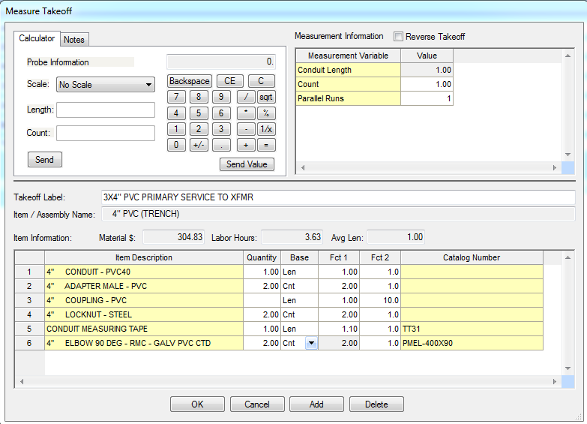
2
3
4
Enter in the Conduit Length recorded on your
FEEDER TAKEOFF SHEET
Set Count = 1
Set Parallel Runs = 3
Click OK
Change Fct 1 and Fct 2 AND Base
Fig. 3

The Takeoff window now displays:
Takeoff: FEEDER CONDUIT FITTINGS

- Double click:
[Line 2] 4" ADAPTER FEM – PVC
In the Measure Takeoff window change:
Count 2
# runs to fill 3
Click on OK

- Double click:
[Line 8] 4" END BELL – PVC
In the Measure Takeoff window change:
Count 2
# runs to fill 3
Click on OK

- Double click:
[Line 41] BASE SPACERS (see Ductbank detail E6.2)
In the Measure Takeoff window change:
Count 18
# runs to fill 3
Click on OK

- Take off the items shown below from the Takeoff: ITEM DATABASE
Item Qty Traverse Code
PVC CEMENT STANDARD (1-QUART) 1.00 1 – 16 – 19 – 3
UNDERGROUND WARNING TAPE - YLW 3" WIDE - PER 1000' ROLL 1.00 4 – 11 – 1– 14

Your Takeoff should now contain the following items:
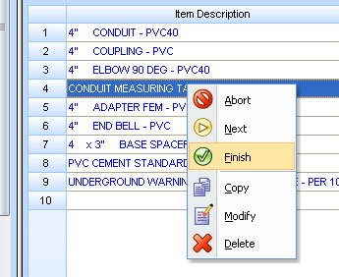
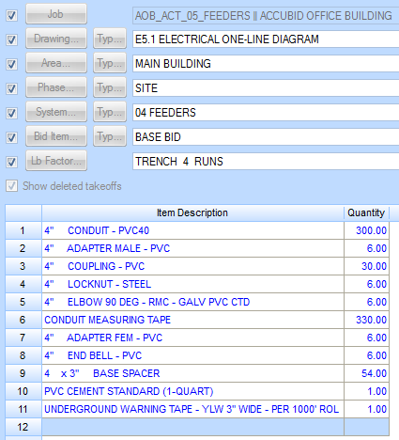
Note:
Your quantities will depend on what you entered for the feeder’s length.
Fig. 4

- Right Click in the Item Description area and select Finish

- On the Feeder Take Off Sheet Place a Red Pencil Line through the LFT/T/90° for this feeder to indicate it has been added to the estimate.

To takeoff the Building Service Entrance, copy the 3x4" PVC PRIMARY SERVICE TO XFMR takeoff to your estimate and modify it as follows:

- In the Audit Trail Description box right click on 3x4" PVC PRIMARY SERVICE TO XFMR and select Copy.
- Right Click in the Audit Trail Description box empty line and select Paste.
- Click OK to retain all settings.
- Right Click on the pasted takeoff and click Change Breakdown. Change the Lb FACTOR breakdown label to:
Breakdown
Lb FACTOR: TRENCH 6 RUNS
Note: All other Breakdown labels will remain the same

- In the Breakdown screen area change the Lb FACTOR breakdown label to: TRENCH 6 RUNS
- Right Click on the 3x4" PVC PRIMARY SERVICE TO XFMR takeoff and select Modify.
- Double Click: [Line 1] 4" CONDUIT - PVC40 and make the following changes:
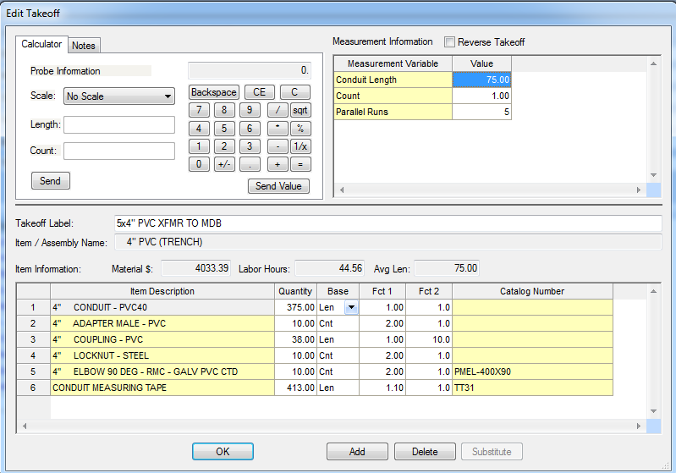
1
3
2
Enter in the Conduit Length recorded on your
FEEDER TAKEOFF SHEET
Set Count = 1
Set Parallel Runs = 5
Click OK
Rename the Takeoff Label
Fig. 5

- Double click on the following items in the Item Description and change the # of runs to fill to 5:
4" ADAPTER FEM - PVC
4" END BELL – PVC

- Change the BASE SPACERS quantity to Count = 8 and # of runs to fill to 5
- Delete the following items:
PVC CEMENT STANDARD (1-QUART)
UNDERGROUND WARNING TAPE - YLW 3" WIDE - PER 1000' ROL

- Add the following items:

Takeoff: FEEDER CONDUIT FITTINGS
[Line 42] 4 x 3" INTERMEDIATE SPACER

In the Measure Takeoff window change:
Count 6
# runs to fill 5
Click on OK

Takeoff: FEEDER WIRE

[Line 1] THHN WIRE
[Line 22] #600 THHN BLACK

- Edit the Measure Takeoff window as shown:
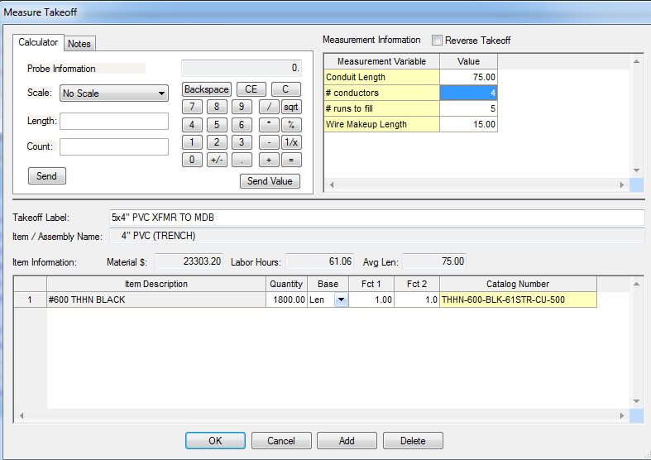
1
2
If necessary enter in the Conduit Length recorded on your FEEDER TAKEOFF SHEET
# conductors = 4
# runs to fill = 5
Wire makeup length = 15 ft
Click OK
Fig. 6

SEE NEXT PAGE
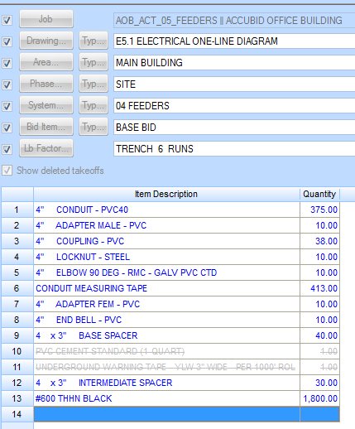

- To complete takeoff, Right Click in the Item Description area and select Finish

- Right click in the Takeoff area to go back to Level 1: Feeder Conduit & Wire: Category

- Continue taking off the Feeders as shown on Pages 7 - 15

Takeoff
Takeoff: FEEDER CONDUIT AND WIRE

Breakdown
DRAWING: E5.1 ELECTRICAL ONE LINE DIAGRAM
PHASE: BASEMENT
SYSTEM: 04 FEEDERS
Lb FACTOR: STANDARD

In the Takeoff Window Double click on:
[Line 1] EMT – STEEL FITTINGS
[Line 6 ] 2" EMT - STEEL SS
[Line 6] 2" EMT STRUT MOUNT

In the Create/Modify Takeoff Description box enter: 2" EMT MDB TO TVSS 4#2, #1G
And click OK
1
Edit the Measure Takeoff window as shown:
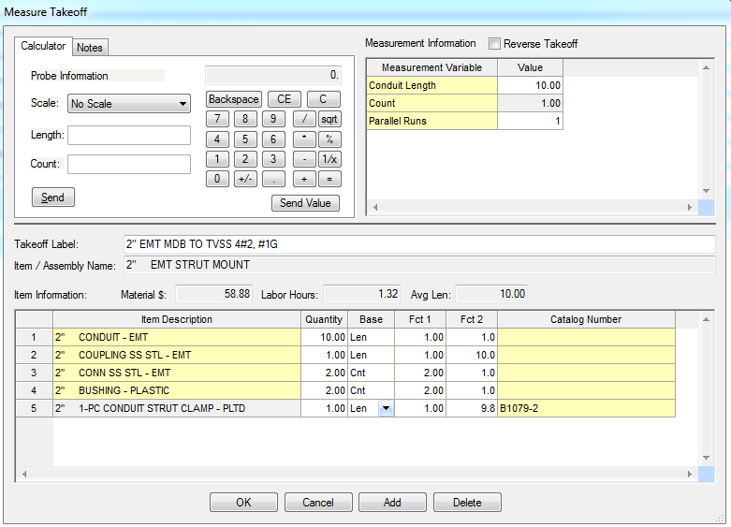
2
3
3
Enter in the Conduit Length recorded on your
FEEDER TAKEOFF SHEET
Count = 1
Parallel Runs = 1
Click OK
If necessary, Change Fct 1 and Fct 2 AND Base
Fig. 7

In the Toolbar click the Next Step button

Add the FEEDER WIRE (HOT AND NEUTRAL CONDUCTORS)
[Line 1] THHN
[Line 11] #2 THHN BLACK

Edit the Measure Takeoff window as shown:
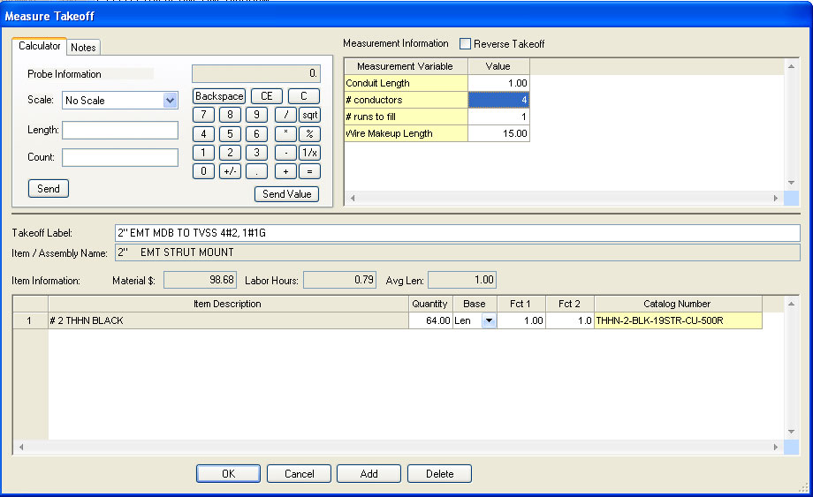
1
2
Enter in the Conduit Length recorded on your
FEEDER TAKEOFF SHEET
# conductors = 4
# runs to fill = 1
Wire Makeup Length = 15%
Click OK
Fig. 8

Add the FEEDER WIRE (GROUND CONDUCTOR)

Double Click on:
[Line 36] #2 THHN GREEN

Change the # of conductors to 1 and click OK
To complete the takeoff right click and select Finish.

Right Click in the Takeoff window to go back to Level 1 and continue the FEEDER Takeoff for this Breakdown.

FEEDER: 1 1/4" EMT MDB TO PNL HB1 4#3, #8G
Conduit
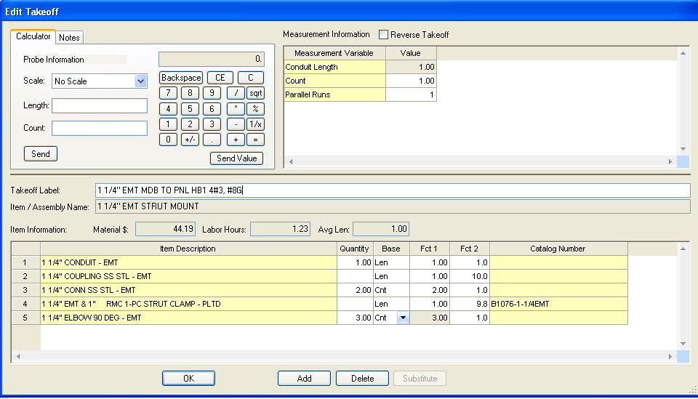
Fig. 9

Wire
(4) #3 THHN BLACK
(1) #8 THHN GREEN

FEEDER: 4" EMT MDB TO PNL H1 4#500 KCMIL, 1#3G
Conduit
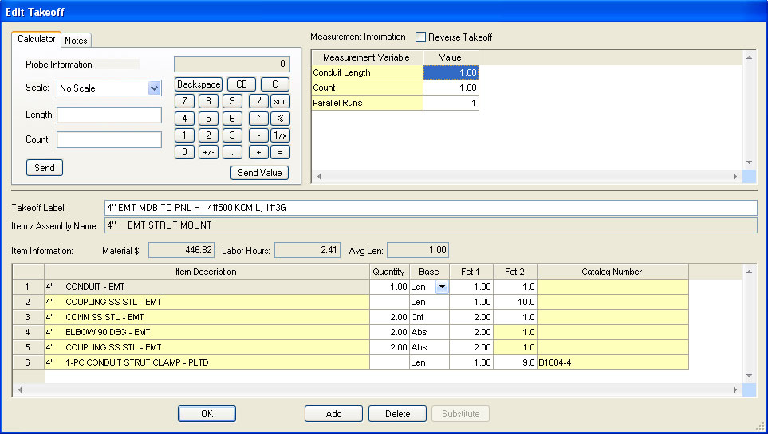
Fig. 10

Wire
(4) #500 THHN BLACK
(1) #3 THHN GREEN

FEEDER: 2 1/2" EMT MDB TO PNL H2 4#4/0, 1#4G
Conduit
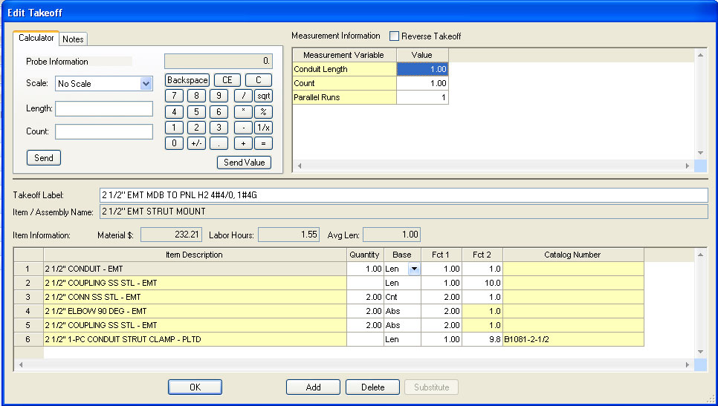
Fig. 11

Wire
(4) #4/0 THHN BLACK
(1) #4 THHN GREEN

Copy and paste the 2 1/2" EMT MDB TO PNL H2 4#4/0, 1#4G takeoff into the audit trail.
Rename the Takeoff Label to 2 1/2" EMT MDB TO PNL H3 4#4/0, 1#4G and change the conduit length to the length recorded on your FEEDER TAKE OFF SHEET.
Be sure to Finish the Takeoff.

Copy and paste the 2 1/2" EMT MDB TO PNL H2 4#4/0, 1#4G takeoff into the audit trail.
Rename the Takeoff Label to 2 1/2" EMT MDB TO PNL H4 4#4/0, 1#4G and change the conduit length to the length recorded on your FEEDER TAKE OFF SHEET.
Be sure to Finish the Takeoff.

Change the Breakdown as follows:

Breakdown
DRAWING: E5.1 ELECTRICAL ONE LINE DIAGRAM
PHASE: FIRST FLOOR
SYSTEM: 04 FEEDERS
Lb FACTOR: STANDARD

Continue the FEEDER Takeoff for this Breakdown (next page).

FEEDER: 1 1/2" LT FLEX PNL H1 TO TL1 PRIMARY
Conduit
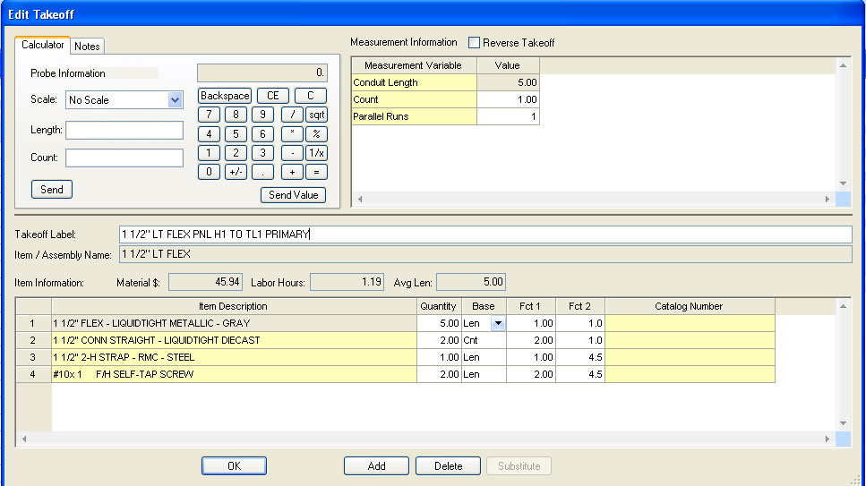
Fig. 12

Wire
(3) #2 THHN BLACK
(1) #8 THHN GREEN

FEEDER: 2 1/2" LT FLEX TL1 TO PNL L1 SECONDARY
Conduit
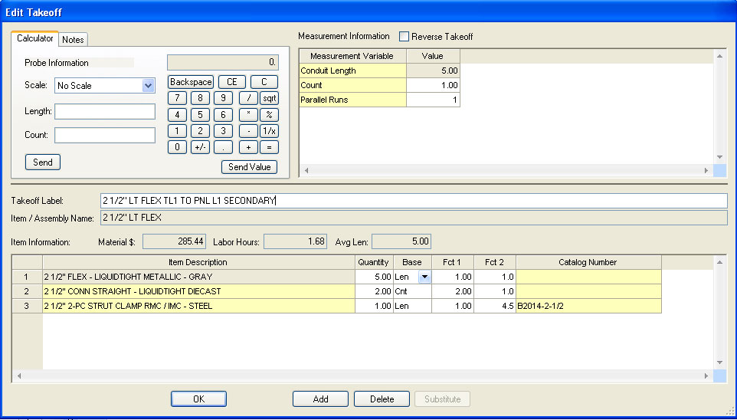
Fig. 13

Wire
(4) #4/0 THHN BLACK
(1) #4 THHN GREEN

Change the Breakdown as follows:
Breakdown
DRAWING: E5.1 ELECTRICAL ONE LINE DIAGRAM
PHASE: Typical FLOORS 2-4
SYSTEM: 04 FEEDERS
Lb FACTOR: STANDARD

FEEDER: 1 1/4" LT FLEX PNL HT TO TLT PRIMARY
Conduit
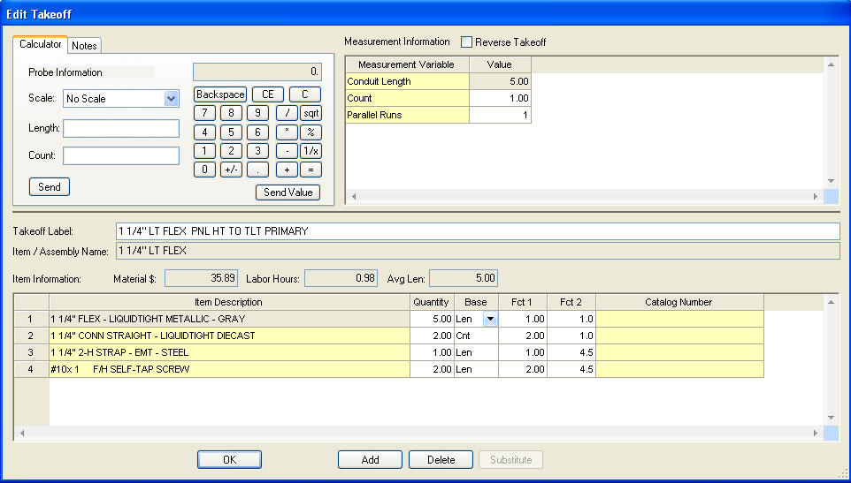
Fig. 14

Wire
(3) #4 THHN BLACK
(1) #8 THHN GREEN

FEEDER: 2" LT FLEX TLT TO LT SECONDARY
Conduit
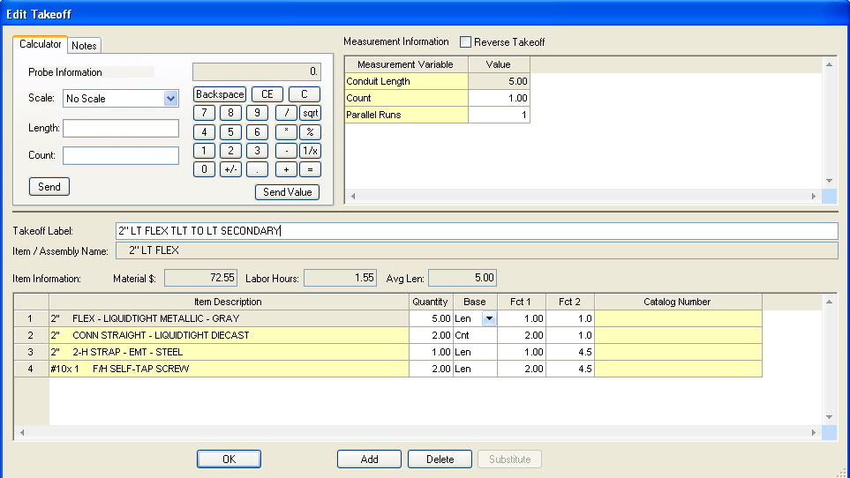
Fig. 15
Wire
(4) #1/0 THHN BLACK
(1) #6 THHN GREEN

- Modify the following takeoffs:
Breakdown
DRAWING: E5.1 ELECTRICAL ONE LINE DIAGRAM
PHASE: SITE
SYSTEM: 04 FEEDERS
Lb FACTOR: TRENCH 4-RUNS

3x4" PVC PRIMARY SERVICE TO XFMR
Add a 1/4" POLYROPE (M) (1 per conduit + 15%)

Breakdown
DRAWING: E5.1 ELECTRICAL ONE LINE DIAGRAM
PHASE: SITE
SYSTEM: 04 FEEDERS
Lb FACTOR: TRENCH 6-RUNS

5x4" PVC XFMR TO MDB
Add a 1/4" POLYROPE (M) (1 per conduit + 15%)
Add (5) 4" DIAM CORE 6" THICK WALL
Add (5) 4" Sleeve and Seal

Breakdown
DRAWING: E5.1 ELECTRICAL ONE LINE DIAGRAM
PHASE: BASEMENT
SYSTEM: 04 FEEDERS
Lb FACTOR: STANDARD

4" EMT MDB TO PNL H1 4#500 KCMIL, 1#3G
Add a 4" Sleeve and Seal

2 1/2" EMT MDB TO PNL H2 4#4/0, 1#4G
Add a 2 1/2 " Sleeve and Seal

2 1/2" EMT MDB TO PNL H3 4#4/0, 1#4G
Add a 2 1/2 " Sleeve and Seal

2 1/2" EMT MDB TO PNL H4 4#4/0, 1#4G
Add a 2 1/2 " Sleeve and Seal

- SAVE your estimate!
- Don’t forget to COLOR YOUR PLANS and RED LINE the feeder take off sheet!

