CM 352 – Electrical Construction Estimating
Accubid Activity #7
Accubid Office Building – SYS 05 MOTOR BR. BRANCH /EQUIP CONNECT

Procedure
- Prepare the MOTOR BRANCH TAKE OFF SHEET and measure and record the length (LFT/T/90°) of each conduit listed on the MOTOR BRANCH TAKE OFF SHEET.

Copying Take Off from One Estimate to Another
Accubid allows users to copy takeoff from one estimate to another.

To copy the 05 MOTOR BR. BRANCH/EQUIP CONNECT takeoff from the estimate Accubid Office Building – MOTORS to YOUR estimate complete the following steps:
- Obtain a copy of the Accubid Office Building – MOTORS from http://lorisweb.com/cmgt352.html To save the file to your hard drive or USB drive right click on the file name Accubid Office Building – MOTORS and select save target as.
Copy the file to C:\Program Files\Accubid data\JOBDATA folder on your computer’s hard drive.
- Start Accubid and open the Job: Accubid Office Building – MOTORS.
- Setup Accubid to display the entire audit trail by un-checking all the Breakdown filter check boxes as shown in Fig. 1.
- Select the entire list of takeoff in the Audit Trail Description list by clicking on Line 1, press and hold down the shift key, and press the down arrow until all takeoff is highlighted.
- Release the Shift key.
- Right click and select Copy. (This copies all of the selected takeoff to the Windows clipboard.)
- Close the estimate and open your estimate: Accubid Office Building – your initials
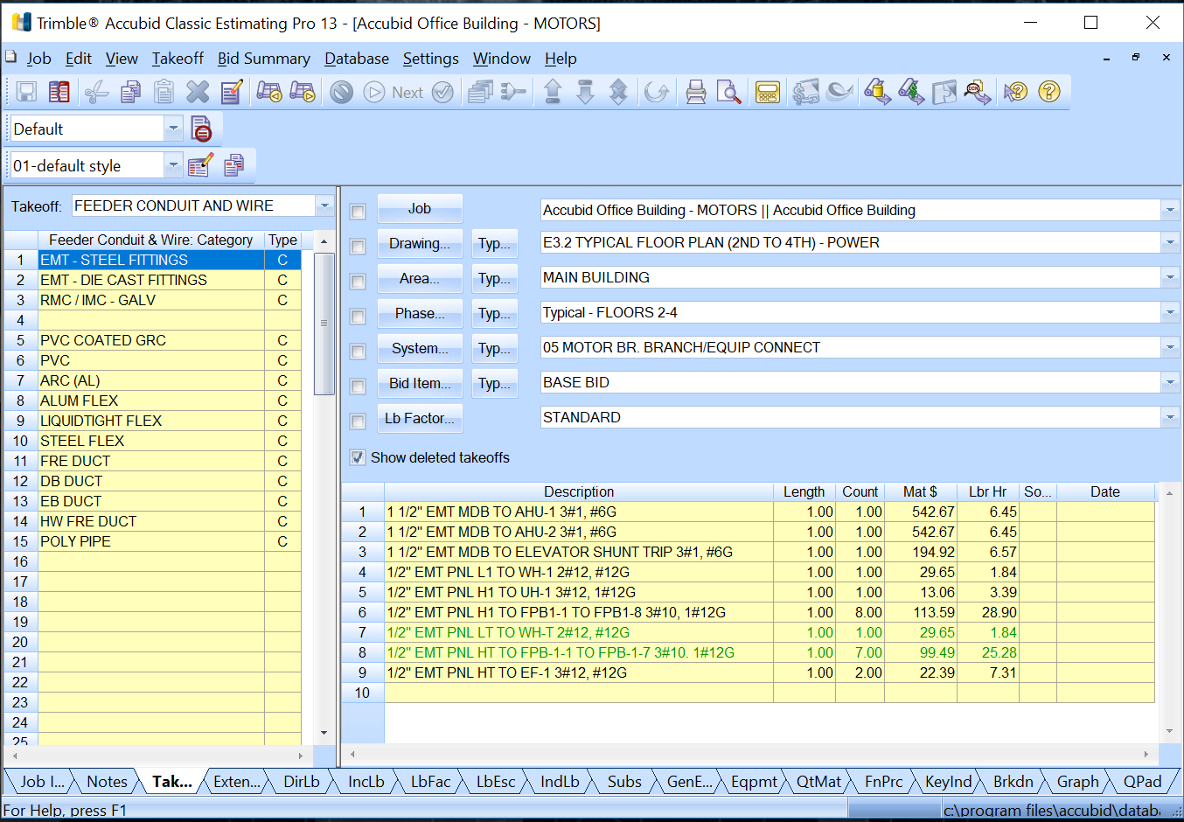
Fig. 1
- Change the Breakdown as follows:
Breakdown
DRAWING: E3.0 BASEMENT FLOOR PLAN - POWER
PHASE: BASEMENT
SYSTEM: 05 MOTOR BR. BRANCH/EQUIP CONNECT
Lb FACTOR: STANDARD

- Right click in the Audit Trail Description box and select Paste.

- In the Paste Takeoffs dialog box under Breakdown Options select “Retain all settings” and leave all other boxes unchecked as shown in Fig. 2 and click OK.
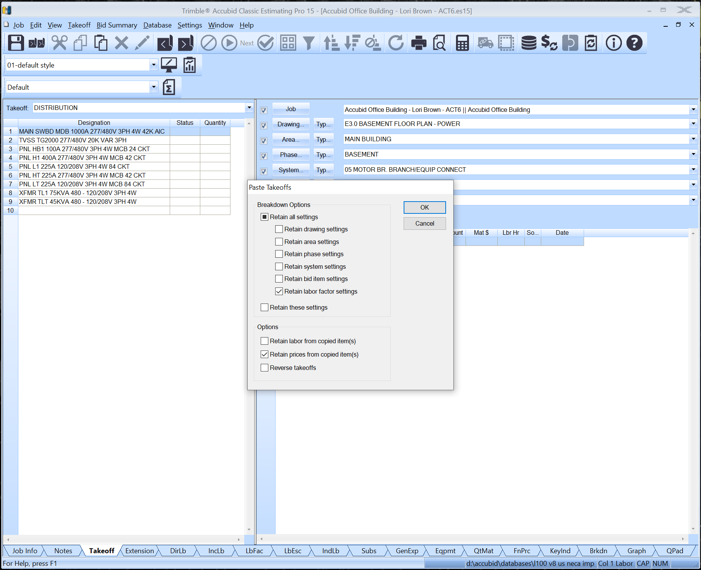
Fig. 2

- Using the Change Breakdown command (Right Click on the Take Off in the audit description list) move the takeoff to the correct Breakdown.

Breakdown
DRAWING: E3.0 BASEMENT FLOOR PLAN - POWER
PHASE: BASEMENT
SYSTEM: 05 MOTOR BR. BRANCH/EQUIP CONNECT
Lb FACTOR: STANDARD

1 1/2" EMT MDB TO DISC. SW. - AHU-1 3#1, #6G
1 1/2" EMT MDB TO DISC. SW. - AHU-2 3#1, #6G
1/2" EMT MDB TO ELEVATOR SHUNT TRIP 3#1, #6G

Breakdown
DRAWING: E3.1 FIRST FLOOR PLAN - POWER
PHASE: FIRST FLOOR
SYSTEM: 05 MOTOR BR. BRANCH/EQUIP CONNECT
Lb FACTOR: STANDARD

1/2" EMT PNL H1 TO WH-1 3#12
1/2" EMT PNL H1 TO UH-1 3#12, 1#12G
1/2" EMT PNL H1 TO FPB1-1 TO FPB1-8 3#10, 1#12G

Breakdown
DRAWING: E3.3 ROOF PLAN - POWER
PHASE: FOURTH FLOOR
SYSTEM: 05 MOTOR BR. BRANCH/EQUIP CONNECT
Lb FACTOR: STANDARD

1/2" EMT PNL HT TO EF-1 3#12, #12G

Breakdown
DRAWING: E3.2 TYPICAL FLOOR PLAN (2ND TO 4TH) – POWER
PHASE: Typical – FLOORS 2-4
SYSTEM: 05 MOTOR BR. BRANCH/EQUIP CONNECT
Lb FACTOR: STANDARD

1/2" EMT PNL HT TO WH-T 3#12
1/2" EMT PNL HT TO FPB-1-1 TO FPB-1-7 3#10. 1#12G

- Edit the length of each of the Motor Branch Conduits using the values recorded on your MOTOR BRANCH TAKE OFF SHEET.
- Color your plans and red line your take off sheet!
- Save your estimate.

https://www.reddit.com/r/electricians/comments/doryqm/just_some_conduit_porn_for_your_morning/

