CM 352 – Electrical Construction Estimating
Accubid Activity #8
Accubid Office Building– SYS 21 FIRE ALARM SYSTEM

Fire Alarm System Devices
Procedure
- Start the program Accubid Pro 15
- Press the CAPS LOCK Key ON
- From the Job Schedule Screen open the file, Accubid Office Building.
- If not already selected, select the Takeoff tab at the bottom of the screen.
- Make sure that the L100 v8 us neca imp is the currently selected database. If not, switch to it by clicking on the Database menu and choosing the Select command.
- Set the breakdown labels as shown in Figure 1.
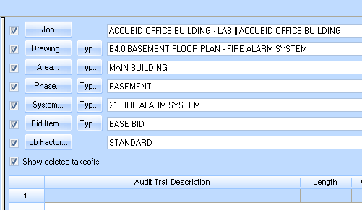
Figure 1

Choose from the Takeoff: COMMON ASSEMBLIES and double click on [Line 22] SYSTEMS – FIRE ALARM ****
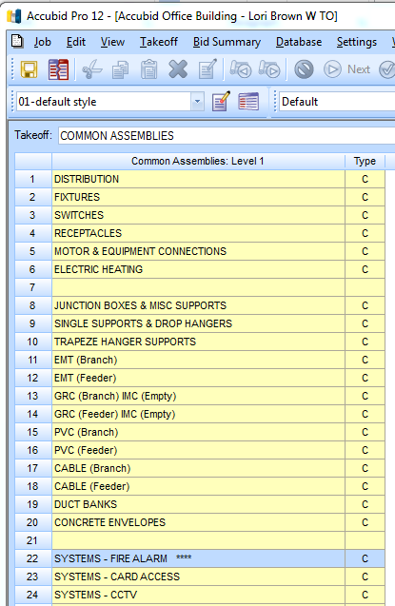
Figure 2
Note: All of the Fire Alarm devices for the Accubid Office Building can be found in the SYSTEMS – FIRE ALARM **** Common Assemblies: Level 2 (Figure 3).
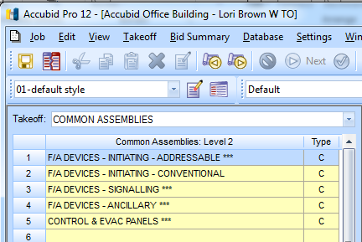
Figure 3

- Using these Common Assemblies and your FAS Take Off Sheet, add the Fire Alarm devices to your estimate. Be sure to change the breakdown labels when appropriate.

- For example, to take off the Smoke Detectors:
Double click on [Line 1] F/A DEVICES – INITIATING – ADDRESSABLE***
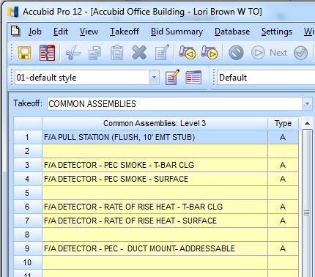
Smoke Detector
Heat Detector
Duct Detector
Pull Station
Figure 4

Fire Alarm System Branch
- Change the Takeoff to, Takeoff: BRANCH CONDUIT AND WIRE
- Set the Breakdown as shown in Figure 5
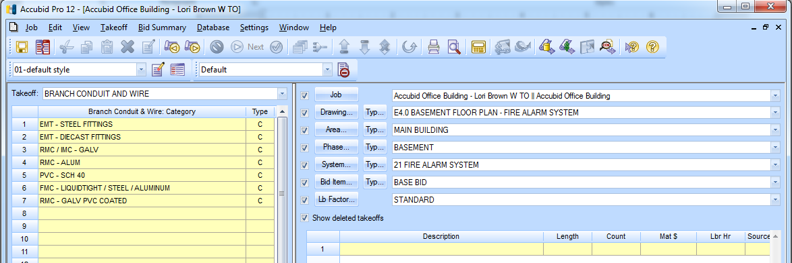
Figure 5

- In the Takeoff: BRANCH CONDUIT AND WIRE double click on:
[Line 1] EMT – STEEL FITTINGS
[Line 2] 3/4" EMT - STEEL SET SCREW W/ BOX
[Line 8] 3/4" EMT STRUT MNT

- In the Measure Takeoff window change the Conduit Length and Count to the value recorded on your FAS Take Off Sheet. Then click the OK button.
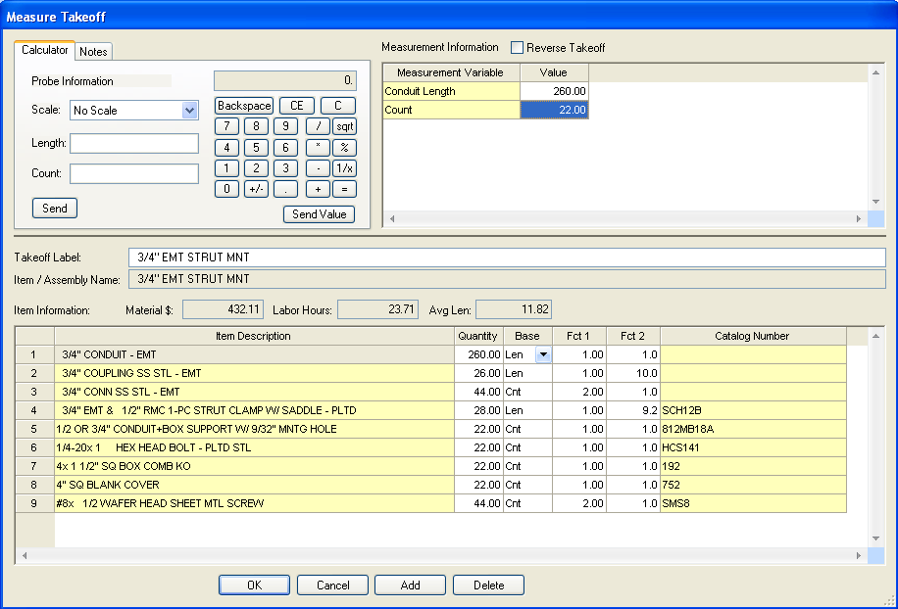
Figure 6

- From the Takeoff: BRANCH CONDUIT FITTINGS: Type add (1) 3/4" Sleeve & Seal
[Line 7] 3/4" SLEEVE & SEAL

- Click on Next Step.
- From the Takeoff: BRANCH WIRE: Type add the #18-2 PR FA Cable
[Line 11] #18 #18 AWM-105 (FA CABLE)
[Line 2] #18- 2P F/A CABLE 105 DEG

- Verify that the Conduit Length, # of Conductors and Wire Makeup % are what you want to add to your estimate and then click the OK button.
- Right click in the audit trail area to finish the takeoff and rename the takeoff to:
3/4" EMT STRUT MNT #18-2PR FAC INPUT – BSMT

- Repeat for the other branch conduits in the basement and name the takeoffs as follows:
3/4" EMT STRUT MNT 4/12 THHN FAC OUTPUT – BSMT
1/2" EMT STRUT MNT 2/14 FAC SHUTDOWN – BSMT

Your completed take off for the basement portion of the FAS should look similar to the take off shown in Figure 7.
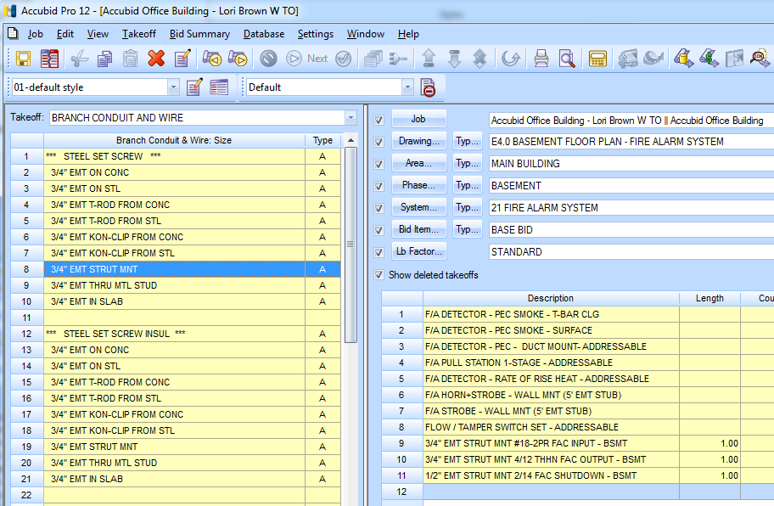
Figure 7

- Add the remaining FAS Branch to the estimate. Be sure to set the BREAKDOWN before taking off any material. Use the following names for each takeoff:
First Floor
3/4" EMT STRUT MNT #18-2PR FAC INPUT – FIRST FLOOR
3/4" EMT STRUT MNT 4/12 THHN FAC OUTPUT - FIRST FLOOR
3/4" EMT STRUT MNT #18-2PR FAC - FACP TO FAAP - FIRST FLOOR

Second and Third Floors
3/4" EMT STRUT MNT #18-2PR FAC INPUT – SECOND & THIRD FLOORS
3/4" EMT STRUT MNT 4/12 THHN FAC OUTPUT - SECOND & THIRD FLOORS

Fourth Floor
3/4" EMT STRUT MNT #18-2PR FAC INPUT – FOURTH FLOOR
3/4" EMT STRUT MNT 4/12 THHN FAC OUTPUT – FOURTH FLOOR

- Save your estimate. Close the file.

