CM 352 – Electrical Construction Estimating
Accubid Activity #9
Accubid Office Building – 07 LIGHTING BRANCH

Procedure
- Obtain your 07 LIGHTING BRANCH completed take off sheet.
- Start the program Accubid Pro 15
- Press the CAPS LOCK Key ON
- From the Job Schedule Screen open the file, Accubid Office Building.
- If not already selected, select the Takeoff tab at the bottom of the screen.
- Set the Breakdown as shown in Figure 1.
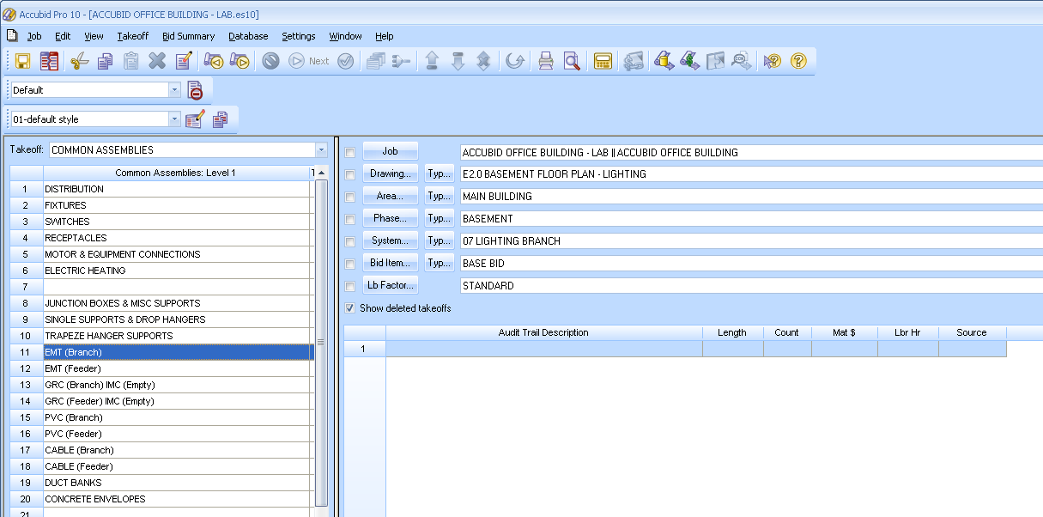
Figure 1

- Choose COMMON ASSEMBLIES from the drop down list in the Takeoff: area of the screen.
- Double click:
[Line 11] EMT (Branch)
[Line 7] EMT STL SS STRUT MOUNT - THHN
[Line 2] 1/2" EMT STRUT MNT 3 #12

- In the Measure Takeoff window make the changes as shown in Figure 2.
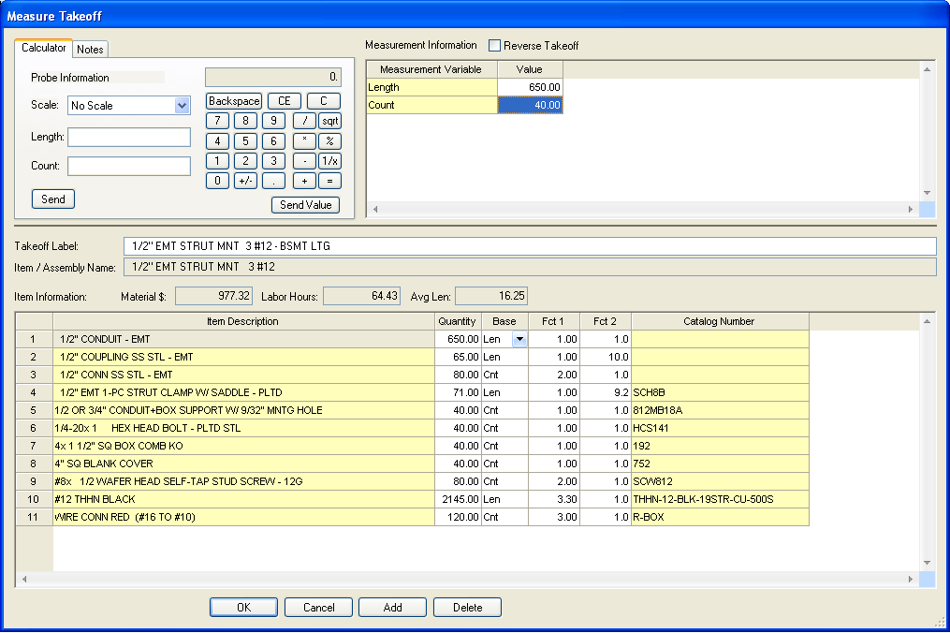
Change the Length and Count (Runs) values to the numbers on your takeoff sheet.
Edit the Takeoff Label as shown.
Figure 2

- Click the OK Button. Using a red pencil draw a RED LINE through the value you just entered into your Accubid estimate that is shown on your takeoff sheet, or else you will be electrocuted.
- The Lighting Branch takeoff appears in the Audit Trail Description as shown in Figure 3.
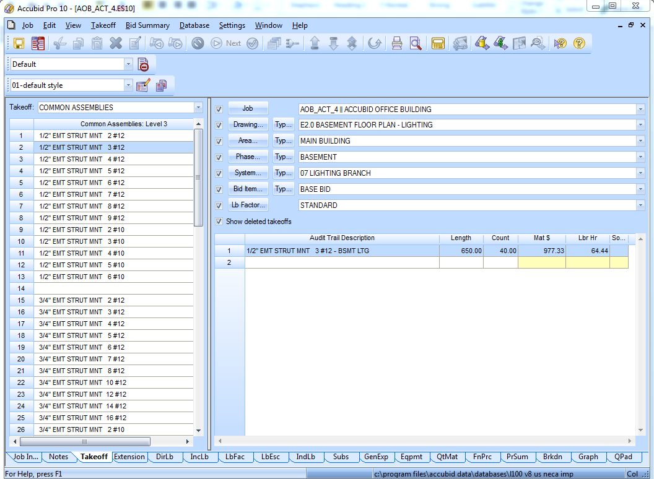
Figure 3
- In the Takeoff: COMMON ASSEMBLIES Level 3 still displays. Double click on the line that correlates to your next Branch Lighting takeoff, i.e.
[Line 3] ½” EMT STRUT MNT 4#12
[Line 4] ½” EMT STRUT MNT 5#12
[Line 5] ½” EMT STRUT MNT 6#12
[Line 6] ½” EMT STRUT MNT 7#12
[Line 7] ½” EMT STRUT MNT 8#12
[Line 9] ½” EMT STRUT MNT 9#12

- In the Measure Takeoff window edit the Length, Count, and Takeoff Label.
i.e.
½” EMT STRUT MNT 4#12 – BSMT LTG
½” EMT STRUT MNT 5#12 – BSMT LTG
Etc….

- Change the Breakdown as shown in Figure 4 and repeat the steps for the First Floor Lighting Branch. Be sure to edit the Takeoff Label, i.e 1/2" EMT STRUT MNT 4#12 – FIRST FLR LTG
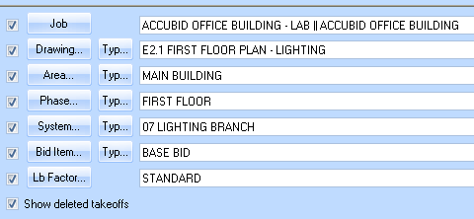
Figure 4

- To takeoff the MC Cable use COMMON ASSEMBLIES and Double Click:
[Line 17] CABLE (Branch)
[Line 1] MC CABLE
[Line 2] #12/2C MC CABLE

- In the Measure Takeoff window edit the Length, Count, and Takeoff Label. See Figure 5.

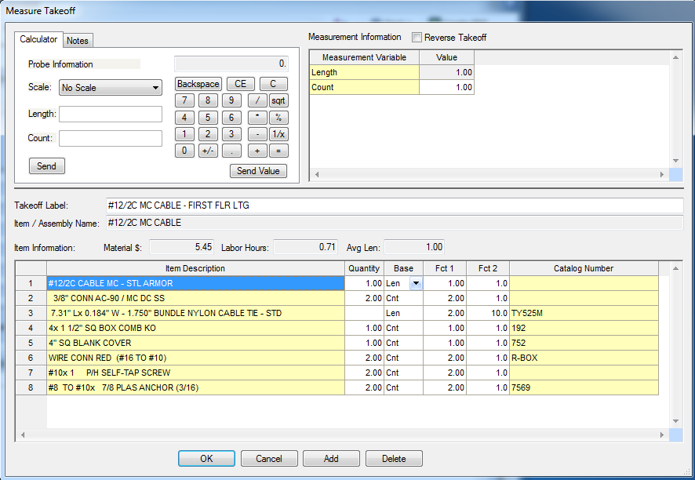
Figure 5

- Change the Breakdown as shown in Figure 6 and repeat the steps for the TYP Floors 2-4 Lighting Branch. Be sure to edit the Takeoff Label, i.e 1/2" EMT STRUT MNT 4#12 – TYP FLRS 2-4 LTG
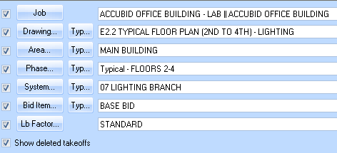
Figure 6

- Save your estimate.

