CM 352 – Electrical Construction Estimating
Accubid Activity #12
Accubid Office Building - 44 INCOMING SERVICE - POWER

INCOMING SERVICE - POWER
Procedure
- Start the program Accubid Pro 15
- Press the CAPS LOCK Key ON
- From the Job Schedule Screen open the file, Accubid Office Building.
- If not already selected, select the Takeoff tab at the bottom of the screen.
- Make sure that the L100 v8 us neca imp is the currently selected database. If not, switch to it by clicking on the Database menu and choosing the Select command.
- In the Accubid Takeoff Screen set the Breakdown as follows:
Breakdown
DRAWING: E5.1 ELECTRICAL ONE LINE DIAGRAM
PHASE: SITE
SYSTEM: 04 FEEDERS
Lb FACTOR: TRENCH 4 RUNS
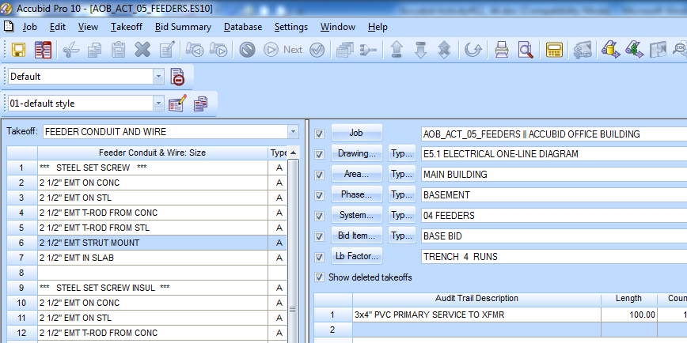
Figure 1

- In the Audit Tail Description right click on the takeoff 3x4" PVC PRIMARY SERVICE TO XFMR and click on the Change Breakdown command.
- In the Change Breakdown window select System: 44 INCOMING SERVICE – POWER and Click OK.
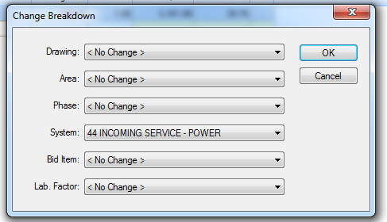
Figure 2
- In the Accubid Takeoff Screen set the Breakdown as shown in Figure 3 and verify in the Audit Trail Description that the Takeoff has been moved.
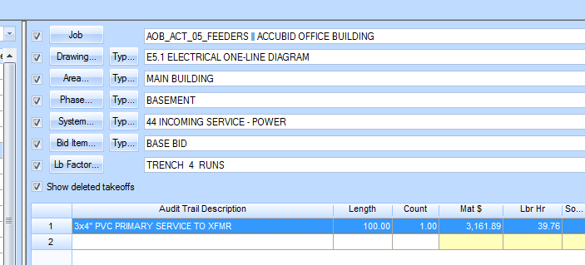
Figure 3

- Save your Estimate.

