CM 352 – Electrical Construction Estimating
Accubid Activity #13
Accubid Office Building - 45 INCOMING SERVICE - TELEPHONE

INCOMING SERVICE - TELEPHONE
Procedure
- Start the program Accubid Pro 15
- Press the CAPS LOCK Key ON
- From the Job Schedule Screen open the file, Accubid Office Building.
- If not already selected, select the Takeoff tab at the bottom of the screen.
- Make sure that the L100 v8 us neca imp is the currently selected database. If not, switch to it by clicking on the Database menu and choosing the Select command.
- Set the breakdown labels as shown in Figure 1.

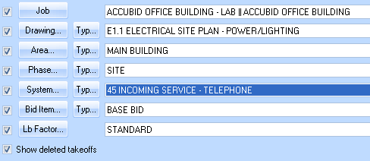
Figure 1

- Choose FEEDER CONDUIT AND WIRE from the drop down list in the Takeoff: area of the screen.
Double click:
[Line 6] PVC
[Line 10] 4" PVC (TRENCH)

- In the Create/Modify Takeoff Description window edit the Takeoff Label as shown in Figure 3 and then click OK.
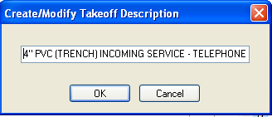
Figure 3

- In the Measure Takeoff window enter in the Conduit Length, Count, and the number of Parallel Runs from your takeoff sheet and make changes to the Item Description and Fct 1and Fct 2 as shown in Figure 4.

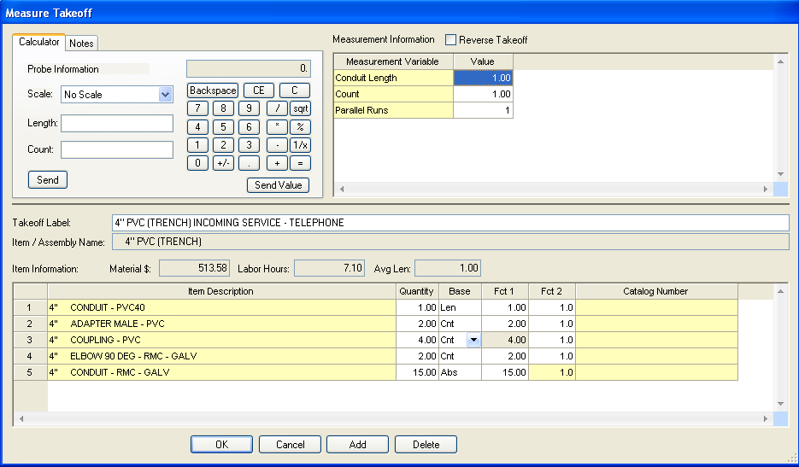
Figure 4

- From the next takeoff window, FEEDER CONDUIT FITTINGS, add a 1/4" POLYROPE (M).
- Right click in the Audit Trail window and click Finish.
- Change the Breakdown as shown in Figure 5.
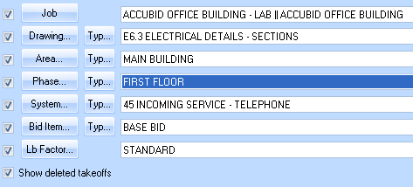
Figure 5

- Choose FEEDER CONDUIT AND WIRE from the drop down list in the Takeoff: area of the screen.
Double click:
[Line 1] EMT - STEEL FITTINGS
[Line 6] 2" EMT - STEEL SS
[Line 6] 2" EMT STRUT MOUNT

- In the Create/Modify Takeoff Description box edit the takeoff label to 2" EMT STRUT MOUNT - FIRST FLOOR TELE/COMM RISER, and then click OK.

- In the Measure Takeoff window enter in the Conduit Length, Count, and Parallel Runs and click OK.
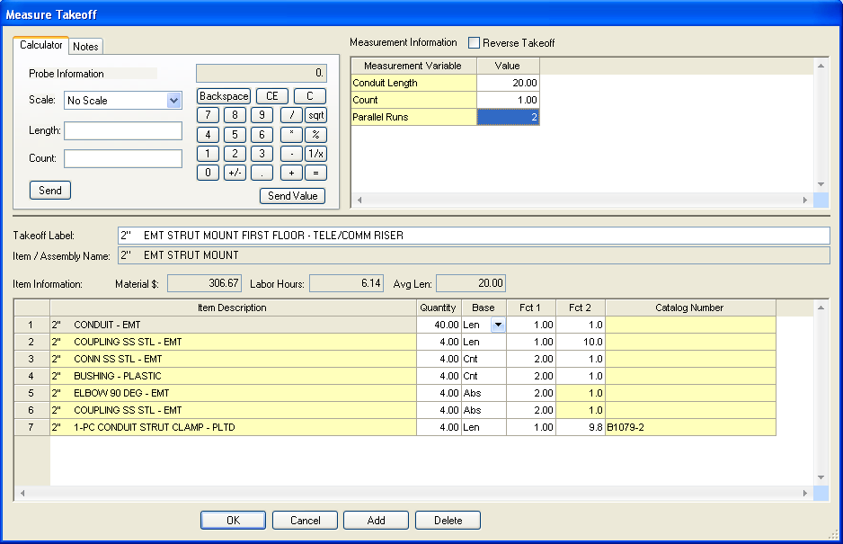
Figure 6

- Click the Next button on the toolbar.
- Double click on:
[Line 10] WIRE PULLING
[Line 7] POLYTWINE

- In the Measure Takeoff window change # conductors value to 1 and click OK.
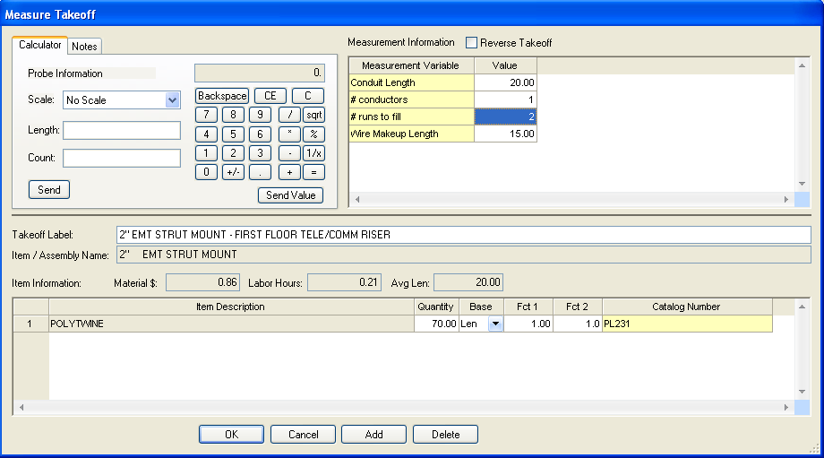
Figure 7.
- Right click in the Audit trail description area and click Finish.
- Right click on the 2" EMT STRUT MOUNT - FIRST FLOOR TELE/COMM RISER in the Audit Description Area and click on the Copy command from the menu.
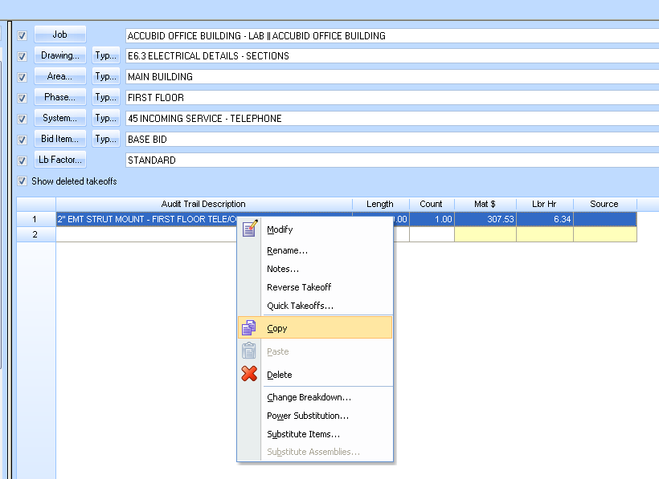
Figure 8

- Change the Breakdown as shown in Figure 9.
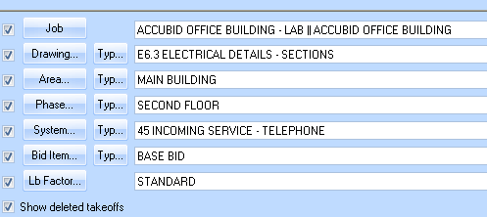
Figure 9

- Right click in the Audit Trail Description Area and click on Paste. In the Paste Takeoffs window make sure Retain all settings in selected and then click OK.
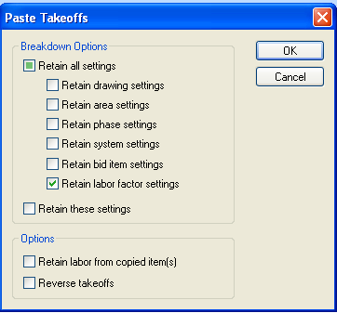
Figure 10

- Right click on the takeoff in the Audit Trail Description and click on Modify.
- Double click on the first Item Description, 2” CONDUIT – EMT, in the takeoff.
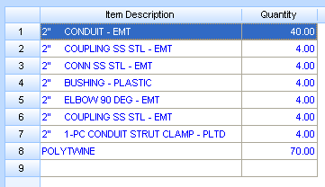
Figure 11

- In the Edit Takeoff window change the Conduit Length value and the Takeoff Label as shown in Figure 12. Click OK.

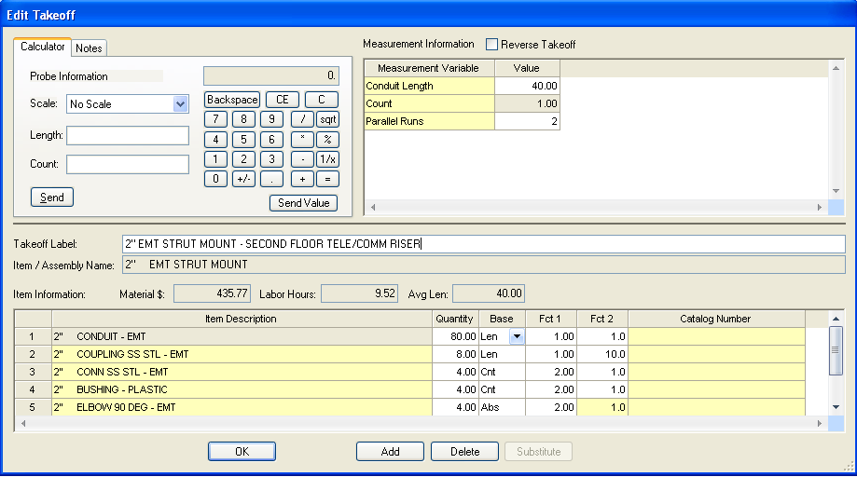
Figure 12

- Right click in the Audit trail description area and click Finish.
- Repeat the process for the third and fourth floor:
2" EMT STRUT MOUNT - THIRD FLOOR TELE/COMM RISER
2" EMT STRUT MOUNT - FOURTH FLOOR TELE/COMM RISER
- Save your estimate.

