**CM 352 – Electrical Construction Estimating**

lightbul

**Accubid Activity #16**

**Accubid Office Building – 38 GROUNDING**

**Procedure**

1. Start the program Accubid Pro 15
2. Press the CAPS LOCK Key ON
3. From the Job Schedule Screen open the file, Accubid Office Building.
4. If not already selected, select the Takeoff tab at the bottom of the screen.
5. Make sure that the **L100 v8 us neca imp** is the currently selected database. If not, switch to it by clicking on the Database menu and choosing the Select command.
6. Set the Breakdown as shown in Figure 1:

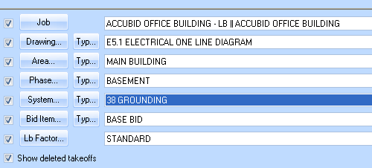

Figure 1

1. In the takeoff area, choose Takeoff: FEEDER CABLE

Double click on:

[Line 8] GROUNDING

[Line 9] #2/0 BARE-CU

1. In the Create/Modify Takeoff Description window change the Takeoff Description as shown in Figure 2 and Click OK.

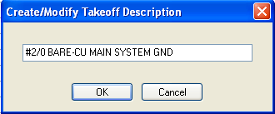

Figure 2

1. In the Measure takeoff window change the Cable Length to 75.00 and click OK.

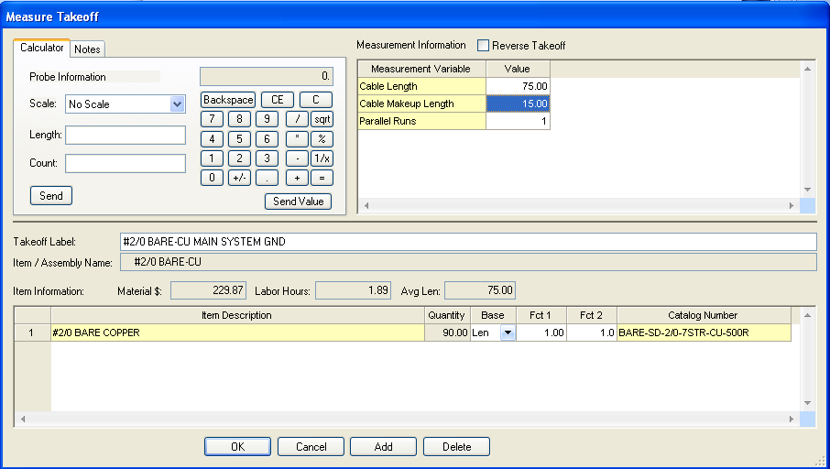

Figure 3

1. From the Takeoff: ITEM DATABASE continue adding the items and quantities as shown in Figure 4 (Traverse Codes are shown next to each item). Add the CONNECT OWNER’S 500 KVA from Takeoff: TEMPORARY ITEMS.

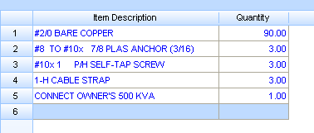

ITEM DATABASE

8, 2, 10, 2

8, 5, 2, 22

4, 6, 2, 1

TEMPORARY ITEMS

Figure 4

1. Right click in the Item Description list in the Audit Trail Description area and click Finish. The takeoff displays in the Audit Trail Description as shown in Figure 5.

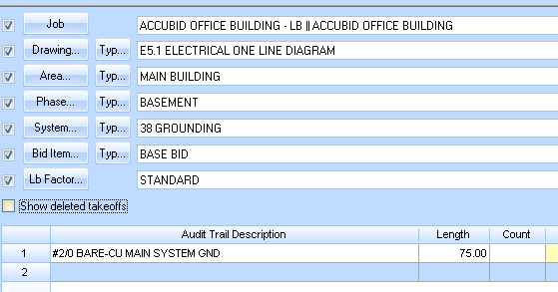

Figure 5

1. In the takeoff area, choose Takeoff: FEEDER CABLE

Double click on:

[Line 8] GROUNDING

[Line 3] #6 BARE-CU

1. In the Create/Modify Takeoff Description window change the Takeoff Description as shown in Figure 6 and Click OK.

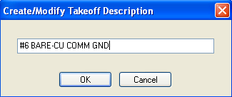

Figure 6

1. In the Measure Takeoff window change the Cable Length to 20.00 and Cable Makeup Length to 5.00 as shown in Figure 7 and click OK.

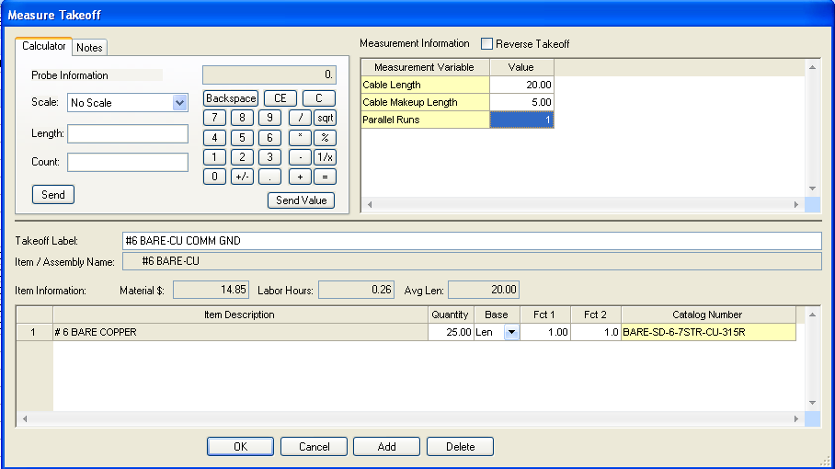

Figure 7

1. Add the items shown in Figure 8 to the Item Description list takeoff. When completed, right click on the Item Description area and click Finish.

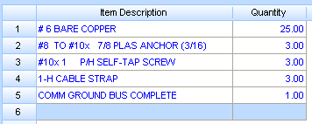

ITEM DATABASE

8, 2, 10, 2

8, 5, 2, 22

4, 6, 2, 1

TEMPORARY ITEMS

Figure 8

1. Set the Breakdown as shown in Figure 9.

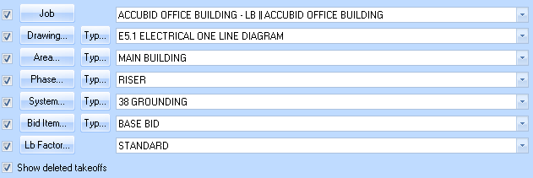

Figure 9

1. Choose Takeoff: FEEDER CABLE

Double click on:

[Line 8] GROUNDING

[Line 9] #2/0 BARE-CU

1. In the Create/Modify Takeoff Description change the description as shown in Figure 10 and click OK.

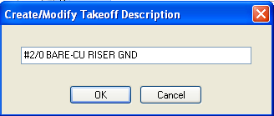

Figure 10

1. In the Measure Takeoff window make the changes shown in Figure 11 and click OK.

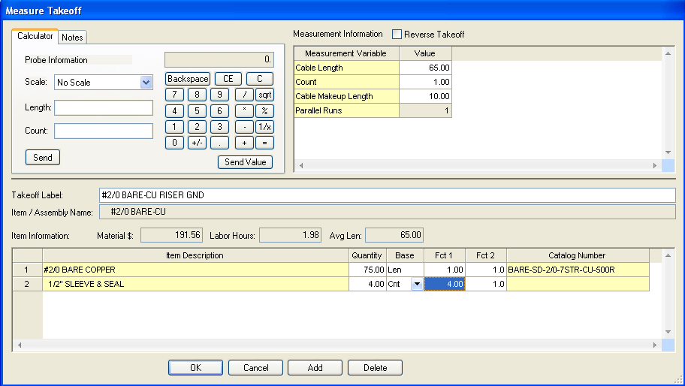

Figure 11

1. From the Takeoff: FEEDER CABLE FITTINGS

Double click:

[Line 15] 1-H CABLE STRAP/ FASTEN (L - 3')

1. In the Measure Takeoff window change the Length to 65 and click OK.

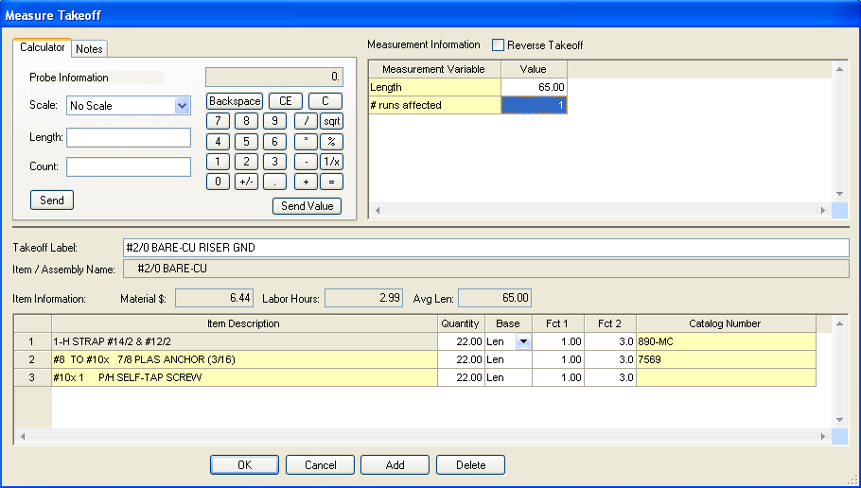

Figure 12

1. Add the TEMPORARY ITEM, SUB ER GROUND BUS COMPLETE (Count = 4) to the takeoff. Right click in the Item Description and click Finish.

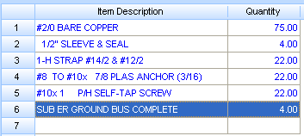

Figure 13

1. Choose Takeoff: FEEDER CABLE

Double click on:

[Line 8] GROUNDNG

[Line 3] #6 BARE-CU

1. Change the Takeoff Description to: #6 BARE-CU COMM RISER GND and click OK.

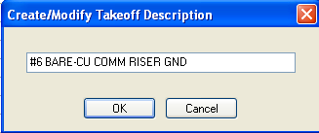

Figure 14

1. In the Measure Takeoff window make the changes shown in Figure 15 and click OK.

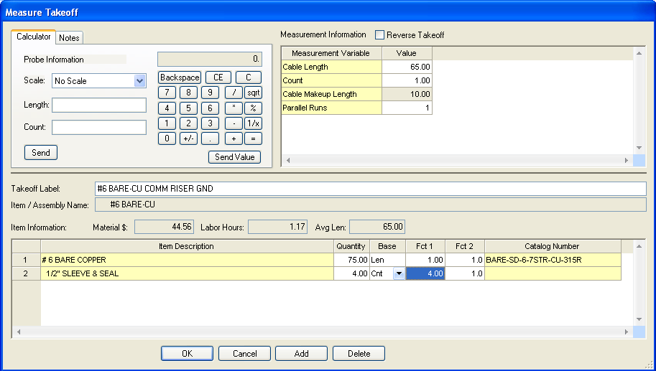

Figure 15

1. From the Takeoff: FEEDER CABLE FITTINGS

Double click:

[Line 15] 1-H CABLE STRAP/ FASTEN (L - 3')

1. In the Measure Takeoff window change the Length to 65 and click OK.
2. Add the TEMPORARY ITEM, COMM GROUND BUS COMPLETE (Count = 4) to the takeoff. Right click in the Item Description and click Finish.

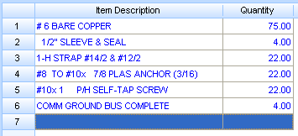

Figure 16

1. Change the Breakdown as shown in Figure 17.

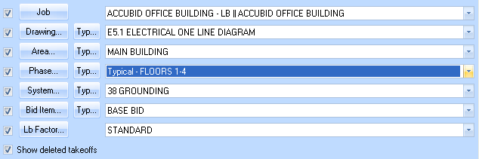

Figure 17

1. Using Takeoff: FEEDER CABLE

Double Click on:

[Line 8] GROUNDING

[Line 3] #6 BARE-CU

1. Edit the Takeoff Description as shown in Figure 18 and click OK.

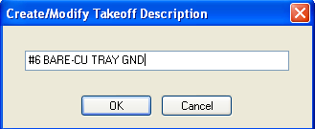

Figure 18

1. Make the changes shown in Figure 19 and click OK.

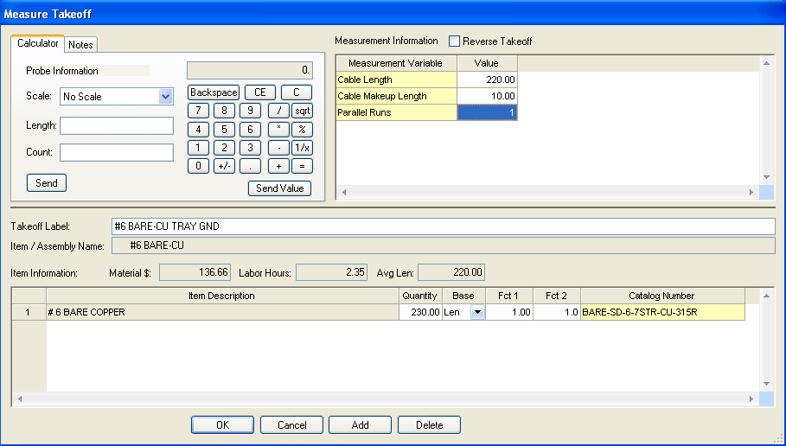

Figure 19

1. Using the ITEM DATABASE add the items and quantities as shown in Figure 20, and right click then click on Finish to complete the takeoff.

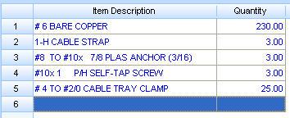

ITEM DATABASE

8, 2, 10, 2

8, 5, 2, 22

4, 6, 2, 1

7, 4, 10

Figure 20

1. Using Takeoff: FEEDER CABLE

Double Click on:

[Line 8] GROUNDING

[Line 3] #6 BARE-CU

1. Edit the Takeoff Description as shown in Figure 21 and click OK.

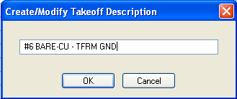

Figure 21

1. Make the changes shown in Figure 22 and click OK.

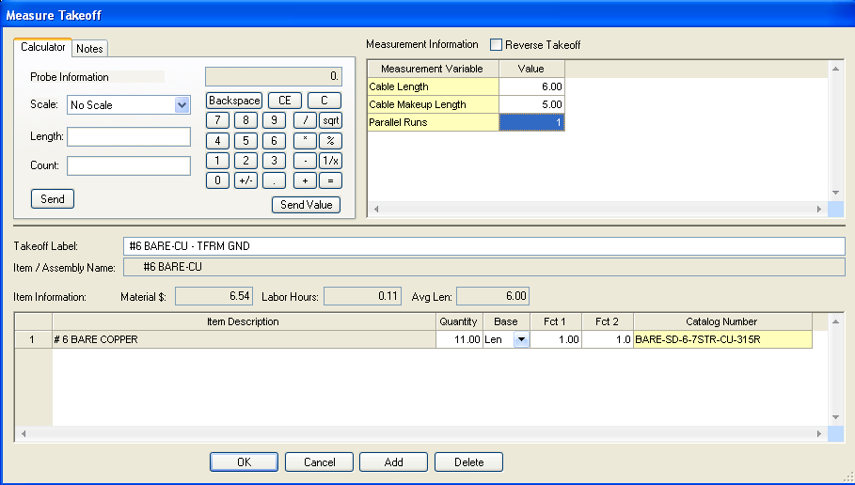

Figure 22

1. From the Takeoff: FEEDER CABLE FITTINGS

Double click:

[Line 15] 1-H CABLE STRAP/ FASTEN (L - 3')

1. In the Measure Takeoff window change the Length to 6 and click OK.
2. Add the ITEM - 3/8" CONN AC-90 / MC DC SS [4, 2, 1, 1] Quantity = 1 to the takeoff.
3. Right Click in the Item Description and click Finish.
4. Using a Green Highlighter color the MDB #2/0 GND and the TRMR #6 GND (TL1, TL2, TL3, & TL4) shown on E5.1 Electrical One-Line Diagram.
5. Save your estimate.