**CM 352 – Electrical Construction Estimating**

lightbul

**Accubid Activity #18**

**Accubid Office Building – 39 LIGHTING CONTROL/DIMMING**

**Procedure**

1. Start the program Accubid Pro 15
2. Press the CAPS LOCK Key ON
3. From the Job Schedule Screen open the file, Accubid Office Building.
4. If not already selected, select the Takeoff tab at the bottom of the screen.
5. Make sure that the **L100 v8 us neca imp** is the currently selected database. If not, switch to it by clicking on the Database menu and choosing the Select command.
6. Set the Breakdown and choose Takeoff: TEMPORARY ASSEMBLIES from the Takeoff list as shown in Figure 1.

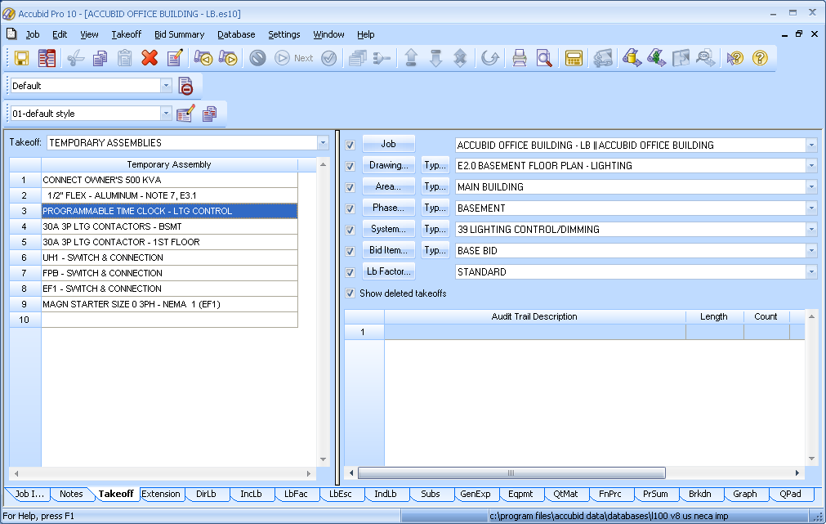

Figure 1

1. Double click on the Temporary Assembly, PROGRAMMABLE TIME CLOCK - LTG CONTROL to add it to your estimate.
2. In the Measure Takeoff window set the Count =1 and click OK.
3. Double click on the Temporary Assembly, 30A 3P LTG CONTACTORS - BSMT to add it to your estimate.
4. In the Measure Takeoff window set the Count =1 and click OK.
5. Change the Breakdown Label, Phase to FIRST FLOOR.
6. Double click on the Temporary Assembly, 30A 3P LTG CONTACTOR - 1ST FLOOR to add it to your estimate.
7. In the Measure Takeoff window set the Count =1 and click OK.
8. Place red lines through the 39 LIGHITNG CONTROL/DIMMING takeoff sheet counts!
9. Save your estimate.