CM 352 – Electrical Construction Estimating
Accubid Office Building
Activity #22 – Exporting to Microsoft Project

Procedure:
- Open your estimate and make sure that you are viewing the Extension screen.
- Group your extension by the organization or breakdown of your job. In this instance group the extension by phase first followed by sort code 7 (labor sort code).
- From the Job menu select Export. The Export dialog box appears.
- From the Export dialog box, select the checkboxes: Extension, Direct Labor, Subcontractors, and Quoted Materials then click the Export to .mpx button.
- In the Export file dialog box select the MS Project (*.mpx) from the “Save as type” list.
- Enter a file name such as ACCUBID OFFICE BUILDING SCHEDULE and then save the file as a MS Project file with the .mpx file extension.
- Click Save.
- To open the file start MS Project and then from the File menu select Open and browse to the folder where the file was saved. The file will open and will display a Gantt chart.

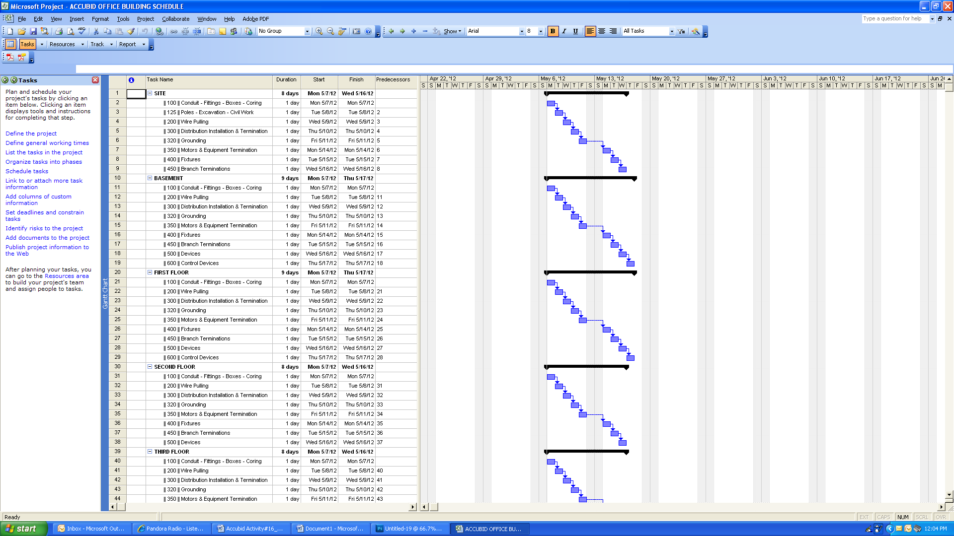
Fig. 1

