LEED for Neighborhood Development
Activity #3
Before completing this Activity Read: Reference Guide for Neighborhood Development v4 – Pages 169-304

Fill-In, Multiple Choice, Matching
Although the LEED ND reference guide does not number the LEED prerequisites and credits, for this exercise they have been numbered in the order presented in the credit category.

- Test your knowledge of how well you know the names of the credits for the Neighborhood Pattern and Design (NPD) credit category:
Credit | Name
P1
P2
P3
C1
C2
C3
C4
C5
C6
C7
C8
C9
C10
C11
C12
C13
C14
C15

- Match the intent shown below to the prerequisite or credit:
Credit | ANS |  | Credit | ANS |  | Credit | ANS
NPD – P1 |  |  | NPD – C4 |  |  | NPD – C10
NPD – P2 |  |  | NPD – C5 |  |  | NPD – C11
NPD – P3 |  |  | NPD – C6 |  |  | NPD – C12
NPD – C1 |  |  | NPD – C7 |  |  | NPD – C13
NPD – C2 |  |  | NPD – C8 |  |  | NPD – C14
NPD – C3 |  |  | NPD – C9 |  |  | NPD – C15

 | INTENT
A | To encourage responsiveness to community needs by involving the people who live or work in the community in project design and planning and in decisions about how the project should be improved or changed over time.
B | To reduce energy consumption, pollution, and harm to human health from motor vehicles by encouraging multimodal travel.
C | To promote projects that have high levels of internal connectivity and are well connected to the community. To encourage development within existing communities that promote transportation efficiency through multimodal transportation. To improve public health by encouraging daily physical activity.
D | To reduce vehicle distance traveled and automobile dependence, encourage daily walking, biking, and transit use, and support car-free living by providing access to diverse land uses.
E | To encourage walking and bicycling and discourage speeding. To reduce urban heat island effects, improve air quality, increase evapotranspiration, and reduce cooling loads in buildings.
F | To conserve land and promote multimodal transportation by encouraging development within existing communities that have high levels of internal connectivity and are well connected to the larger community. To improve public health by encouraging daily physical activity and reducing motor vehicle emissions.
G | To minimize the environmental harms associated with parking facilities, including automobile dependence, land consumption, and rainwater runoff.
H | To encourage transit use and reduce vehicle distance traveled by providing safe, convenient, and comfortable transit waiting areas.
I | To promote community interaction and engagement by integrating schools into the neighborhood. To improve students’ health by encouraging walking and bicycling to school.
J | To promote socially equitable and engaging neighborhoods by enabling residents from a wide range of economic levels, household sizes, and age groups to live in a community.
K | To enhance community participation and improve public health by providing recreational facilities close to work and home that facilitate physical activity and social networking.
L | To provide open space close to work and home that enhances community participation and improves public health.
M | To promote transportation efficiency and reduce vehicle distance traveled. To improve public health by providing safe, appealing, and comfortable street environments that encourage daily physical activity and avoid pedestrian injuries.
N | To promote the environmental and economic benefits of community based food production and improve nutrition through better access to fresh produce.
O | To increase the proportion of areas usable by a wide spectrum of people, regardless of age or ability.
P | To conserve land. To promote livability, walkability, and transportation efficiency and reduce vehicle distance traveled. To leverage and support transit investments. To improve public health by encouraging daily physical activity.

- Neighborhood Pattern and Design emphasizes the creation of ____________________, ____________________, mixed-use neighborhoods with good connections to nearby communities.

- List features that increase pedestrian activity:
1. | 4.
2. | 5.
3. | 6.

- Public spaces, such as parks, plazas, and playing fields, can encourage __________________ interaction and active recreation while helping control ____________________ runoff and reducing urban ____________________ effects.

- NPD Prerequisite: Walkable Streets
Requirements
Design and build the project to achieve all of the following:
- __________ of new buildings have a ____________________ entry onto the ____________________ network or other public space, such as a park or plaza, but not a ____________________ lot. Whether opening to the circulation network or other public space, the functional entry must be connected to a ____________________ or equivalent provision for walking. If the public space is a square, park, or plaza, it must be at least _________ feet (15 meters) deep, measured at a point perpendicular to each entry.

- At least _________ of the block length of the existing and new circulation networks within and bordering the project has a __________________ building-height-to-street-centerline ratio of _________ (i.e., a minimum of _________ foot [300 millimeters] of building height for every _________feet [450 millimeters] of width from street ____________________ to building façade). Alleys may be omitted from the calculations.
- Projects that __________________ a part of the circulation network must meet only their proportional share of the height-to-width ratio (i.e., only on the project side of the circulation network).
- Building __________________ is measured to eaves or, for a flat-roof structure, to the rooftop. For buildings with multiple heights or widths, use __________________ heights or widths weighted by each portion’s share of the total height or width.

- Continuous ____________________ or equivalent all-weather routes for walking are provided along _________ sides of _________ of the circulation network __________________ length within the project, including the project side of circulation network bordering the project. Bicycle- and pedestrian-only paths __________________ this requirement. New sidewalks must be at least _________ feet (2.5 meters) wide on retail or mixed-use blocks and at least _________ feet (1.2 meters) wide on all other blocks.

- No more than _________ of the block length of the circulation network within the project is faced directly by __________________ and service bay openings. __________________ may be omitted from the calculations.

Portions of projects containing __________________ buildings or contributing buildings in a designated historic district subject to review by a local historic preservation entity are __________________ from (b), (c), and (d) if approval for compliance is not granted.

Portions of projects containing __________________ buildings or contributing buildings in historic districts listed in or eligible for listing in a state provincial, or regional register, or the National Register of Historic Places that are subject to review by a state historic preservation office or the National Park Service (or local equivalent for projects outside the U.S.) are __________________ from (b), (c), and (d) if approval for compliance is not granted.

Residents of highly __________________ neighborhoods drive nearly _________ fewer miles (kilometers) than their counterparts in the least walkable neighborhoods; they thereby reduce traffic-related emissions by as much as 2,000 grams of __________________ dioxide per person per day while increasing their physical fitness, social interaction, and neighborhood safety.

List strategies to improve a neighborhood’s walkability:
1.
2.
3.
4.

A __________________ zone, such as __________________ parking or a planting strip between the sidewalk and the street, can greatly enhance a sidewalk’s walkability.

- NPD Prerequisite: Compact Development
Requirements
Design and build the project to meet the __________________ specified below. __________________ densities must be met for both (1) the __________________ project at full build-out and (2) the __________________ of the project that will be built within _________ years of the date that the __________________ new building of any type is occupied.

Case 1. Projects with Access to Quality Transit
For projects with existing or planned transit service (i.e., service with the funding commitments as specified in SLL Prerequisite Smart Location) that meets or exceeds the _________-point threshold in SLL Credit Access to Quality Transit, build at the following densities, based on the walking distances to the transit service specified in that SLL credit:
- for residential components located within the walking distances: _________ or more dwelling buildable land units per acre (30 DU per hectare) of buildable land available for residential uses;
- for residential components falling outside the walking distances: _________ or more dwelling units per acre (17.5 DU per hectare) of buildable land available for residential uses;
- for nonresidential components located within the walking distances: _________ or higher floor-area ratio (FAR) for the buildable land available for nonresidential uses; and
- for nonresidential components falling outside the walking distances: _________ or higher FAR for the buildable land available for nonresidential uses.

If the project location is served by a transit agency whose guidelines for minimum service densities are __________________ than the densities required by this prerequisite, the project __________________ achieve those service densities instead.

Case 2. All Other Projects
Build any ___________________________ components of the project at a density of _________ or more dwelling units per acre (17.5 DU per hectare) of available for residential uses.

Build any ___________________________ components of the project at a density of _________ or higher FAR for the buildable land available for nonresidential uses.

For All Projects
Density calculations include all __________________ and __________________ buildings within the project boundary, excluding those portions of parking __________________ devoted exclusively to parking.

If the __________________ component of the project meets the minimum density requirement but the __________________________ component does not, or vice versa, include only the qualifying density. Use that component’s dwelling units or nonresidential floor area in the numerator and the total buildable land area in the denominator. If the resulting density meets the minimum requirement, the prerequisite is achieved.

- NPD Prerequisite: Connected and Open Community
Requirements
Meet the requirements of Case 1 if the project has no ___________________________ network intersections within the project boundary and is _________ acres or less in size. All other projects must meet Case 2.

Case 1. Surrounding Connectivity
Locate the project such that the connectivity within _________-mile (400 meters) of the project boundary is at least _________ intersections per square mile (35 intersections per square kilometer). Any part of the circulation network that is counted toward the connectivity requirement must be available for general public use and not __________________. Gated areas are not considered available for public use, with the exception of ___________________________ and __________________ care campuses and __________________ bases where gates are used for security purposes.

Additionally, any __________________ network within the project must be available for general public use and not gated.

Case 2. Internal Connectivity
Design and build the project such that its internal connectivity is at least _________ intersections per square mile (54 intersections per square kilometer).

Any part of the ___________________________ network counted toward the connectivity requirement must be available for general public use at all times and not __________________. Additionally, no more than _________ of the project area may be accessed via circulation network that is gated. Education campuses, health care campuses, and military bases where gates are used for security purposes are exempt from the _________ limit, and ___________________________ within those projects may be __________________ toward the connectivity requirement.

Design and build the project with at least _________ through-connection (of the circulation network) intersecting or terminating at the project boundary at least every _________ feet (245 meters), or at existing abutting intervals and intersections of the circulation network, whichever is the shorter distance. These requirements do not apply to portions of the boundary where connections cannot be made because of physical __________________, such as prior platting of property, construction of existing buildings or other barriers, slopes steeper than _________, railroad and utility rights-of-way, existing limited-access motor vehicle rights-of-way, and parks and dedicated open space.

A circulation network—well-connected pedestrian, bicycle, and vehicular routes—and _________________ block sizes provide direct, efficient routes for walking and bicycling to nearby destinations.

A __________________ intersection density is one of the single most important factors for increased levels of walking, as well as for increasing transit use and reducing vehicle distance traveled.

- NPD Credit: Walkable Streets
Requirements

A project may earn a maximum of _________ points, awarded according to Table 1.
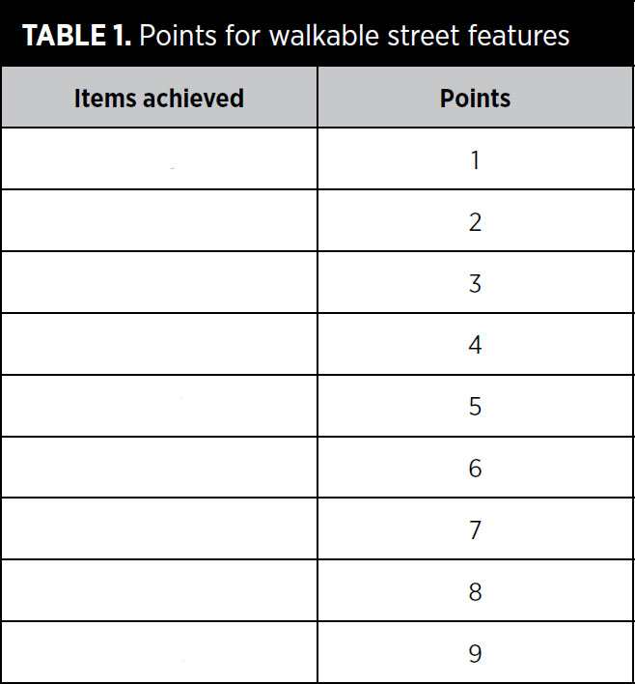

Façades and Entries
- At least _________ of the total linear distance of building façades facing the circulation network in the project is no more than _________ feet (7.5 meters) from the property line.

- At least _________ of the total linear distance of building façades facing the circulation network in the project is no more than _________ feet (5.5 meters) from the property line.

- At least _________ of the total linear distance of mixed-use and nonresidential building façades facing the circulation network in the project is within _________ foot (300 millimeters) of a sidewalk or equivalent walking route.

- Functional entries to the building occur at an average of _________ feet (23 meters) or less along nonresidential or mixed-use buildings or blocks.

- Functional entries to the building occur at an average of _________ feet (9 meters) or less along nonresidential or mixed-use buildings or blocks.

Items (d) and (e) are cumulative.

Ground-Level Use and Parking
- All ground-level retail, service, and trade uses that face a public space have clear glass on at least _________ of their façades between _________ and _________ feet (900 and 2500 millimeters) above grade.

- If a façade extends along a sidewalk, no more than _________ of its length or _________ feet (15 meters), whichever is less, is blank (without doors or windows).

- Any ground-level retail, service, or trade windows facing the circulation network must be kept visible (unshuttered) at __________________; this must be stipulated in covenants, conditions, and restrictions (CC&Rs) or other binding documents.

- On-street parking is provided on at least _________ of both sides of the block __________________ of all new and existing motorized portions of the circulation network, including the project side of bordering circulation network. The percentage of _________-street parking is calculated by dividing the length of street designated for parking by the total length of the curb along each street, including curb cuts, driveways, and intersection radii. Space within the parking lane that is occupied by corner bulb-outs (within 24 feet [7 meters] of an intersection), transit stops, and motorcycle or bicycle parking may be counted as designated for parking in this calculation. __________________ may be exempted.

- Continuous sidewalks or equivalent provisions for walking are available along both sides of the entire circulation network within the project, including the project side of the circulation network bordering the project. Bicycle- and pedestrian-only paths meet this requirement. New sidewalks must be at least _________ feet (3 meters) wide on retail or mixed-use blocks and at least _________ feet (1.5 meters) wide on all other blocks. Note that these requirements specify wider sidewalks than required by NPD Prerequisite Walkable Streets. Alleys may be exempted.

- If the project has ground-floor dwelling units, the principal level of at least _________ of those units has an elevated finished floor at least _________ inches (60 centimeters) above the sidewalk grade. Below-grade basement spaces and/ or accessory dwelling units are exempt from this requirement.

- In nonresidential or mixed-use projects, _________ or more of the total number of office buildings includes groundfloor retail along _________ of the length of the street-level façade; _________ of mixed-use buildings include groundfloor retail, live-work spaces, or ground-floor dwelling units along at least _________ of the street-level façade; and all businesses or community services on the ground floor are accessible __________________ from sidewalks along the circulation network or other public space, such as a square, park, or plaza, but _________ parking lot.

- At least _________ of the block length of the circulation network within the project has a minimum building-height-to-street-centerline ratio of __________________ (i.e., at least 1 foot (30 centimeters) of building height for every 1.5 feet (45 centimeters) of width from circulation network centerline to building façade). Alleys may be exempted.

Projects that border a part of the circulation network must meet only their ___________________________ share of the height-to-centerline ratio (i.e., only on the project side of the circulation network).

Building height is measured to __________________ or, for a flat-roof structure, to the __________________, and width is measured façade to ___________________________. For buildings with multiple heights or widths, use __________________ heights or widths weighted by each portion’s share of the total height or width.

Design Speeds for Safe Pedestrian and Bicycle Travel
- _________ of the length of new residential-only motorized parts of the circulation network within the project is designed for a target speed of no more than _________ mph (30 km/h).

- _________ of the length of new nonresidential or mixed-use motorized parts of the circulation network within the project is designed for a target speed of no more than _________ mph (40km/h). A multiway boulevard, with travel lanes separated from access lanes by medians, may apply this requirement to its outer access lanes only (through-lanes are exempt), provided pedestrian crosswalks are installed across the boulevard at intervals no greater than _________ feet (245 meters).

Sidewalk Intrusions
- At-grade crossings with driveways account for no more than _________ of the length of sidewalks within the project.

Measuring compliance for nearly all the requirements in the Walkable Streets credit (requirements a-p)
relies on one of the following base measurements (Figure 1):
1.
2.
3.
4.

Doors exclusively designated ___________________________ exits and garage doors not designed as pedestrian entrances are not considered __________________ entries.

Low-E glass with at least _________ visible light transmittance (VLT) qualifies as __________________ glass.

- NPD Credit: Compact Development
Requirements
Design and build the project such that residential and nonresidential components achieve the densities per acre (per hectare) of buildable land listed in Table 1 at __________________ or within _________ years of the date that the first new building of any type is occupied (excluding those portions of parking structures devoted to parking), whichever is lower.

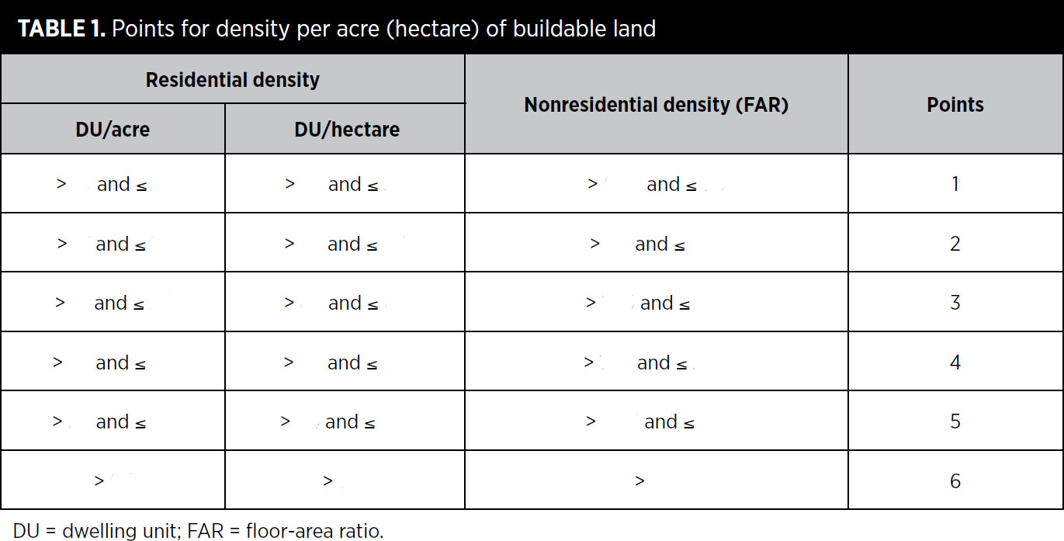

The scoring of a mixed-use project is calculated with a weighted average, according to the following steps.
- Determine the total floor area of all residential and nonresidential uses.
- Calculate the percentage residential and percentage nonresidential of the total floor area.
- Determine the density of each component as measured in dwelling units per acre or hectare and floor-area ratio, respectively.
- Referring to Table 1, find the appropriate points for the densities of the residential and nonresidential components.
- If the points are different, multiply the point value of the residential component by its percentage of the total floor area and multiply the point value of the nonresidential component by its percentage. Add the two scores.

- NPD Credit: Mixed-Use Neighborhoods
Requirements
Locate or design the project such that _________ of its dwelling units are within a _________-mile (400-meter) walking distance of the number of uses (see Appendix 1) listed in Table 1. For projects with no dwelling units, _________ of dwelling units within a _________-mile (400-meter) walking distance of the project boundary must be within a _________-mile (400-meter) walking distance of the number of uses within the project specified in Table 1.

The specified number of uses must be in place by the time of _________ occupancy of total building floor area (exclusive of portions of parking structures devoted to parking).

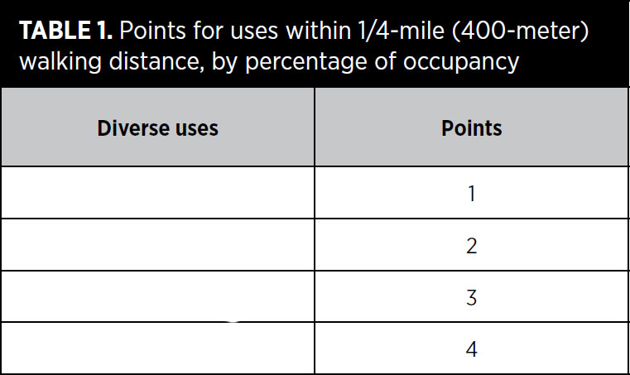

The following restrictions apply.
- A use may be counted as only _________ use type (e.g., a retail store may be counted only once even if it sells products in several categories).
- No more than _________ uses in each use type may be counted (e.g., if five restaurants are within the required distance, only two may be counted).
- The uses accessible to each counted dwelling unit must represent at least _________ categories.

For projects with regional-serving retail of __________________ or more square feet (13 935 square meters) only
Additionally, a project that has at least one large retail use (defined as a use totaling __________________ or more square feet [7 000 or more square meters]), must also meet at least the _________-point threshold for transit service under SLL Credit Access to Quality Transit. In this case, planned transit service can be counted. Each large retail use must be served by at least _________ transit stop providing trips that qualify under that SLL Credit.
If transit service is planned but not yet operational, the project must demonstrate one of the following:
- The relevant transit agency has a signed full-funding __________________ agreement with the Federal Transit Administration (or equivalent national agency for projects outside the U.S.) that includes a revenue operations date for the start of transit service. The revenue operations date must be no later than the day by which _________ of the project’s total building floor area will be occupied.
- For bus, streetcar, bus rapid transit, or ferry service, the transit agency must certify that it has an approved budget that includes specifically allocated funds sufficient to provide the planned service at the levels listed above and that service at these levels will begin no later than the day by which _________ of the project’s total building floor area will be occupied.
- For rail service other than streetcars, the transit agency must certify that preliminary engineering for a rail line has begun. In addition, the service must meet either of these two requirements:
- A state legislature or local subdivision of the state (or local government for projects outside the U.S.) has authorized the transit agency to expend funds to establish rail transit service that will begin no later than the date by which _________ of the project’s total building floor area will be occupied.
OR
- A local government has dedicated funding or reimbursement commitments from future tax revenue for the development of stations, platforms, or other rail transit infrastructure that will serve the project no later than the date by which _________ of the project’s total building floor area will be occupied.

- NPD Credit: Housing Types and Affordability
Requirements
Meet the requirements of one or more of the following options.
OPTION 1. DIVERSITY OF HOUSING TYPES (1–3 POINTS)
Include a sufficient variety of housing sizes and types in the project such that the total variety of planned and existing housing within the project achieves a __________________ Diversity Index score greater than _________, using the housing categories below. Projects of less than _________ acres (50.5 hectares) may calculate the Simpson Diversity Index for the area within _________-mile (400 meters) of the project’s ___________________________ center. The Simpson Diversity Index calculates the probability that any two randomly selected dwelling units in a project will be of a different type.

Score = 1 – Σ (n/N)²
where
n = the total number of dwelling units in a single category, and
N = the total number of dwelling units in all categories.

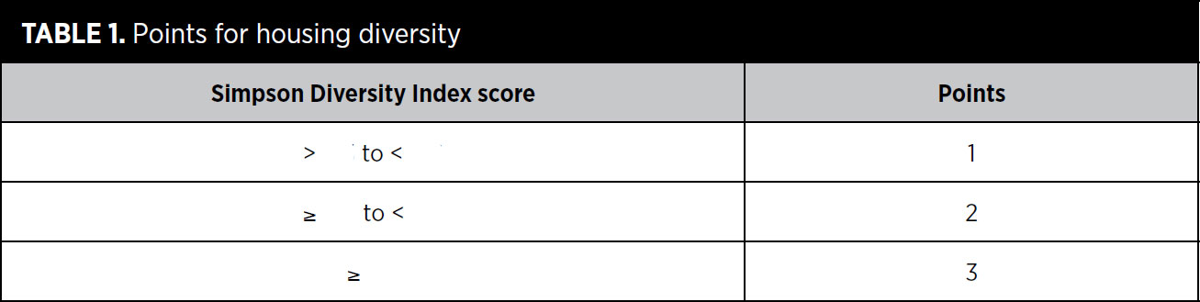

Housing categories are defined by the dwelling unit’s net floor area, exclusive of any garage, as listed in Table 2.
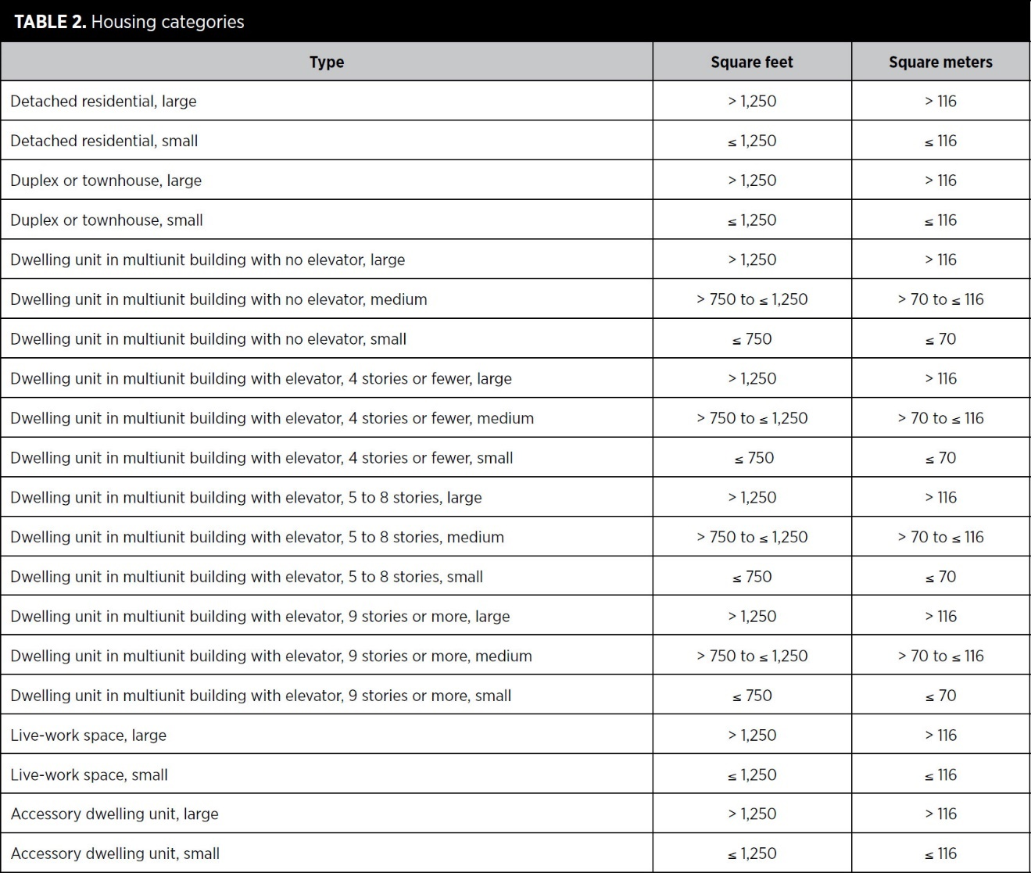

For the purposes of this credit, townhouse and live-work units may have individual ground-level entrances or be within a multiunit or mixed-use building. Double counting is prohibited; each dwelling may be classified in only one category. The number of stories in a building is inclusive of the ground floor regardless of its use.

AND/OR

OPTION 2. AFFORDABLE HOUSING (1–3 POINTS)
Include a proportion of new rental and/or for-sale dwelling units priced for households earning less than the __________________ median income (AMI). Rental units must be maintained at affordable levels for a minimum of _________ years. Existing dwelling units are exempt from requirement calculations. Meet any combination of thresholds in Table 3, up to a maximum of 3 points.

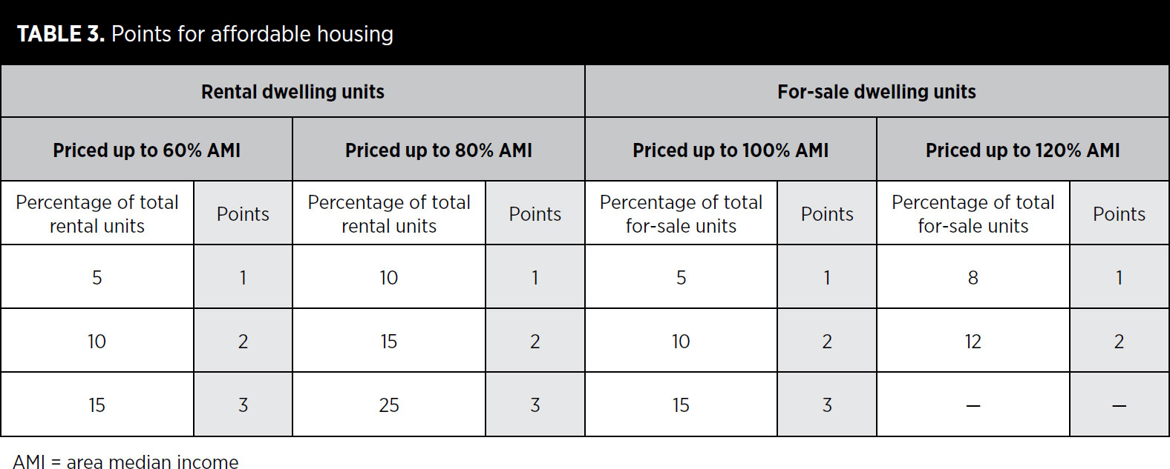

AND/OR

OPTION 3. HOUSING TYPES AND AFFORDABLE HOUSING (1 POINT)
A project may earn an additional point by earning at least _________ points in Option 1 and at least _________ points in Option 2 (at least one of which must be for providing housing at or below _________ AMI).

The measure for diversity of housing is based on a well-known metric in ecology, the __________________ __________________ Index, adapted and simplified for use in planning.

__________________ __________________ income (AMI) is a standardized measure of the median income for a given place.

- NPD Credit: Reduced Parking Footprint
Requirements
For new nonresidential buildings and multiunit residential buildings, either do not build new off-street parking lots, or locate all new off-street surface parking lots at the _________ or _________, leaving building frontages facing the ___________________________ network free of surface parking lots (__________________ may be exempted).

Use no more than _________ of the total development footprint area for all new off-street surface parking facilities, with no individual surface parking lot larger than _________ acres (0.8 hectare). For the purposes of this credit, __________________ parking facilities include ground-level garages unless they are under habitable building space. Underground or multistory parking facilities can be used to provide additional spaces. On-street parking spaces are exempt from this limitation.

Provide ___________________________ parking for carpool or shared-use vehicle parking spaces equivalent to at least _________ of the total off-street parking spaces for each nonresidential and mixed-use building on the site. Such parking spaces must be marked and within _________ feet (60 meters) walking distance of entrances to the building served.

In the U.S., pavement covers roughly _________ of the surface area in average residential areas and _________ to _________ of the surface area in average nonresidential areas.

- NPD Credit: Connected and Open Community
Requirements
Locate or design the project such that its internal ___________________________ falls within one of the ranges listed in Table 1. If the project has no internal circulation network, the connectivity within a _________-mile (400-meter) distance of the project boundary must be used.

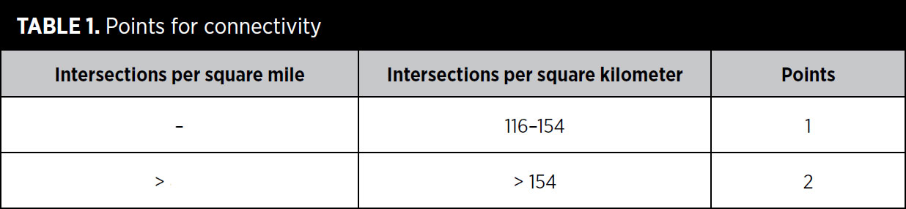

All parts of the ___________________________ network that are counted toward the connectivity requirement must be available for general __________________ use at all times and not __________________. No more than 10_________of the project area may be accessed via circulation network that is gated. Education campuses, health care campuses, and military bases where gates are used for security purposes are exempt from the _________ limit, and intersections within those projects may be counted toward the connectivity requirement.

AND

Design or locate the project such that a through-connection (of the circulation network) intersects or terminates at the project boundary at least every _________ feet (122 meters) or at existing abutting intervals and intersections of the circulation network, whichever is the shorter distance. Include a pedestrian or bicycle __________________-connection in at least _________ of any new culs-de-sac. These requirements do not apply to portions of the boundary where connections cannot be made because of physical obstacles, such as prior platting of property, construction of existing buildings or other barriers, slopes steeper than _________, wetlands and water bodies, railroad and utility rights-of-way, existing limited access motor vehicle rights-of-way, and parks and dedicated open space.

- NPD Credit: Transit Facilities
Requirements
Work with the transit agency or agencies serving the project to inventory ___________________________ transit stops and __________________ transit stops within the project boundary that will be warranted within _________ years of project completion (because of either increased ridership on existing service or planned transit).

At those locations,
- Confirm that transit facilities will be funded by __________________ the transit agency or the project developer.
- Install transit agency-approved shelters and any other required improvements at existing stops. Reserve space for transit facilities or install transit facilities at new stops.

Shelters must be ___________________________, be at least partially enclosed to buffer __________________ and rain, have seating and illumination, and have signage that display transit ___________________________ and route information.

- NPD Credit: Transportation Demand Management
Requirements
Achieve at least _________ of the following options.
Earn 1 point for every two options, for a maximum of 2 points. For the purposes of this credit, existing buildings and their occupants are exempt from the requirements.

OPTION 1. TRANSIT PASSES
__________________ transit passes valid for at least _________ year, subsidized to _________ of regular price, to each resident and employee locating within the project during the first __________________ years of project occupancy (or longer). __________________ the availability of subsidized transit passes to project occupants.

AND/OR

OPTION 2. DEVELOPER-SPONSORED TRANSIT
Provide _________-round, ___________________________-sponsored transit service (vans, shuttles, buses) from at least _________ central point in the project to other major transit facilities or to other destinations, such as a retail or employment center, with service no less frequent than _________ daily weekday trips and _________ daily weekend trips. The service must begin by the time the project’s total floor area is _________ occupied and must be guaranteed for at least __________________ years beyond project buildout. The occupancy requirement is met when residents are living in _________ of the dwelling units and/or employees are working in _________ of the total nonresidential floor area.

Provide transit stop shelters and bicycle racks adequate to meet projected demand but no less than _________ shelter and _________ bicycle rack at _________ transit stop. Shelters must be covered, be at least partially enclosed to buffer wind and rain, and have seating and illumination. Bicycle racks must have a two-point support system for locking the frame and wheels and must be securely __________________ to the ground or a building.

AND/OR

OPTION 3. VEHICLE SHARING
Locate the project such that _________ of the dwelling units and nonresidential use entrances are within a _________-mile (400-meter) walking distance of at least one vehicle in a vehicle-sharing program, as specified below, depending on project size.
- If the project has fewer than _________ dwelling units and/or employees, provide one vehicle.
- If the project has more than _________ dwelling units and/or employees and has a minimum transit service of _________ daily weekday trips and _________ daily weekend trips, provide at least one additional vehicle and __________________ space for every _________ dwelling units and/or employees.
- If the project has more than _________ dwelling units and/or employees but does not have transit service at the frequencies specified above, provide at least _________ additional vehicle and parking space for every _________ dwelling units and/or employees.

For each vehicle, dedicate _________ parking space accessible to vehicle-sharing members. ___________________________ to project occupants the availability and benefits of the vehicle-sharing program. Commit to providing vehicles to the locations for at least _________ years. If a new vehicle-sharing location is planned, the vehicle-sharing program must begin by the time the project’s total floor area is _________ occupied. The occupancy requirement is met when residents are living in _________ of the dwelling units and/or employees are working in _________ of the total nonresidential floor area.

AND/OR

OPTION 4. UNBUNDLING OF PARKING AND PARKING FEES
For _________ of multiunit residential units and/or nonresidential floor area, the associated parking spaces must be sold or rented ___________________________ from the dwelling units or nonresidential floor area.

Set parking fees within the project boundary for all off-street parking __________________ to or __________________ than the cost of ___________________________ usage for public transit. Off-street parking in this instance does not include parking devoted to individual, detached residential units.

AND/OR

OPTION 5. GUARANTEED RIDE HOME PROGRAM
Major employers within the project must commit to providing a guaranteed ride __________________ program for employees. A major employer accounts for more than _________ of the workers on the project site. The program must provide _________ rides to employees who have carpooled, taken transit, walked, or cycled to work but must leave because of an unexpected personal emergency. Rides may be on taxis, company cars, or rental cars.

AND/OR

OPTION 6. FLEXIBLE WORK ARRANGEMENTS
Major employers within the project must commit to promoting and supporting flexible work arrangements with the goal of reducing vehicle trips during __________________ commuting hours. A major employer accounts for more than _________ of the workers on the project site. The employer must develop internal policies that outline the terms under which employees can engage in telework, flextime, compressed work weeks, staggered shifts, or other arrangements. These policies must also describe how the program will be promoted to employees.

- NPD Credit: Access to Civic and Public Places
Requirements

Locate _________ of planned and existing dwelling units and nonresidential use entrances within a _________-mile (400 meters) walk of at least _________ civic and passive use space. The spaces must be at least _________ acre (0.067 hectare) in area. Spaces less than _________ acre (0.4 hectare) must have a proportion no narrower than _________ unit of width to _________ units of length.

Projects larger than _________ acres (4 hectares) must have a median space size of at least _________ acre (0.4 hectare). Spaces over _________acre (0.2 hectare) that are used to meet the _________ threshold are included in the median calculation.

- NPD Credit: Access to Recreation Facilities
Requirements
Locate or design the project so that a publicly accessible outdoor recreation facility at least _________-acre (0.4 hectares) in area, or a publicly accessible indoor recreational facility of at least _________ square feet (2325 square meters), lies within a _________-mile (800-meter) walking distance of _________ of new and existing dwelling units and nonresidential use entrances. Outdoor recreation facilities must consist of physical improvements and may include “tot lots,” swimming pools, and sports fields, such as baseball diamonds.

- NPD Credit: Visitability and Universal Design
Requirements
Case 1. Projects with New Dwelling Units
Design a minimum of _________ of the new dwelling units (but not less than one dwelling unit per type) in accordance with ICC A117.1, Type C, Visitable Unit, for each of the following residential building types:
- detached single-dwelling-unit buildings;
- attached single-dwelling-unit buildings; and
- buildings with two or three dwelling units.

Each unit must also have a kitchen, living area, bedroom, and full bath on an accessible level.

For multiunit buildings with four or more dwelling units, design a minimum of _________ of the units (but not less than one) to meet the requirements of one of the following options. This category includes mixed-use buildings with dwelling units.

OPTION 1. UNIVERSAL DESIGN FEATURES THROUGHOUT THE HOME
Throughout the home, include at least five of the following universal design features:
- easy-to-grip __________________ door handles;
- easy-to-grip cabinet and drawer __________________ handles;
- easy-to-grip __________________ mechanisms on doors and windows;
- easy-to-grip single-lever faucet handles;
- easy-touch rocker or hands-free __________________;
- motion-detector lighting at entrance, in hallways and stairwells, and in closets, and motion-detector light switches in garages, utility spaces, and basements;
- large, high-contrast print for controls, signals, and the house or unit numbers;
- a built-in shelf, bench, or table with knee space below, located outside the entry door with weather protection overhead, such as porch or stoop with roof, awning, or other overhead covering;
- a minimum _________-inch (80-centimeter) clear door opening width for all doorways;
- tread at the entrance, on stairs, and other areas where slipping is common, with color contrast difference between stair treads and risers; and
- interior floor surfaces (e.g., low-pile carpets, hard-surface flooring) that provide easy passage for a wheelchair or walker, with color contrast between floor surfaces and trim; no carpet is permitted in a kitchen, bathroom, or other wet areas of the dwelling unit.

OR

OPTION 2. KITCHEN FEATURES
On the main floor of the home (or on another floor, if an elevator or stair lift is provided), provide a kitchen with hard-surface flooring, plumbing with single-lever controls, a _________-foot (1.5-meter) turning radius, and at least _________ of the following universal design features:
- variable-height (28- to 42-inch [70- to 110-centimeter]) or adjustable work surfaces, such as countertops, sinks, and cooktops;
- clear knee space under sink and cooktops (this requirement can be met by installing removable base cabinets or fold-back or self-storing doors), cooktops and ranges with front or side-mounted controls, and wall mounted ovens at a height to accommodate a seated adult;
- a _________ kick area at the base of lower cabinets with a minimum height of _________ inches (23 centimeters), and full extension drawers and shelves in at least half (by volume) of the cabinets;
- contrasting color treatment between countertops, front edges, and floor;
- adjustable-height shelves in wall cabinets; and
- glare-free task lighting.

OR

OPTION 3. BEDROOM AND BATHROOM FEATURES
On the main floor of the building (or on another floor, if an elevator or stair lift is provided), include all of the following:
In at least one accessible bedroom,
- Size the room to accommodate a twin bed with a _________-foot (1.5-meter) turning radius around the bed.
- Install a clothes closet with a _________-inch (80-centimeter) clear opening with adjustable-height closet rods and shelves.

In at least one full bathroom on the same floor as the bedroom,
- Provide adequate maneuvering space with a _________-by-_________-inch (75-by-120 centimeter) clear floor space at each fixture.
- Center the toilet _________ inches (45 centimeters) from any side wall, cabinet, or tub, and allow a 3-foot (90-centimeter) clear space in front.
- Install broad blocking in walls around toilet, tub, and/or shower for future placement and relocation of grab bars.
- Provide knee space under the lavatory (this requirement may be met by installing removable base cabinets or fold-back or self-storing doors).

Install a long mirror whose bottom is no more than _________ inches (90 centimeters) above the finished floor and whose top is at least _________ inches (180 centimeters) high.

In addition, all bathrooms must have hard-surface flooring, all plumbing fixtures must have __________________-lever controls, and tubs or showers must have __________________-held showerheads.

Case 2. Projects with Noncompliant Routes and No New Dwelling Units
This case applies to projects that have no new residential units and are either (1) retrofitting existing public rights-of-way or publicly accessible travel routes that are not in compliance with the Americans with Disabilities Act (ADA, for private sector and local and state government facilities) or the Architectural Barriers Act (ABA, for federally funded facilities), or (2) building new publicly accessible travel routes that are not legally required to meet ADA-ABA accessibility guidelines.

Design, construct, or retrofit _________ of the rights-of-way and travel routes in accordance with the ADA-ABA accessibility guidelines, as applicable, or local equivalent for projects outside the U.S., whichever is more stringent.

- NPD Credit: Community Outreach and Involvement
Requirements
OPTION 1. COMMUNITY OUTREACH (1 POINT)
Engage the community in the following ways. Each activity must be led by the development team and be directly related to the LEED ND project.

Predesign
Meet with __________________ property owners, residents, business owners, and workers; local planning and community development officials; and any current residents or workers at the project site to solicit and document their input on the proposed project before beginning design.

Preliminary design
Advertise and host at least one open community meeting other than an official public hearing or recurring citizen advisory meeting, to generate comments on the preliminary project design concept. Work directly with community associations and/or the local government to advertise the meeting(s). Collect and summarize comments generated at the meeting(s).

Modify the project’s preliminary __________________ as a direct result of community input, or if modifications are not made, explain why community input did not generate design modifications.

Ongoing communication
Establish ongoing means for communication between the developer and the community throughout the design and construction phases and, in cases where the developer maintains any control, after construction.

OR

OPTION 2. CHARRETTE (2 POINTS)
Comply with Option 1 and conduct a design charrette or interactive workshop of at least _________ days that is open to the public and includes, at a minimum, participation by a representative group of nearby property owners, residents, business owners, and workers in the preparation of conceptual project plans and drawings.

OR

OPTION 3. ENDORSEMENT PROGRAM (2 POINTS)
Comply with Option 1 and obtain an endorsement from an ongoing local or regional nongovernmental program that systematically reviews and endorses __________________ growth development projects under a rating or jury system.

- NPD Credit: Local Food Production
Requirements
Establish ___________________________, ___________________________, and ___________________________ (CC&R) or other forms of deed restrictions stating that the growing of produce is not prohibited in project areas, including greenhouses, any portion of residential front, rear, or side yards; or balconies, patios, or rooftops. Greenhouses but not gardens may be prohibited in front yards that face the circulation network.

Meet the requirements of one of the following three options.

OPTION 1. NEIGHBORHOOD GARDENS (1 POINT)
Dedicate permanent and viable __________________ space or related facilities (such as greenhouses) within the project as specified in Table 1 (exclusive of existing dwellings). Ensure solar access and provide fencing, watering systems, garden bed enhancements (such as raised beds), secure storage space for tools, and pedestrian access for these spaces. Ensure that the spaces are owned and managed by an entity that includes occupants of the project in its decision making, such as a community group, homeowners association, or public body.
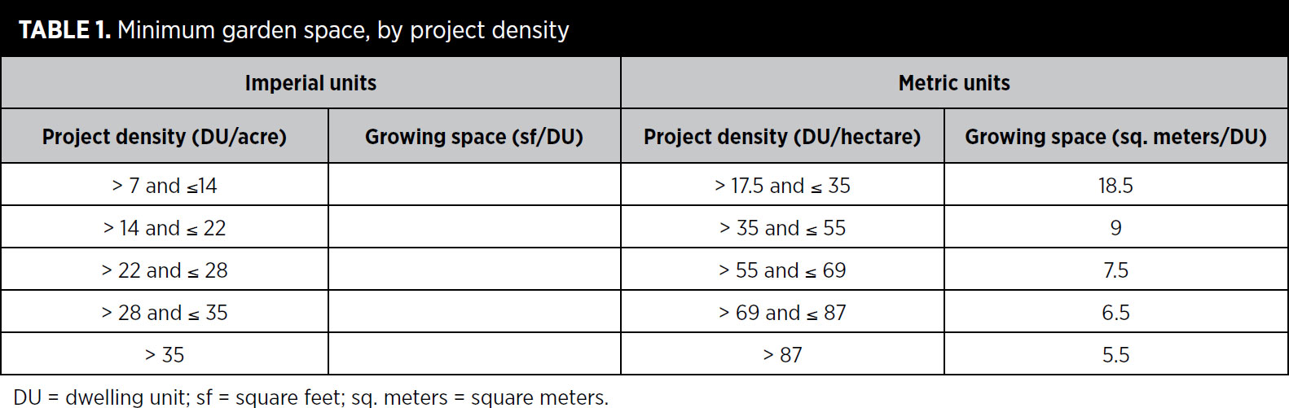

An established community garden outside the project boundary but within a _________-mile (800-meter) walking distance of the project’s ___________________________ center can satisfy this option if the garden otherwise meets all the requirements.

OR

OPTION 2. COMMUNITY-SUPPORTED AGRICULTURE (1 POINT)
Purchase __________________ in a community-supported agriculture program located within _________ miles (240 kilometers) of the project site for at least _________ of dwelling units within the project (exclusive of existing dwelling units). Each counted dwelling unit must receive CSA service for at least _________ years, beginning when it is occupied. Shares must be delivered to a point within _________-mile (800 meters) of the project’s geographic center on a regular schedule not less than __________________ per month at least __________________ months of the year.

OR

OPTION 3. PROXIMITY TO FARMERS MARKET (1 POINT)
Locate the project’s geographic center within a _________-mile (800-meter) walking distance of an existing or planned __________________ market that is open or will operate at least _________ weekly for at least _________ months annually. Farmers market vendors may sell only items grown within _________ miles (240 kilometers) of the project site. A planned farmers market must have firm commitments from farmers and vendors that the market will meet all the above requirements and be in full operation by the time _________ of the project’s total floor area is occupied.

- NPD Credit: Tree-Lined Shaded Streetscapes
Requirements
OPTION 1. TREE-LINED BLOCKS (1 POINT)
Provide trees at intervals of no more than _________ feet (12 meters) (exempting driveways) along at least _________ of the total existing and planned block length within the project, and on the project side of blocks bordering the project, between the vehicle travel way (if there is one) and walkway. __________________ may be exempted from the block length calculations.

AND/OR

OPTION 2. SHADED SIDEWALKS (1 POINT)
Provide shade from trees or permanent structures over at least _________ of the total length of existing and planned sidewalks within or bordering the project (alleys may be exempted). Trees must provide shade within _________ years of landscape installation. Use the estimated crown diameter to calculate the length of sidewalk shaded.

AND
For All Projects with Street Tree Plantings From a registered landscape architect (or local equivalent for projects outside the U.S.), obtain a determination that planting details are appropriate to growing healthy trees, taking into account tree species, root medium, and width and soil volume of planter strips or wells, and that the selected tree species are not considered invasive in the project context according to USDA or the state agricultural extension service (or local equivalent for projects outside the U.S.).

Option 1 rewards trees along the circulation network, using block length as a metric. Qualifying blocks must have trees no more than _________ feet (12 meters) apart.

Option 2 takes a complementary approach, using the total length of shaded sidewalks in the project regardless of spacing. This distinction is intended to capture the direct benefits of shade for pedestrians.

A _________-year estimated canopy growth is used to measure shade in Option 2, in recognition of the time it takes for trees to become established and provide shade.

Any sections of a block where trees are missing or farther apart than _________ feet (12 meters) do not count toward the _________ minimum tree-lined requirement.

List eligible permanent shade structures:

List shade strategies that are ineligible:

- NPD Credit: Neighborhood Schools
Requirements
Include in the project a residential component that constitutes at least _________ of the project’s total building floor area, and locate or design the project such that at least _________ of the dwelling units are within a _________-mile (800-meter) walking distance of the __________________ building entry of an existing or new elementary or middle school or within a _________-mile (1600-meter) walking distance of the functional building entry of an existing or new high school. If the school combines an elementary or middle school with a high school, _________ of the dwelling units must be a _________-mile (800 meter) walking distance of the functional building entry.

For any new school, the school __________________ must commit that the school will be open by the time _________ of the project dwelling units are occupied. A legally binding warrant committing to open the school by this time must be provided at the time of first building occupancy.

Portions of the circulation network within or bordering the project boundary that lead from dwelling units to the school site must have (1) a complete network of ___________________________ on both sides and (2) either continuous ___________________________ lanes or a combination of traffic control and calming measures (alleys may be exempted). If the school is planned as part of the project, it must be designed such that pedestrians and cyclists can easily reach building entrances without crossing bus zones, parking entrances, and student drop-off areas.

New school campuses within the project boundary must not exceed the following limits:
high school (students 15-18 years old), _________ acres (6 hectares);
middle school (students 11-14 years old), _________ acres (4 hectares); and
elementary school (students 6-10 years old), _________ acres (2 hectares).

Schools combining grade levels from more than one category may use the grade level with the __________________ allowable limits.

Facilities on the school site (e.g., athletic fields, playgrounds, multipurpose interior spaces) for which there is a formal joint-use agreement with another entity may be deducted from the __________________ site area of the school.

bicycle network a continuous network consisting of any combination of the following:
- off-street bicycle paths or trails at least _________ feet (2.5 meters) wide for a two-way path and at least _________ feet (1.5 meters) wide for a one-way path
- physically designated on-street bicycle lanes at least _________ feet (1.5 meters) wide
- streets designed for a target speed of _________ mph (40 kmh)

