 | Green Building Practices and LEED Green Associate Exam Preparation
Lorisweb.com
LEED Core Concepts Guide (LCCG)
Section 5. About USGBC and LEED – Pgs. 84-93

U.S. Green Building Council (USGBC)
USGBC “Our Work”
Advocacy / Policy Library
Community
Education
LEED BD+C: New Construction
LEED BD+C: Core and Shell
LEED BD+C: Schools
LEED BD+C: Retail
LEED BD+C: Healthcare
LEED BD+C: Data Centers
LEED BD+C: Hospitality
LEED BD+C: Warehouses and Distribution Centers

LEED BD+C: Homes
LEED BD+C: Multifamily Midrise
Greenbuild
LEED Green Building Program

LEED Rating System
LEED for Building Design and Construction (BD+C)
LEED for Interior Design and Construction ID+C)
LEED for Operations and Maintenance (O+M)
LEED for Neighborhood Development (ND)
Homes
Cities

Rating System Structure
Prerequisites – REQUIRED
Credits – Optional
Achieving LEED certification requires satisfying all prerequisites and earning a minimum number of credits.

LEED Credit Categories
Location and Transportation (LT)
Sustainable Sites (SS)
Water Efficiency (WE)
Energy and Atmosphere (EA)
Materials and Resources (MR)
Indoor Environmental Quality (EQ)

Bonus Categories
Innovation (IN)
Regional Priority (RP)

LEED ND Rating System
Smart Location and Linkage (SLL)
Neighborhood Pattern and Design (NPD)
Green Infrastructure and Buildings (GIB)

All Rating Systems
Integrative Process (IP)
Additionally, LEED emphasizes the critical role of the integrative process and ongoing performance monitoring across all phases and project types.

LEED Rating Systems Point System
100 Base Points
6 Innovation and 4 Regional Priority Bonus Points
Total = 110 points
LEED Certification Levels
Certified, 40–49 points
Silver, 50–59 points
Gold, 60–79 points
Platinum, 80+ points

LEED System Development and Evolution
“ .. improvements to LEED are based on principles of transparency, openness, and inclusiveness involving volunteer committees and working groups, as well as USGBC staff, and are approved by a membership-wide vote.”

LEED Pilot Credits
LEED Pilot Credit Library plays an important role in the evolution of LEED.
Project teams may attempt any of these pilot credits under the Innovation categories and earn points by providing USGBC with feedback on the credits’ efficacy and achievability.
USGBC collects and integrates this feedback to refine the pilot credits, and worthwhile credits are then added to the balloted LEED rating system.

Credit Weightings
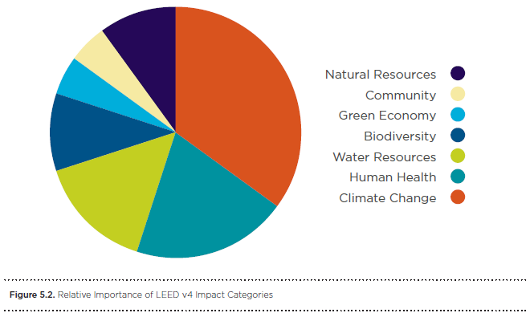

Green Building Codes, Standards, and Rating Systems
The International Green Construction Code (IGCC), including ASHRAE Standard 189.1 as an alternate path to compliance, is a widely supported and first-of-its-kind regulatory framework that recognizes an entire set of risks not otherwise addressed in the codes.

LEED Green Associate Practice Exam 6 – Apr 2_2018
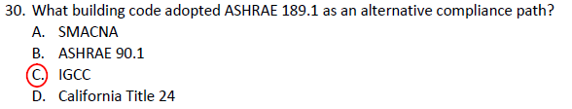

How Do you Find my 9 LEED Green Associate Practice Exams?
https://lorisweb.com/LGAPE/
LEED Project Certification
Project Registration
Application Preparation
All done using LEED Online
Submission
Application Review
Certification

Project Credit Interpretation Rulings and LEED Interpretation
At times a project team may want clarification, further guidance, or additional ways to comply with the rating system’s requirements. Project teams therefore have several options in engaging with USGBC and GBCI during the certification submittal process.

Project credit interpretation rulings (Project CIRs), administered by GBCI, allow teams to obtain technical guidance on how LEED requirements pertain to their projects. Project CIRs do not guarantee credit award; the project applicant must still demonstrate and document achievement during the LEED certification application process. The ruling remains confidential and generally applies only to the one project.

LEED Interpretations, however, are precedent setting; project teams are required to adhere to all LEED Interpretations posted before their registration date. These are posted publicly in the online Addenda database.

LEED Professional Credentials
LEED Green Associate
LEED Accredited Professional
LEED Fellow

Credential maintenance Program (CMP)
15 Hours LEED Green Associate Continuing Education

