|  |  |
| --- | --- |
|  | **Green Building Practices and LEED Green Associate Exam Preparation** |

**Lorisweb.com**

**GA01 LEED Core Concepts Guide – Section 5. About USGBC and LEED**



**U.S. Green Building Council (USGBC)**  [http://usgbc.org](http://usgbc.org/)

**USGBC’s Vision**

Buildings and communities will regenerate and sustain the health and vitality of all life within a generation.

**USGBC is transforming the building landscape in a number of ways:**

**Advocacy -** [**https://www.usgbc.org/about/advocacy**](https://www.usgbc.org/about/advocacy)

USGBC is accelerating the uptake of policies and initiatives that enable and encourage market transformation toward a sustainable built environment.

**Community -** [**https://www.usgbc.org/membership**](https://www.usgbc.org/membership)

USGBC is a movement of community leaders, professionals, businesses, and innovators working to accomplish a single bold vision: healthy, efficient and equitable buildings and communities for all.

***USGBC community membership – Individuals***

***USGBC national membership - companies and organizations***

**Education -** [**https://www.usgbc.org/courses-and-events**](https://www.usgbc.org/courses-and-events)

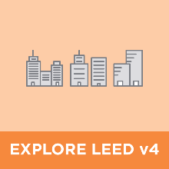 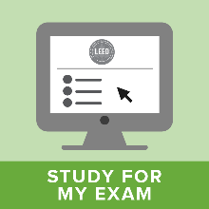 

**Greenbuild International Conference and Expo -** <https://informaconnect.com/greenbuild/>



**LEED Green Building Program -** [**http://www.usgbc.org/leed**](http://www.usgbc.org/leed)

Leadership in Energy and Environmental Design (LEED) program – third-party certification program

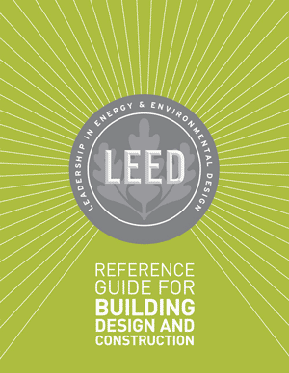 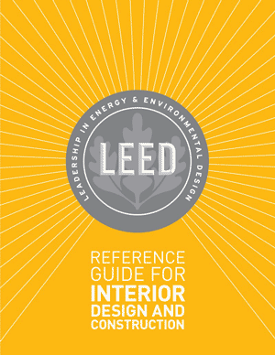 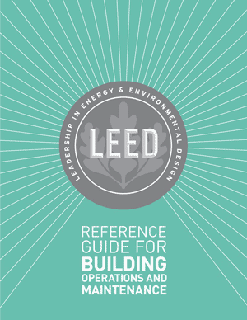 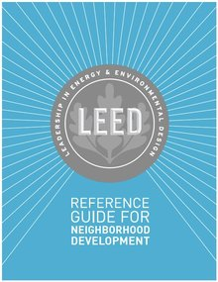 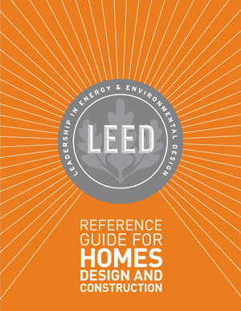



**LEED Rating Systems**

The following project types and scopes are addressed by LEED rating systems:

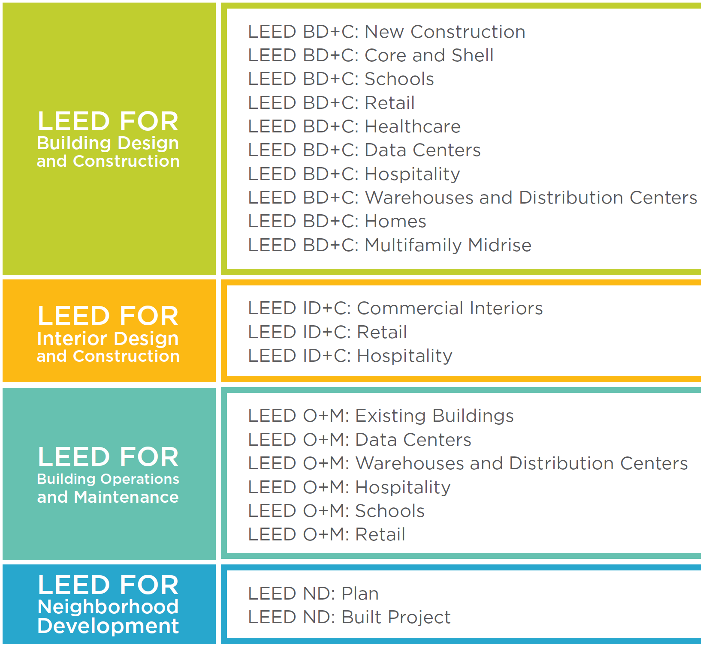

LEED (Leadership in Energy and Environmental Design) is the world's most widely used green building rating system. LEED certification provides a framework for healthy, highly efficient, and cost-saving green buildings, which offer environmental, social and governance benefits. LEED certification is a globally recognized symbol of sustainability achievement, and it is backed by an entire industry of committed organizations and individuals paving the way for market transformation.

**Rating System Structure**

**Prerequisites**

* Required elements or green building strategies that must be included in any LEED-certified project.
* Establish a minimum level of sustainability.

**Credits**

* Optional elements—strategies that projects can elect to pursue to gain points toward LEED certification.

**Achieving LEED certification requires:**

* Meet the Minimum Program Requirements (MPRs)
* Satisfy all prerequisites
* Earn a minimum number of credits for the desired level of certification

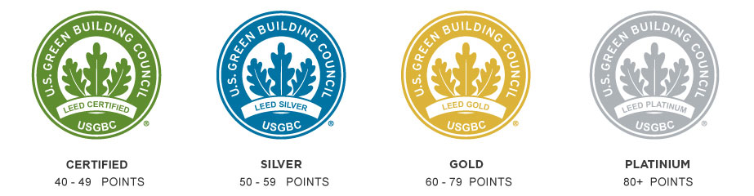

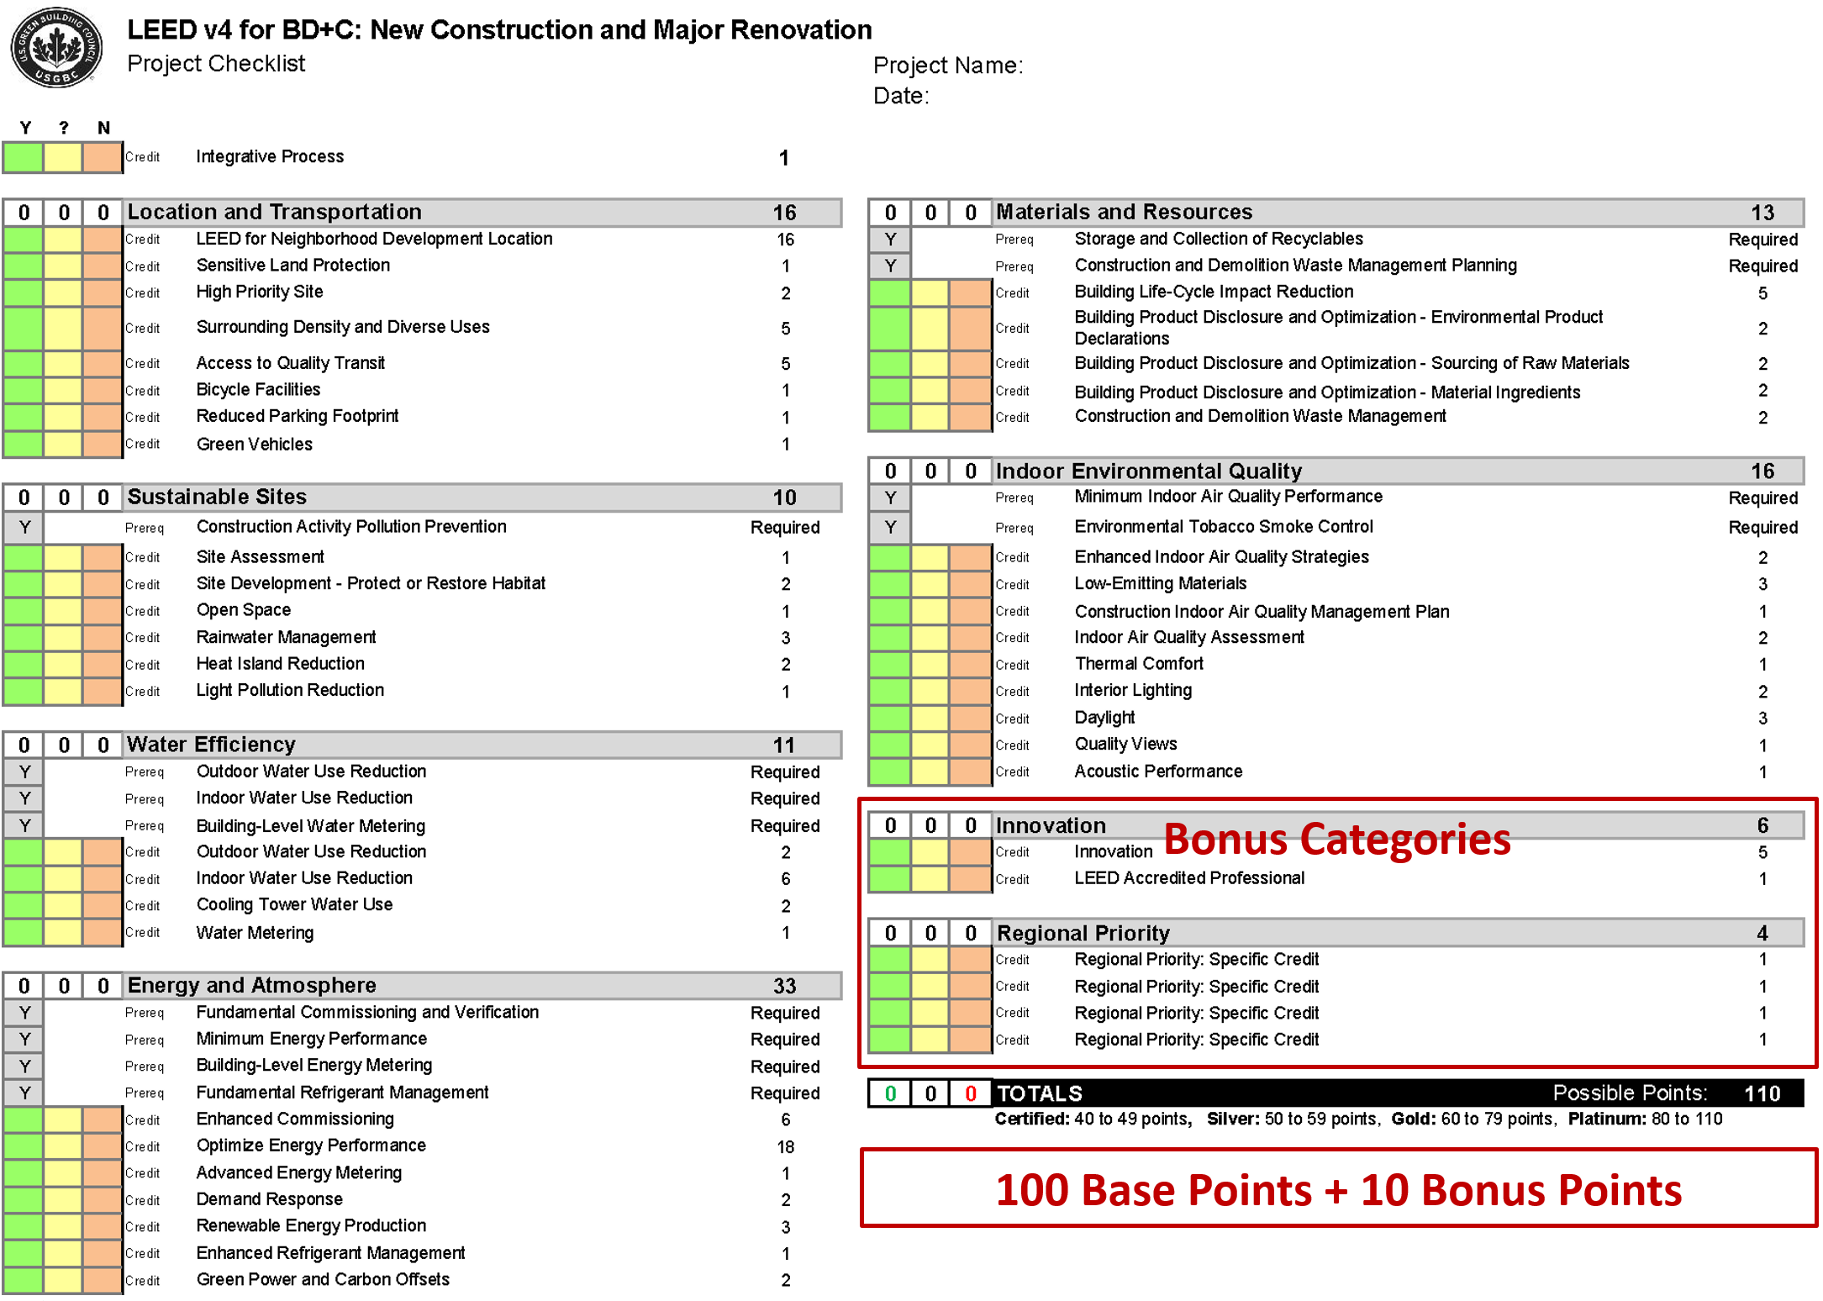

**LEED v4 Credit Categories**

|  |  |
| --- | --- |
|  | **Location and Transportation (LT)**. LEED emphasizes location and transportation issues by rewarding development that preserves environmentally sensitive places and takes advantage of existing infrastructure, community resources, and transit. It encourages access to open space for walking, physical activity, and time spent outdoors. Credits also encourage smart transportation choices and access to a diversity of uses. |
|  | **Sustainable Sites (SS)**. Choosing a building’s site and managing that site during construction are important considerations for a project’s sustainability. LEED credits addressing sustainable sites discourage development of previously undeveloped land and damage to ecosystems and waterways; they encourage regionally appropriate landscaping, control of rainwater runoff, and reduced erosion, light pollution, heat island effect, and construction-related pollution. |
|  | **Water Efficiency (WE)**. Buildings are major users of our potable water supply. The goal of credits addressing water efficiency is to encourage smarter use of water, inside and out. Water reduction is typically achieved through more efficient appliances, fixtures, and fittings inside and water-wise landscaping outside. |
|  | **Energy and Atmosphere (EA)**. LEED encourages a wide variety of strategies to address energy consumption, including commissioning; energy use monitoring; efficient design and construction; efficient appliances, systems, and lighting; demand response, and the use of renewable and clean sources of energy, generated on-site or off-site. |
|  | **Materials and Resources (MR)**. During both construction and operations, buildings generate large amounts of waste and use tremendous volumes of materials and resources. These credits encourage the selection of sustainably grown, harvested, produced, and transported products and materials. They promote the use of life-cycle assessment to holistically evaluate materials and the disclosure and optimization of material chemical ingredients. |
|  | **Indoor Environmental Quality (EQ)**. The average American spends about 90% of the day indoors, where pollutant concentrations may be two to 100 times higher than outdoor levels. Thus indoor air quality can be significantly worse than outside. LEED credits promote strategies that can improve indoor air, provide access to natural daylight and views, and improve acoustics. |
|  | **Innovation (IN)**. LEED promotes innovation by offering points for improving a building’s performance well beyond what is required by the credits or for incorporating green building ideas that are not specifically addressed elsewhere in the rating system. This credit category also rewards the inclusion of a LEED Accredited Professional on the project team. |
|  | **Regional Priority (RP)**. USGBC’s regional councils, chapters, and affiliates have identified the environmental concerns that are most important for every region of the country, and LEED credits that address those local priorities have been selected for each region. A project team that earns a regional priority credit earns one bonus point in addition to any points awarded for that credit. |
|  |  |
| **LEED for Neighborhood Development is organized around three main categories, focusing on where, what, and how to build green at a community scale.** | |
|  | **Smart Location and Linkage (SLL)**. This section of the rating system provides guidance on where the project is built, encouraging the selection of sites with existing services and transit. |
|  | **Neighborhood Pattern and Design**. Neighborhoods should be compact, complete, connected, and convivial. The intent of credits in this category is to create environments that are walkable, vibrant with mixed-use establishments, and connected to the larger community. |
|  | **Green Infrastructure and Buildings**. This category focuses on measures that can reduce the environmental harms associated with the construction and operation of buildings and infrastructure within neighborhoods, with a goal of not just reducing the environmental consequences, but also enhancing the natural environment. |

LEED rating systems have 100 base points plus six Innovation points and four Regional Priority points, for a

total of 110 points.

**The level of certification is determined according to the following scale:**

Certified 40–49 points

Silver 50–59 points

Gold 60–79 points

Platinum 80+ points

**Rating System Development and Evolution**

Since its launch in 2000, LEED has been evolving to address new markets and building types, advances in practice and technology, and greater understanding of the environmental and human health impacts of the built environment. These ongoing improvements to LEED are based on principles of transparency, openness, and inclusiveness involving volunteer committees and working groups, as well as USGBC staff, and are approved by a membership-wide vote.

**Credit Weightings**

The weightings ensure that LEED assigns higher point values to the credits with the strongest relationship to the impact categories of greatest concern.

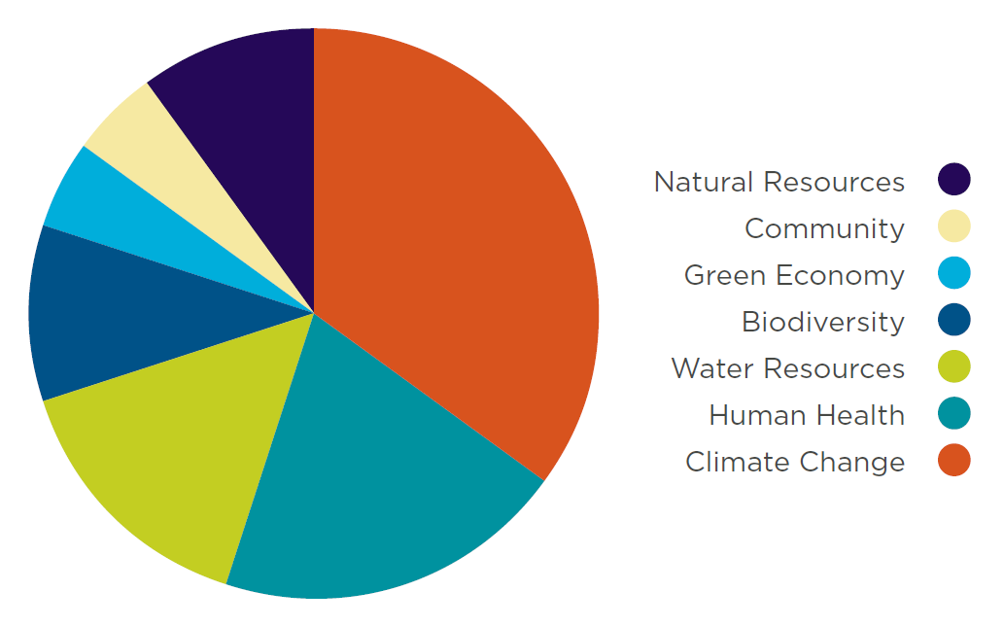

**LEED Impact Categories**

**“What should a LEED project accomplish?”**

Reverse Contribution to Global Climate Change

Enhance Individual Human Health and Well-Being

Protect and Restore Water Resources

Protect, Enhance and Restore Biodiversity and Ecosystem Services

Promote Sustainable and Regenerative Material Resources Cycles

Build a Greener Economy

Enhance Social Equity, Environmental Justice, and Community Quality of Life

**Green Building Codes, Standards, and Rating Systems**

**California Green Building Code (CALGreen Code)**

<http://www.bsc.ca.gov/Home/CALGreen.aspx>

The California Green Building Standards Code (CALGreen Code) is Part 11 of the California Building Standards Code (Title 24) and is the first statewide "green" building code in the US.

**International Green Construction Code (IGCC)**

<http://www.iccsafe.org/codes-tech-support/international-green-construction-code-igcc/international-green-construction-code/>

The **International Green Construction Code** (IGCC), including ASHRAE Standard 189.1 as an alternate path to compliance, is a widely supported and first-of-its-kind regulatory framework that recognizes an entire set of risks not otherwise addressed in the codes.

**Project Certification** [**http://www.usgbc.org/cert-guide**](http://www.usgbc.org/cert-guide)

**LEED certification** provides independent, third-party verification that a building project meets the highest green building and performance measures.

Early in the development of a project, the integrated project team needs to determine the project’s goals, the level of certification to pursue, and the credits that will help them achieve it.

**LEED certification involves four main steps:**

1. **Register** your project by completing key forms and submitting payment.
2. **Apply** for LEED certification by submitting your completed certification application through [LEED Online](http://usgbc.org/leedonline) and paying a certification review fee.
3. **Review.** Your LEED application is reviewed by GBCI.
4. **Certify.** Receive the certification decision. If you’ve earned LEED certification: congratulations!

**Project Registration**

* The LEED process begins with registration. The project team submits a registration form and a fee to GBCI.
* It is helpful if the **project administrator—the team member who registers** the project—has previous green building and LEED project experience; ideally, he or she is a LEED Accredited Professional with Specialty.
* Once registered, the team receives information, tools, and communications that will help guide the certification process.
* All project activity, including registration and credit compliance documentation, is completed in **LEED Online**, a data collection portal through which the team uploads information about the project. This site provides **credit templates** to be completed and signed by a specified member of the team.

**Application Preparation**

* Each LEED credit and prerequisite has documentation requirements that must be completed as part of the application process.
* The project team selects the credits it has chosen to pursue and when the necessary documentation, including required information and calculations, has been assembled, the project team uploads the materials to LEED Online.

**Submission**

* When the team is ready for its application to be reviewed, the **project administrator** submits the appropriate fee and documentation.
* For LEED BD+C and ID+C projects, the team can wait to submit documentation until the building project is complete, or the team can seek review of its **design-related** prerequisites and credits before completion, and then apply for **construction-related** credits after the project is finished.

**Application Review**

* Whether the design and construction credits are submitted together or separately, each credit undergoes one **preliminary** **review**.
* The certification reviewer may request additional information or clarification.
* The team then submits final documentation. After the **final review**, a team may appeal any adverse decisions on individual credits for an additional fee.

**Certification**

* Certification is the final step in the LEED review process.
* Once the final application review is complete, the project team can either accept or appeal the final decision.
* LEED-certified projects receive formal certificates of recognition, a plaque, and tips for marketing the achievement.
* Projects may be included in USGBC’s online LEED Project Directory of registered and certified projects.

**Project Credit Interpretation Rulings**

Project credit interpretation rulings (Project CIRs), administered by GBCI, allow teams to obtain technical guidance on how LEED requirements pertain to their projects.

* Project CIRs do not guarantee credit award; the project applicant must still demonstrate and document achievement during the LEED certification application process.
* The ruling remains confidential and generally applies only to the one project.

**LEED Interpretations**

LEED Interpretations, however, are precedent setting; project teams are required to adhere to all LEED Interpretations posted before their registration date.

These are posted publicly in the online Addenda database.

**LEED Professional Credentials**

[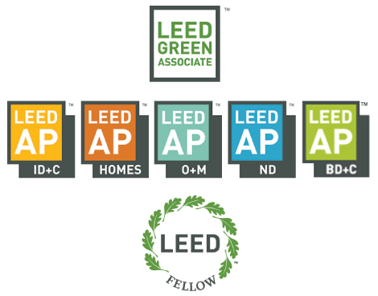](http://www.usgbc.org/credentials)

**LEED GREEN ASSOCIATE** validates basic understanding of green building and the professional field, as gained through experience in sustainability and green building or related educational experience

**LEED ACCREDITED PROFESSIONAL** demonstrates a deep familiarity with the LEED rating systems developed through active participation in and contribution to a LEED-registered project

**LEED FELLOW** distinguishes professional leadership, contribution to the standards of practice and body of knowledge, and continual improvement in the field

**Maintaining your credential**

**All LEED professionals are required to maintain their credential by earning continuing education hours.**

LEED Green Associates must earn 15 continuing education hours within two years of earning their credential.

LEED APs must earn 30 continuing education hours within two years of earning their credential.

**Certificates**

**LEED for Homes Green Raters** provide in-the-field verification services at each and every LEED for Homes project.

Earn a **Green Classroom Professional** certificateand further the mission of creating green schools for everyone within this generation. Green classroom professionals advocate for healthier, more environmentally responsible places in which to work and teach.