|  |  |
| --- | --- |
|  | **Green Building Practices and LEED Green Associate Exam Preparation** |

**Lorisweb.com**

**GA01 LEED Core Concepts Guide – Section 2. Sustainable Thinking**

**Green Building and Sustainability**

Three major concepts integral to green building and sustainability:

1. Systems thinking
2. Life cycle thinking
3. Integrated processes

**Systems Thinking**

**system** an assemblage of parts that interact in a series of relationships to form a complex whole, which serves particular functions of purposes.

**Types of Systems**

**Open System** - materials and resources are constantly brought in from the outside, used in some way, and then released outside the system in some form of waste.

**Closed System** - is one where a quantity or series of quantities cannot enter or leave the system.

**More sustainable.**

**Feedback Loops**

The concept of feedback loops helps explain how systems work.

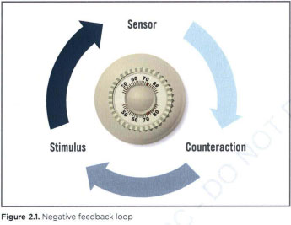

This type of feedback loop is called a **negative feedback loop** because embedded in the system's response to a change is a Signal for the system to stop changing when that response is no longer needed. Negative feedback loops enable a system to self correct and stay within a particular range of function or performance. Thus, they keep systems stable.

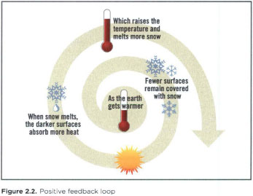

**Positive feedback loops**, on the other hand, are self-reinforcing: the stimulus causes an effect, and the effect produces even more of that same effect. Population growth is a positive feedback loop. The more babies who are born, the more people there will be in the population to have more babies. Therefore, the population can be expected to rise until acted upon by another force, such as an epidemic or shortage of resources.

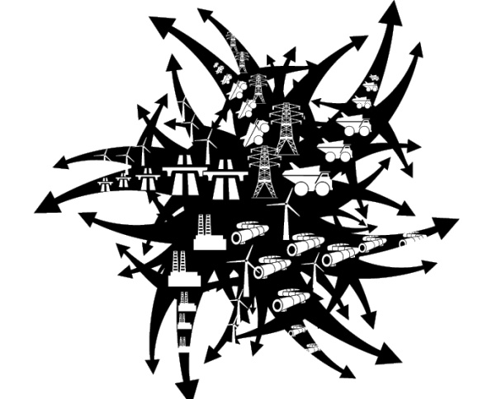**Unchecked, positive feedback loops can create chaos in a system.**

**Positive Feedback Loop**

**heat island effect** the absorption of heat by hardscapes, such as dark, non-reflective pavement and buildings, and its radiation to surrounding areas. Particularly in urban areas, other sources may include vehicle exhaust, air-conditioners, and street equipment; reduced airflow from tall buildings and narrow streets exacerbates the effect.

**Negative Feedback Loop **

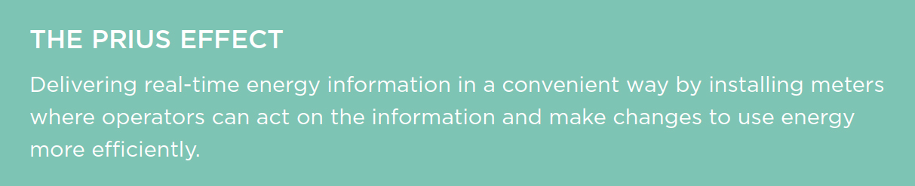

**Leverage Points**

To influence the behavior of a system, it is important to find the leverage points—places where a small intervention can yield large changes.

Providing building occupants with real-time energy information is an example of using a leverage point to alter behavior.

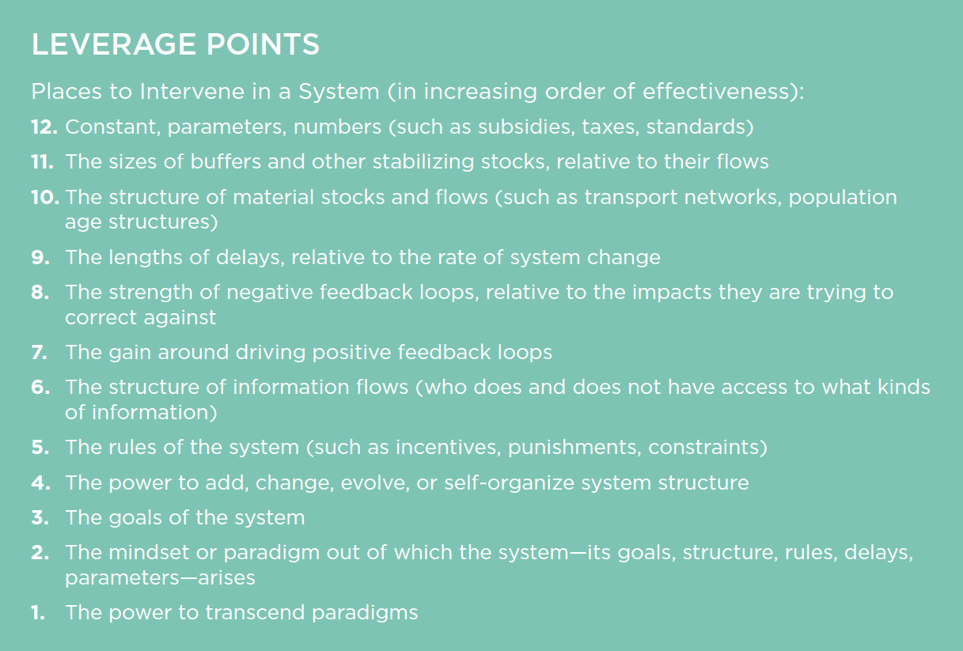

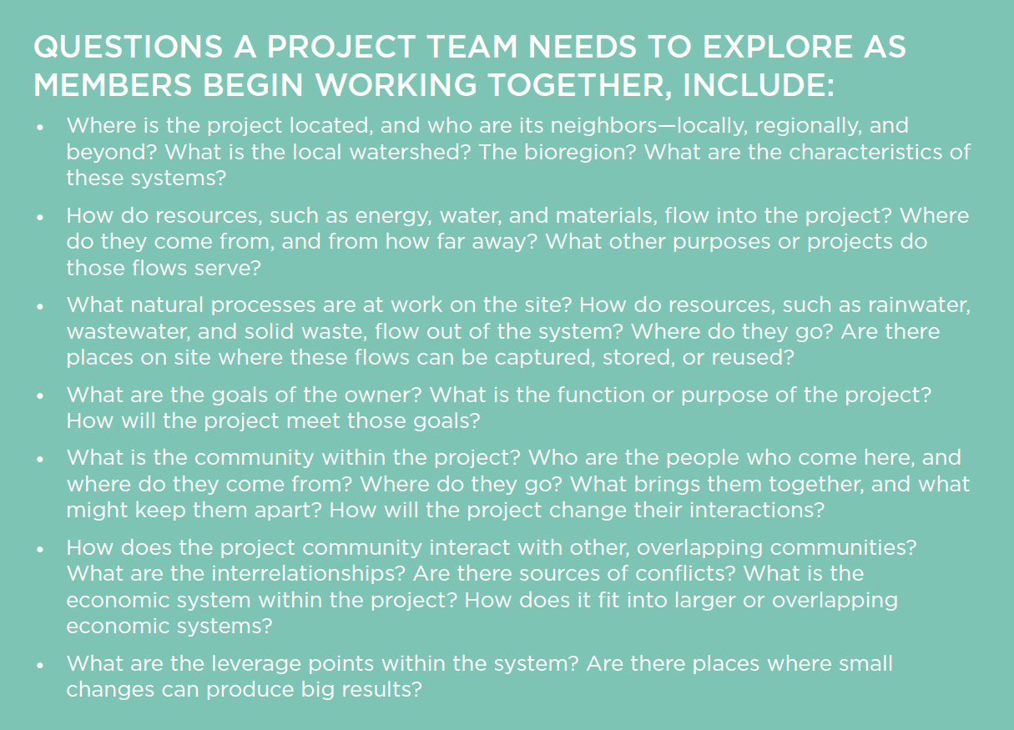

**Life-Cycle Approach**

**What is LCA?**

Life Cycle Assessment (LCA) is a tool used to evaluate the potential **environmental** impact of a product, process or activity throughout its entire life cycle by quantifying the use of resources ("inputs" such as energy, raw materials, water) and environmental emissions ("outputs" to air, water and soil) associated with the system that is being evaluated.

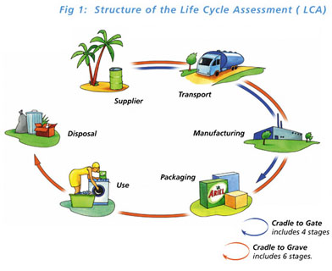

**What is LCC?**

Life Cycle Costing (LCC) a process of costing that looks at both purchase and operating costs as well as relative savings over the life of the building or product.

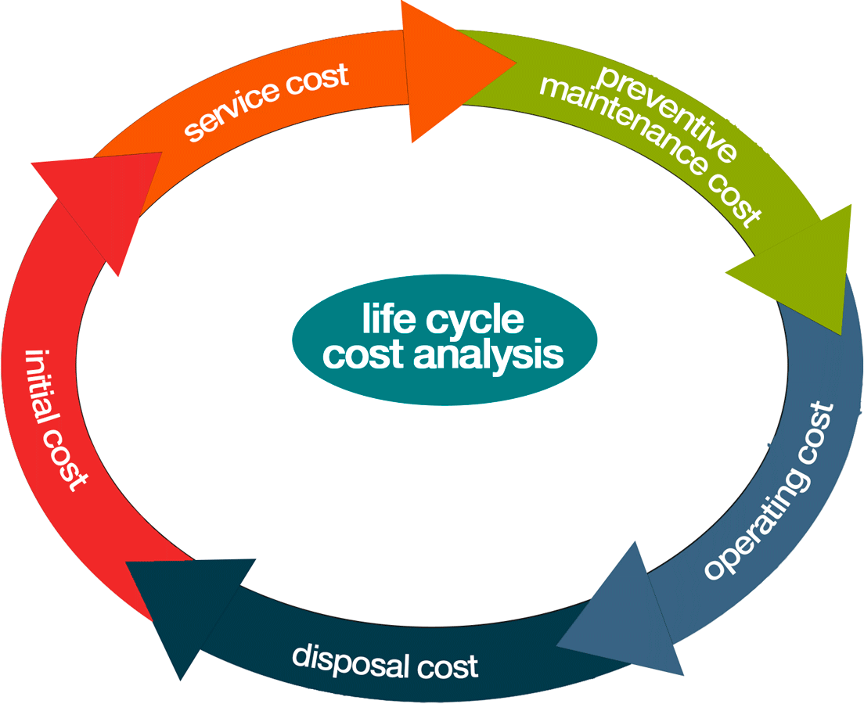

**Life-Cycle Costing**

LCC can be used in comparing alternatives with different initial and operating costs.

For a building this usually includes the following costs:

* Initial purchase, acquisition, or construction
* Fuel
* Operation, maintenance, and repair
* Replacement
* Disposal (or residual value for resale or salvage)
* Finance charges
* Other intangible benefits or costs, such as increased employee productivity

**The Key to Sustainability**

* Establish goals and targets early in the process
* Understand the systems that are in play
* Anticipate how those systems are likely to change and evolve

Assembling the right team, establishing goals, and understanding the systems and metrics for success will help ensure that we move closer to a sustainable built environment.

**Integrative process**

**Phases of the Integrative Process**

**discovery**—is also the most important and can be seen as an expansion of what is conventionally called predesign. Actions taken during discovery are essential to achieving a project’s environmental goals cost-effectively.

**design and construction** — begins with what is conventionally called schematic design. Unlike its conventional counterpart, however, in the integrative process, design will incorporate all of the collective understandings of system interactions that were found during discovery.

**occupancy, operations, and performance feedback** — Here, the integrative process measures performance and sets up feedback mechanisms. Feedback is critical to determining success in achieving performance targets, informing building operations, and taking corrective action when targets are missed.

**Design Synergies**

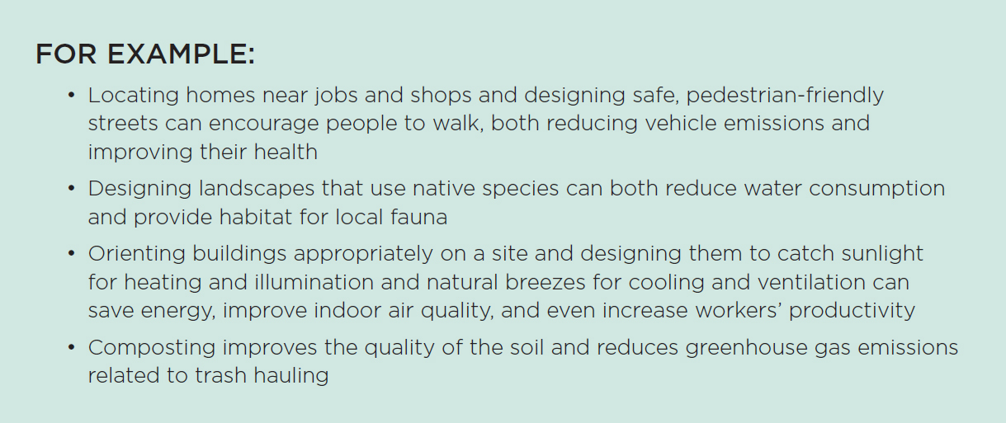

**Practitioners of an Integrative Process**

Must develop new skills that might not have been required in their past professional work:

* Critical thinking and questioning
* Collaboration
* Teamwork and communication
* Deep understanding of natural processes

An integrative process is a different way of thinking and working, and it creates a team from professionals who have traditionally worked as separate entities.

**The Integrative Process**

* Requires more time and collaboration during the early conceptual and design phases than conventional practices.
* Time must be spent building the team, setting goals, and doing analysis before any decisions are made or implemented.
* This upfront investment of time, however, reduces the time it takes to produce construction documents.