 | Green Building Practices and LEED Green Associate Exam Preparation
Lorisweb.com
GA01 LEED Core Concepts Guide - Section 3. Sustainable Thinking at Work: New Processes for Building Green

Green Building
Green building requires a new way of thinking and approaching the design, construction, operation, and renovation of buildings and communities.
- How do teams organize as part of an integrative process?
- How do systems thinking change the way sites are developed?
- How does life-cycle assessment affect materials selection?

How does this new approach work in real life?
Getting Started
Principles for Successful Practice

Process Matters
A good process is essential to good outcomes.

Get in Early

Follow Through
- Ensure that the strategies and technologies are maintained or adapted as necessary to remain effective.
- Ongoing training ensures knowledgeable operation and maintenance of these strategies and technologies, as well as an opportunity to provide feedback on the challenges faced and lessons learned.

Look Beyond First Costs to Long-Term Savings
- Green Building often shifts cost earlier. Increased efficiency and savings come later.
- Up-front goal setting, analysis, and evaluation of alternatives will assist in making decisions that result in savings over the long term through synergies and integration.
- Synergies are actions that complement each other, creating a whole greater than the sum of its parts.
- The savings are often reflected in life-cycle costing.

Include and Collaborate
- Multidisciplinary team of professionals
- Members of the community involved or affected by the project
- Look at the big picture, not just individual elements

Establishing an Iterative Process
Integrated Project Delivery (IPD)

an approach that involves people, systems, and business structures (contractual and legal agreements) and practices. The process harnesses the talents and insights of all participants to improve results, increase value to the owner, reduce waste, and maximize efficiency through all phases of design, fabrication, and construction. (Adapted from American Institute of Architects)

Design-build and IPD enable team members to participate from the early project stages, including goal setting and initial brainstorming.

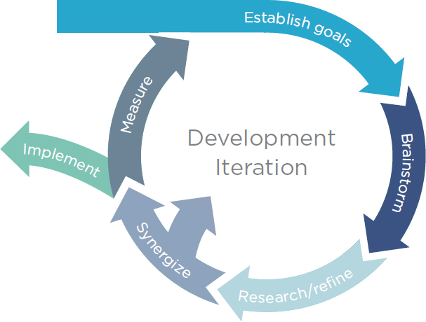
Iterative Process
- An iterative process is circular and repetitive. It provides opportunities for setting goals and checking each idea against those goals.
- Defining critical milestones, assigning champions, and clarifying goals up front will enable projects of all sizes and types to incorporate sustainability more effectively.

Types of Meetings
- Charrette
- Team Meeting
- Small Task Group
- Stakeholder Meeting

Charrette
an intensive, multiparty workshop that brings people from different disciplines and backgrounds together to explore, generate, and collaboratively produce design options.

At least one initial strategy meeting or LEED “charrette” generally held at the beginning of the project
Charrettes assist in establishing green goals
Goal – to develop possible design and strategies for greening a space

Deliverables
The typical deliverables from the initial strategy meeting are:
- LEED certification goal (certification level)
- LEED scorecard that shows the targeted credits for pursuit (LEED checklist)

Team Meeting
Allow the group to work together creatively on new synergies.

Small Task Group
Opportunity to explore particular topics, conduct research, and refine the ideas for presentation at a later team meeting.

Stakeholder Meeting
Held with neighbors, community members, and others with a vested
interest in the project.
They enhance a project team’s interaction with and understanding of community issues, concerns, and ideas.

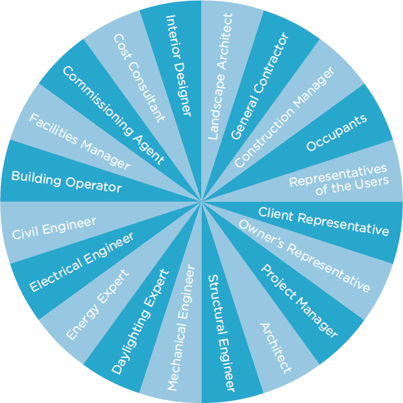
Team Selection

Project Team
Broad
Inclusive
Collaborative
Provide Training

Goal Setting
Green Building Projects
Must be grounded in strong goals and set a pathway to ensure they are achieved.

Clear goals articulate what the project will be designed to accomplish, by:
- Making sure that the vision is clear
- Providing a frame of reference for the whole project
- Defining the sustainability targets and keeping the project on track to meet them

Metrics and Targets
Goals Assessments and Measurements
S = Specific Metrics
M = Measurable Qualitative
A = Attainable Quantitative
R = Realistic
T = Timely

Example
Goal - neighborhood project be walkable

Quantitative
Percentage of homes that are within a quarter-mile of destinations such as parks, restaurants, and stores.

Qualitative
Does the project have functional sidewalks?

Observation of the System

Data Gathering and Interpretation
Often requires expertise of technical specialists:
Hydrologists
Ecologists
Engineers
Economists
Anthropologists

Tools
Systematic data collection and analysis
Mapping
Occupant surveys
Building walkthroughs
Audits

Geographical information systems (GIS) can help illustrate how different elements intersect and overlap.

Map layers might show soils, infrastructure, shade, wind patterns, species distribution, land uses, demographics, roads and transit routes, traffic patterns, walkways and barriers, material flows, and solid waste pathways.

Maps can also display growth projections, targeted development areas, and other indicators of how the site is likely to change over time.

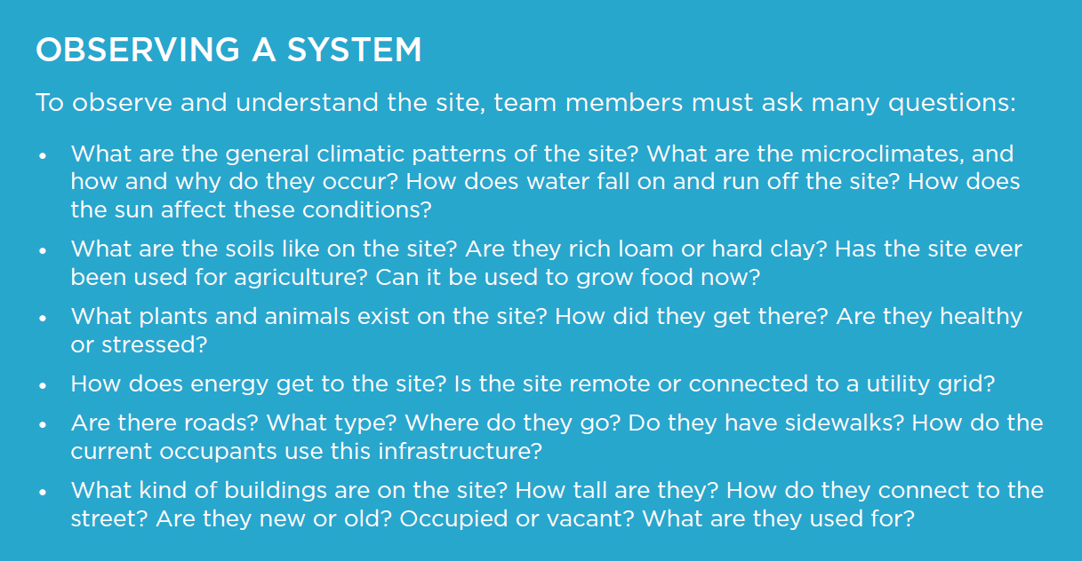

Exploration and Selection of Technologies and Strategies
Sustainable Design
Requires thinking methodically through the types of strategies for each aspect of the system and evaluating alternatives against project goals through an iterative process.

Example - Designing a new waste management plan
Waste Hauler #1 Waster Hauler #2
Cost less Higher recycling diversion rate
Accepts only sorted recyclables Accepts commingled recyclables

Team values both recycling and cost savings. Now what?

What if another project goal is to reduce GHG emissions associated with solid waste?
The team would then have to consider additional information, such as the distance of each waste management facility from the project site, the types and sizes of trucks used for hauling, and their associated emissions factors.

That example illustrates four important points.
- When systems thinking is applied to sustainable design, it is often necessary to consider information beyond cost. A wide range of tools can help teams evaluate components of a system, including modeling, life-cycle analysis, and life-cycle cost analysis, as well as inventorying. These tools and technologies will be discussed in Section 4.
- Even if the system is evaluated using a complex computer model, the best solution may depend on the team’s goals, metrics, and targets, as well as their resources. The alternatives must be analyzed and evaluated against the goals.
- Although alternatives are often viewed as an either-or choice, there may be more than two options. In the waste hauler example, the question is about more than which hauler to select. When deciding between two alternatives, the project team must ask whether there is a third option (or a fourth or a fifth …). The question can spark the creativity needed to find new solutions that lead to sustainability.
- Sometimes other variables, besides goals, targets, and costs, may make certain solutions inappropriate for the site. Sustainable design means finding not only the measures that perform best in a model but also the solutions that will perform best over the life of the project.
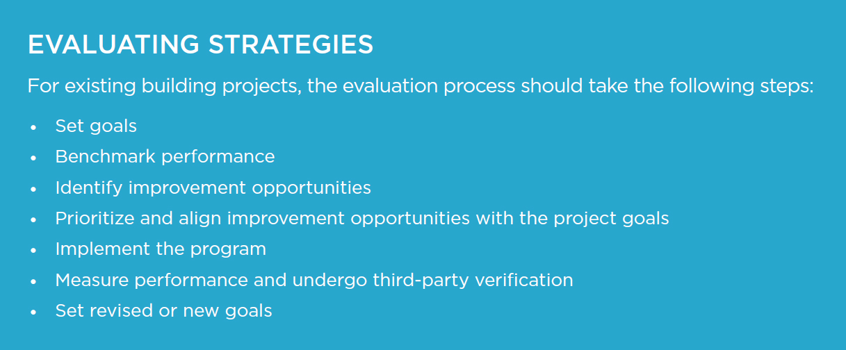

Value Engineering
a formal review based on the project’s intended function and conducted to identify alternatives that reduce costs and improve performance, is a critical part of the sustainable design process.

Implementation
Planning and Design Phase

Up-front Planning
- Helps keep a project on schedule and on budget
- Protects achieving the projects goals

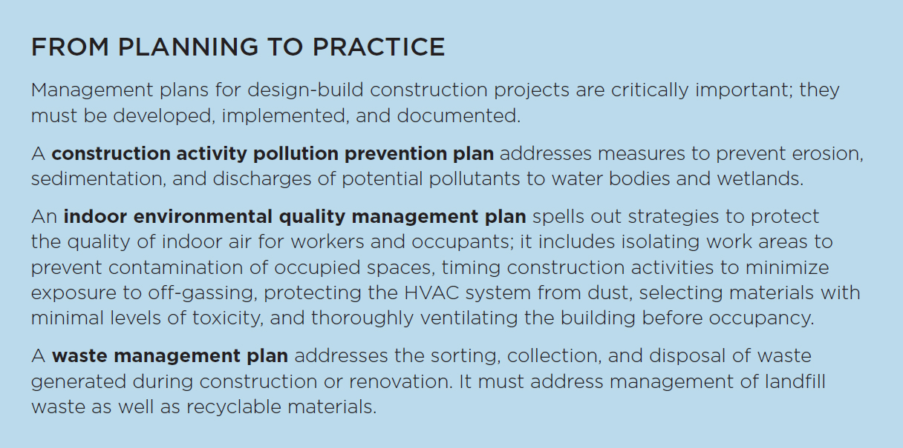

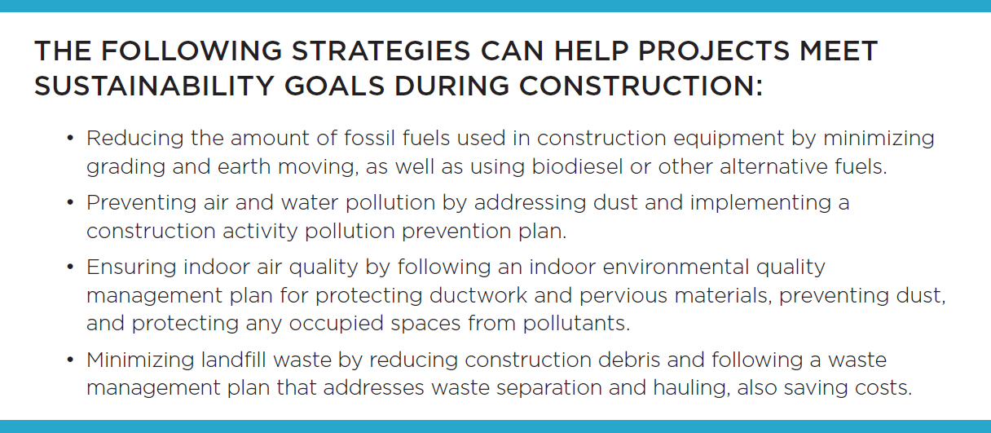

Documentation
Essential for verifying achievement of sustainability goals
Maintain clear and organized documentation throughout implementation will help to ensure success.

Examples:
Change orders
Chain-of-custody letters
Waste hauling tickets
Updated/revised construction management plans
Commissioning or retrocommissioning reports
LEED documents

On-Going Performance
Green Buildings and Neighborhoods

The construction and operations of green building and neighborhood projects are never really complete.
- Requires on-going delivery or production of resources
- Routine maintenance and upkeep
- Data collection and feedback
- Training – occupants and personnel

Building System Performance
Regular inspections and maintenance to reveal problems or opportunities for improvement:
- Retro-commissioning
- Energy and water audits
- Solid waste audits
- Occupant surveys, including thermal comfort and transportation analysis
- Green purchasing and green housekeeping program assessments

Measurement and Verification
- Essential to identifying opportunities for improvement.
- The right information needs to flow to the right place.
- The flow of information can be used as a feedback loop within the built environment to promote continuous improvements and support the commitment to sustainability.

