|  |  |
| --- | --- |
|  | **Green Building Practices and LEED Green Associate Exam Preparation** |

**Lorisweb.com**

Integrated Process (IP)

GA08 Integrative Process - Pgs. 8-11

Location and Transportation (LT)

GA02 Excerpt LT Overview. LEED BD+C RG v4 - Pgs. 55-57

GA08 Location and Transportation (LT) - Pgs. 12-31

LCCG Section 4. Location and Transportation - Pgs. 52-55

Sustainable Sites (SS)

GA02 Excerpt SS Overview. LEED BD+C RG v4 - Pgs. 137-138

GA08 Sustainable Sites (SS) - Pgs. 32-51

LCCG Section 4. Sustainable Sites - Pgs. 56-60

**Integrative Process (IP)**

|  |  |  |  |  |  |  |  |  |  |
| --- | --- | --- | --- | --- | --- | --- | --- | --- | --- |
|  | **Integrative Process** | | | | | | | | |
| Adaptation | | NC | CS | S | R | DC | WDC | HOS | HC |
| Total | | 1 | 1 | 1 | 1 | 1 | 1 | 1 | 1 |
| Integrative Project Planning and Design | | -- | -- | -- | -- | -- | -- | -- | req |
| Integrative Process | | 1 | 1 | 1 | 1 | 1 | 1 | 1 | 1 |

Prerequisite: Integrative Project Planning and Design

Required

This prerequisite applies to: Healthcare

**Intent**

Maximize opportunities for integrated, cost-effective adoption of green design and construction strategies, emphasizing human health as a fundamental evaluative criterion for building design, construction, and operational strategies. Utilize innovative approaches and techniques for green design and construction.

**Requirements**

**Owner’s Project Requirements (OPR) Document**

Develop a health mission statement that addresses the “triple bottom line” values - economic, environmental, and social. People – Planet – Profit

**Preliminary Rating Goals**

LEED meeting – preferable before schematic design

Minimum four key project team members and the Owner or Owner’s representative

**Integrated Project Team**

**Design Charrette**

Conduct a minimum four-hour, integrated design charrette with the project team.

Goal - optimize the integration of green strategies across all aspects of building design, construction, and operations, drawing on the expertise of all participants.

Credit: Integrative Process - 1 point

This credit applies to: NC, CS, S, R, DC, WDC, HOS, HC

**Intent**

To support high-performance, cost-effective, equitable project outcomes through an early analysis of the interrelationships among systems.

**Requirements**

|  |  |
| --- | --- |
| Discovery:  Energy-Related Systems  Water-Related Systems | Implementation  Develop a Project Team Letter - summarizes the team’s integrative process approach and describes the difference that this integrative approach made in terms of improving project team interaction and project performance. |

**Other Key Points to Remember**

**Integrative Process**

The strategies in the Integrative Process credit are recommended for all LEED projects because they encourage integration during early design stages, when it will be the most effective.

Approaching certification using an integrative process gives the project team the greatest chance of success.

The process includes three phases:

Discovery

Design and Construction

Occupancy, Operations, and performance feedback

**LEED Work Plan**

Establish Project Goals

Develop the LEED Scorecard

**Location and Transportation (LT)**

GA02 Excerpt LT Overview. LEED BD+C RG v4 - Pgs. 55-57

Building Location

* Compact development
* Alternative transportation
* Connection to amenities

Existing infrastructure

Public transit, street networks, pedestrian paths, bicycle networks, services and amenities, and existing utilities, such as electricity, water, gas, and sewage

Alternatives to private automobile use:

* Walking
* Biking
* Vehicle shares
* Public transit

Reduce Green House Gas (GHG) Emissions from vehicle use.

Reusing previously developed land, cleaning up brownfield sites, and investing in disadvantaged areas conserve undeveloped land and ensure efficient delivery of services and infrastructure.

Limit Parking.

Provide bicycle storage.

Alternative-fuel facilities.

Preferred parking for green vehicles.

**Walking distances** must be measured along infrastructure that is safe and comfortable for pedestrians: sidewalks, all-weather-surface footpaths, crosswalks, or equivalent pedestrian facilities.

**Bicycling distances** must be measured along infrastructure that is safe and comfortable for bicyclists: on-street bicycle lanes, off-street bicycle paths or trails, and streets with low target vehicle speed (25 mph or less).

LCCG Section 4. Location and Transportation - Pgs. 52-55

**Location**

**Transportation**

**Neighborhood Pattern and Design**

GA08 Location and Transportation (LT) - Pgs. 12-31

|  |  |
| --- | --- |
|  | **Location and Transportation** |

|  |  |  |  |  |  |  |  |  |
| --- | --- | --- | --- | --- | --- | --- | --- | --- |
| Adaptation | NC | CS | S | R | DC | WDC | HOS | HC |
| Total | 16 | 20 | 15 | 16 | 16 | 16 | 16 | 9 |
| LEED for Neighborhood Development Location | 16 | 20 | 15 | 16 | 16 | 16 | 16 | 9 |
| Sensitive Land Protection | 1 | 2 | 1 | 1 | 1 | 1 | 1 | 1 |
| High Priority Site* | 2 | 3 | 2 | 2 | 2 | 2 | 2 | 2 |
| Surrounding Density and Diverse Uses | 5 | 6 | 5 | 5 | 5 | 5 | 5 | 1 |
| Access to Quality Transit* | 5 | 6 | 4 | 5 | 5 | 5 | 5 | 1 |
| Bicycle Facilities | 1 | 1 | 1 | 1 | 1 | 1 | 1 | 1 |
| Reduced Parking Footprint* | 1 | 1 | 1 | 1 | 1 | 1 | 1 | 1 |
| Green Vehicles | 1 | 1 | 1 | 1 | 1 | 1 | 1 | 1 |

**Sustainable Sites (SS)**

GA02 Excerpt SS Overview. LEED BD+C RG v4 - Pgs. 137-138

The Sustainable Sites (SS) category rewards decisions about the environment surrounding the building, with credits that emphasize the vital relationships among buildings, ecosystems, and ecosystem services. It focuses on restoring project site elements, integrating the site with local and regional ecosystems, and preserving the biodiversity that natural systems rely on.

Recent trends like exurban development and sprawl encroach on the remaining natural landscapes and farmlands, fragmenting and replacing them with dispersed hardscapes surrounded by nonnative vegetation.

Rainwater runoff carries such pollutants as oil, sediment, chemicals, and lawn fertilizers directly to streams and rivers, where they contribute to eutrophication and harm aquatic ecosystems and species.

SS credits are designed for projects to avoid harming habitat, open space, and water bodies.

Low Impact Development (LID)

* Minimize construction pollution.
* Reduce heat island effects and light pollution.
* Mimic natural water flow patterns to manage rainwater runoff.

|  |  |
| --- | --- |
| Light Pollution Reduction credit | backlight-uplight-glare (BUG) method |
| Site Development—Protect or Restore Habitat credit | working with conservation organizations  to target financial support for off-site habitat protection |
| Rainwater Management credit | replicating natural site hydrology |
| Heat Island Reduction credit | using three-year aged SRI values for roofs and SR values for nonroof hardscape |

LCCG Section 4. Sustainable Sites - Pgs. 56-60

**Site Design and Management**

**Rainwater Management**

Increase infiltration of rainfall into the ground, capture and reuse it, and use natural processes to treat the remaining water that runs off the property.

[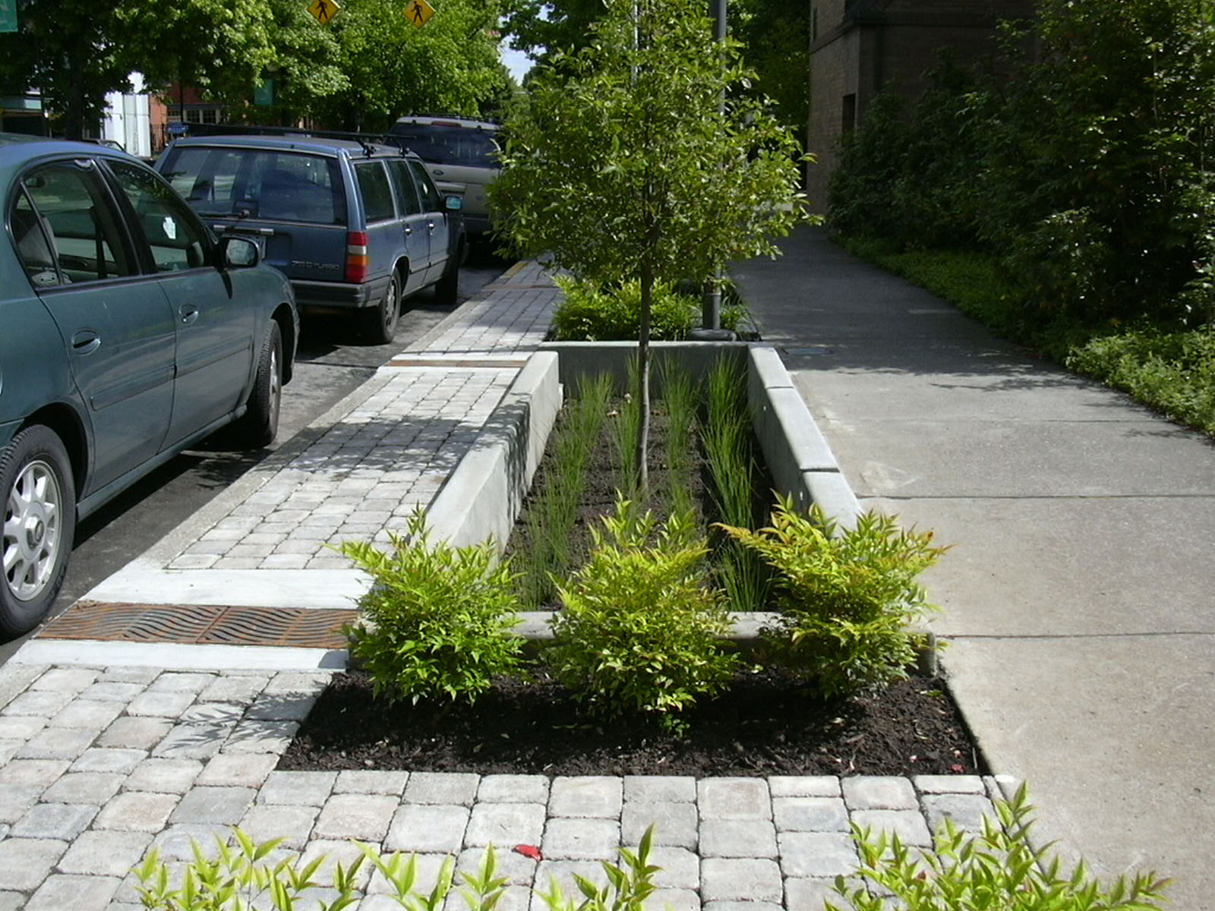](http://www.youtube.com/watch?v=eozVMJCYHCM&feature=related)

**Heat Island Effect**

<https://www.usgbc.org/glossary>

**heat island effect** the thermal absorption by hardscape, such as dark, nonreflective pavement and buildings,

and its subsequent radiation to surrounding areas. Other contributing factors may include vehicle exhaust, air conditioners, and street equipment. Tall buildings and narrow streets reduce airflow and exacerbate the effect.

**infrared (thermal) emittance** a value between 0 and 1 (or 0% and 100%) that indicates the ability of a material to shed infrared radiation (heat). A cool roof should have a high thermal emittance. The wavelength range for radiant energy is roughly 5 to 40 micrometers. Most building materials (including glass) are opaque in this part of the spectrum and have an emittance of roughly 0.9, or 90%. Clean, bare metals, such as untarnished galvanized steel, have a low emittance and are the most important exceptions to the 0.9 rule. In contrast, aluminum roof coatings have intermediate emittance levels. (Adapted from Lawrence Berkeley National Laboratory)

**solar reflectance (SR)** the fraction of solar energy that is reflected by a surface on a scale of 0 to 1. Black paint has a solar reflectance of 0; white paint (titanium dioxide) has a solar reflectance of 1. The standard technique for its determination uses spectrophotometric measurements, with an integrating sphere to determine the reflectance at each wavelength. Determine the SR of a material by using the Cool Roof Rating Council Standard (CRRC-1).

**solar reflectance index (SRI)** a measure of the constructed surface’s ability to stay cool in the sun by reflecting solar radiation and emitting thermal radiation. It is defined such that a standard black surface (initial solar reflectance 0.05, initial thermal emittance 0.90) has an initial SRI of 0, and a standard white surface (initial solar reflectance 0.80, initial thermal emittance 0.90) has an initial SRI of 100. To calculate the SRI for a given material, obtain its solar reflectance and thermal emittance via the Cool Roof Rating Council Standard (CRRC-1). SRI is calculated according to ASTM E 1980. Calculation of the aged SRI is based on the aged tested values of solar reflectance and thermal emittance.

**three-year aged SR or SRI** **value** a solar reflectance or solar reflectance index rating that is measured after three years of weather exposure

**thermal emittance** the ratio of the radiant heat flux emitted by a specimen to that emitted by a blackbody radiator at the same temperature (adapted from Cool Roof Rating Council)

GA08 Sustainable Sites (SS) - Pgs. 32-51

|  |  |
| --- | --- |
|  | **Sustainable Sites** |

|  |  |  |  |  |  |  |  |  |
| --- | --- | --- | --- | --- | --- | --- | --- | --- |
| Adaptation | NC | CS | S | R | DC | WDC | HOS | HC |
| Total | 10 | 11 | 12 | 12 | 11 | 11 | 10 | 9 |
| Construction Activity Pollution Prevention | req | req | req | req | req | req | req | req |
| Environmental Site Assessment | -- | -- | req | -- | -- | -- | -- | req |
| Site Assessment | 1 | 1 | 1 | 1 | 1 | 1 | 1 | 1 |
| Protect or Restore Habitat* | 2 | 2 | 2 | 2 | 2 | 2 | 2 | 1 |
| Open Space | 1 | 1 | 1 | 1 | 1 | 1 | 1 | 1 |
| Rainwater Management* | 3 | 3 | 3 | 3 | 3 | 3 | 3 | 2 |
| Heat Island Reduction* | 2 | 2 | 2 | 2 | 2 | 2 | 2 | 1 |
| Light Pollution Reduction | 1 | 1 | 1 | 1 | 1 | 1 | 1 | 1 |
| Site Master Plan | -- | -- | 1 | -- | -- | -- | -- | -- |
| Tenant Design and Construction Guidelines | -- | 1 | -- | -- | -- | -- | -- | -- |
| Places of Respite* | -- | -- | -- | -- | -- | -- | -- | 1 |
| Direct Exterior Access | -- | -- | -- | -- | -- | -- | -- | 1 |
| Joint Use of Facilities | -- | -- | 1 | -- | -- | -- | -- | -- |