 | Green Building Practices and LEED Green Associate Exam Preparation
Lorisweb.com

Water Efficiency (WE)
GA02 Excerpt WE Overview. LEED BD+C RG v4 - Pgs. 257-258
GA08 Water Efficiency (WE) - Pgs. 52-66
LCCG Section 4. Water Efficiency - pgs. 61-63

Energy and Atmosphere (EA)
GA02 Excerpt EA Overview. LEED BD+C RG v4 - Pgs. 323-324
GA08 Energy and Atmosphere (EA) - Pgs. 67-90
LCCG Section 4. Energy and Atmosphere - pgs. 64-70

Water Efficiency (WE)
GA02 Excerpt WE Overview. LEED BD+C RG v4 - Pgs. 257-258

The Water Efficiency (WE) credit category addresses the reduction of:
- Indoor Water Use
- Outdoor Water Use
- Process/Specialized Water Use
- And Metering

potable water
water that meets or exceeds U.S. Environmental Protection Agency drinking water quality standards (or a local equivalent outside the U.S.) and is approved for human consumption by the state or local authorities having jurisdiction; it may be supplied from wells or municipal water systems

nonpotable water
water that does not meet drinking water standards

graywater
“untreated household waste water which has not come into contact with toilet waste. Graywater includes used water from bathtubs, showers, bathroom wash basins, and water from clothes-washers and laundry tubs. It must not include wastewater from kitchen sinks or dishwashers” (Uniform Plumbing Code, Appendix G, Gray Water Systems for Single-Family Dwellings); “wastewater discharged from lavatories, bathtubs, showers, clothes washers and laundry sinks” (International Plumbing Code, Appendix C, Gray Water Recycling Systems). Some states and local authorities allow kitchen sink wastewater to be included in graywater. Other differences can likely be found in state and local codes. Project teams should comply with the graywater definition established by the authority having jurisdiction in the project area.

process water
water that is used for industrial processes and building systems, such as cooling towers, boilers, and chillers. It can also refer to water used in operational processes, such as dishwashing, clothes washing, and ice making.

The conservation and creative reuse of water are important because only 3% of Earth’s water is fresh water.

Sources of Potable Water
- Public water supply (municipal)
- Wells

Wastewater
- Piped to processing plant.
- Septic tanks

Importance of Metering
Energy required to treat water for drinking, transport it to and from a building, and treat it for disposal represents a significant amount of energy use not captured by a building’s utility meter. (GHG Red Flag!)

In the U.S., buildings account for 13.6% of potable water use. (LCCG – 12%)

Designers and builders can construct green buildings that use significantly less water than conventional construction by incorporating native landscapes that eliminate the need for irrigation, installing water efficient fixtures, and reusing wastewater for nonpotable water needs.

The WE category comprises three major components: indoor water (used by fixtures, appliances, and processes, such as cooling), irrigation water, and water metering. Several kinds of documentation span these components, depending on the project’s specific water-saving strategies.

Site Plans
Fixture Cutsheets
Alternative Water Sources
- Graywater reuse
- Rainwater harvesting
- Municipally supplied wastewater (purple pipe)

Note: Team cannot apply the same water to multiple credits unless the water source has sufficient volume to cover the demand of all the uses (e.g., irrigation plus toilet-flushing demand).

Occupancy Calculations
FTE
- A LEED BD+C: New Construction project has 400 full-time (40 hrs/wk) and 200 part-time (10 hrs/wk) employees. How many Full Time Equivalent (FTE) must be included for indoor water efficiency calculations?
- 400
- 450
- 500
- 600

LCCG Section 4. Water Efficiency - pgs. 61-63
The operation of buildings, including landscaping, accounts for approximately 47 billion gallons per day—12% of total water use.

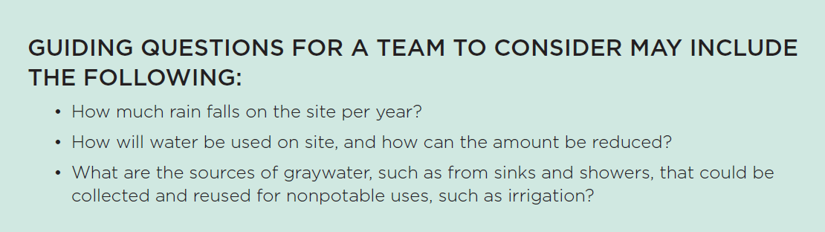

Indoor Water Use
Indoor use encompasses water for urinals, toilets, showers, kitchen or break room sinks, and other applications typical of occupied buildings.

Indoor Water Use Reduction
Installing water-efficient fittings and fixtures
Use nonpotable water for flush functions
Installing submeters to track and log water use trends, check fixture performance, and identify problems.

Industrial Processes and Systems
Cooling Towers
Boilers
Substitute harvested rainwater and nonpotable water sources
Chillers
Washing machines
Dishwashers

Submeters
Report how much water is used by systems and fixtures.
Alerts building maintenance to leaks and other inefficiencies.

Water Efficiency Goals
- Infiltrate rainwater on site to recharge the local aquifer.
- Use water more efficiently.
- Reduce the buildings water demand from indoor water (used by fixtures, appliances, and processes, such as cooling), and irrigation water.
- Install building level water meter and sub meters to track consumption and identify issues.

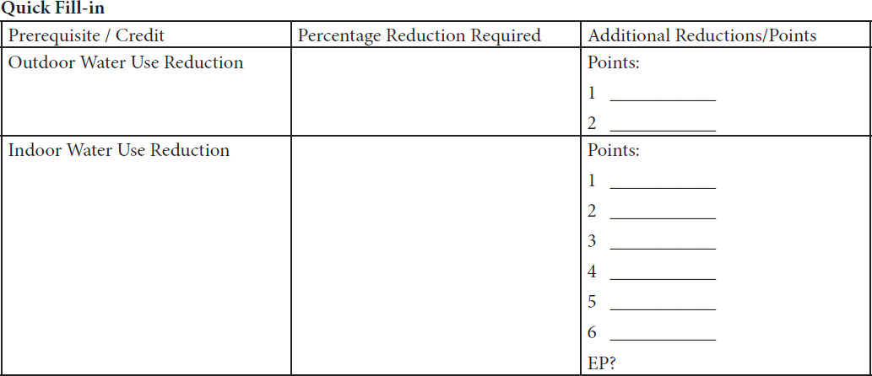

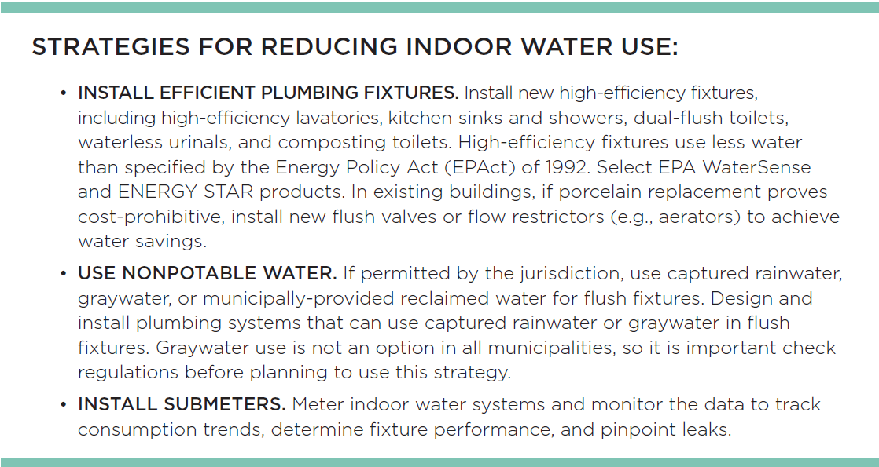

Outdoor Water Use
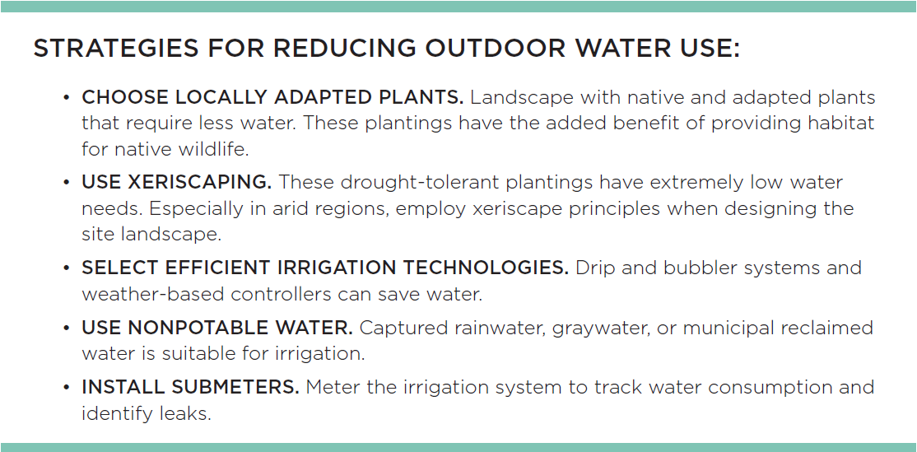

GA08 Water Efficiency (WE) - Pgs. 52-66

 |  |  | Water Efficiency
Adaptation |  | NC |  | CS | S | R | DC | WDC | HOS | HC
Total |  | 11 |  | 11 | 12 | 12 | 11 | 11 | 11 | 11
Outdoor Water Use Reduction |  | req |  | req | req | req | req | req | req | req
Indoor Water Use Reduction |  | req |  | req | req | req | req | req | req | req
Building-Level Water Metering |  | req |  | req | req | req | req | req | req | req
Outdoor Water Use Reduction |  | 2 |  | 2 | 2 | 2 | 2 | 2 | 2 | 1
Indoor Water Use Reduction |  | 6 |  | 6 | 7 | 7 | 6 | 6 | 6 | 7
Cooling Tower and Process Water Use |  | 2 |  | 2 | 2 | 2 | 2 | 2 | 2 | 2
Water Metering |  | 1 |  | 1 | 1 | 1 | 1 | 1 | 1 | 1

Energy and Atmosphere (EA)
GA02 Excerpt EA Overview. LEED BD+C RG v4 - Pgs. 323-324

EA Prerequisites (Required) and Credits Address:
Energy use reduction
Energy-efficient design strategies
Renewable energy sources

Nonrenewable Energy Sources
Oil
Coal
Natural Gas

Energy Efficient Green Buildings incorporate Designs that reduce overall energy needs.
- Building Orientation
- Glazing selection
- Choosing climate-appropropriate building materials
- Passive heating and cooling
- Natural ventilation
- High-efficiency HVAC systems w/smart controls
- Generating renewable energy on the project site
- Purchase green power

Commissioning Process
Critical to ensuring high-performance buildings.

Demand Response Programs
Increases grid efficiency.
Shift Load - Reduce electricity use during peak times.
Shed load – turn off equipment and lights!

LCCG Section 4. Energy and Atmosphere - pgs. 64-70
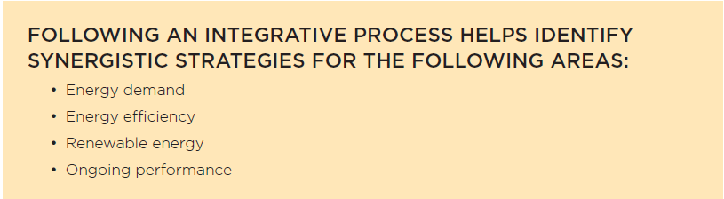

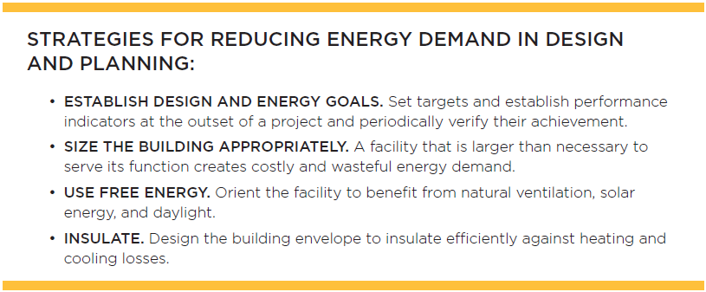

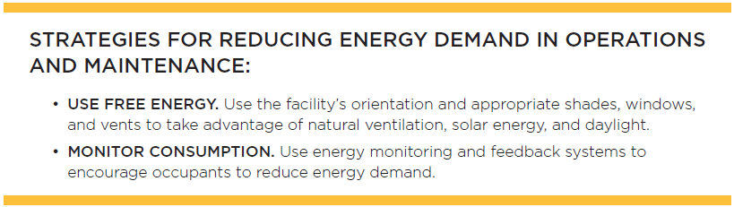

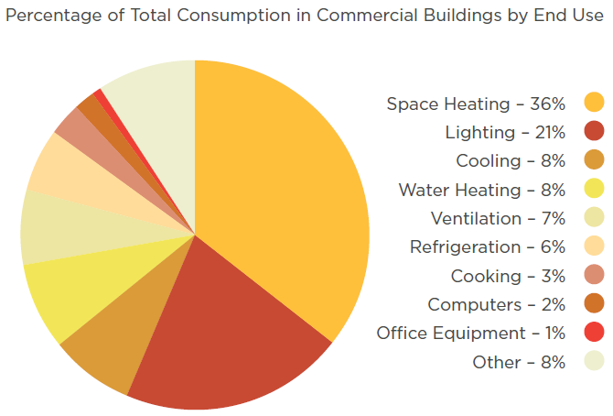

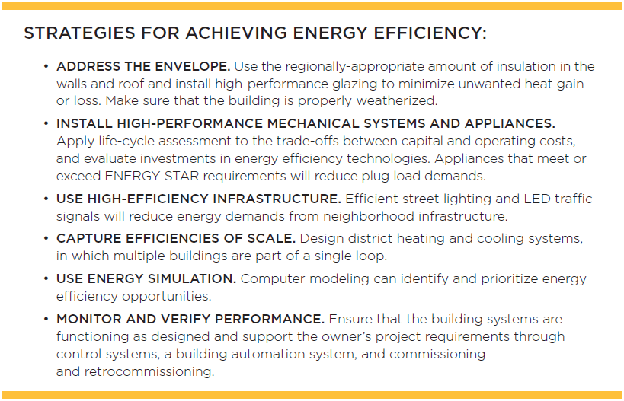

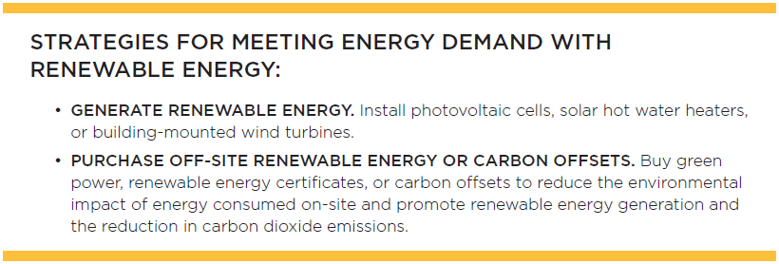

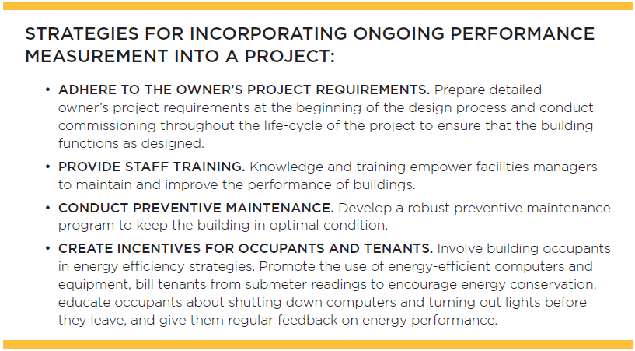

GA08 Energy and Atmosphere (EA) - Pgs. 67-90

 | Energy and Atmosphere (EA)
Adaptation |  | NC | CS | S | R | DC | WDC | HOS | HC
Total |  | 33 | 33 | 31 | 33 | 33 | 33 | 33 | 33
Fundamental Commissioning and Verification |  | req | req | req | req | req | req | req | req
Minimum Energy Performance |  | req | req | req | req | req | req | req | req
Building-Level Energy Metering |  | req | req | req | req | req | req | req | req
Fundamental Refrigerant Management |  | req | req | req | req | req | req | req | req
Enhanced Commissioning |  | 6 | 6 | 6 | 6 | 6 | 6 | 6 | 6
Optimize Energy Performance* |  | 18 | 18 | 16 | 18 | 18 | 18 | 18 | 20
Advanced Energy Metering |  | 1 | 1 | 1 | 1 | 1 | 1 | 1 | 1
Grid Harmonization |  | 2 | 2 | 2 | 2 | 2 | 2 | 2 | 2
Renewable Energy |  | 5 | 5 | 5 | 5 | 5 | 5 | 5 | 5
Enhanced Refrigerant Management |  | 1 | 1 | 1 | 1 | 1 | 1 | 1 | 1

