|  |  |
| --- | --- |
|  | **Green Building Practices and LEED Green Associate Exam Preparation** |

**Lorisweb.com**

**Materials and Resources (MR)**

GA02 Excerpt MR Overview. LEED BD+C RG v4 - Pgs. 475-480

GA08 Materials and Resources (MR) - Pgs. 91-112

LCCG Section 4. Materials and Resources - Pgs. 71-76

**Indoor Environmental Quality (EQ)**

GA02 Excerpt EQ Overview. LEED BD+C RG v4 - Pgs. 611-616

GA08 Indoor Environmental Quality (EQ) - Pgs. 113-143

LCCG Section 4. Indoor Environmental Quality - Pgs. 77-81

**Materials and Resources (MR)**

GA02 Excerpt MR Overview. LEED BD+C RG v4 - Pgs. 475-480

**The Materials and Resources (MR) category addresses:**

* Minimizing the embodied energy and other impacts associated with the extraction, processing, transport, maintenance, and disposal of building materials.

**The Waste Hierarchy**

Construction and demolition waste constitutes about 40 percent of the total solid waste stream in the United States and about 25% of the total waste stream in the European Union.

In its solid waste management hierarchy, the U.S. Environmental Protection Agency (EPA) ranks source reduction, reuse, recycling, and waste to energy as the four preferred strategies for reducing waste.

**Life-cycle assessment (LCA)**

* Life-cycle assessment (LCA) provides a more comprehensive picture of materials and products, enabling project teams to make more informed decisions that will have greater overall benefit for the environmental, human health, and communities, while encouraging manufacturers to improve their products through innovation.
* LCA is a “compilation and evaluation of the inputs and outputs and the potential environmental impacts of a product system throughout its life cycle.”

**Qualifying Products and Exclusions**

* The MR section addresses “permanently installed building products,” which as defined by LEED refers to products and materials that create the building or are attached to it.

Examples include structure and enclosure elements, installed finishes, framing, interior walls, cabinets and casework, doors, and roofs. Most of these materials fall into Construction Specifications Institute (CSI) 2012 MasterFormat Divisions 3-10, 31, and 32. Some products addressed by MR credits fall outside these divisions.

* Furniture is not required to be included in credit calculations. However, if furniture is included in MR credit calculations, all furniture must be included consistently in all cost-based credits.
* Special equipment, such as elevators, escalators, process equipment, and fire suppression systems, is excluded from the credit calculations. Also excluded are products purchased for temporary use on the project, like formwork for concrete.

**Determining Product Cost**

To calculate the total materials cost of a project, use either the actual materials cost or the default materials cost.

* **Actual materials cost**. This is the cost of all materials being used on the project site, excluding labor but including delivery and taxes.
* **Default materials cost**. The alternative way to determine the total materials cost is to calculate 45% of total construction costs. This default materials cost can replace the actual cost for most materials and products, as specified above. If the project team includes optional products and materials, such as furniture and MEP items, add the actual value of those items to the default value for all other products and materials.

**Location Valuation**

Several credits in the MR section include a location valuation factor, which adds value to locally produced products and materials. The intent is to incentivize the purchase of products that support the local economy.

* Products and materials that are extracted, manufactured, and purchased within 100 miles of the project are valued at 200% of their cost (i.e., the valuation factor is 2).
* The distance must be measured as the crow flies, not by actual travel distance.

Example:

A project team purchases 50 doors salvaged from a local deconstruction site and sold through a local Habitat for

Humanity ReStore for $500. The value of equivalent new doors is documented at $400 each, or $20,000. Their contribution to the credit is as follows:

$20,000 x 1.0 criterion valuation * 2.0 location valuation = $40,000

$40,000 is the total sustainable criteria value for these doors

**Determining Material Contribution of an Assembly**

Product value ($) = Total product cost ($) x (%) product component by weight x (%) meeting sustainable criteria



LCCG Section 4. Materials and Resources - Pgs. 71-76

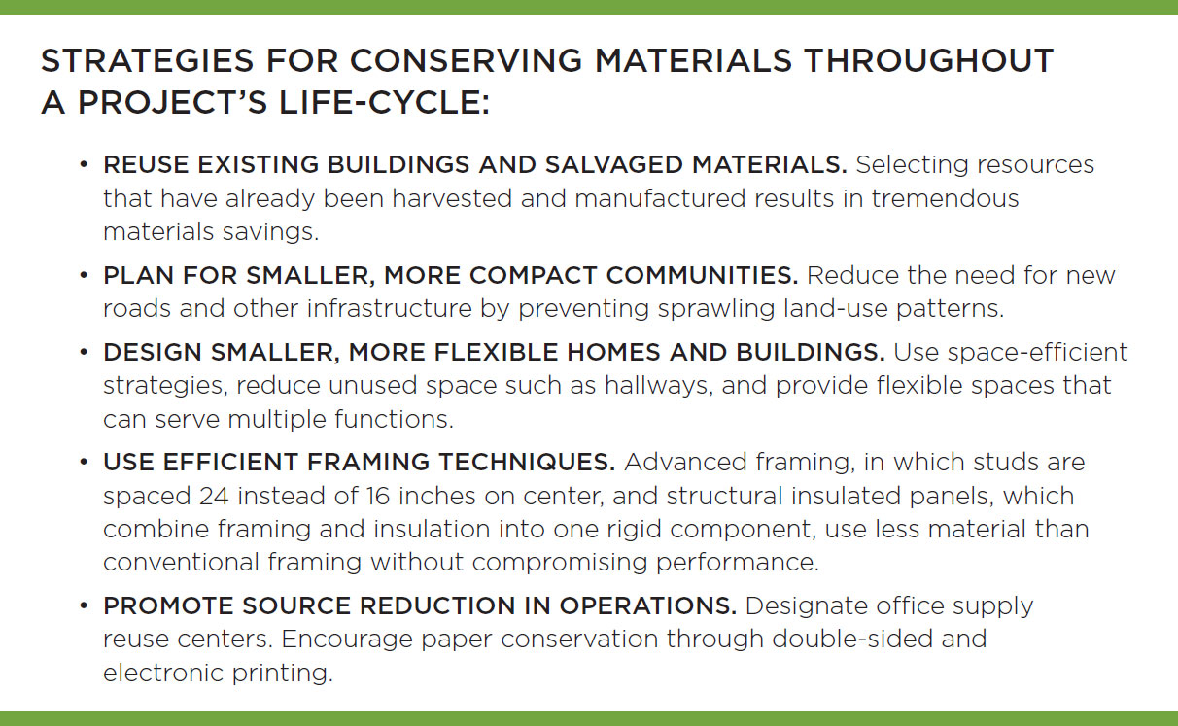

**Environmentally preferable attributes to consider include:**

* Support the local economy
* Sustainably grown and harvested
* Have intended end-of-life scenarios that avoid landfill
* Contain recycled content from industrial or consumer sources
* Made of bio-based material
* Free of toxins
* Long lasting, durable, and reusable
* Made in factories that support human health and workers’ rights

Product transparency tools like life-cycle assessment (LCA), Environmental Product Declarations (EPDs), and material ingredient disclosures provide a more comprehensive picture of materials and products, enabling project teams to make informed decisions.

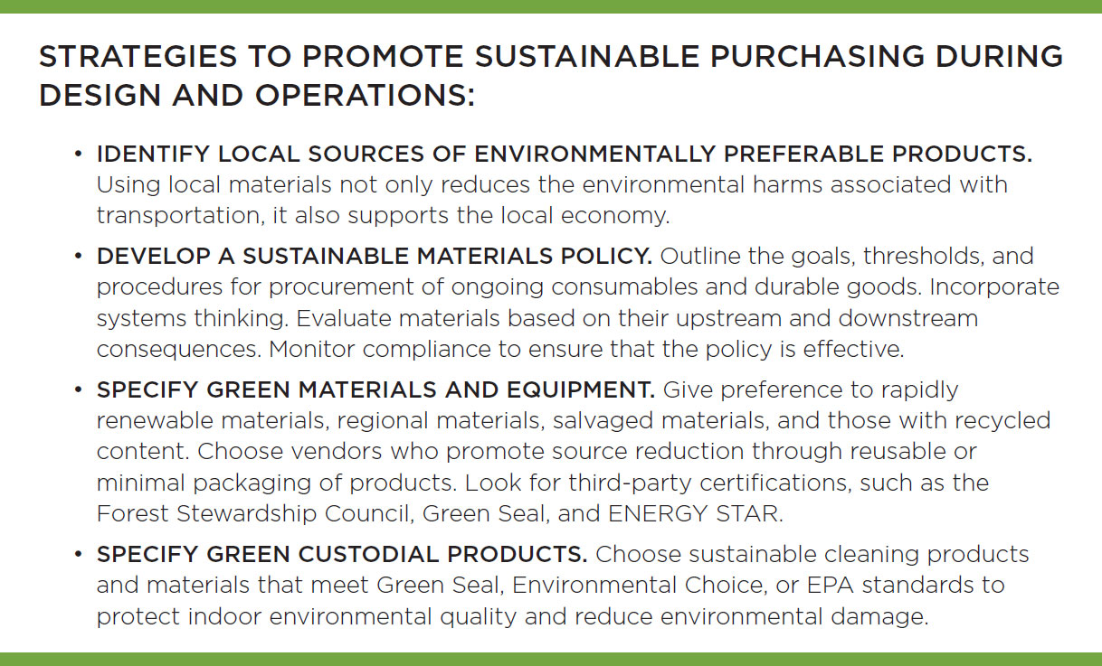

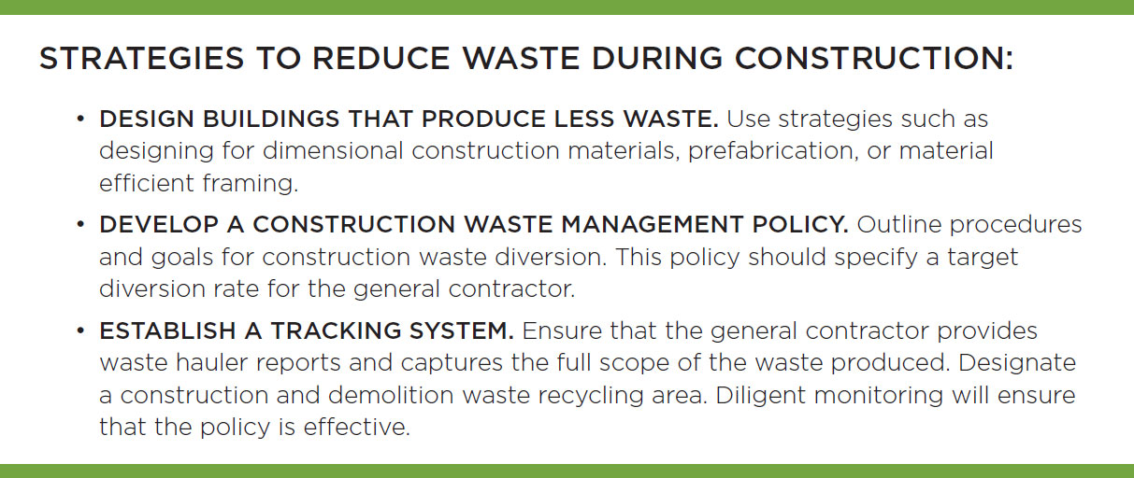

**Waste Stream Audit**

* Understanding the content of a waste stream is the first step to improving the waste diversion rate at a facility.
* Results from the waste audit can reveal opportunities for increasing recycling and waste diversion and be used to adjust the recycling procedures at the facility.

**Waste Management and Reduction**

* Solid waste disposal contributes directly to greenhouse gas emissions through transportation and the production of methane—a potent greenhouse gas—in landfills.
* The intent of LEED credits in this category is to reduce the waste that is hauled to and disposed of in landfills or incineration facilities.
* In its solid waste management hierarchy, EPA ranks source reduction, reuse, recycling, and waste-to-energy as the four preferred strategies for reducing waste in landfills.
* Close the life-cycle loop by reusing and recycling on-site materials

GA08 Materials and Resources (MR) - Pgs. 91-112

|  |  |
| --- | --- |
|  | **Materials and Resources (MR)** |

|  |  |  |  |  |  |  |  |  |
| --- | --- | --- | --- | --- | --- | --- | --- | --- |
| Adaptation | NC | CS | S | R | DC | WDC | HOS | HC |
| Total | 13 | 14 | 13 | 13 | 13 | 13 | 13 | 19 |
| Storage and Collection of Recyclables | req | req | req | req | req | req | req | req |
| Const. and Demolition Waste Mgmt. Planning | req | req | req | req | req | req | req | req |
| PBT Source Reduction - Mercury | -- | -- | -- | -- | -- | -- | -- | req |
| Building Life-Cycle Impact Reduction* | 5 | 6 | 5 | 5 | 5 | 5 | 5 | 5 |
| BPD&O - Environmental Product Declarations* | 2 | 2 | 2 | 2 | 2 | 2 | 2 | 2 |
| BPD&O - Sourcing of Raw Materials* | 2 | 2 | 2 | 2 | 2 | 2 | 2 | 2 |
| BPD&O - Material Ingredients* | 2 | 2 | 2 | 2 | 2 | 2 | 2 | 2 |
| PBT Source Reduction - Mercury | -- | -- | -- | -- | -- | -- | -- | 1 |
| PBT Source Reduction - Lead, Cadmium & Copper | -- | -- | -- | -- | -- | -- | -- | 2 |
| Furniture and Medical Furnishings* | -- | -- | -- | -- | -- | -- | -- | 2 |
| Design for Flexibility | -- | -- | -- | -- | -- | -- | -- | 1 |
| Const. and Demolition Waste Management* | 2 | 2 | 2 | 2 | 2 | 2 | 2 | 2 |

**Indoor Environmental Quality (EQ)**

GA02 Excerpt EQ Overview. LEED BD+C RG v4 - Pgs. 611-616

**The Indoor Environmental Quality (EQ) category addresses:**

* Indoor Air Quality
* Thermal, visual, and acoustic comfort

**High-quality indoor environments:**

* Enhance productivity
* Decrease absenteeism
* Improve the building’s value
* Reduce liability for building designers and owners

**Cross-Cutting Issues**

**Floor Area Calculations and Floor Plans**

For many of the credits in the EQ category, compliance is based on the percentage of floor area that meets the credit requirements.

**Space Categorization**

**Occupied versus unoccupied space**

All spaces in a building must be categorized as either occupied or unoccupied.

* **Occupied spaces** are enclosed areas intended for human activities.
* **Unoccupied spaces** are places intended primarily for other purposes; they are occupied only occasionally and for short periods of time—in other words, they are inactive areas.

**Regularly versus nonregularly occupied spaces**

Occupied spaces are further classified as regularly occupied or nonregularly occupied, based on the duration of the occupancy.

**Regularly occupied spaces** are enclosed areas where people normally spend time, defined as more than one hour of continuous occupancy per person per day, on average; the occupants may be seated or standing as they work, study, or perform other activities.

For spaces that are not used daily, the classification should be based on the time a typical occupant spends in the space when it is in use.

**For example**, a computer workstation may be largely vacant throughout the month, but when it is occupied, a worker spends one to five hours there. It would then be considered regularly occupied because that length of time is sufficient to affect the person’s well-being, and he or she would have an expectation of thermal comfort and control over the environment.

**Occupied space subcategories**

Occupied spaces, or portions of an occupied space, are further categorized as individual or shared multioccupant, based on the number of occupants and their activities.

* An **individual** occupant space is an area where someone performs distinct tasks.
* A **shared multioccupant** space is a place of congregation or a place where people pursue overlapping or collaborative tasks.

**Occupied space subcategories**

Occupied spaces can also be classified as densely or nondensely occupied, based on the concentration of occupants in the space.

* A densely occupied space has a design occupant density of 25 people or more per 1,000 square feet, or 40 square feet or less per person.
* Occupied spaces with a lower density are nondensely occupied.

**Indoor Air Quality**

* The best way to prevent indoor pollutants is to eliminate or control them at the sources.

LCCG Section 4. Indoor Environmental Quality - Pgs. 77-81

**Lighting, Acoustics, Occupant Experience**

**Thermal Comfort**

* Thermal comfort includes more than just temperature; it also includes humidity and air movement.

**Lighting Levels**

Lighting levels and views to the outdoors are other important aspects of the indoor experience. Providing enough lighting for particular tasks is critical to protect occupants’ eyesight over time.

* Studies by the **Heschong Mahone Group** have demonstrated that providing daylighting in classrooms can improve student scores by 7% to 18%.

GA08 Indoor Environmental Quality (EQ) - Pgs. 113-143

|  |  |
| --- | --- |
|  | **Indoor Environmental Quality (EQ)** |

|  |  |  |  |  |  |  |  |  |
| --- | --- | --- | --- | --- | --- | --- | --- | --- |
| Adaptation | NC | CS | S | R | DC | WDC | HOS | HC |
| Total | 16 | 10 | 16 | 15 | 16 | 16 | 16 | 16 |
| Minimum Indoor Air Quality Performance | req | req | req | req | req | req | req | req |
| Environmental Tobacco Smoke Control | req | req | req | req | req | req | req | req |
| Minimum Acoustic Performance | -- | -- | req | -- | -- | -- | -- | -- |
| Enhanced Indoor Air Quality Strategies* | 2 | 2 | 2 | 2 | 2 | 2 | 2 | 2 |
| Low-Emitting Materials* | 3 | 3 | 3 | 3 | 3 | 3 | 3 | 3 |
| Construction Indoor Air Quality Mgmt Plan | 1 | 1 | 1 | 1 | 1 | 1 | 1 | 1 |
| Indoor Air Quality Assessment | 2 | -- | 2 | 2 | 2 | 2 | 2 | 1 |
| Thermal Comfort | 1 | -- | 1 | 1 | 1 | 1 | 1 | 1 |
| Interior Lighting | 2 | -- | 2 | 2 | 2 | 2 | 2 | 1 |
| Daylight | 3 | 3 | 3 | 3 | 3 | 3 | 3 | 2 |
| Quality Views* | 1 | 1 | 1 | 1 | 1 | 1 | 1 | 2 |
| Acoustic Performance | 1 | -- | 1 | -- | 1 | 1 | 1 | 2 |