|  |  |
| --- | --- |
|  | **Green Building Practices and LEED Green Associate Exam Preparation** |

**Lorisweb.com**

**GA03 LEED v4 Impact Category and Point Allocation Process Overview**

**Introduction**

LEED provides a way to quantify the benefits of sustainable building.

The point allocation process employed by the LEED Rating System serves as a method for producing a simplified guide for building project teams to navigate complex and competing issues affecting us on a global scale.

This paper addresses the weighting system and process that was developed for LEED v4.

**Background**

**Early Versions of LEED**

* Technical Advisory Group (TAC)

**LEED 2009**

* Weighting System
* 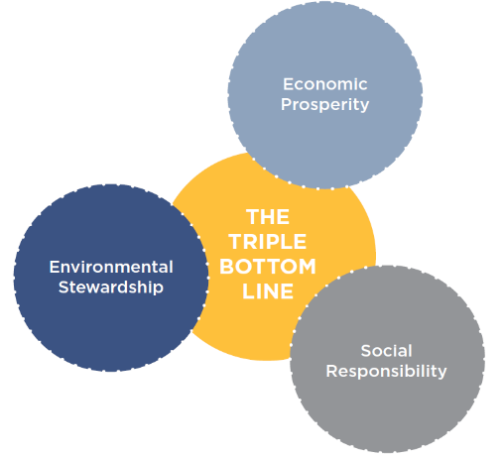Impact categories were derived from the Environmental Protection Agency’s [TRACI](https://www.epa.gov/chemical-research/tool-reduction-and-assessment-chemicals-and-other-environmental-impacts-traci) categories, which are widely used to conduct Life-Cycle Assessments (LCA).

**LEED v4**

* The LEED Steering Committee approved a set of new Impact Categories that focus on the social, environmental and economic goals of LEED and measure each strategy according to their ability to meet those goals.
* “What should a LEED project accomplish?”

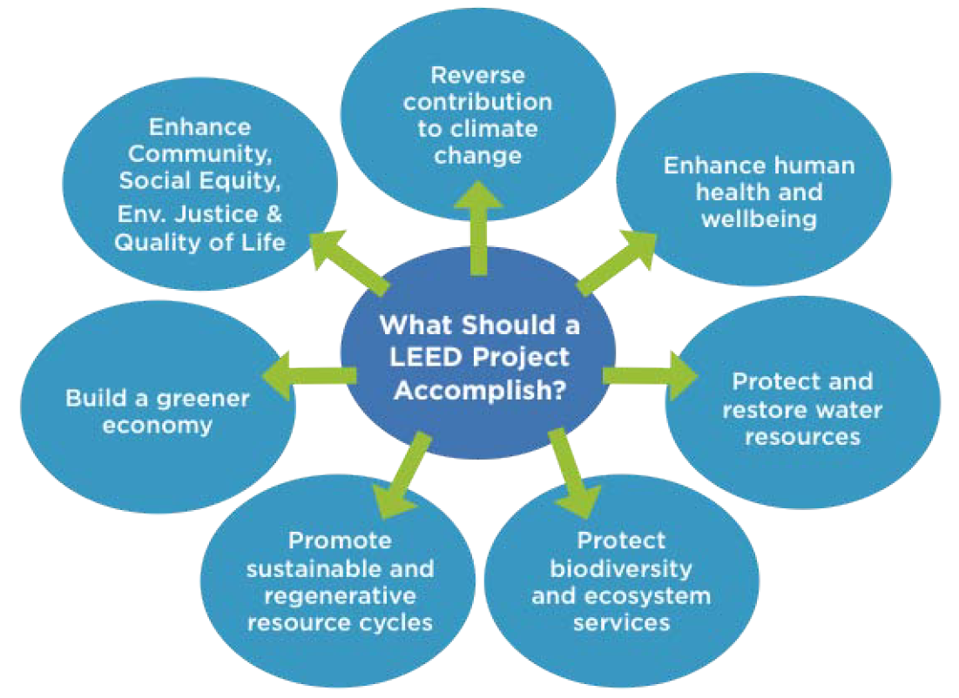

* LEED v4 also generated another innovation—a web-based tool that enables multivariate associations between strategies and impacts.
* The LEED Rating System allocates points to incentivize building project teams to comply with requirements that best address the social, environmental, and economic outcomes identified by USGBC.

**Overview of LEED Structure**

**LEED Rating System**

The LEED Rating System is a voluntary, consensus driven, internationally recognized green building certification system providing third-party verification that a building or community was designed and built using strategies aimed at improving performance across metrics such as energy savings, water efficiency, CO2 emissions reduction, improved indoor environmental quality, and resource stewardship.

**LEED Rating System**

* Design Guide
* Verification system used to measure progress in defined performance goals
* Encourages Integrated Project Delivery – Collaboration vs Isolation

**LEED Credit Categories**

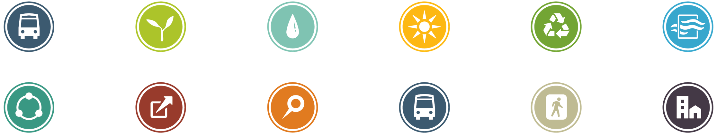

Location and Transportation (LT) • Sustainable Sites (SS) • Water Efficiency (WE) • Energy and Atmosphere (EA) • Materials and Resources (MR) • Indoor Environmental Quality (EQ) • Integrated Process • Innovation (IN) • Regional Priority (RP) • Smart Location and Linkages (SLL) • Neighborhood Pattern and Design (NPD) • Green Buildings and Infrastructure (GBI)

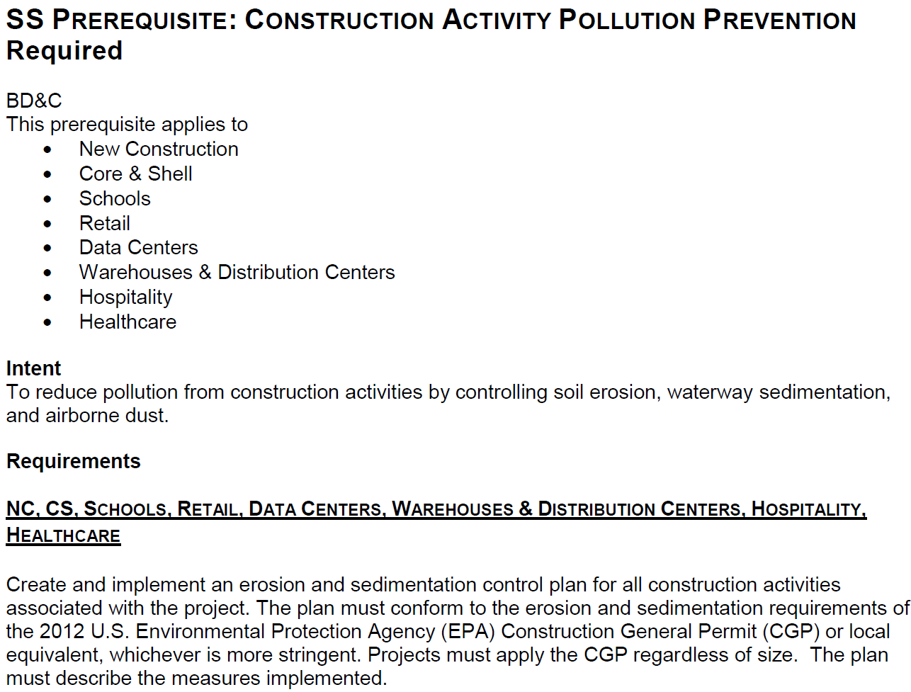**LEED Credits**

* Prerequisites – Required
* Credits - Optional

**Achieving LEED certification requires:**

* Meet the Minimum Program Requirements (MPRs)
* Satisfy all prerequisites
* Earn a minimum number of credits for the desired level of certification

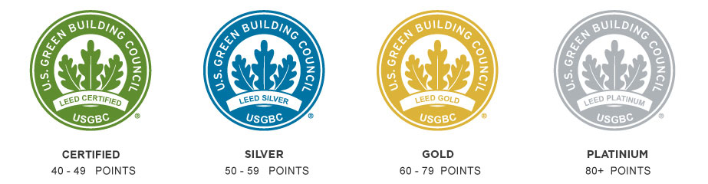

**LEED System Goals**

**Referred to as “Impact Categories”**

Reverse Contribution to Global **Climate Change**

Enhance Individual **Human Health** and Well-Being

Protect and Restore **Water Resources**

Protect, Enhance and Restore **Biodiversity** and Ecosystem Services

Promote Sustainable and Regenerative **Material Resources** Cycles

Build a **Greener Economy**

Enhance Social Equity, Environmental Justice, and **Community** Quality of Life

**Point Allocation Methodology**

Credits that significantly contribute to accomplishing the system goals of the seven impact categories are given more emphasis by being assigned more points.

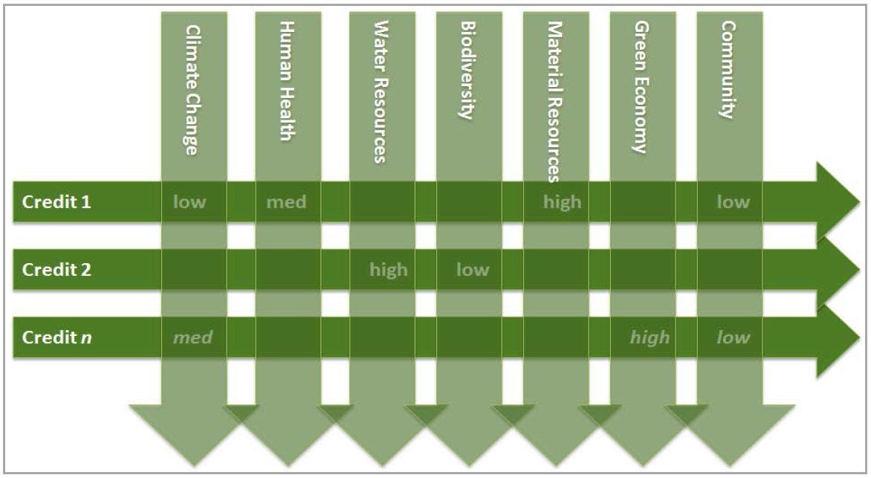

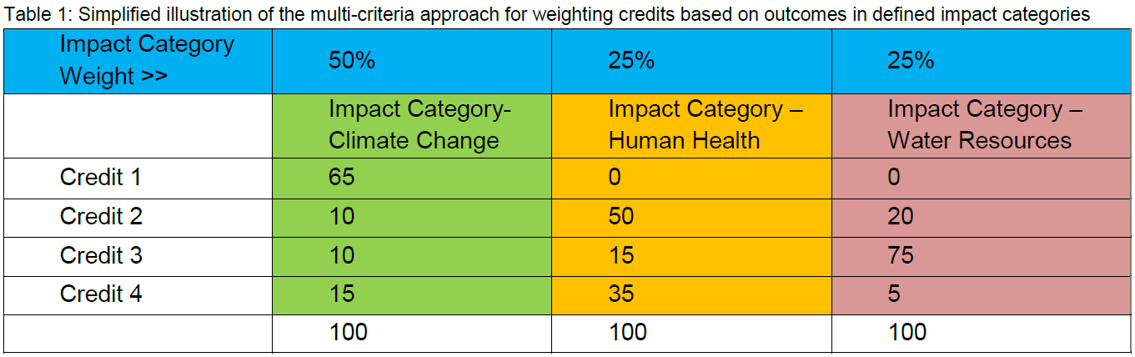

**Impact Category Weighting Layer**

* Applied to the overall weighting process
* Each of the LEED’s Impact Categories vary in scale, scope, severity, and relative contribution from the built environment to these impacts.

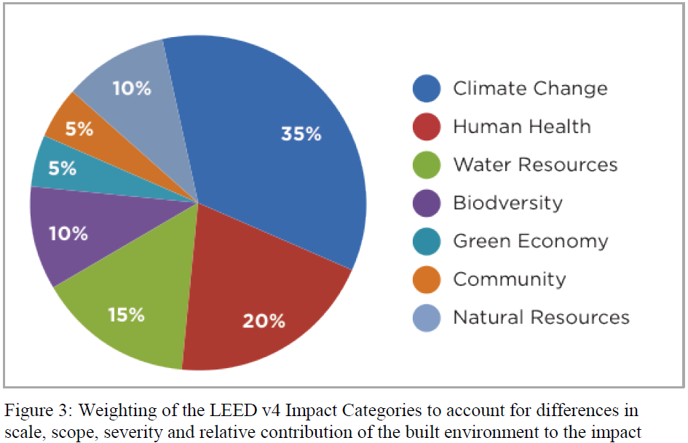

**Credit Outcome Weighting**

The relative strength of a relationship, or association, between a credit outcome and goal within an Impact Category contributes to each credit’s point value.

* Date Driven – i.e. CO2e footprint
* Qualitative Associations- i.e. low, medium, or high

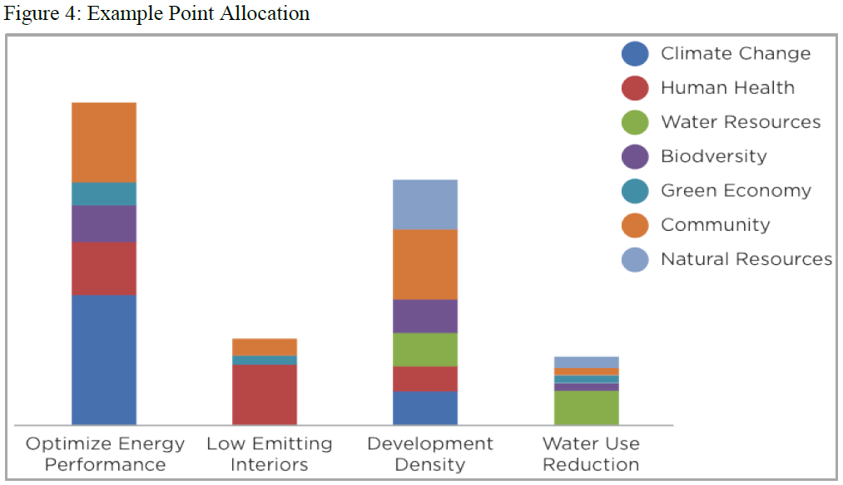

More than 4,000 associations relative to the **efficacy**, **duration**, and **control** of the benefit are made to accomplish this task.

A set of bounding assumptions is defined for each impact category to avoid double counting impacts.

The weights are then compiled to generate a scorecard based on the desired amount of total points (100 points for LEED v4) and the minimum number of points for each credit (1 point minimum for LEED v4).

**LEED Scorecard Development**

**Impact Category Definitions**

**Reverse Contribution to Global Climate Change**

* GHG Emissions Reduction from Transportation Energy Use
* GHG Emissions Reduction from Materials and Water Embodied Energy Use
* GHG Emissions Reduction by Embodied Energy of Water Reduction
* GHG Emissions Reduction from a Cleaner Energy Supply
* Global Warming Potential Reduction from Non-Energy Related Drivers

**Enhance Individual Human Health and Well-Being**

* Support Occupant Comfort and Well-Being
* Protect Human Health from Direct Exposure to Negative Health Impacts
* Protect Human Health Globally and Across the Entire Built Environment Life Cycle

**Protect and Restore Water Resources**

* Water Conservation
* Water Quality Protection
* Protection and Restoration of Water Regimes and Natural Hydrological Cycles

**Protect, Enhance and Restore Biodiversity and Ecosystem Services**

* Local Biodiversity, Habitat Protection and Open Spaces
* Global Biodiversity, Habitat Protection and Land Preservation
* Sustainable Use and Management of Ecosystem Services

**Promote Sustainable and Regenerative Material Resources Cycles**

* Reduce Raw Material Resources Extraction
* Move to Cyclical, Non-Depleting Material Cycles
* Reduce Negative Environmental Impacts throughout the Materials Life-Cycle

**Build a Greener Economy**

* Enhance the Value Proposition of Green Building
* Strengthen the Green Building Industry and Supply Chain
* Promote Innovation and Integration of Green Building Products and Services
* Incentivize Long Term Growth and Investment Opportunities
* Support Local Economies

**Enhance Social Equity, Environmental Justice, Community Health and Quality of Life**

* Create a Strong Sense of Place
* Provide Affordable, Equitable and Resilient Communities
* Promote Access to Neighborhood Completeness Resources
* Promote Human Rights and Environmental Justice

**Association Factors**

Using the Impact Categories and components, associations between LEED credit requirements and Impact Category goals are measured and scaled (quantitatively if possible, qualitatively if not) to each component through three distinct lenses.

* Relative Efficacy
* Duration
* Control

**Relative Efficacy** - A measure of whether a credit outcome is associated with a given Impact Category component, and how strong that association is.

* Is the credit outcome related to the component?
* If yes, how strong, weak, or negative is the credit outcome linked to the component relative to other credits?
* No association
* Low association
* Medium association
* High association
* Negative association

**Duration** - This is a measure of how long the benefits or consequences of the credit outcome can be expected to last.

* 1-3 Years
* 4-10 Years
* 11-30 Years
* 30+ Years (Building/Community Lifetime)

**Control** - This indicates which individual or actor is most directly responsible for ensuring that the expected outcome of the credit outcome is actually achieved. It is assumed that when the expected outcome of a credit is dependent on Occupants (e.g. biking to work because of the availability of bicycle racks), the certainty of the outcome is lowest and therefore the association weight is discounted the most heavily. If the outcome is not dependent on an individual (e.g. thermal mass as a passive heating/cooling strategy), then the certainty of that outcome is assumed to be the highest and is then not discounted at all.

* Occupants
* Operation and Maintenance Staff (or construction crew)
* Owner (or Developer)
* Passive

**Scorecard Rules**

USGBC has instituted conventions aimed at simplifying the output of the weightings process and into a scorecard:

* 100 base points – the base LEED Rating System is a 100-point system.
* 1-point minimum - All credits in the rating system are worth at least one point.
* Whole points - Rounding conventions are used to ensure that fractional credit values are rounded to the nearest whole point.

**Conclusions: Lessons Learned**

* A more robust and transparent articulation of USGBC goals
* Ability to measure current and future success of the LEED rating system
* Technical Development Agenda
* Importance of Prioritization
* Simplicity to the user
* LEED Customization – Multiple Lenses of Sustainability

**Appendix A – Detailed Impact Category and Components Purpose**

In order to make accurate and consistent decisions on the associations between LEED credits and impact category components, detailed definitions and system boundaries were needed for each component.

**Reverse Contribution to Global Climate Change**

Reverse contribution to the primary drivers of climate change that are within the control of the building industry and addressable through the LEED rating system.

The reduction of fossil-fuel based energy consumption is the most impactful way that a project can help to reverse its contribution to climate change.

The following components break this down to the particular areas where a project can effect change.

**GHG Emissions Reduction from Building Operations Energy Use**

To target energy use reductions directly associated with building operations. This includes all building

systems and operations within the building or associated grounds that rely on electricity or other fuel sources

for energy consumption.

**GHG Emissions Reduction from Transportation Energy Use**

To target energy use reductions associated with the transportation of building occupants, employees,

customers, visitors, business travel, etc.

**GHG Emissions Reduction from the Embodied Energy of Materials and Water Use**

To target GHG-emissions reductions associated with the energy use and processes required in the extraction, production, transportation, conveyance, manufacturing, assembly, distribution, use, posttreatment, and disposal of materials, products and processed water. Any measures that directly reduce the use of potable water, non-potable water, or raw materials (e.g. reduced packaging, building reuse) will indirectly reduce energy as well because of the embodied energy associated with these product life cycles.

**GHG Emissions Reduction from a Cleaner Energy Supply**

To target actions and measures that support a cleaner, less GHG-emissions intensive energy supply and a greater reliance on renewable sources of energy.

**Global Warming Potential Reduction from Non-Energy Related Drivers**

To address the non-energy related climate change drivers (e.g. albedo, carbon sinks, non-energy related GHG emissions) and identifies actions that reduce these contributions to climate change (e.g. land use changes, heat island reduction, reforestation, refrigerant purchases).

**Enhance Individual Human Health and Well-Being**

Protect and improve individual human health through changes in how we design, construct and operate within the built environment.

**Support Occupant Comfort and Well-Being**

To support the mental health, well-being and vitality of building occupants.

Examples of included measure are: improved daylighting, indoors acoustics, greater access to the outdoors, closer proximity to community services, increased ventilation, etc.

The scope of this component is focused on the building use phase of the building cycle, and within the project boundary.

**Protect Human Health from Direct Exposure to Negative Health Impacts**

To focus on measures that can lead to improved general health and a reduction of factors (e.g. toxicity levels, carcinogenic substance levels, accidents/injury) that contribute to increased rates of morbidity and/or mortality for building occupants and construction workers.

Examples of these might include low VOC building materials, pre-occupancy flush outs, improved construction management practices, improved ventilation rates.

The scope of this component includes: building occupants and design & construction crew during the construction phase and use phase of the building cycle, within the project boundary and its immediate surroundings.

**Protect Human Health Globally and Across the Built Environment Life Cycle**

To focus on measures that can lead to improved general health and reduce factors that contribute to increased rates of morbidity and/or mortality for all those who are involved or are affected by the impacts of a building project during its product life cycle. This component includes any impacts upstream or downstream of the construction and use phases of a building but excludes the use phase and construction phase because these impacts are accounted for in the other components of the Human Health impact category.

Examples of included measures are: (1) the reduction on the reliance of fossil fuels that, through their extraction (i.e. mining) and processing (e.g. as an energy source, or other product), result in localized pollution and harmful human health effects; (2) the use of building materials that minimize the use of harmful chemical and substances during its production, manufacturing, and distribution (3) building materials that are manufactured in a socially responsible way that do not jeopardize the health and working conditions of employees.

**Protect and Restore Water Resources**

Protect and restore the water resources and the important ecological, social and economic services that they provide.

**Water Conservation**

To focus on the reduction of overall water consumption within a building and its associated grounds.

The scope of this component is water use within the project boundary during construction and use phase of the building life cycle.

Examples would include reduction of indoor potable water use.

**Water Quality Protection**

To focus on water quality protection of potable water supplies on local and regional scales. This includes measures that can affect potable water quality of runoff and wastewater that leaves the project and re-enters the watershed.

The scope of this component includes local and regional water bodies that are upstream and downstream of the project during the construction and use phase of the building life cycle.

Examples would include wastewater treatment and storm water runoff reduction.

**Protection and Restoration of Water Regimes and Natural Hydrological Cycles**

To address water regimes and hydrological cycles on a global scale. This component considers the entire building life cycle, and how each phase of that cycle impacts water resources and natural hydrological cycles at local, regional scales, across the globe (as opposed to at the project site).

Scope that is included in the other water resources components is excluded here.

Examples of measures that impact water regimes at this scale include: off-site habitat protection; sustainable food purchasing that reduces harmful agricultural runoff, non-water-intensive energy production, purchasing of building materials that rely on sustainable mining practices, decreased reliance on fossil fuels whose extraction and processing can negatively impact water regimes.

**Protect, Enhance and Restore Biodiversity and Ecosystem Services**

Protect, enhance and restore biodiversity and habitat, and the vital ecosystem services that they provide. This includes habitat and ecosystems that are local and regional in relation to the project, as well as a global perspective on the built environment's ability to impact ecosystem function, biodiversity and habitat.

**Local Biodiversity, Habitat Protection and Open Spaces**

To protect, restore and enhance biodiversity, habitat and open space within and surrounding the project site.

The scope of this component pertains to the full project life cycle.

Examples of this would include selecting native vegetation, local species sensitivity during site selection and design, open space protection and onsite habitat protection, infill/brownfield development, etc.

**Global Biodiversity, Habitat Protection and Land Preservation**

To protect, restore and enhance biodiversity, habitat, and land preservation from a global perspective.

The scope of this component pertains to the full project life cycle.

Examples of this would include offsite habitat protection, sustainable forestry products, avoidance of chemical that have high levels of known ecosystem toxicity, responsible mining practices.

**Sustainable Use and Management of Ecosystem Services**

To support and promote the sustainable management of all ecosystem services and resources provided to society by the environment.

The scope of this component pertains to the full project life cycle on a local, regional and global scale. There will be significant overlap between this component and the other two components of this impact category because in most cases, the protection of biodiversity and ecosystems provide multiple benefits to economy and society.

Examples of measures that preserve vital ecosystem services include: storm water management, urban forests, erosion controls, open spaces, sustainable food purchasing, etc.

**Promote Sustainable and Regenerative Material Resource Cycles**

Promote sustainable and regenerative material resource cycles that conserve natural resources, minimize negative environmental impacts throughout the materials cycle, and initiates a shift to materials cycles that become a positive contributor to the environment and human health.

**Reduce Raw Material Resources Extraction**

To reduce the overall demand of raw materials and natural resources that building materials and products are derived from. Energy fuels are excluded from this component as the conservation of fuels is captured within the climate change impact category.

Examples of this would include whole building reuse, building interiors reuse, recycling, extended product lifecycles, etc.

**Move to Cyclical, Non-Depleting Material Cycles**

To shift to materials cycles that become a positive contributor to the environment and human health. Materials cycles should be fully closed loop and eventually fully integrated with the natural system cycles that govern our planet and life on it.

**Reduce Negative Environmental Impacts Throughout the Materials Life-Cycle**

To reduce the life cycle environmental and human health impacts that are associated with the materials cycle.

Examples of this would include a reduction of ozone-depleting refrigerants, sustainable and socially responsible purchasing of materials, landfill diversion, etc.

**Build a Greener Economy**

Build and foster a green economy that views green building practices and overall sustainability as a central component of continued growth and long-term profit. To ensure that sustainability is properly recognized and valued, and the hidden costs of environmentally and socially negligible building practices are accounted for so that financially sound decision-making and sustainability driven decision-making can be fully compatible.

**Enhance the Value Proposition of Green Building**

To actively engage the building industry, building occupants, facility managers, visitors, and all others who interact with buildings to better understand and recognize the importance and value of green buildings. Green building strategies that are tangible, highly visible, quantifiable, improve our ability to more accurately measure progress, educate, or otherwise to help to communicate the importance of green building are included in this component.

Examples of these include: green building education, measurement &verification, advanced building metering, on-site renewable energy systems, advanced lighting systems, mixed use developments, open spaces, daylighting, etc.

**Strengthen the Green Building Industry and Supply Chain**

To support the variety of green building services, products, materials and knowledge-base that supply the on-going market transformation to truly sustainable built environment practices.

Examples include: high efficiency water technology products, low-emitting materials, green cleaning products, integrative design services, building commissioning services, recycled products, etc.

**Promote Innovation and Integration of Green Building Products and Services**

To identify and promote new innovation in green building products, technologies, materials, services and processes in order to continually pull the market forward. Integration of existing and new technologies, services and the project teams that support these are critical for successful implementation of innovation.

Examples include: integrated design services, charrettes, advanced building performance monitoring, ongoing commissioning, building occupant feedback and response systems, zero net energy, zero net water, passive cooling and heating, shared facilities.

**Incentivize Long Term Growth and Investment Opportunities**

To highlight green building strategies that represent a strong return on investment opportunity or clearly contribute to an increase in the overall financial value of a building or property, including enhanced productivity of occupants. Identifying building practices that are both financially and environmentally/socially synergistic is an important aspect of sustainability.

Examples include: energy efficiency improvement measures, water efficiency improvement measures, daylighting, enhanced ventilation, proximity to services and public transit.

**Support Local Economies**

To support the local economies surrounding a project site. Green building should contribute to healthier more prosperous communities and help to build green economies from the ground up.

**Enhance Social Equity, Environmental Justice, and Community Quality of Life**

Support the long-range vision for the future growth and development of community that provides universally accessible economic opportunities, supports environmental justice and human rights, addresses issues of social equity, improves quality of life, and nurtures cultural vitality. This category explores the importance that buildings have in the context of the greater community that surrounds them, and how they can powerfully shape the culture, politics, values, prosperity, health, and happiness of the citizens that are unavoidable affected by them.

**Create a Strong Sense of Place**

To create a strong sense of place in communities by focusing on human-scale environments that allow for seamless interaction and engagement of citizens with their environment and each other. A stronger sense of place provides means creating more opportunities for cultural, social and recreational interactions, improving community aesthetics, creating a strong sense of identity with the community and a greater sense of connectivity between members of that community.

Examples of measures that contribute to sense of place include: light pollution reduction, tree-lined streets, quality views, ecologically-conscious landscaping, green roofs, open spaces, civic spaces, historical preservation, greater connection to the outdoors, pedestrian friendly communities, human scale environments, cultural expression and the freedom to express values/beliefs through building design.

**Provide Affordable, Equitable and Resilient Communities**

To provide affordable and equitable communities and neighborhoods that address community-level economic, social and environmental problems. Neighborhoods should have an adequate supply of healthful, high-performing, affordable housing that is well connected to critical goods and services, public transportation, and employment opportunities.

Neighborhood development and redevelopment should focus on the management of community resources (including natural resources, ecosystem services, economic resources, civic resources, recreational resources, and social services) and enable local networks that will continue to foster and strong and diverse local economies, and benefits that feed back to the community. Communities should be built to be resilient and stable under shifting economic conditions, climatic conditions, and natural disasters.

Examples of measures and policies include: affordable housing, diverse and mixed use communities, universal design, housing and jobs proximity, heat island reduction strategies, open and dense street grids, design for walkability and bikability.

**Promote Access to Neighborhood Completeness Resources**

To promote development patterns that support diverse, accessible and proximate location to vital services including employment, education, healthcare, healthy food, recreation, civic and public spaces, retail, and other basic services.

Examples include: proximity to diverse uses, community services and public transit, compact development patterns, mixed use buildings, walkability, bikability, proximity to open spaces and civic spaces, open and accessible parks and recreational facilities, proximity to high quality public education facilities and resources, local land conservation and natural resources protection, protection of local water bodies high performance and high quality design of public buildings.

**Promote Human Rights and Environmental Justice**

To promote basic universal human rights as they pertain to the built environment and enable communities to uphold environmental justice.

Examples include: reclaiming and repurposing vacant, obsolete or contaminated land and buildings, strengthening local and regional food supply chains, implementing sustainable cleaning, purchasing and facility management policies, ensure safe drinking water quality, indoor air quality, indoor environmental quality, support community and city involvement through the provision of civic and public spaces, designing buildings that are climate adaptable and durable.