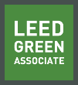 | Green Building Practices and LEED Green Associate Exam Preparation
Lorisweb.com

GA04 LEED v4 User Guide

Demanding More from Our Buildings
LEED v4 – November 2013
- Stronger Energy performance
- Better materials
- Increased water efficiency
- Accounting for human experience

Create significant global and local change through resource-efficient, cost-effective green buildings.

Better Buildings are Our Legacy
By looking at the Whole Building as interconnections, buildings can be built and operated in a more sustainable and efficient way.

Choose the right team of people.

LEED v4 leverages integrative process to help project teams better understand the interconnectivity that exists throughout building systems and the phases of building design and construction.

LEED v4 addresses 21 different market sector adaptations:
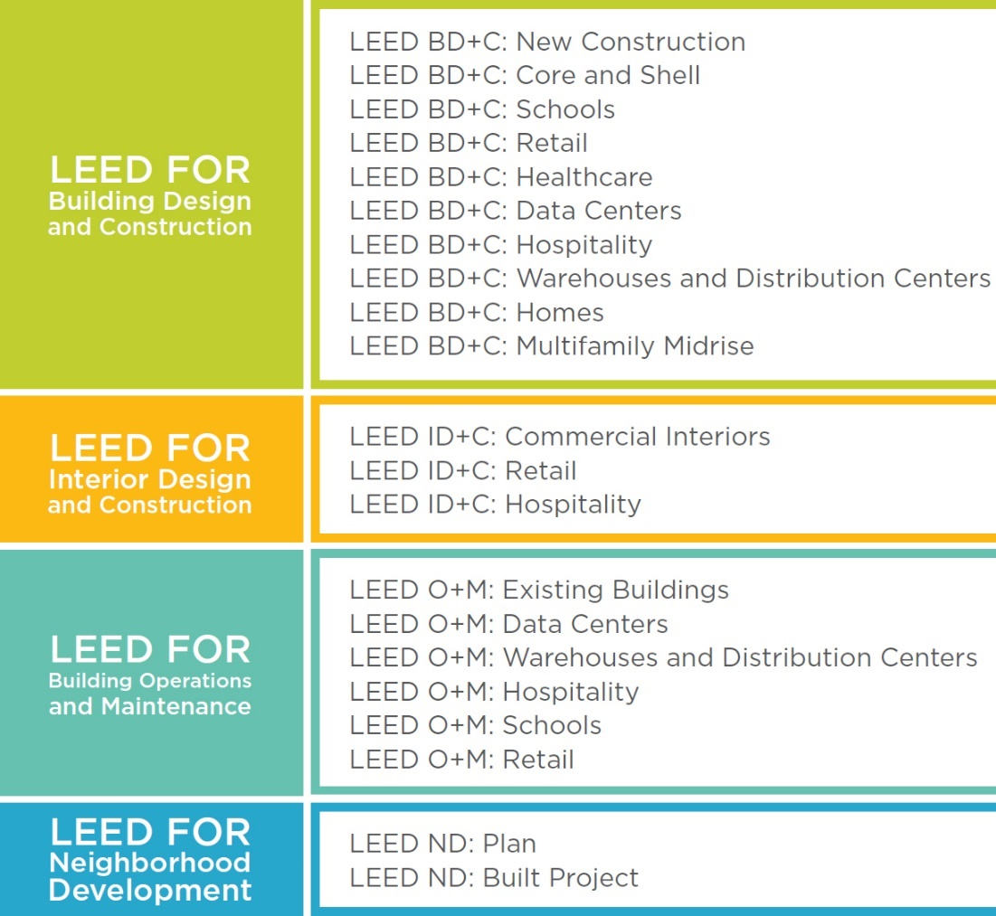
Using LEED v4
Documentation
- Combined forms for prerequisites and credits. Reduces the amount of overlap and duplicative work.
- Downloadable calculators. Increased transparency to provide LEED users a better understanding of the equations behind the calculations.
- Less documentation needed. There are many instances where industry standard documentation provides all of the information needed to confirm credit compliance and submittal documents have been modified to reflect that.

Reference Guides
Primary source for teams to understand and achieve LEED credit requirements.
Web based contains supplemental material – videos, tutorials, presentations and documents.
LEED is a marketplace standard of best practice in designing, building, operating and maintaining buildings.

Improved Environmental Outcomes
LEED’s goals are referred to as “impact categories”
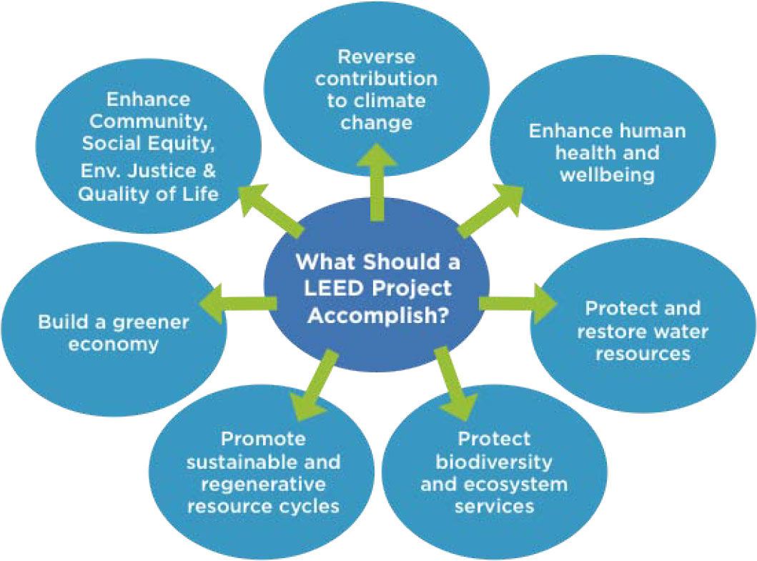

LEED Certification Process
Certification begins with rating system selection and project registration.
Documentation is then prepared for all prerequisites and for the credits the team has chosen to pursue.

Application Process
Credit templates are submitted for review
Preliminary review Provides the project team with technical advice on credits that require additional work for achievement.
Final review Contains the project’s final score and certification level. It ca be accepted or appealed of the team believes additional consideration is warranted.
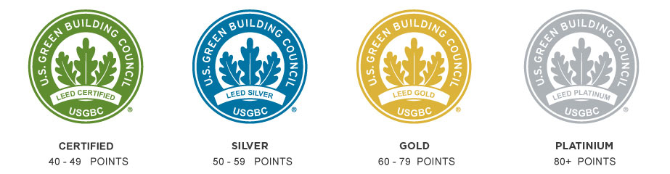
Preparing for LEED Certification
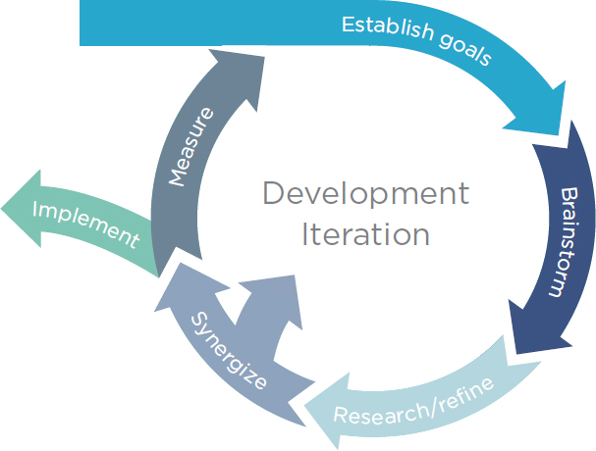
Integrative Process – gives the project team a greater chance of success.
Discovery. The most important phase of the integrative process, discovery can be thought of as an extensive expansion of what is conventionally called predesign. A project is unlikely to meets its environmental goals cost-effectively without this discrete phase. Discovery work should take place before schematic design begins.

Design and construction (implementation). This phase begins with what is conventionally called schematic design. It resembles conventional practice but integrates all the work and collective understanding of system interactions reached during the discovery phase.

Occupancy, operations, and performance feedback. This third stage focuses on preparing to measure performance and creating feedback mechanisms. Assessing performance against targets is critical for informing building operations and identifying the need for any corrective action.

Minimum Program Requirements
- Must be in a permanent location on existing land.
- Must use reasonable LEED boundaries.
- Must comply with project size requirements.

Rating System Selection
Identify an appropriate rating system
Determine best adaptation
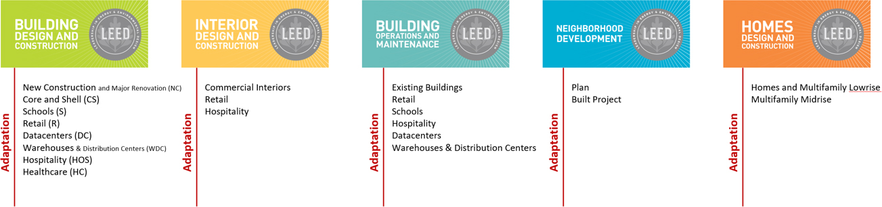

Rating System Descriptions
Choosing Between Rating Systems

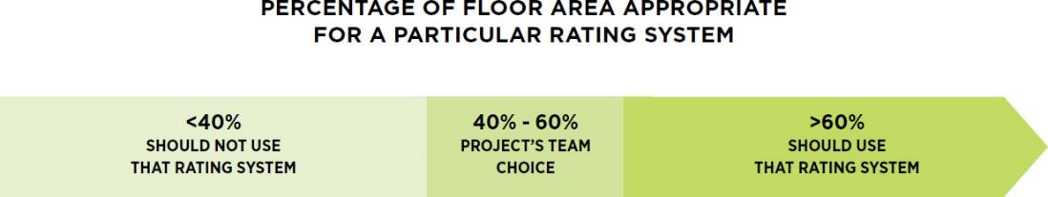

[See GA02 – Getting Started]

