|  |  |
| --- | --- |
|  | **Green Building Practices and LEED Green Associate Exam Preparation** |

**Lorisweb.com**

**GA06 LEED Certification Fees -**[**https://new.usgbc.org/cert-guide/fees**](https://new.usgbc.org/cert-guide/fees)

**LEED Certification Fees**

**Introduction**

**Registration and Certification Fees**

**Registration Fees**

* Flat fee paid up front at the time of registration.
* Rates are based on the fee schedule published at the time of registration.
* Discounted pricing for USGBC members (Owner or Project Administrator).

**Certification Fees**

* Based on your project's rating system and size.
* Calculated and paid when an application is submitted for review in LEED Online (either LEED Online or through ARC).
* Fees for either the standard and split review cover both the preliminary and final reviews.
* Discounted pricing for USGBC members (Owner or Project Administrator)

**What is included with LEED fees?**

* Integration and access to the new Arc platform: All projects in LEED Online have automatic access to Arc at no additional cost; simply log into Arc and link to your project.
* A dedicated LEED Coach: Newly registered projects are given a dedicated LEED Coach. LEED Coaches have more than a decade of green building and LEED expertise and can assist with questions during your LEED certification process.
* Award-winning customer service: Our customer service team has received 13 awards since 2013, including “Customer Service Team of the Year” from the American Business Awards and the International Business Awards.

<https://www.usgbc.org/tools/leed-certification/fees>

(2/22/2024)

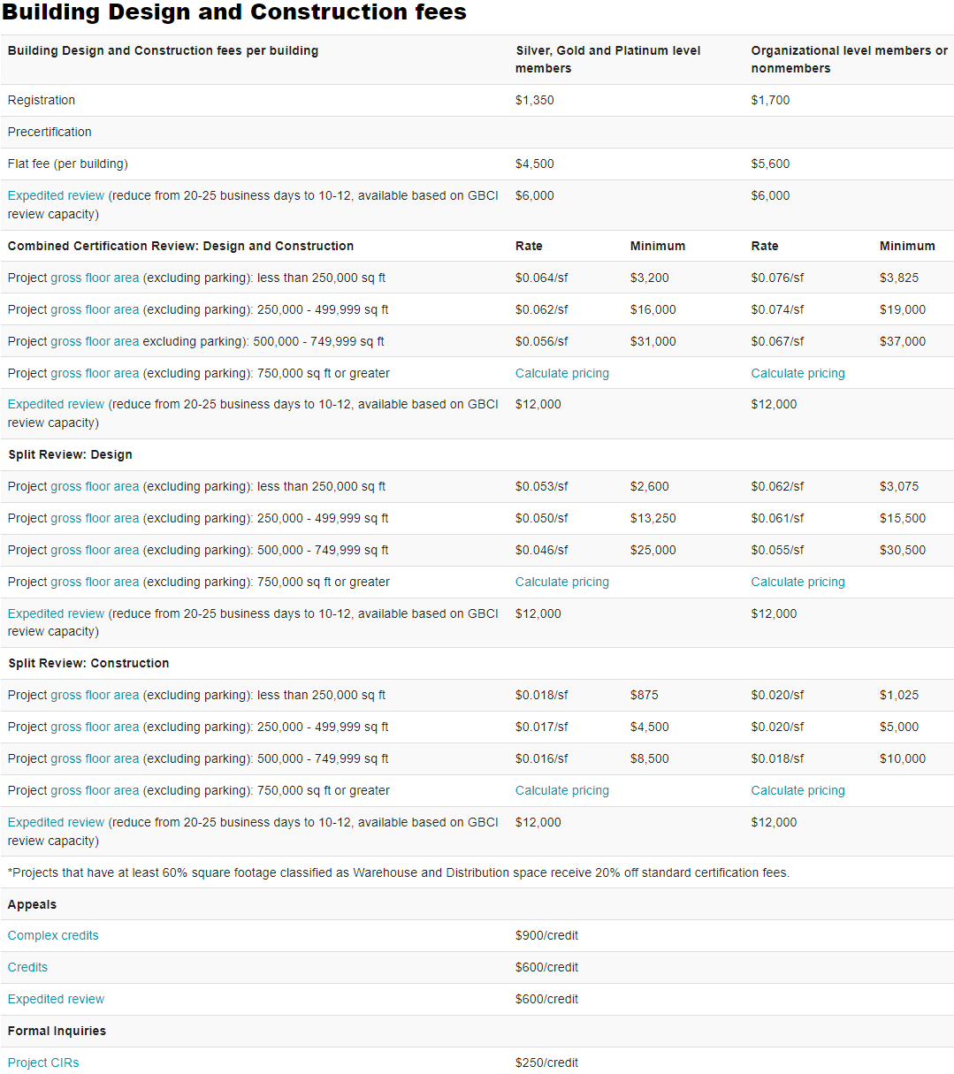

**LEED requirements and other guidance**

<https://support.usgbc.org/hc/en-us/articles/4526830606355-LEED-requirements-and-other-guidance#ruling>

**Formal inquiries and unpublished guidance**

**What is a credit interpretation ruling?**

A credit interpretation ruling (CIR), is the decision on a formal inquiry, submitted by a project team prior to a project's review. Formal inquiries can be used to obtain formal approval of how a team intends to apply LEED requirements to particular project circumstances to request a ruling on an exceptional approach to a credit. When a formal inquiry is submitted, our review team will let you know if your proposed approach to a particular credit or prerequisite is consistent with published rating system requirements and intent.

If approved, when it comes time to submit your application for review, you will need to reference the CIR and provide documentation demonstrating fulfillment of the approved strategy within your application for certification.

Keep in mind, also, that CIRs are not precedent setting; your project team can only utilize the ruling for the project under which the CIR was submitted. CIRs for LEED commercial projects are filed through LEED Online.

**How do I submit a CIR for review?**

CIRs are submitted through LEED Online for rating systems using that platform. Please follow these instructions to submit a CIR.

**What is a LEED Interpretation?**

A LEED Interpretation (LI) is an official answer to a formal inquiry about implementing LEED on a project. They help project teams understand how their projects can meet LEED requirements and provide clarity on existing options.

LEED Interpretations are:

* Precedent-setting: LEED Interpretations can be used by any project certifying under an applicable rating system adaptation and version. Project teams are required to adhere to LEED Interpretations posted before their registration date. This also applies to other addenda and corrections. Adherence to rulings posted after a project registers is optional but encouraged.
* Published online: LEED Interpretations are published in the Addenda database.
* Subject to consensus-based review: LEED Interpretations undergo review by USGBC member-selected volunteer LEED committees.

**How do I submit a LEED Interpretation for review?**

LEED Interpretation requests can no longer be submitted by project teams. Teams may submit a CIR for review. If the CIR appears to be precedent-setting, as described above, review staff will direct the inquiry through the consensus-based review process and follow up with the project team. Teams may include the words “LEED Interpretation” in the beginning of their inquiry, and this option will be considered.

**What are addenda?**

In typical usage, Addenda often refers to the published lists of edits to LEED rating systems and reference guides. According to the Foundations of LEED, Appendix 3, Addenda is also the overarching term to describe:

* corrections,
* clarifications,
* interpretations (also known as LEED Interpretations), and
* alternative compliance paths (ACPs).

Addenda are published quarterly, after they have been through the USGBC committee review process.

**Where can I find addenda that apply to my project?**

Corrections, clarifications, and LEED Interpretations can all be found in the Addenda database.

Corrections and clarifications also are published in tables, organized by page number of the LEED Reference Guides. These tables are published in the USGBC Resource Library.

<https://www.usgbc.org/addenda>