 | Green Building Practices and LEED Green Associate Exam Preparation
Lorisweb.com

GA05 Guide to LEED Certification: Commercial

LEED Process

LEED certification involves four main steps:
- Register your project by completing key forms and submitting payment.
- Apply for LEED certification by submitting your completed certification application through LEED Online and paying a certification review fee.
- Review. Your LEED application is reviewed by GBCI.
- Certify. Receive the certification decision. If you’ve earned LEED certification: congratulations!

Achieving LEED certification requires:
- Meet the Minimum Program Requirements (MPRs)
- Satisfy all prerequisites
- Earn a minimum number of credits for the desired level of certification

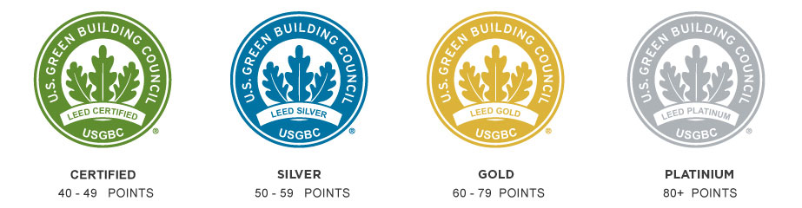

Minimum Program Requirements (MPRs)
Building projects pursuing LEED v4 certification must:
- Be in a permanent location on existing land
- Use reasonable LEED boundaries
- Comply with project size requirements

Select the appropriate Rating System for your project.
LEED v4 Rating System Selection Guidance
- Identify an appropriate rating system
- Determine the best adaptation

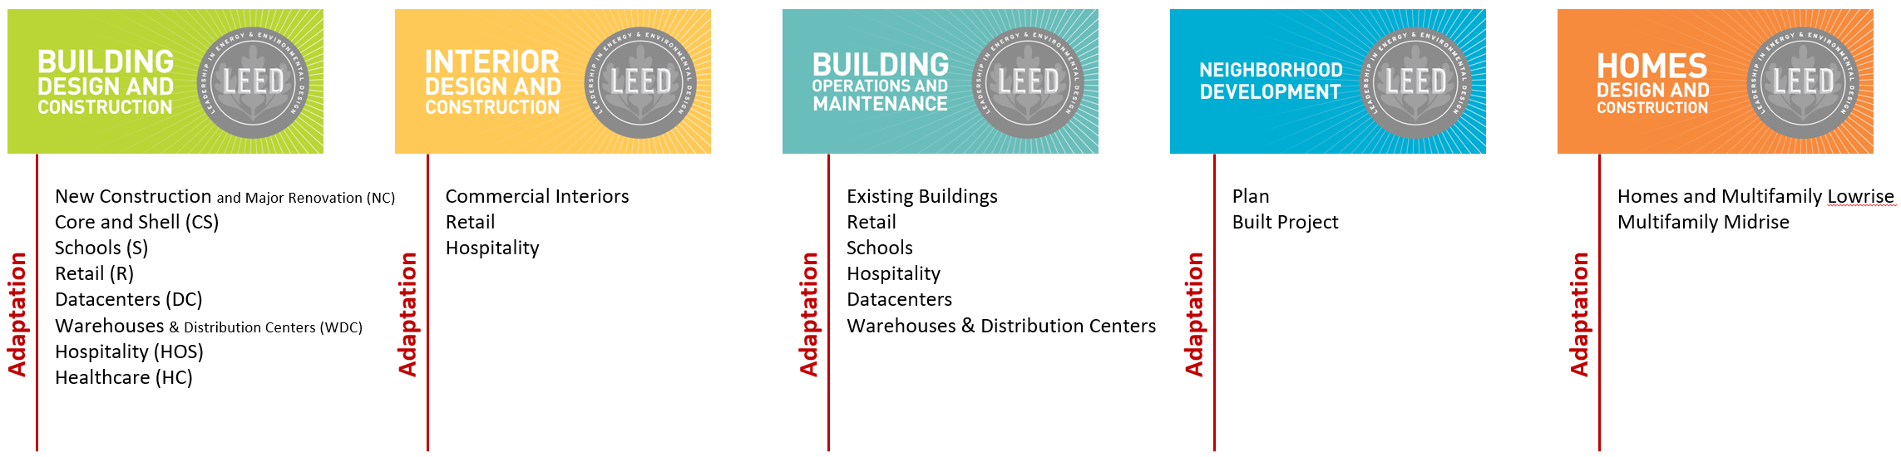

LEED Rating Systems
LEED for Building Design and Construction. Buildings that are new construction or major renovation.
At least 60% of the project’s gross floor area must be complete by the time of certification (except for LEED BD+C: Core and Shell).
Must include the entire building’s gross floor area in the project.

LEED BD+C: New Construction and Major Renovation. New construction or major renovation of buildings that do not primarily serve K-12 educational, retail, data centers, warehouses and distribution centers, hospitality, or healthcare uses. High-rise residential buildings 4 stories or more can use New Construction or Multifamily Midrise.
LEED BD+C: Core and Shell Development. Buildings that are new construction or major renovation for the exterior shell and core mechanical, electrical, and plumbing units, but not a complete interior fit-out. LEED BD+C: Core and Shell is the appropriate rating system to use if more than 40% of the gross floor area is incomplete at the time of certification.
LEED BD+C: Schools. Buildings made up of core and ancillary learning spaces on K-12 school grounds. LEED BD+C: Schools may optionally be used for higher education and non-academic buildings on school campuses.
LEED BD+C: Retail. Buildings used to conduct the retail sale of consumer product goods. Includes both direct customer service areas (showroom) and preparation or storage areas that support customer service.
LEED BD+C: Data Centers. Buildings specifically designed and equipped to meet the needs of high density computing equipment such as server racks, used for data storage and processing. LEED BD+C: Data Centers only addresses whole building data centers (greater than 60%).
LEED BD+C: Warehouses and Distribution Centers. Buildings used to store goods, manufactured products, merchandise, raw materials, or personal belongings, such as self-storage.
LEED BD+C: Hospitality. Buildings dedicated to hotels, motels, inns, or other businesses within the service industry that provide transitional or short-term lodging with or without food.
LEED BD+C: Healthcare. Hospitals that operate twenty-four hours a day, seven days a week and provide inpatient medical treatment, including acute and long-term care.

LEED for Interior Design and Construction. Interior spaces that are a complete interior fit-out.
In addition, at least 60% of the project’s gross floor area must be complete by the time of certification.

LEED ID+C: Commercial Interiors. Interior spaces dedicated to functions other than retail or hospitality.
LEED ID+C: Retail. Interior spaces used to conduct the retail sale of consumer product goods. Includes both direct customer service areas (showroom) and preparation or storage areas that support customer service.
LEED ID+C: Hospitality. Interior spaces dedicated to hotels, motels, inns, or other businesses within the service industry that provide transitional or short-term lodging with or without food.

LEED for Building Operations and Maintenance. Buildings that are fully operational and occupied for at least one year.
The project may be undergoing improvement work or little to no construction.
Must include the entire building’s gross floor area in the project.

LEED O+M: Existing Buildings. Existing buildings that do not primarily serve K-12 educational, retail, data centers, warehouses and distribution centers, or hospitality uses.
LEED O+M: Retail. Existing buildings used to conduct the retail sale of consumer product goods. Includes both direct customer service areas (showroom) and preparation or storage areas that support customer service.
LEED O+M: Schools. Existing buildings made up of core and ancillary learning spaces on K-12 school grounds. May also be used for higher education and non-academic buildings on school campuses.
LEED O+M: Hospitality. Existing buildings dedicated to hotels, motels, inns, or other businesses within the service industry that provide transitional or short-term lodging with or without food.
LEED O+M: Data Centers. Existing buildings specifically designed and equipped to meet the needs of high density computing equipment such as server racks, used for data storage and processing. LEED O+M: Data Centers only addresses whole building data centers.
LEED O+M: Warehouses & Distribution Centers. Existing buildings used to store goods, manufactured products, merchandise, raw materials, or personal belongings (such as self-storage).

LEED for Neighborhood Development. New land development projects or redevelopment projects containing residential uses, nonresidential uses, or a mix.
Projects may be at any stage of the development process, from conceptual planning through construction.
It is recommended that at least 50% of total building floor area be new construction or major renovation. Buildings within the project and features in the public realm are evaluated.

LEED ND: Plan. Projects in conceptual planning or master planning phases, or under construction.
LEED ND: Built Project. Completed development projects.

LEED BD+C: Homes and Multifamily Lowrise. Single-family homes and multi-family residential buildings of 1 to 3 stories. Projects 3 to 5 stories may choose the Homes rating system that corresponds to the ENERGY STAR program in which they are participating.

LEED BD+C: Multifamily Midrise. Multi-family residential buildings of 4 or more occupiable stories above grade. The building must have 50% or more residential space. These buildings may also use LEED BD+C: New Construction.

Choosing Between Rating Systems
- 40/60 Rule provides guidance for making a decision when several rating systems appear to be appropriate for a project.
- To use this rule, first assign a rating system to each square foot or square meter of the building, and then choose the most appropriate rating system based on the resulting percentages.
- The entire gross floor area of a LEED project must be certified under a single rating system and is subject to all prerequisites and attempted credits in that rating system, regardless of mixed construction or space usage type.
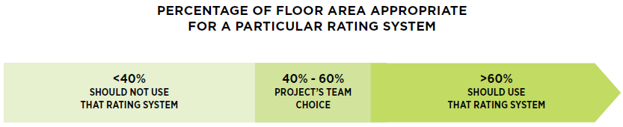

Register
LEED Online - online portal through which projects submit their application for certification, as well as access a variety of tools and resources, provide the registration information related to their project, submit payment and sign the certification agreement (the project owner must do this last one).

Once registered, the project application will be accessible in LEED Online.

From LEED Online the project team can be assembled and the entire LEED documentation process is managed.

Project Team Roles
- Owner
- Agent
- Project Administrator

Owner
The owner of the project is the person (or entity) who has the authority to hold and control the real and personal property associated with the project, and accepts (or authorizes the acceptance of) the certification agreement.

While there may be multiple owners for a particular project (submit a Confirmation of Primary Owner’s Authority Form), USGBC asks that projects identify a single individual to administer the certification process.

Big takeaway: the owner has ultimate control over the LEED certification application, meaning that GBCI - the organization responsible for administering LEED certification, will respond to the owner regarding the administration of the project over any other member of the project team.

Agent
The agent is the person (or entity) who is granted actual authority by the owner to register the project and accept the certification agreement.

If the project uses this option, they must upload a signed Confirmation of Agent’s Authority Form.

Project Administrator
This team member acts as a project manager, overseeing the LEED project as well as which project team members are responsible for certain tasks, credits or prerequisites.

The project administrator plays a key quality role by checking that the LEED submission is complete and accurate before submitting the project to GBCI for review, and accepting the review results once the review is complete.

Note: the individual who initially registers the project will automatically be granted the role of the project administrator, but the owner may transfer this role to another team member at any time.

LEED Certification Deadlines
As new versions of the LEED rating systems are introduced, earlier versions are phased out so that USGBC is constantly pushing for the transformation they aspire to.

At any given point, LEED rating systems are either:
- Open for registration and certification, or
- Closed for registration, but open for certification, or
- Closed for registration and certification (sunset)
Deadlines are published on the USGBC Website @ http://www.usgbc.org/cert-guide/deadlines

Recertification (LEED O+M Only)
- For certification to remain current projects must recertify within five years of the previous certification.
- Projects are eligible for recertification after 12 months and every 12 months thereafter.

Campus Projects
Examples: a corporate or educational campus, government installation or commercial development

- Projects planning to certify more than one building located on a single shared site and under the control of a single entity, may register their project as a campus or group project to streamline the documentation needed to submit for review.
- Individual building registration and certification fees apply to campus and group projects.
- Depending on the campus approach selected, projects will pursue a slightly modified registration process, as compared to one-off project registration.

Campus credit approach
This approach enables projects to streamline the documentation process by earning “campus credits” – prerequisites and credits that can be applied to all LEED projects on the master site.

Project’s register a “master site,” which includes a general narrative of the overall campus projects and a schematic site plan, in addition to registering each individual project on the site.

Campus group project approach
Project’s register the group of projects on the site as a single LEED project that will then receive a single LEED rating and certification.

To be eligible:
LEED BD+C and LEED ID+C projects must be under the same construction contract and be constructed at the same time.

LEED O+M projects must be under the same ownership and management, share the same performance period and have substantially similar space types.

The team’s campus project documentation must demonstrate that the group of projects collectively meets the credit requirements using a “group credit.”

Projects may use a campus group project certification independently or in combination with campus credits documented under a master site review, through the campus credit approach.

Apply
- Collect and submit the appropriate documentation via LEED Online
- The project team identifies the LEED credits to pursue and assigns them to project team members.
- Team members collect information, perform calculations and analysis, and prepare documentation demonstrating achievement of the prerequisites and selected credits.
- Completed documentation is uploaded using LEED Online
- The Project Administrator submits the application along with the certification review fee.
- GBCI reviews the project documentation.

LEED O+M Projects
- Performance period for any prerequisite or credit may be extended to a maximum of 24 months preceding the certification application.
- All performance periods must overlap and come to a conclusion within one month of each other.
- Completed application must be submitted for review within 60 days of the conclusion of the performance period.

Campus Projects
Campus credit approach: If the project team is pursuing this approach, document all campus credit information within the master site.
Campus group project approach: The project team’s group project documentation must demonstrate that the group of projects collectively meets the credit requirements using a “group credit.”
Group project certification may be used independently or in combination with campus credits documented under a master site review, through the campus credit approach above.

Review
Part 1: Preliminary Review
- Project administrator submits the completed application.
- GBCI checks the application for completeness and compliance with the selected rating system and attempted credits.
- GBCI will respond with its preliminary review within 20-25 business days, indicating which prerequisites and credits are anticipated to be awarded during final review, pending further information or denied.
- Team can accept the preliminary review results as final, submit new or revised documentation, or attempt additional credits before submitting for final review.

Part 2: Final Review
- This stage allows the project team to submit supplementary information or amend the application.
- GBCI suggests clarifications are submitted within 25 business days after receiving the preliminary review results. GBCI will then review revised or newly submitted prerequisites and credits, and reconsider any anticipated credits or prerequisites for which information has changed since the return of the preliminary review.
- GBCI will respond with a final LEED certification review report within 20-25 business days, marking prerequisites and attempted credits as either awarded or denied.
- Project team may either accept the review results as final, or revise the application and resubmit, this time as an appeal.

Part 3: Appeal Review
- This stage provides one additional round of review and allows the project team to submit supplementary information, amend the application or add new credits not previously attempted.
- GBCI will review the pending or newly submitted prerequisites and credits, and reconsider any anticipated credits or prerequisites for which information has changed since the return of the final review.
- The fee associated with appeals varies depending on the level of complexity of the credits or prerequisites involved in the appeal.
- GBCI will respond with an appeal LEED certification review report within 20-25 business days, marking prerequisites and attempted credits as either awarded or denied.
- Like the final review, the project team can either accept the appeal review results as final, or submit a further appeal. There is no cap on the number of appeals you may submit.

Standard Review (all Rating Systems)
- The project administrator submits the entire application (all credits and prerequisites) once the project team has completed the project.

Split Review (LEED BD+C and LEED ID+C Rating Systems)
- Design credits and prerequisites are submitted at the conclusion of the project’s design phase.
- Construction credits and prerequisites at the conclusion of the project’s construction phase.
- Designed to help project teams determine if the project is on track to achieve LEED certification at its preferred level.
- Only credits and prerequisites identified as design credits can be submitted during the design review, and the application must be submitted before your project is substantially completed.
Precertification Review (LEED for BD+C: Core & Shell projects only)
- Optional review pathway available for a fee for LEED BD+C: Core & Shell projects that is focused on their intended design and construction strategies.
- USGBC offers precertification to help projects attract tenants and to help determine which credits and prerequisites the project is likely to achieve during the full review.

Expedited Review
- Contact GBCI at least five business days (please allow longer if you are paying by check) prior to submitting an application to request an expedited review to cut the review time in half (reduced from 20-25 business days to 10-12 business days per review phase).
- There is an additional charge for this service, and GBCI’s ability to fulfill requests depends on their current review capacity.
- If GBCI can accommodate the request, they will confirm availability and provide a custom review schedule for the project.

Submitting an Inquiry
- Allows project teams to gain clarification before registering a project or during the documentation process.
- Registered Projects – submit inquiries through LEED Online
- Projects that have not registered can reach out to GBCI
- Address only one prerequisite or credit per inquiry.

Credit Interpretation Ruling (CIR)
- Obtain technical guidance related to a particular credit or facet of the LEED rating system.
- Review team decides if the interpretation of a particular credit or prerequisite is consistent with published rating system requirements. [Can be appealed.]
- Must provide documentation demonstrating fulfillment of the CIR and indicate the approved CIR within the application for certification.
- CIRs are not precedent setting; the project team can only utilize the ruling for the project under which the CIR was submitted.

LEED Interpretation (LI)
- Administered by USGBC
- LEED Interpretations focus on the evolution of the LEED rating system and are published periodically in the form of official addenda.
- Differ from Project CIRs in that, as USGBC issued addenda, these rulings are precedent-setting and applicable to all projects registered in the future.
- Projects registered before a LEED Interpretation is published may voluntarily elect to follow these revisions.

Deadline for Submitting for Review
LEED BD+C and LEED ID+C rating systems
Must submit for a construction phase review (preliminary standard review or preliminary construction review) no later than two years after the project is substantially completed (the date on which the building receives a certificate of occupancy or similar official indication that it is fit and ready for use).

LEED O+M projects
Are required to submit for review within 60 days of the end of their performance period.

Campus projects
Campus credit approach: USBGC recommends that projects complete the master site review prior to submitting any associated, individual or group projects for review, since the campus credits earned through the master site review will then become available to the individual or group projects associated with it.

Appeals
If a project team feels that the results of a review appeal or a CIR appeal are incorrect and wish to challenge those results, they may do so by contacting GBCI.

Upgrading the Project’s Version of LEED Online
- Check the USGBC Website for available upgrades.
- If the project has been submitted for review, it will need to stick with the version of LEED Online that it was registered with – the project cannot be transferred.

Certify
Accepting the certification is the final step in the LEED review process.

- Once the final application review is complete, the project team can either accept or appeal GBCI’s final certification report.
- Once the project team has accepted the final certification report, the project will be deemed “closed out” –meaning that the project team will no longer be able to appeal the certification level or review decisions for specific credits or prerequisites.

Certification Levels
LEED Certified™ 40-49 points earned
LEED Silver® 50-59 points earned
LEED Gold® 60-79 points earned
LEED Platinum® 80+ points earned

Promote the LEED-certified Project!
USGBC provides a Public Relations Guide for LEED-certified projects
USGBC provides a formal Certificate of Recognition
Projects can order LEED Plaques and Certificates

How USGBC is Using Project Data
- LEED-registered and certified projects are, by default, considered “public” projects, and thereby included in USGBC’s public LEED project directory.
- Projects can opt-out of the LEED project directory and publicity opportunities as a “private project” at the time of registration: specific instructions on how to do so are available in LEED Online.

Deadline for achieving certification
- Each rating system will remain open and available for certification for at least six years after the rating system registration close date.
- To certify a project under a specific rating system, projects must submit for certification by that rating system's certification close date, also called the sunset date.
- If the project team has difficulty meeting this deadline, the can reach out to GBCI—they’ll work with them on a solution for their project.

Expiration of LEED certification
LEED O+M projects, must recertify within five years of the previous certification.

Revocation of LEED certification
- In rare situations, LEED certification may be revoked.
- USGBC created the Certification Challenge Policy to ensure that all LEED project submittals and subsequent reviews by GBCI team members are done so with integrity, accuracy and truthfulness.
- A certification challenge may be initiated by GBCI or by any third party within 18 months of a project’s certification.
- Projects must retain all project documentation related to certification, and the achievement of prerequisites and credits, on-site at the certified project for two years after receiving certification, to ensure that this information is available in case of a challenge.

Fees
Registration Fee
- Flat Fee paid at the time of registration
- Organizational Level or Non-members: $1,700
- Silver, Gold and Platinum Level Members: $1,350

Certification Fee
- Charged on a per-project (building) basis
- Based on the size of the project and the rating system under which the project is registered
- Due when the project team submits the application for review. GBCI will not begin the review until payment in full has been received and cleared their system

Other Fees
- Appeals
- Formal Inquiries: Credit Interpretation Rulings (CIRs)
- Expedited Review
- Precertification Review (Optional, LEED CS Only)

Resources and Tools

General Resources
Credit Library
Addenda database
Pilot Credit library
Regional Priority Credit lookup
LEED Online: v4, v3
Legal agreements: LEED Certification Agreement, Confirmation of Agent's Authority, Confirmation of Primary Owner's Authority, Change of Owner Agreement

BD+C specific
LEED v4 Reference Guide
Rating System Document
Checklist

