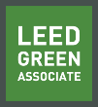 | Green Building Practices and LEED Green Associate Exam Preparation
Lorisweb.com
Kick-Off Meeting – September 11, 2024
Preparing for the LEED Green Associate Professional Credential

Introduction
Instructor: Lori Brown
Email: labrown2@csuchico.edu
Web Site: lorisweb.com
Cell: 530.519.1147
ZOOM Link: https://us02web.zoom.us/j/82775860795?pwd=IJhqpSjiw3ik46LO29RcSgZZxYS5Se.1
Day/Time: Wednesday (9/18 – 11/6) - 7:00 pm – 8:15 pm CT

Course Resources

https://lorisweb.com
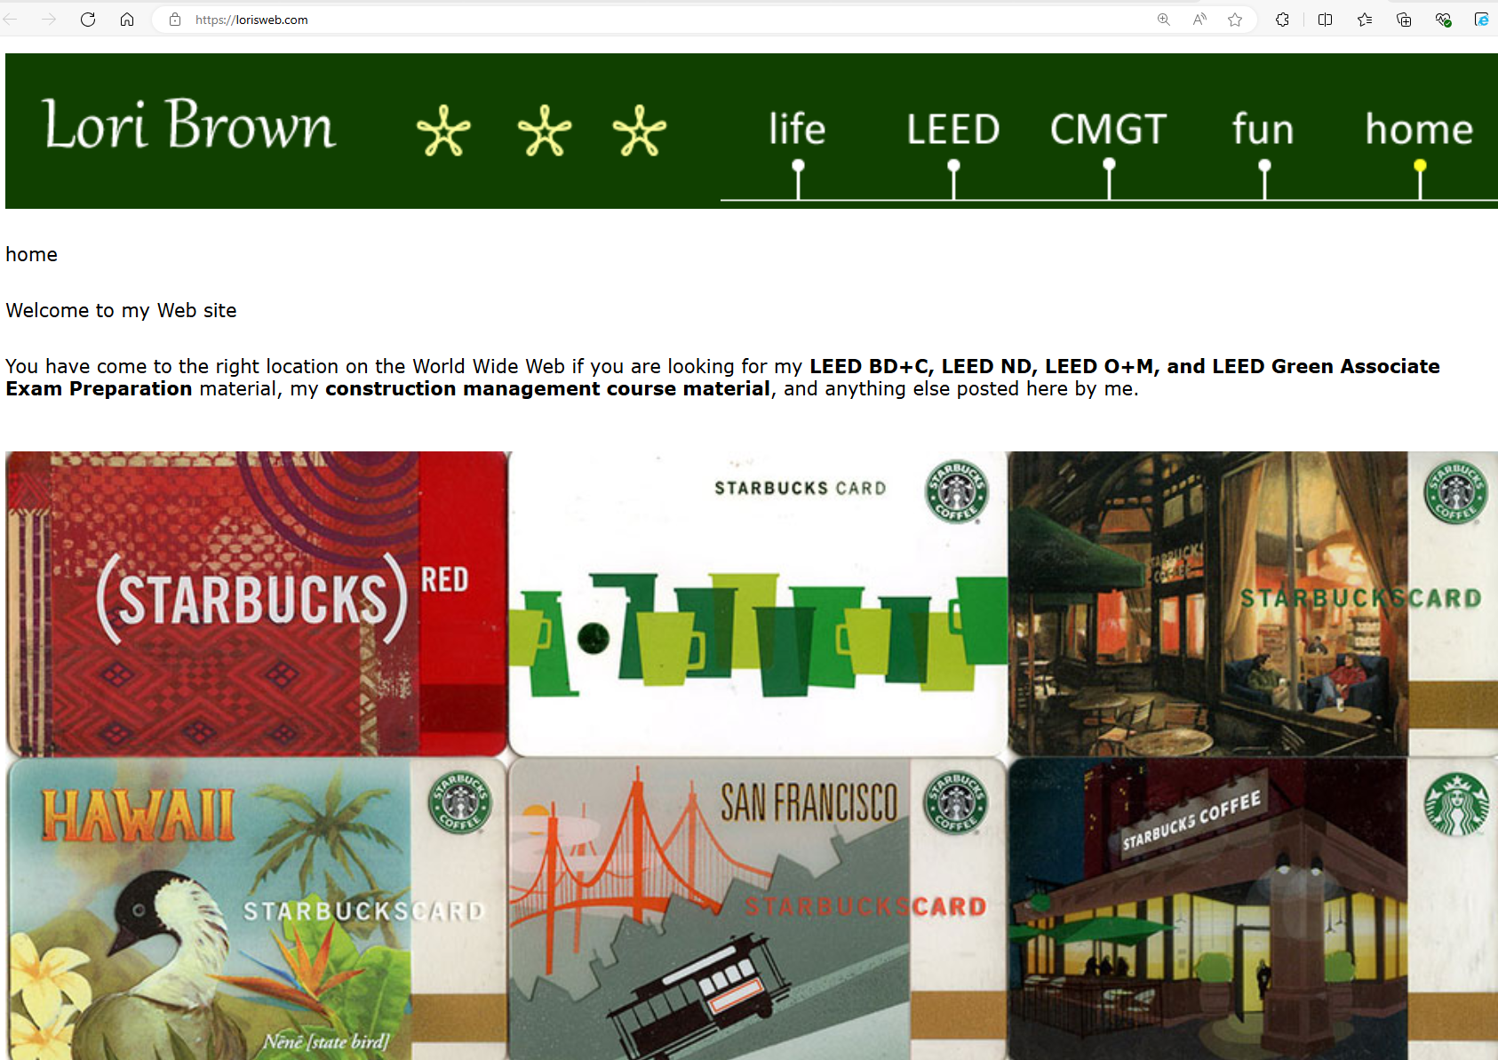

https://lorisweb.com/leedga_8.html
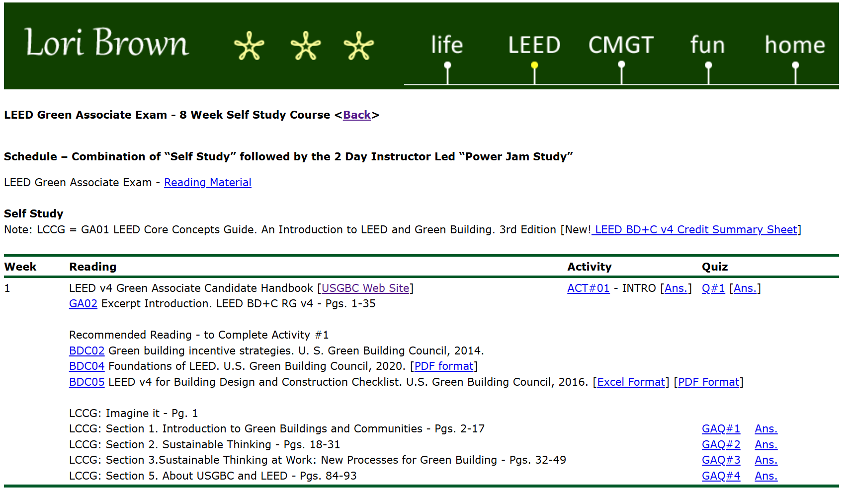

DropBox Folder - Online Course Material
https://www.dropbox.com/scl/fo/t4dnq86eddywjbsyqag48/AL8MqjncIRt8ii2Eb5bnF-k?rlkey=0fuylcre63064o51c2ndm2wmf&st=fgdq3f09&dl=0

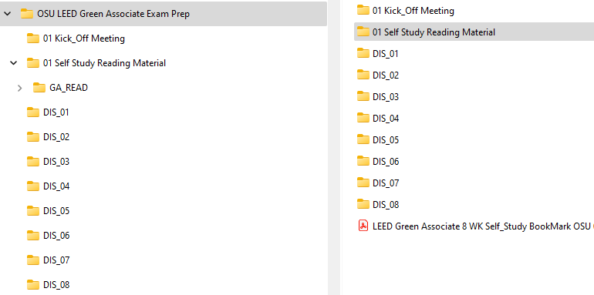

- Course Material will be added on-going. Please be sure to check the folders frequently.
- Printing handouts is not required, but it may be helpful if that is your preferred style for learning.

Steps for Preparing for the LEED Green Associate Exam

Step 1. Read the LEED Green Associate Candidates Handbook

Step 2. Create a USGBC Account (usgbc.org)

Step 3. Sign Up and Schedule a Date to Take the LEED Green Associate Exam

Step 4. Read the Required Referenced Material (see, LEED Green Associate Candidate Handbook, pg. 19)

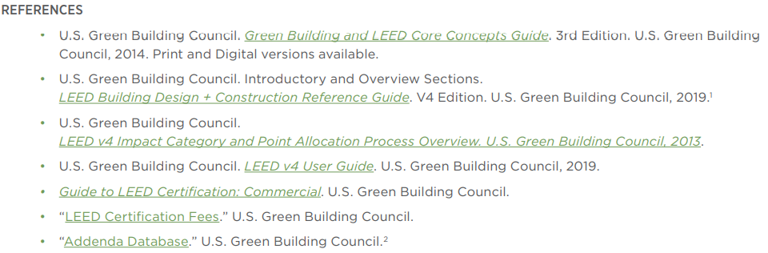

All reading material can be found on lorisweb.com/leed.html and in the DropBox Folder

Step 5. Attend the eight-week online workshop and the two-day in person Power Jam Study!

Step 6. Take and pass the LEED Green Associate Exam!

Step 7. Enjoy your new professional credential!

About the USGBC
USGBC | U.S. Green Building Council

Mission and Vision
Green building for everyone within a generation.

At USGBC, our vision is that buildings and communities will regenerate and sustain the health and vitality of all life within a generation. Our mission is to transform how buildings and communities are designed, built and operated, enabling an environmentally and socially responsible, healthy, and prosperous environment that improves the quality of life. We're committed to transforming our built environment through LEED, the world’s most preeminent green building system. Today there are more than 105,000 LEED-certified buildings in nearly 190 countries.

Embracing market Priorities
Green building practices are more important than ever. Green buildings save money, improve efficiency, lower carbon emissions and create healthier places for people. They are critical to addressing climate change and meeting ESG goals, enhancing resilience, and supporting more equitable communities.
USGBC is at the forefront of industry discussions and actively advancing these priorities within the market. Dive into our comprehensive resources, reports, and articles that highlight the intersection between LEED and key topics: decarbonization, electrification, equity, ESG, green finance, human health, net zero and resilience.
Modeling the mission and values
The USGBC headquarters in Washington, D.C., has been awarded a prestigious triple Platinum certification in LEED, TRUE and WELL. This trio of certifications reflects USGBC’s commitment to healthy, productive, sustainable and responsible work environments. The headquarters, reflects the changing office landscape, with a clear emphasis on decarbonization, indoor environmental quality and resource efficiency. Learn more.

Advocacy
Advocating for green buildings and communities.

Driving the development of green buildings
Sustainability and green building are projected to see growth for years to come, with its influence reaching across the U.S. economy, generating significant environmental and social benefits. Backed by community, research and tools, we use advocacy, partnerships, and campaigns to drive the development of green buildings and communities.
Our advocacy goals:
- Ensure that taxpayer dollars being spent on federal, state and municipal buildings are investing in buildings that cost less to build and operate and are healthier for people.
- Ensure that lawmakers and elected officials have access to current and cutting-edge information on green building and resilient cities and communities so they can make the best decisions on behalf of their constituents.
- Ensure that policies incentivize and encourage the use of LEED and other resources that create economic, environmental and social value.
- Leverage our external engagements and contacts to promote organizational reputation and relevance for resilience, equity, climate, and quality of life.
Join the Advocacy Working Group for timely updates and opportunities to get involved. Whether it's a five-minute call or email to your elected representative or jumping in to help on an Advocacy Day, we appreciate our volunteers and everything they do to further the green building mission and vision. View the Advocacy Working Group brief to learn more and join the working group.
Advocacy priorities
Discover green building-related and LEED-specific policies across the U.S. in the USGBC Policy Library. The library shares details on policies at the federal, state and local levels that incentivize, require or otherwise promote green building measures, including LEED.
Green building codes
Green building strategies are increasingly being introduced into traditional building codes, addressing the cross-cutting categories of site selection, water conservation, energy efficiency, renewables, indoor environmental quality and resource conservation. With large U.S. states and metro areas leading the way, governments and local jurisdictions have adopted green building criteria as policy.
As traditional building code evolves to include sustainability measures, that upward movement helps redefine leadership and what LEED can do to transform the market. These forces work together, fueling higher levels of building performance and sustainability. With the full force of the USGBC and GBCI’s core competencies in standards creation, verification, education and high-performance building data tracking, we are committed to speeding the evolution of green building codes far and wide—and establishing minimum green requirements for buildings, providing baseline green benefits and a foundation for applying LEED. Learn more.
USGBC Policy Library
The USGBC Policy Library is an interactive tool that showcases policies that incentivize, require, or encourage high-performance buildings, including but not limited to LEED, across state and local jurisdictions in the United States.
Policies, including structural incentives like density and height bonuses and expedited or no-cost permitting, information mechanisms, and financial incentives like tax credits, grants and low interest loans - help drive the market for high-performance buildings.
If there is a high performance building policy, or any policy that references LEED, in your jurisdiction that is not shown on this map, we encourage you to submit them to publicpolicies@usgbc.org.

LEED - https://www.usgbc.org/leed

Leadership in Energy and Environmental Design

LEED rating system
The most widely used green building rating system.

LEED-certified green buildings are better buildings.
LEED (Leadership in Energy and Environmental Design) is the world's most widely used green building rating system. LEED certification provides a framework for healthy, highly efficient, and cost-saving green buildings, which offer environmental, social and governance benefits. LEED certification is a globally recognized symbol of sustainability achievement, and it is backed by an entire industry of committed organizations and individuals paving the way for market transformation.
LEED v5 is the newest version of LEED. It marks a transformative milestone in the built environment’s alignment with a low-carbon future and addresses critical imperatives such as equity, health, ecosystems and resilience. Learn more.
A LEED for every project
LEED is for all building types and all building phases including new construction, interior fit outs, operations and maintenance and core and shell. Check out our interactive Discover LEED tool to get started; then, use the rating system selection guidance to select a rating system.

LEED system goals
LEED-certified buildings are critical to addressing climate change and meeting ESG goals, enhancing resilience, and supporting more equitable communities. LEED is a holistic system that doesn’t simply focus on one building element, such as energy, water or health. Instead, it looks at the big picture, factoring in all critical elements that work together to create the best building possible. The goal of LEED is to create better buildings that:

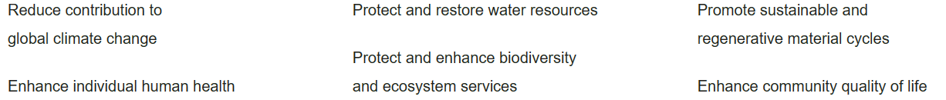

Of all LEED credits, 35% relate to climate change, 20% directly impact human health, 15% impact water resources, 10% affect biodiversity, 10% relate to the green economy, and 5% impact community and natural resources. In LEED v4.1, most LEED credits are related to operational and embodied carbon. Learn more.

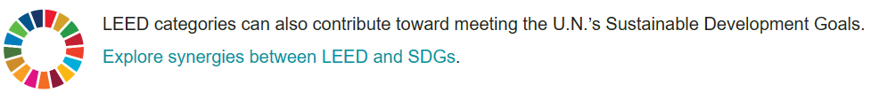

Better for business, people and the environment.
Millions of people live, work and learn in LEED-certified buildings worldwide. Here's why.

Better of business and the bottom line
LEED buildings have a higher resale value and lower operational costs than non-LEED buildings. LEED is an essential strategy for achieving ESG, decarbonization and equity goals. LEED-certified buildings are a solid asset for investors, occupiers, and communities. They've proven to be top-performing commercial real estate investments.

Help meet investor’s ESG goals
Command higher rents
Boast lower vacancies post-pandemic
Increased occupany rates
Acquire premium pricing

LEED helps investors measure and manage their real estate performance. It allows investors to implement management practices that prioritize building efficiency, decrease operational costs and increase asset value.

Better for people
LEED-certified buildings focus on occupant well-being, offering a healthier and more satisfying indoor space while addressing community and public health. The rating system focuses on strategies like banning smoking and reducing toxic exposure from materials to improve air quality. Active design and supporting the production of local, sustainable foods promote physical activity and healthy eating.

Happier employees and occupants
Bring in the good, keep out the bad
Heathier air quality
Reduced pollution

Employers in LEED-certified spaces report higher recruitment and retention rates and increased employee productivity*.

Better for the environment
LEED buildings use less energy and water, utilize renewable energy and fewer resources, create less waste, and preserve land and habitat. LEED certification is a global solution for cities, communities and neighborhoods. Through sustainable design, construction and operations, LEED can help new and existing buildings to reduce carbon emissions, energy and waste, conserve water, prioritize safer materials, and lower our exposure to toxins.

Tackle climate change
Reduce energy use and carbon emissions
Reduce waste
Fewer cars, fewer miles driven
Green materials

Buildings account for almost 40% of global energy-related CO2 and are critical in tackling climate change.

Energy-efficient buildings reduce pollution and improve outdoor air quality in major industrialized areas, making LEED a critical tool in reducing smog.

By building to LEED standards, buildings contributed 50% fewer GHGs than conventionally constructed buildings due to water consumption, 48% fewer GHGs due to solid waste and 5% fewer GHGs due to transportation*.

How LEED works
To achieve LEED certification, a project earns points by adhering to prerequisites and credits that address carbon, energy, water, waste, transportation, materials, health and indoor environmental quality. Projects go through a verification and review process by GBCI and are awarded points that correspond to a level of LEED certification: Certified (40-49 points), Silver (50-59 points), Gold (60-79 points) and Platinum (80+ points).

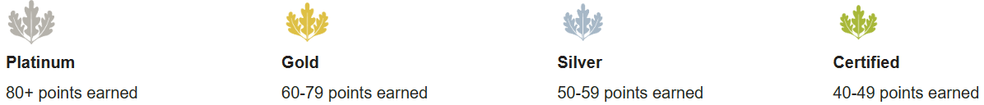

LEED is backed by USGBC—the developers of LEED—and an entire industry of committed organizations and individuals who are paving the way for market transformation. USGBC invests more than $30 million annually to maintain, operate and improve LEED and its customer delivery.

